REPORT OF THE PROJECT
Scheme for Protection and Preservation of Endangered Languages
for the Month of August
LANGUAGE : KHANA
DISTRICT : RAMBAN

SUBMITTED TO
Central Institute of Indian Languages
(Ministry of Human Resource Development, Govt. of India, Department of Higher Education)
Manasagangotri, Mysore – 570 006 (Karnataka).
Principle investigator : Prof. Aadil Amin Kak
Resource persons : 1. Humaira Khan
2. Javaid Ahmad Lone
3. Sumia Tariq

Khana is the language primarily spoken in the hilly area of Chamalvas situated in District Ramban ,tehsil Banihal . The area is situated in the central Himalayas on the eastern side of the National Highway which passes through the Banihal Pass. 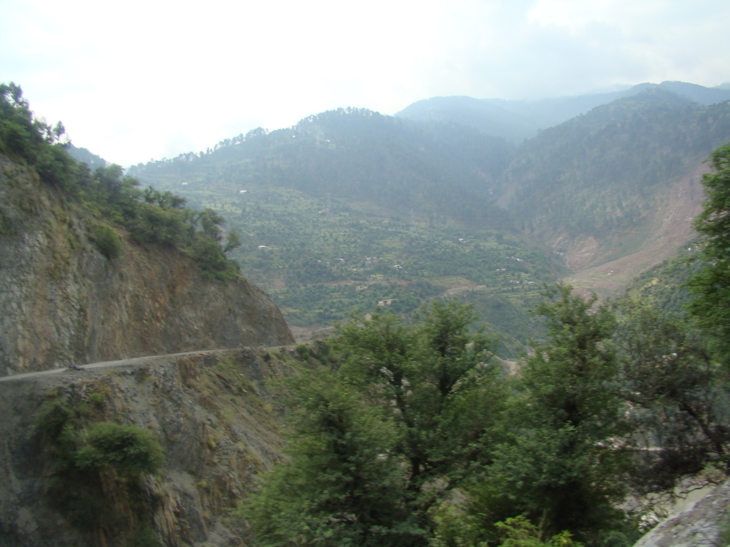
.
The Road Winding along the Mountain Slope.

Chamalvas is a small village located at a distance of about 30 kilometers from Ramban district properTehsilBanihal. It is situated at a high altitude on a mountain top called Hansraj Mountain, which runs along with PirPanjal mountain range of Great Himalayas. The main land mark in the area is a rivulet popularly called BaddaNaalah which is joined by another rivulet called Bichellary in Ramsoo area of Ramban district, whose way uphill leads to the area of Neel. On its North lie Kapran and Hallansedaar areas.

Aerial View.

About 60 families reside in this village. Some families have a history of about 100 – 200 years of residing in this area.A chunk of khana speaking population is scattered in Neel chidous area as well which is a few kilometers away from Chamalvas.
The District is known, not only for its rich cultural heritage and ethical values but also popular for its age-old traditions of secularism and the spirit of tolerance, which have been since times immemorial, binding the people together. Khana is the mother tongue of about 500-600 persons. The native speakers reported that they are living in this area from several generations. According to the oral tradition in this region, people of this area are descendants of people who had migrated to this place from the several other places and settled here. At present, the people have developed a unique sub-culture different in many respects from the rest of the state, as well as a unique sense of identity towards their mother tongue.
According to the local residents of district Ramban and tehsil Banihal,the Khana/speakers were given the name Khah by the Kashmiris of Banihal.As per the local knowledge the word ‘Kha’ means ‘mountain dwellers’ and was used by Kashmiri speakers in derogatory sense for the people of that area, which showed that khana people probably had a lower status. When these people used to visit the market of banihal city for various purposes, they used to get noticed by their dressing pattern and their way of talking, etc. They used to wear multi colored clothes ( i.e shirt and trousers of two different colors and turban of differentcolor)so they were also known as du reng( bi colored) by the Kashmiri speakers. They looked entirely different from Kashmiris who took them as backward, uncivilized and mountain dwellers speaking some different language and hence gave them the name Khah/ khanaPoguli speakers consider Kha speakers inferior to themselves. According to them, Kha speakers were originally brought there as labourers to work on their fields. Later they got settled there.
Some families are said to have migrated from Batmaloo area of Srinagar district to Neel and then from Neel to Chamalvas. The reasons of migration may vary from person to person but no common reason has been stated by the people.Population consists of Kashmiris and Gujjars and they have friendly relations with each other
LANGUAGE AND IDENTITY
The language spoken in this region is Khana. It is locally known as Kha. It is spoken by almost 500-600 residents and is the main medium of communication in this area. Neighbouring languages include Kashmiri, Poguli and Dogri. Khana is the main language used by the people in their homes, fields and other informal situations. Children also speak Khana in informal situations. Apart from Khana, Kashmiri and Urdu are spoken in the region, but the Urdu spoken here resembles Pahari. Hindi is also spoken to some extent. As far as the schools are concerned, Urdu and Kashmiri are used. So it can be said that these two languages are formal where as Khana is informal. In mosques and religious meetings conversations are held in Urdu /Kashmiri as the speakers of languages other than Khana can come together and exchange views. Religious hymns and songs are recited in either Kashmiri or Urdu.
Regarding their language and their identity, their elders believe that this language is their virasat i.e. their inheritance which has to be carried on by every new born child. as well. This multilingual nature can probably be attributed to their daily needs of communication with other people at their employment sites ,etc.
The older generation seems to prefer adherence to this important cultural component whereas the younger generations do not feel that this has any importance. The reason why the older generation prefers to adhere to this cultural component is probably because of some emotional bond by which they wish to be identified.

Khana has no ancient written document or literature. Not even a single radio or TV program is broadcasted and no newspapers are printed in Khana, which means the language is not used in media.
The language used while communicating with people outside community is determined by the language of the person concerned i.e. Kashmiri with Kashmiris, Dogri with Dogris, Urdu with people other than themselves. Even though the medium of instruction in schools is English but their proficiency in it is poor. Though these languages are also spoken with ease, Khana continues to be the widely used language. Being a miltilingual society switching from one language to other is common.

ARCHITECTURE:
The culture of a community is reflected in its style of architecture(structure of houses,artifactsused,etc.)

A Double Story House with Verandahs.
The houses of the khana community are located in a scattered manner on the slope, sometimes forming groups of not more than four. These houses are approached from the road and connected to each other by rough and steep tracks. The slope is covered by woody shrubs and long grasswith a terrace here and there, either occupied by a house or houses, a cowshed or a patch of corn or vegetables.

A Cowshed.

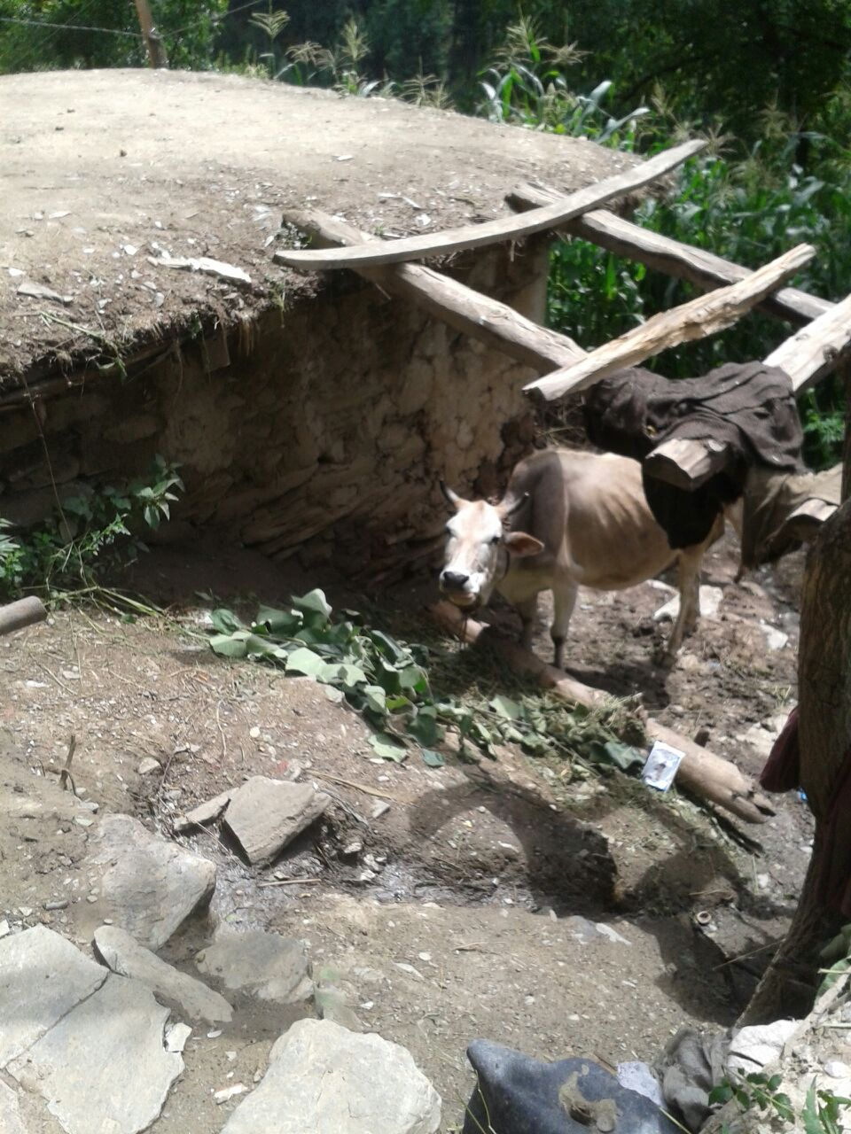

The Roof of a House.
The houses are made of timber and flat stones much larger than bricks held together by clay. The roofs are made of tin sheets supported by timber. In olden days they were roofed with straw and mud.

The Ceiling of a Room Made of Timber. ( Composed of planks and beams)
The houses are single or double storied structures with more than half of the length and less than half of the breadth of the lower story occupied by a verandah.
Front of a House.
This verandah is accessed by a short flight of steps from the outside, if it is on a level higher than the ground or one simply steps into the verandah, if it is level with the ground. The interior of the house opens onto the verandah by means of a single wooden door. The door leads into a narrow hallway. Three rooms open onto this hallway, one on the right and two on the left. The right one is a sitting room. Out of the other two rooms, the one furthest from the entry is a kitchen, the floor of which is furnished with a single mat of grass.

Shelves inside the Kitchen.

The remaining room may be a bedroom or a sitting room.

The Drawing Room.
The upper story is accessed by a woodenstaircase and has the same number of rooms as the lower story. These are arranged in the same manner as the ones in the lower story, but all of them function as bed rooms and the hallway is reached from the opposite side by the staircase.
There are no walls or fences round the houses. The spaces in front of the houses are very small and cannot be called yards. Z The Stairs.
Because the community lives on a mountain slope, the movement up and down the slope is sometimes made easy by series of steps made of flat stones as shown in the picture above.
ECONOMY AND OCCUPATION
Economically speaking, people here in general belong to middle class and lower middle class. Most of the people in this region are illiterate, poverty being the main reason. The people residing here earn their living by farming and labor. Men work outside the homes while women are mostly involved in household activities. Water is supplied from a spring which is about 1km far from the village. There are no rivers found here.There is only one hospital located at a distance of 2kms from the village but it is deprived of basic facilities and is not in a good condition. It is under construction yet. In the recent past rice was also being cultivated in the area but because to scarcity of rain rice cultivation stopped. Furthermore, some fruits are also grown. Trees, which produce nuts, are also observed in the area
A significant proportion of the community population is involved in that occupational economic activity which gives them significant income. They do not have a fixed occupation as such but people are mostly self employed like contractors, carpenters, masons, butchers, grocers, and drivers as well.

A Government Store.

A Shop.

They don’t have to undergo any formal training in their respective occupations i.e. working at fields, running a shop etc. in this way these occupations become family occupations. In the broader functional framework these occupations provide the basic sources needed for human survival in the community.
Most of the people mainly subsist on labor. Agriculture is only the secondary source of subsistence.

A Terrace of Corn.
People maintain kitchen gardens and cultivate corn on small terraces cut into the steep mountain slope. There is a dilapidated school nearby which apparently has made no difference over the years, judging by the fact thatalmost all the men who provide for their families areundereducated (below the 8th standard on an average). Women receive no education and work at home.Government jobs are, therefore, rare.
COMMON ACTIVITIES
People spend their spare time in farming. Men and women can work together sometimes but kitchen is managed by women only. Women fetch water for the family. Winters are harsh and women have to face a lot of difficulties in fetching and boiling water by burning wood. Family occupation does not necessarily pass on from generation to generation.

Poultry.

A list of some main social activities of men and women separately upheld by all the community members is as follows:-
ACTIVITIES OF WOMEN | ACTIVITIES OF MEN
All domestic work | All non-domestic work
Cooking food | Shopping
Care of domestic animals | All occupational work
Handicraft work | Handicraft work(occasionally)
Visiting relatives(frequently) | Visiting relatives(occasionally)
Preparing food for family members

It may be seen that, in the content of above mentioned sex based division of labor there exists a pre-determined traditional framework in which women carry out works with in the family and perform the out family activities .The above mentioned social activities of males as well as females are ideal – typical in nature. But, in practice, certain deeper and wider changes have been experienced in the community .As a result, a serious and significant , derivation from there predetermined social activities is observed in the community.

But, as far as the family issues and decision are concerned, girls/women are not given full preference to speak and to make their own decisions. Keeping in view the guest –host relationship; the interaction of the locals within them and with the outsiders is good. The locals at their own level have intimate and friendly relations and they are very hospitable with the outsiders. Visiting neighbors is not frequent but, they have developed a string of community consciousness and the degree of solidarity. At the same time, they usually show high regards to the outsiders and treat them as honorable guests and provide them all they need.

PEOPLE AND RELIGION
The religion of the community is Islam.TheKhana community is mostly inhabited by the Sunni Muslims with moderate beliefs. They follow certain beliefs and practices like the belief in the AlmightyAllah,finality of the Prophet Muhammad(pbuh),sacredness of Holy Quran ,praying five times a day and performing Hajj ifpossible.The basic religious practice of fasting among Muslims is normally followed by majority of the Khana Muslims very seriously. In this practice people keep fast from dawn to dusk (rOzdaeri). So almost all the community members the males, females and children do fast strictly during the month of Ramazan. Such beliefs and practices shape the social patterns of the life of community people.
A Mosque.
The younger generation is taught to carry forward these beliefs, customs and traditions. They are always guided by their elders to remain oriented towards right path. The whole life in the community is dominated by the religion. In fact the life-pattern can be characterized as the "religious way of life". Every walk of life and every matter was viewed in terms of religion, its permission, restrictions and objections for both the sects in their own ways. In actuality Islam stands as the most-referred point (for Muslims) in the community. Thus all the community members practice the ideas and ideals of religion and avoid everything which religion has prohibited and considered undesirable and they want their children to follow them. Khana people often visit shrines to get their needs and aspirations fulfilled. For this purpose they perform the rituals like cloth fixing (dash) on the windows and doors of the shrine(s). Such rituals are performed when the need of the person is fulfilled.

BELIEFS AND SUPERSTITIONS
The beliefs related to superstitions also exist in the community.
If a person while leaving from home is called back is considered inauspicious
- If a person goes out in dark to the jungle or some isolated place, he/she may be possessed by evil spirits(djinns, fairies)
- It is also believed that adults should not sit under a walnut or deodar tree with children, as these trees are possessed with evil spirits. It is believed that their superstitions are in fact scientific in nature. It is said that both walnut trees as well as deodars release carbon dioxide instead of oxygen and hence growing children are especially dissuaded from playing under these trees. Children are also told that it is not safe to go near springs and other water sources. Some people claimed that the superstition comes from the fact that snakes are often found near springs in hot weather as they are cold blooded creatures and need to cool down near springs and other water bodies.
A Pot Hanging at the Corner of a House to Ward off Evil.
The presence of superstition is revealed by the fact that they hang some ugly thing (such as an old mangy shoe, a broken pot etc.) at one of the outside front corners under the eaves of their houses to safeguard their homes from the evil eye, as is shown above in the picture.
PHYSICAL FEATURES AND DRESS
The people of the Khana community are easily distinguishable from the rest of the Kashmiri urban population, but resemble with the rural kashmiri people in terms of their dressing sense, food habits,etc.
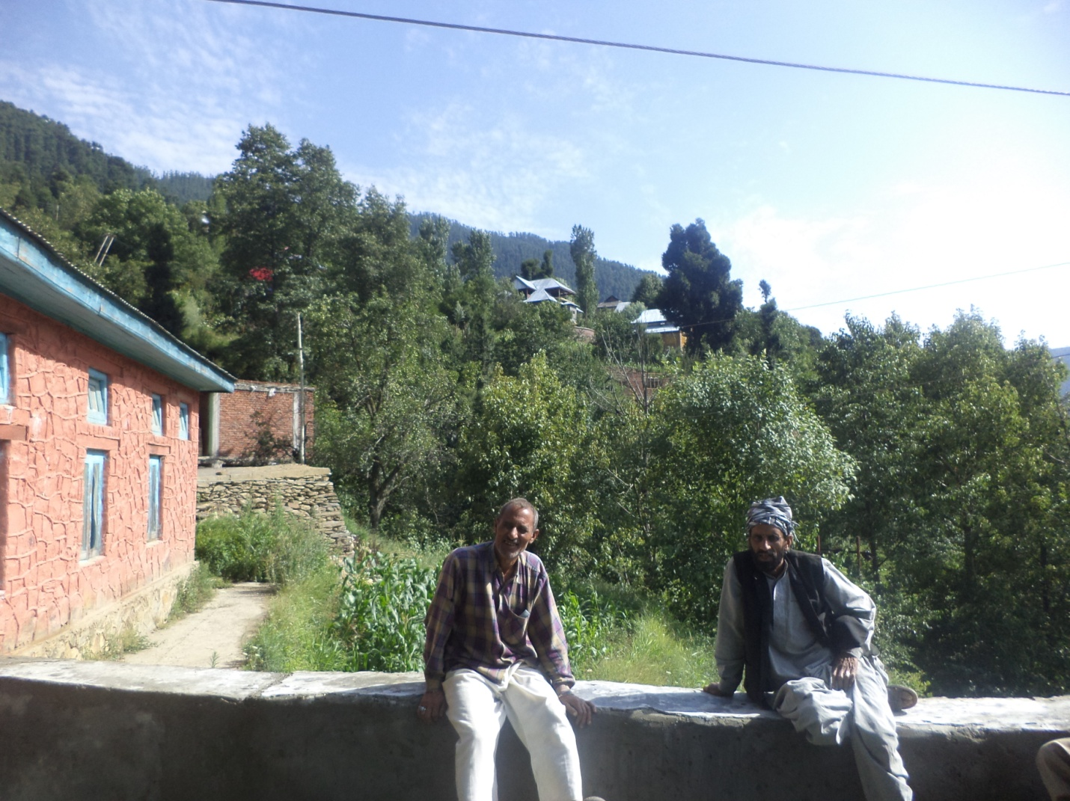
Men of the Community.

A Typical Woman of the Community.

They have a slightly darker complexion than Kashmiri’s and they also differ in their style of living, dressing patterns, and other facial features, etcThe slightly darker complexion may be due to the higher intensity of sunlight on the mountain slopes. Men usually wear Khandresses and sadir(waist coat) with turban and most of them have long beard (Muslims). with the changing time and impact of modernization the younger generation has adopted the modern dressing pattern, i.e pant-shirt, etc.(only males).Females still follow the same old dressing patternof salwaar suit with their heads usually covered and nose pierced ,usually in elder women.

FAMILY SETUP
In the study of social interactions one of the most important aspects is family type. Family type controls various types of social interactions of an individual e.g. it is observed that the out of community marriages are mostly done by nuclear families as compared to joint families. The children brought up in joint families speak Khana more fluently as compared to children brought up in nuclear families.
It is found that the main structure of family in the community is of two types.
A joint family system is preferred over nuclear family. Elders of the family are respected. Males and females are given equal rights. Mothers raise children as the males of the family are usually engrossed in earning bread and butter for the family.
Majority of the households have nuclear family structure where in two generations of parents and their un-married children live together. The increasing number of nuclear structure of families is one of the major causes of their children not learning ‘Khana’ language .On the other hand, minority of households have joint family structure wherein three or more than three generations (i.e. .was observed that the number of ‘Khana’ speaking children is greater in joint families as compared to nuclear families.

WORDLIST

The words given in the word list are tentative. The investigator has to use his knowledge and experience in collecting words pertaining to the eco system of the community.

All the words should be recorded and simultaneously transcribed.

Natural Objects |  | Transcription
1. | air | / tsʰatʰ/
2. | cave | /dʰar/
3. | clay | /miʈ/
4. | cloud | /obur/
5. | coral | /zoɖ/
6. | desert | /reːtliː/
7. | earth | /zamiːn/
8. | earthquake | /bunʲul/
9. | fire | /naːr/
10. | flood | /pʰalaɖ/
11. | fog | /paɖ/
12. | forest | /van/
13. | gold * | /sɔn/
14. | heat | /ɡaram/
15. | high tide | θed lehar
16. | hill | /pahaːɽ/
17. | Ice | /ʃiːn/
18. | lightning | /ɡaɡɽaːj ɡatsʰɨn/

19. | low tide | /lɔkci lehar/
20. | moon | /tsandar/
21. | mountain | /pahaːɽ/
22. | mud | /ɡaːrɨ/
23. | night | /raːt/
24. | pebble | /rə̃ɖ/
25. | rain | /roːad/
26. | river | /darijaːv/
27. | rock | /pəis/
28. | sand | /reːt/
29. | sea | /darijaːv/
30. | sky | /aːsmaːn/
31. | slope | /valuɽ/
32. | Snow * | /ʃiːn/
33. | star | /taːrɡan/
34. | stone | /ɽõɖ/
35. | storm | /tuːpʰaːn/
36. | sun | /doːs/
37. | sunshine | /doːs sĩj kirnɨ/
38. | thunder | /ɡaɡɽaːj/
39. | valley | /vaːdiː/
40. | water | /pãːj/
41. | wave | /havaːh/
42. | wind | /vaːvɨ tuːpʰaːn/

Pronouns
43. | I | /aːũː/
44. | my | /mʲuːn/
45. | we | /asoː/
46. | you | /tusõː/
47. | he | / su muhun/
48. | she | /su kuɖmɛn/
49. | it | /joː/
50. | this | /su/
51. | that | /su/
52. | these | /as saːraj/
53. | those | /toːu saːraj/
54. | all | /sab/
Kinship Terms |  | Reference Terms | Address  Terms
55. | brother (elder,  younger) | /boɖ baːrun/
56. | brother’s wife | /bai kaːkanʲ/
57. | brother's daughter | /baːrni sũd kuɽ/
58. | brother's son | /baːrni sũd nʲuk/
59. | brother's wife | /bai kaːkan/
60. | daughter-in- law | /noːh/
61. | daughter-in- law's  father | /soĩj/
62. | daughter-in- law's  mother | /soĩjɨ baːj/

63. | daughter's daughter | /ɡuʃ sĩd ɡuʃ/
64. | daughter's son | /poːatroː/
65. | daughter's son's  daughter | /parpoːt/
66. | daughter's son's son | /parpoːt/
67. | elder/younger sister's  husband | /bʲamɨ/
68. | father-in-law | /ʃuhur/
69. | father's brother (elder,  younger) | /picoː/
70. | father's brother's  daughter | /piːc bihen/
71. | father's brother's son | /pʲuːc baːrun/
72. | father's brother's wife | /pitrɛɳ/
73. | father's father | /doːd/
74. | father's mother | /daːdʲ/
75. | father's sister (elder,  younger) | /popʰ/
76. | father's sister's  daughter | /poːpʰatur beːhan/
77. | father's sister's son | /poːpʰatur baːrun/
78. | grand daughter | /nik sĩd kuɽ, poːatriː/
79. | grand father (F) | /doːad/
80. | grand father (M) | /noːn/
81. | grand mother (F) | /daːdʲ/

82. | grand mother (M) | /nɛn/
83. | grand son | /baːputur/
84. | husband | /kʰaːvãd/
85. | husband's brother  (elder, younger) | /dear/
86. | husband's brother's  wife | /dear sĩd kuɖmɛn/
87. | husband's sister (elder,  younger) | /zɛm/
88. | husband's sister's  husband | /zɛm sũd kʰaːvand/
89. | man (young, old) | /dʒavaːn muhun/
90. | mother | /buɖɨ muhun/
91. | mother- in- law | /mɛl/
92. | mother's brother | /ʃaːh/
93. | mother's brother's  daughter | /maːm/
94. | mother's brother's son | /maːmaːtɨr beːn/
95. | mother's brother's wife | /maːmaːtur baːrun/
96. | mother's father | /noːan/
97. | mother's mother | /nɛn/
98. | mother's sister | /mɛʃ/
99. | mother's sister's  daughter | /maːʃaːtɨr beːn/
100. | mother's sister's  husband | /mɛʃ, maːsuː/

101. | mother's sister's son | /maːʃaːtur baːrun/
102. | sister (elder, younger) | /bəɖ behan/
103. | sister, elder | /behan, bəɖ behan/
104. | sister’s husband | /bʲemɨ/
105. | sister-in- law (elder,  younger) | /saːl/
106. | sister's daughter | /bʰɛɳai/
107. | sister's son | /bʰɛɳou/
108. | son | /nʲuk/
109. | son-in- law | /zaːmaːtur/
110. | son-in- law's father | /riʃdaːr/
111. | son-in- law's mother | /riʃdaːr baːj/
112. | son's daughter | /poːatriː/
113. | son's son | /poːatroː/
114. | widower | /rõɳɖ/
115. | wife's brother (elder,  younger) | /hohar/
116. | wife's elder/younger  brother's wife | /hɛhar sĩd kuɖmɛn/
117. | wife's elder/younger  sister's husband | /saːl baj/
118. | wife's sister (elder,  younger) | /saːl/
119. | woman | /kuɖmɛn/
120. | blind (male, female) | //kɔːn/kɛn//

121. | boy | /bakaʈ/
122. | bride | /mehreːn/
123. | bridegroom | /mahraːz
124. | child | /nʲuk/
125. | daughter | /kuɖʲ/
126. | family | /ʈabar/
127. | father | /moːl/
128. | girl | /kuɖʲ/
129. | king | /baːdʃah/
130. | male | /maɽad/
131. | marriage | /jeːl/
132. | miser | /kõndʒuːs/
133. | parents | /moːl mɛl/
134. | queen | /baːdʃaːh baːj/
135. | sister | /beːan/
136. | widow | /rãnɖ/
137. | wife | /kudmɛn/
138. | woman | /kuɖmɛn/
Animals & Fauna and Flora
(FLORA PLANTS)
139. | ant | /krimniː/
140. | bear | /ʃoːput/
141. | bird | /tsəɖ/
142. | buffalo (male, female) | /miːʃ/
143. | bull | /sanɖɨ/

144. | butterfly | /põːpuɖ/
145. | calf (male, female) | /votsʰ/
146. | cat | /bɛɽ/
147. | cattle | /miːʃ/
148. | centipede | /kanstoːl/
149. | chick | /puːt/
150. | cockroach | /uʈal/
151. | conch | /zoɖ/
152. | cow | /ɡau/
153. | crocodile | /maɡarmacʰ/
154. | crow | /kaːv/
155. | deer | /ruːs/
156. | dog | /hon/
157. | donkey | /kʰoːtɨ/
158. | earthworm | /laus/
159. | elephant (male,  female) | /həːθ, hɛθniː/
160. | feather | /par/
161. | fish | /ɡaːd/
162. | fly | /maːcʰ/
163. | fox | /lɛʃ/
164. | goat | /seːl/
165. | honey bee | /mɛcʰ ɡan/

166. | horn | /hẽɡ/
167. | horse | /ɡoːɖ/
168. | house fly | /maːcʰ/
169. | insect | /kʲom/
170. | jackal | /ɡɔʃaːl/
171. | leech | /drɨk/
172. | lion | /ʃaːl/
173. | lizard | /kɔ̃kut/
174. | louse | /zɔi/
175. | mare | /ɡuːɖ/
176. | mongoose | /navlɨpuːt/
177. | monkey | /mɔkuɖ/
178. | mosquito | /moh/
179. | mouse | /ɡoɡuɽ/
180. | nest | /oːl/
181. | peacock | /moːr/
182. | pig | /soːr/
183. | pony | /kʰaccar/
184. | puppy | /hõːi baccɨ/
185. | rabbit | /kʰarɡoːʃ/
186. | rat | /ɡoɡuɽ/
187. | rhinoceros | /mũɖuk/

188. | scorpion | /bʲuts/
189. | sheep | /ɡeb/
190. | snail | /kõi ɡaːv/
191. | snake | /saraf/
192. | sparrow | /tsʰəɖ/
193. | spider | /zoːzul/
194. | squirrel | /ɡaɖdʒiːn/
195. | tiger | /ʃoːput/
196. | toad | /mũɖuk/
197. | tortoise | /katsʰuaː/
198. | tusk | /hɛθ sanɨ dãt/
199. | wasp | /cumɛɖ/
200. | wing | /pakʰɨ/
201. | worm | /lɔːs/
Body Part, Bodily Condition &
Function
202. | ache/pain | /daːh/
203. | acidity | /mʲaːdɨ ɡoːv ʰaʈɨ/
204. | ankle | /ɡiʈ
205. | arm - right, left | /daʃni θən, kʰauɖi θən/
206. | asthma | /tam/
207. | back (of body) | /caːɖ/
208. | beard | /dɛɖ/
209. | belly | /jiɖ/
210. | birth | /pɛdɨ/

211. | blood | /raθ/
212. | body | /dʒisɨm/
213. | bone | /aɖli/
214. | breast | /cʰɛt/
215. | cheek | /ɡalɨ/
216. | chest | /cʰɛt/
217. | chicken pox | /dutsʰil/
218. | chin | /kam/
219. | cholera | /hɛzaː/
220. | cold (ailment) | /tuːɖ/
221. | corpse | /laːʃ/
222. | cough | /tsɛs/
223. | cripple (male, female) | /lõɡ,lə̃ɡ/  ̃
224. | dead body | /pʰəɖ ɡʲomut/
225. | deaf | /zoɖ/
226. | death | /pʰəɖ ɡoː/
227. | diarrhea | /dʒalaːbɨ/
228. | dog | /hon/
229. | dumb (male, female) | /zoɖ , zəɖ/
230. | dwarf (male, female) | /tsʰoʈ/
231. | ear | /kan/
232. | epilepsy | /laʈʰ/
233. | eunuch | /lɛ̃s/
234. | eye | /aːcʰ/
235. | eye-brow | /bumɨ/
236. | eyelid | /ʈaːrɨ/

237. | face | /buθ/
238. | fart | /tsʰĩːʈ/
239. | female | /maːdɨ/
240. | fever | /tap/
241. | finger | /õɡliː/
242. | fist | /muʈʰ/
243. | flesh | /maːz/
244. | foot | /kʰor/
245. | forehead | /ɖik/
246. | hair | /mas/
247. | hand (left, right) | /aːθ(daʃun aːθ ,kʰaːuɖ aːθ)/
248. | head | /laʈ/
249. | health | /sehat/
250. | heart | /dil/
251. | heel | /θuːrʲ/
252. | hiccough/hiccup | /hʲuk/
253. | hip | /ɡaɡri/
254. | hunger | /bucʰ/
255. | ill | /bemaːr/
256. | jaw | /taːɽ kʰə̃ɖ/
257. | knee | /koːʈʰ/
258. | lame (male, female) | /lõɡ, lə̃ɡ baːj/
259. | leg | /zãnɡ/
260. | lips | /oːʈʰ/
261. | liver | /krehnɨmaːz/
262. | lung | /ʃuʃ/

263. | malaria | /tap/
264. | moustache | /ɡucʰ/
265. | mouth | /ɛʃ/
266. | nail | /nam/
267. | neck | /ɡarden/
268. | nose | /nas/
269. | pain | /daːh/
270. | palm (of hand) | /aːθ ab/
271. | pimple | /pʰalɨ/
272. | pus | /paːk/
273. | rib | /adlɨ/
274. | saliva | /laːl zaɖ cʰes/
275. | shoulder | /pʰijok/
276. | skeleton | /aɖjɨ krõz/
277. | skin | /camɖɨ/
278. | skull | /ləʈ/
279. | sleep | /nindar/
280. | small pox | /dutsʰil/
281. | spine | /kamrɨ sun aɖli/
282. | spit | /θukɨ traːjĩ/
283. | sprain | /matsʰ/
284. | stomach | /mʲaːdɨ/
285. | stool/shit | /ɡus/
286. | sweat | /ɡaram/
287. | tears | /oʃ/
288. | teeth | /dãt/

289. | thigh | /matsʰ/
290. | thirst | /tri hot/
291. | thumb | /nʲuʈʰ/
292. | toe | /kʰur nʲuʈʰ/
293. | tongue | /zʲu/
294. | tooth | /dãt/
295. | urine | /muc/
296. | vomit | /ulʈiː/
297. | waist | /kamar/
298. | wrist | /hotsʰ/
299. | yawn | /zam/
Food, Drinks (Cooking & Utensils)
300. | ashes | /saːs/
301. | beef | /baɖɨ maːz/
302. | black pepper | /krihun marɨts/
303. | butter | /sreh/
304. | buttermilk | /maːhtrɨ/
305. | cashew | /kaːdʒuː/
306. | chilli | /piple/
307. | coconut | /kʰɔprɨ/
308. | cooked rice | /baːtɨ/
309. | curd | /zaːntumoː dud/
310. | dhenki (husk) | /sreh/
311. | egg | /ʈʰoːal/
312. | fire | /naːr/
313. | flame | /kãŋ/

314. | flour (dry) | /oʈ/
315. | food | /kʰaːlnu/
316. | garlic | /ruhũn/
317. | ghee | /ɡʲuː/
318. | groundnut | /mũɡpʰəl/
319. | haldi (turmeric) | /lidar/
320. | hay | /hokʰ ɡaːs/
321. | ladle (made of steel or  metal) | /dũɡɨ/
322. | lid | /ʈʰaːn/
323. | liquorice (joshthi  madhu) | /ʃiːrɨ/
324. | maize (corn) | /makəːi/
325. | matchstick | /ɡanak tuːl/
326. | milk | /dud/
327. | mustard | /sɔzli/
328. | oil | /tʲeːl/
329. | pomegrenate | /dɛɖim/
330. | rice | /tavun/
331. | rice (cooked) | /baːt/
332. | Roti | /mãdʒɨ/
333. | salt | /nuːn/
334. | smoke | /doːm/
335. | steam | /baːh/
336. | sugar cane | /ʈoːan/
337. | sweet potato | /kʰanɖɨ muːl/
338. | tamarind | /imliː/

339. | taste | /saːd/
340. | tea | /caːj/
341. | wheat | /ɡɔlam/
Clothing, Ornaments & Care * (to
be photographed also)
342. | anklet | /ɡiʈan laːɡcɨ paːjal/
343. | bangles | /bẽɡɖɨ/
344. | bindi | /bindiː/
345. | cap | /ʈepʲ/
346. | comb | /kãŋai/
347. | ear-ring | /kanɨ vaːjal/
348. | garland | /haʈis maːl/
349. | loin cloth | /lãŋoːʈ kasun/
350. | mirror | /ʃiːʃɨ/
351. | necklace | /həʈ sund haːr/
352. | nose-pin | /rũɡ/
353. | rain hat (made of  leaves) | /tən paːhan ʈəpʲ/
354. | ring | /vaːjal/
355. | sari | /sɛɽ/
356. | scent (odour) | /muʃuk/
357. | scissors | /dukɛɽ/
358. | turban | /dastaːr/
House, Parts of House *(to be
photographed)
359. | bathroom | /sraːn kuːʈʰ/
360. | boundary | /baːɖ/
361. | brick | /siːr/

362. | ceiling | /loːɽ/
363. | cot | /kʰaʈ/
364. | cowshed | /ɡuaːɖ/
365. | door/entrance | /dehliː/
366. | fence | /baːɖ/
367. | floor | /puθur bicʰvaːi/
368. | foundation | /bunijaːd kaːɖam/
369. | house | /dʒaːj/
370. | hut | /dʒʰoːpɖiː/
371. | key | /kũz/
372. | lock | /kuluf/
373. | mat | /vaɡav/
374. | pillar | /θam/
375. | roof | /loɽ, ʈiːnuː cʰat/
376. | room | /kamrɨ/
377. | stair/step | /hʲeːɽ/
378. | swing | /halal noː
379. | wall | /aːʈ/
380. | well (water) | /kʰɔɖ/
Vegetable & Flora
381. | banana | /kʲeːlɨ/
382. | brinjal | /baɖ vãːɡun/
383. | chilly | /piplɨ/
384. | dry ginger | /ʃũɖ/
385. | flower | /poːʃ/
386. | fruit | /mʲevɨ/

387. | garlic | /ruhan/
388. | grass | /ɡaːs/
389. | lady's finger | /binɖiː/
390. | leaf | /patar/
391. | lime | /cuːnɨ/
392. | maize (corn) | /makaːi/
393. | mango | /am/
394. | Medicinal herbs | /dʒaɖiː buːʈiː/
395. | neem | /niːm/
396. | onion | /ɡanɖɨ/
397. | pea | /kaɽɨ/
398. | peepul | /papal/
399. | petal | /pãkʰuɖiː/
400. | tulsi | /tulsiː/
401. | wood | /kaːʈʰ/
Farming & Agriculture
402. | arecanut / betel nut | /cʰaliːdʒaː/
403. | farmer | /zamindaːr/
404. | field | /kʰeːc/
405. | paddy | /daːn/
406. | plant | /kol/
407. | plough | /albɛn/
408. | root | /muːl/
409. | rope | /raz/
410. | saw | /ɛr/

411. | seed | /bʲoːl/
412. | shepherd | /van ɡoːl/
Profession
413. | barber | /nʲeːd/
414. | blacksmith | /kʰaːr/
415. | boatman | /hɛ̃z/
416. | broker | /dalaːl/
417. | carpenter | /cʰaːn/
418. | cobbler | /muːc/
419. | farmer | /zamindaːr/
420. | goldsmith | /sɔ̃jar/
421. | hunter | /ʃikɛr/
422. | midwife | /daːj/
423. | milkman | /lɛɡiː/
424. | moneylender | /karɨz daːr/
425. | potter | /kraːl/
426. | priest | /ibaːdat karan voːl/
427. | snake charmer | /sarapʰ racʰnɨ voːl/
428. | sorcerer | /dʒɛdkʰoːr/
429. | teacher | /ɡuruː/
430. | washer man | /doːb/
431. | weaver | /dʒulaːi/
432. | work | /kaːr/
Sports & Games (Elicit native
games for male & female)
433. | toy | /ɡendunuː/

434. | wrestling | /dab dab/
Entertainment
435. | clarion | /sɔrnai/
436. | cymbals | /
437. | dance
438. | dancer
439. | doll | /ɡuɖijaː/
440. | drama | /kehɛniː/
441. | drum (types of drum) | /ɖoːl/
442. | flute | /bansariː/
443. | kite | /patãŋ/
444. | music | /ɡaːniː voːl/
445. | picture | /ʃakal/
446. | puppet show | /kaʈputliː/
447. | song (folk / modern) | /deːsiː ɡaːnɨ/
448. | village show (yatra) | /vorus/
Adpositions (collect these in
sentences)
449. | all | /saːraj/
450. | again | /saːraj/
451. | alone | /jakluj/
452. | always | /har wakt/
453. | bad | /kʰaraːb/
454. | beautiful | /poʈʰmut/
455. | big | /boɖ/
456. | bitter | /tsʰuʈʰ/

457. | black | /kruhnui/
458. | blind | /koːn/
459. | clever | /caːlaːk/
460. | dead | /pʰəʈ ɡʲomut, mɔɽdɨ/
461. | deep | /son/
462. | front of | /ɛɡbakʰ/
463. | green (colour of leaf) | /nʲuəl/
464. | half | /oɖuj/
465. | hungry | /bucʰhot/
466. | lean (man, woman) | /kamzoːr, kamzoːr kuɖmɛn/
467. | old | /buɖɨ/
468. | red | /uzlɨ/
469. | rotten | /zəl ɡʲoːmut/
470. | sharp | /trɔʃ/
471. | small | /lɔkcɨ/
472. | strong | /doɽ/
473. | suddenly | /hãŋ mãŋ/
474. | tall (man, woman) | /zʲuːʈʰ muhun/
475. | then | /doi/
476. | there | /tʲoh/
477. | ugly | /bad ʃakal/
478. | up | /ub/
479. | upside down | /ub kʰuloː/
480. | white | /cʰut/
481. | yellow | /uzloː/

* Directions & Measurements
482. | down | /kʰuloː/
483. | east | /maʃrik/
484. | north | /ʃumaːl/
485. | rightside | /daʃni bakʰ/
486. | south | /kʰavɖi bakʰ/
487. | west | /kibloːz bakʰ, cidpaːtneː/
*Time & Seasons
488. | afternoon | /dusliː baːd/
489. | day after tomorrow | /cim dus, iːs/
490. | day before yesterday | /acɨ/
491. | evening | /varniː/
492. | midnight | /nesɨb raːt/
493. | month | /rit/
494. | rainy season | /barsaːt/
495. | Summer | /ɡarmiː/
496. | time | /wakt/
497. | today | /aːz/
498. | tomorrow | /rɛic/
499. | week | / sat dus/
500. | winter | /tuːɽ /
501. | year | /ver/
502. | yesterday | / iːs/
Functional Words (collect these in sentences)
503. | after | /tes patɨ/

504. | and | /dujɨ/
505. | because | /kuzɨ/
506. | before | /əɡiː/
507. | behind | /patɨ/
508. | but | /leːkin/
509. | from | /baɡ/
510. | if | /aɡar/
511. | into | /ɡʲoh/
512. | like | /inɛr/
513. | near | /hotuj/
514. | out | /baːhar/
515. | under | /kʰuloː/
Interrogatives
516. | how | /kinɛr/
517. | what | /kut/
518. | when | /kaːr/
519. | where | /koːr/
520. | which | /kam/
521. | who | /koːr/
522. | why | /kudʒi/
Numbers & Numerals
Collect basic numerals 1-9
Numbering System
Verbs (elicit these in sentences)
523. | to abuse | /likɨ kaːɖĩ/
524. | to adopt (a child) | /moːɖ raʈnu/

525. | to alight ( as a bird or  butterfly) | /zamiːnas mãz vasun/
526. | to answer | /dʒavaːb dʲun/
527. | to arrange (put things  in or der) | /põːtus pãːt racʰ/
528. | to ascend, climb (a  hill) | /uksuːn/
529. | to ask (to question) | /savaːl prison/
530. | to ask for, some thing | /mãŋnoː/
531. | to attack | /hamlɨ karnoː
532. | to bark (as a dog) | /võvraːj karɨn/
533. | to bathe (one's self) | /pãi manɖnoː/
534. | to beat (a drum) | /ɖoːl vaːl noː/
535. | to beat (somebody) | /maːr dʲoːn/
536. | to become | /kĩːz banaːvun/
537. | to belch | /ɖakaːr aːs/
538. | to believe | /boroːs karun/
539. | to bend (stick) | /moːɖ pʰeːrnuː/
540. | to bind | /ɡə̃ːtʰ racʰnu/
541. | to bite | /cop ditsʰun/
542. | to bless (give a  blessing) | /doi kʰeːr karnuj/
543. | to bloom (produce  flowers) | /poːʃ pʰultam tɨ/
544. | to blow (with the  mouth) | /pʰuk dʲuːn/
545. | to boil (a method of  cooking) | /pʰukar dʲuːn/
546. | to boil (the water) | /pãi ɡrakalnuː/
547. | to bore (a hole) | /suraːkʰ karnuː/
548. | to bow (bend the  body) | /kʰuloː nam nuː/

549. | to break ( a pot) | /baznu/
550. | to break (stick) | /limbeːz/
551. | to breathe | /ʃaːh kʰaːlnu/
552. | to brew (beer) | /ʃaraːb banaːv nu/
553. | to bring (something to  a place) | /aːn nu, vaːtal nu/
554. | to build ( a house) | /dʒaːj banaːvɨn/
555. | to burn | /zɛlʲun/
556. | to burn (as a fire,  intrans)
557. | to burn (trans)
558. | to bury ( a dead body) | /dafan karnu/
559. | to call | /tsʰadal nu/
560. | to carry (in hand) | /əθas mãz nʲun/
561. | to carry ( on shoulder/  head) | /pʰekis maː toːlnuː/
562. | to carve (a figure) | /ɡaɽnuː/
563. | to catch (an animal in  a trap) | /zoːlas mãz raʈnuː/
564. | to catch (chase and  catch) | /raʈnuː/
565. | to celebrate | /kʰuʃiː manaːvɨn/
566. | to change (alter) | /badluːn/
567. | to chant (mantras) | /pʰuk dʲuːn/
568. | to chase (pursue with  intent to catch) | /laːɽɨ pʲuːn/
569. | to chew (to food) | /caːpun/
570. | to chop | /ʈoːʈɨ karnɨ/
571. | to clap (the hands) | /aːθ vaːlun/
572. | to climb (a tree) | /kɔlis uksuːn/

573. | to close (a bag) | /reːʈraːsun/
574. | to collect (scattered  thing) | /poluːd/
575. | to comb (hair) | /kanɡaː valniː/
576. | to come | /juːn/
577. | to command (order  some) | /tsaː dun/
578. | to cook | /pakaːnu/
579. | to cough | /tseːs karun/
580. | to count | /ɡanzar nuː/
581. | to cover | /ʈhãːɖ dun/
582. | to crawl (as a baby) | /vaha nuː/
583. | to crush(oil seeds) | /pihnuː/
584. | to cry (weep) | /baːɖaː dun/
585. | to cultivate (tend crop) | /baːv nuː/
586. | to cure (an illness) | /ilaːdʒ karnuː/
587. | to cut | /lon nuː/
588. | to cut (hair) | /maːs tsaʈ nuː/
589. | to dance | /nats nuː/
590. | to decay | /zaːl nuː/
591. | to deny (having done  something) | naːkaːr karnuː/
592. | to die | /phɨl ɡats nuː/
593. | to dig | /ɡaːɖnuː/
594. | to dig (a hole) | /khoɖ ɡaːɖ nuː/
595. | to dig up (root crops) | /dʒaɖeː poʈ tunu/
596. | to dilute (add water) | /paːniː ralaːvnuː/
597. | to disappear | /raːj ɡoː/

598. | to disperse (go away  from being together) | /baːɡ baːɡ ɡatsun/
599. | to dissolve | /tsen ɡoː/
600. | to drag (a heavy  object) | /heːsaː ɡoː/
601. | to draw (a picture) | /banaːvur/
602. | to draw (water) | /kaːɖnuː/
603. | to dream | /khoːb pasnoː/
604. | to drink | /pijun/
605. | to drive(cattle or other  animals) | /naʃnoː/
606. | to drown | /ɖuːb ɡatsnoː/
607. | to earn | /kamal noː/
608. | to eat | /khaːl noː/
609. | to embrace (each  other) | /naːl moθ karnoː/
610. | to extinguish (a fire) | /naːr tset karnoː/
611. | to faint | /behoːʃ ɡoː/
612. | to fall | /roɖ ɡatsnoː/
613. | to fall down | /khuloː roːz doː/
614. | to fast | /phakaː renoː/
615. | to feed | /khaː lel noː/
616. | to fetch water (go and  get) | /paːniː pijoːnuː/
617. | to fight | /laɖəːj karnoː/
618. | to fight (with each  other) | /khaːn veːr laɖnoː/
619. | to fill ( a jar with  water) | /paːniː barnoː/
620. | to float | /tarnoː/
621. | to fly | /oːp tol niː/

622. | to fold (arms) | /khɨn pheːrniː/
623. | to fold (cloth) | /tah karnas/
624. | to gather together  (assemble) | /eɡdʒaː ɡatsnoː/
625. | to get (come and get) | /eɡnoj ɡin noː/
626. | to get angry | /tsakh jin/
627. | to get up (arise) | /dʒaːɡan/
628. | to give | /dun/
629. | to go | /ɡatsnoː/
630. | to gossip | /kaθ karɨn/
631. | to graze (the cattle) | /ɡotsɨri tsulazi/
632. | to greet | /doj kheːr salaːm karnuː/
633. | to grind (grain) | /pih nuː/
634. | to guide (show the  way ) | /vaθ chalni/
635. | to harvest | /phasɨl lon nuː/
636. | to help | /madat karniː/
637. | to hit | /dakɨ dun/
638. | to hunt | /ʃikaːr karnuː/
639. | to irrigate (crops) | /vazak nuː/
640. | to joke | /mokhoː karun/
641. | to jump | /uʈh to lɨn/
642. | to kick | /tsaɖ din/
643. | to kill | /maːr noː/
644. | to kiss | /muːʈh dun/
645. | to kneel down (take a  position) | /kuɖeː keːr namnuː/
646. | to knock (on a door) | /dad laɖəːj karnaj/

647. | to laugh | /has noː/
648. | to leak (as a pot) | /kuʈh toːlɨn/
649. | to lean (against  something) | /daːkh deː bunuː/
650. | to lick | /fiʃ no;/
651. | to lie down (assume a  position) | /ʃõŋnoː/
652. | to love | /pjaːriː karnoː/
653. | to make | /banaːv noː/
654. | to measure (volume) | /nin noː/
655. | to meet | /ʃan kõːd/
656. | to milk (a cow) | /duːd dohnaː/
657. | to mix | /ralaːv nuː/
658. | to mutter (speak  indistinctly) | /baɡɖaːj karnaː/
659. | to name (give a name) | /naːm ɡinnoː/
660. | to nod | /loːʈaː lal noː/
661. | to open | /jajɨh livun/
662. | to pain | /daː ɡatsnoː/
663. | to peel (strip skin of  fruit like banana) | /tsalmun/
664. | to pick up (off ground) | /paːlnoː/
665. | to pierce | /suraːk karun/
666. | to pinch | /tsopnej dijin/
667. | to plant (roots or  cuttings) | /bavnuː/
668. | to play (musical  instrument) | /vaːlnoː/
669. | to plough | /baːvnuː/
670. | to pray | /duaː karnuː/

671. | to predict, foretell | /peʃan ɡoːjiː/
672. | to prepare | /banaːv nuː/
673. | to press (with fingers) | /dabaːv nuː/
674. | to prick (as a thorn) | /tsaːpunuː/
675. | to pull out (tooth) | /udʒaː ɖaːlnuː/
676. | to push | /dakɨ dun/
677. | to quarrel | /laɖaːj karniː/
678. | to remove (take away) | /halal nuː/
679. | to rescue | /bacaːv nuː/
680. | to respect | /jazat karniː/
681. | to return, go back (to a  place) | /vaːpas che ɡatsnuː/
682. | to ripen (as a fruit) | /pakaːv nuː/
683. | to rob | /tsuːr karniː/
684. | to rub | /miʈalnoː/
685. | to run | /bav tol niː/
686. | to run away, flee | /beʃ ɡatsun/
687. | to sacrifice | /kɔrbəːniː diːn/
688. | to save | /bacaːv nuː/
689. | to say/tell | /vannuː/
690. | to scold | /ʃoːr karnuː/
691. | to scratch | /ɡakh ɖalnoː/
692. | to scream | /zoːrɨ krek din/
693. | to sell | /kiːnuː/
694. | to sharpen ( a knife) | /teːz karman/
695. | to shiver | /θar laɡɨn/

696. | to shoot ( a gun, a  bow) | /ɡuːl diːn/
697. | to shout | /bakvaːr karnoː/
698. | to shrink | /hədʒ ɡoː/
699. | to sigh | /piaːr karnoː/
700. | to sing | /ɡennoː/
701. | to sit | /bennoː/
702. | to sleep | /ʃeɡ ɡatsat/
703. | to smear | /maθnoː/
704. | to smell | /muʃɨk ɡiniː/
705. | to smile | /hasnoː/
706. | to smoke (tobacco) | /naʃ karʃuː/
707. | to sneeze | /tsiːkiː jen/
708. | to speak | /vannuː/
709. | to spit | /θɔkɨ traːvun/
710. | to sprinkle (with  water) | /tsaːɖal noː/
711. | to sprout | /phas noː/
712. | to squeeze | /ciːɡaɖ noː/
713. | to stamp (with the  feet) | /θap θam dijin/
714. | to stand up | /udiː ɡatsɨt/
715. | to stir (while cooking) | /ralaːv nuː/
716. | to stretch (something) | /khiːcɨ noː/
717. | to sweep | /ʈel karmats/
718. | to swell | /muʃɨk ɡin niː/
719. | to swim | /tar noː/
720. | to take off (clothing) | /palav valav nuː/

721. | to talk, converse | /kaθ karɨn/
722. | to taste | /tsaːp nuː/
723. | to tell (a story) | /kahaːniː vanniː/
724. | to throw | /badal noː/
725. | to tickle | /khar cun/
726. | to touch | /tsʰuh nuː/
727. | to turn around (turn  one's self) | /pataːr hej pheːr nuː/
728. | to turn aside (divert  someone) | /jak tarfaj pheːr nuː/
729. | to turn back | /patvaːr peːr nuː/
730. | to visit | /samkhun ɡatsnuː/
731. | to wait | /zaːɡ nuː/
732. | to wake up | /huʃaːr ɡatsɨt/
733. | to walk (not run) | /bav nuː/
734. | to wander | /raːj ɡoː/
735. | to want | /chah tiː/
736. | to warn | /khabar dəːriː din/
737. | to wash | /chal nuː/
738. | to weave (cloth) | /bun nuh/
739. | to wed, marry | /jeːl karnuː/
740. | to wet (make wet) | /ɡiːlaː karnaː/
741. | to whisper | /coɡliː karnoː/
742. | to wink | /əch ʈoːr karnoː/
743. | to winnow | /bakheː karnoː/
744. | to wipe off | saːf karnoː/
745. | to wither (as a plant) | /zeɖ ɡoː/

746. | to work | /kaːr kər/
747. | to worship | /ibaːdat karniː/
748. | to wrestle | /dab dab karniː/
749. | to wring (clothes) | /ciːɖ noː/
750. | to write | /likhijeː/
751. | to yawn | /zaːniː karniː/

