REPORT OF THE PROJECT
Scheme for Protection and Preservation of Endangered Languages
for the Month of November
LANGUAGE : BHADRALIUM
DISTRICT : DODA
SUBMITTED TO
Central Institute of Indian Languages
(Ministry of Human Resource Development, Govt. of India, Department of Higher Education)
Manasagangotri, Mysore – 570 006 (Karnataka).
Principle investigator : Prof. Aadil Amin Kak
Resource persons : 1. Shahid Yousuf Gilkar
2. Farha Aarif
3 . Sumaiya Jehangir

Dept. of Linguistics,
University of Kashmir
Phonology
Consonant Gemination
Consonant Gemination occurs when a spoken consonant is pronounced for an audibly longer period of time than a short consonant. It is distinct from stress. Consonant Gemination is found in BHADRALIUM.

/-nn-/ | /saː ɡinnoː/ | ‘to breathe’
/-nn-/ | /ɡannuː/ | ‘to count’
/-nn-/ | /bunnuː/ | ‘ to weave (cloth)’
/-tt-/ | /kuttar/ | ‘dog’
/-tt-/ | /kuttak/ | ‘dog’
/-vv-/ | /bãvve/ | ‘eye-brow’

Diphthongs
A diphthong is actually a gliding vowel in which there is a transition from one position to another. Phonetically, diphthongs are represented by a pair of vowels. Diphthongs or combinations of vowel sequences can be seen in BHADRALIUM. They are found at the medial position.

/ie/- |  | /hiev/ | ‘ice’
/ie:/- |  | /tieːʈh/ | ‘fart’
/iuː/- |  | /niuːl/ | ‘mongoose’
/uoː/- |  | /suoːr/ | ‘pig’
/aːu/- | dʒichuɖaːul/ |  | ‘snail’
/ioː /- | /nitsioːɖ nuː/ |  | ‘to wring (clothes)’
/uo /- | /muor/ |  | ‘to stamp (with the feet)
/uo /- | /suoːr/ |  | ‘pig’
/eə /- | /leəɡɨɖaː khoːl naː |  | ‘to take off (clothing)’

Syllable structure
In BHADRALIUM, syllabification has been done as-
i. Monosyllabic,
ii. Disyllabic, and
iii. Polysyllabic words

- MONOSYLLABIC PATTERN

 | V | /uː/ | ‘that’
 | CV | /jeː/ | ‘it/ this’
 | VC | /aɡ/ | ‘fire’
 | CVC | /baːt/ | ‘air’

- DISYLLABIC PATTERN

 | CV-CVC | /puhaːl/ | ‘shepherd’
 | CV-CV | /keːlaː/ | ‘banana’
 | CVC-CV | /ɡanɖoː/ | ‘onion’
 | V-CV | /aːriː/ | ‘saw’
 | CVC-CVC | /turkhaːn/ | ‘carpenter’
 | VC-CV | /ubruː/ | ‘up’
 | VC-CVC | /asmaːn/ | ‘sky’

- POLYSYLLABIC PATTERN

 | V-CV-CV | /uː menuː/ | ‘he’
 | CV-CV-CVC | /dʒaːduːɡar/ | ‘sorcerer’
 | CV-CVC-CVC | /samandar/ | ‘sea’
 | CV-CCV-CV | /ɡardʒinoː/ | ‘thunder’
 | CVC-CV-CV | /termoːciː/ | ‘cobbler’
 | CV-CV-CV-CV | /dʒɨɖiːbuːtiː/ | ‘medicinal herb’
 | CVC-CV-CV-CV | /kankhədʒuːraː/ | ‘centipede’

SUPRASEGMENTAL FEATURES
- NASALISATION
Those sounds which are produced with resonance through the nose are known as nasal sounds. The velum is lowered in this process by which some air escapes through the nose. Nasalization is the process of addition of nasal resonance to those sounds which are not nasal in ordinary circumstance. The nasalized vowels of BHADRALIUM are / ĩː/, / ẽ/, / ẽː/, / õ/, / õː/, / ã/, / ãː/, /ũ/ and / ũː/
Some of these occurrences of nasalized vowels are shown below:

NASALIZED VOWEL | TRANSCRIBED WORD | MEANING
ĩː | /sĩːŋ/ | horn
ĩː | /pĩːpɨniː/ | eyelid
ẽ | /kẽɖoː/ | wood
ẽː | /kẽːɡat/ | lizard
ẽː | /kẽːcvaː/ | earthworm
ẽː | /mẽːndoː/ | toad
õ | /ʃõʈh/ | dry ginger
õː | /paŋɡõː/ | wing
õː | /tsõːʈiː/ | chin
õː | /khõːpɨɖiː/ | skull
õː | /lõːɡ/ | nose-pin
õː | /dʒõːpɨɖiː/ | hut
õː | /patlõː/ | leaf
ã | /bãvveː/ | eye-brow
ã | /ãv/ | I
ã | /pãkh/ | feather
ã | /sãp/ | snake
ã | /ɡoãtsɨ/ | moustache
ã | /ãvʈhiː/ | ring
ãː | /cãːdniː/ | moon
ãː | /khãːsiː/ | cough
ãː | /dʒãːdʒar/ | anklet
ãː | /miʈãːv/ | to rub
ãː | /ãːh barnaː/ | to sigh
ãː | /ãːdiː/ | wind
ũ | /dũvaːriː/ | fog
ũː | /paːvũː/ | foot
ũː | /dʒũː/ | louse
ũː | /tũː/ | smoke
ũː | /ɡevũː/ | wheat
ũː | /kũːdʒiː/ | key
ũː | /kjũːki/ | because
ũː | /ũːɖiː/ | under

- PALATALIZATION
Palatalization is not a prominant feature of Bhadralium ,and is seen very rarely. Some of the examples of palatalized words in BHADRALIUM are:

/ɡuɖʲaː/ | doll
/kʲũːki/ | because
ɡovajʲoː/ | to sing

Aspiration
Aspiration is feature of BHADRALIUM. Some of the examples of aspiration in BHADRALIUM are:

/pheːpɨɖaː/ | Lung
/phoːɖoː/ | Pimple
/phekuː/ | Shoulder
/phuːloː/ | Flower
/phal/ | Fruit
/dupher/ | Afternoon
/pitsh/ | Bear
/atsh/ | Eye
/tshitoː/ | White
/utshɨnoː/ | to jump
/piʈh/ | Back (of body)
/peːʈh/ | Belly
/ʈhanɖ/ | Cold (ailment)
/muʈhiː/ | Fist
/oːʈh/ | Lips
/khiliɡ/ | Waist
/dukh/ | Food
/dukhnoː/ | Hungry
/chaknoː/ | to sprinkle (with water)
/chaː/ | Buttermilk

Pictoral description of the various items used in the community.

/gana:rdzot/

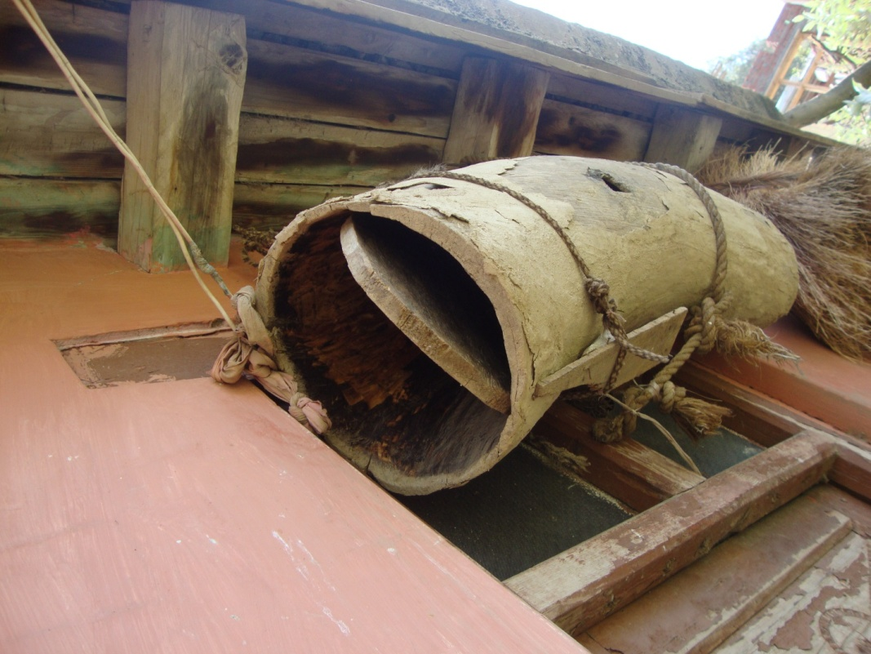

This is part of a tree trunk hollowed out to house a /gan/ (a swarm) of wild bees. It has a circular lid on each side and a hole in the middle of its length for bees to get in and out. It is hung anywhere on the outside of a house, except the front side. This shows that the people of the community possess the knowledge of bee rearing (apiculture).

/tshaenpu:/

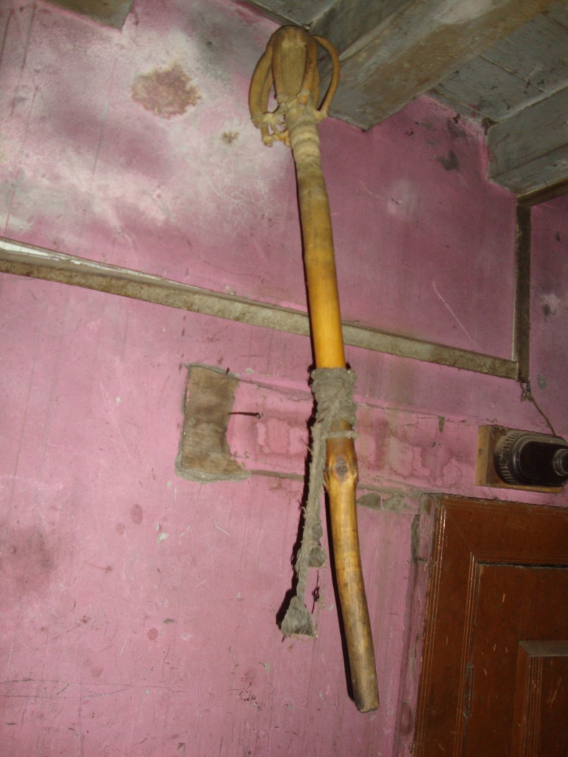

This is used to churn milk. It is made, apparently, from a part of a stem of some plant, the branches of which-- which grow in whorls—are hacked off except on one side, where they are cut at a distance of about six inches from the stem; the parts of branches still attached to the stem are then turned back on the stem and tied to it.
/kada/

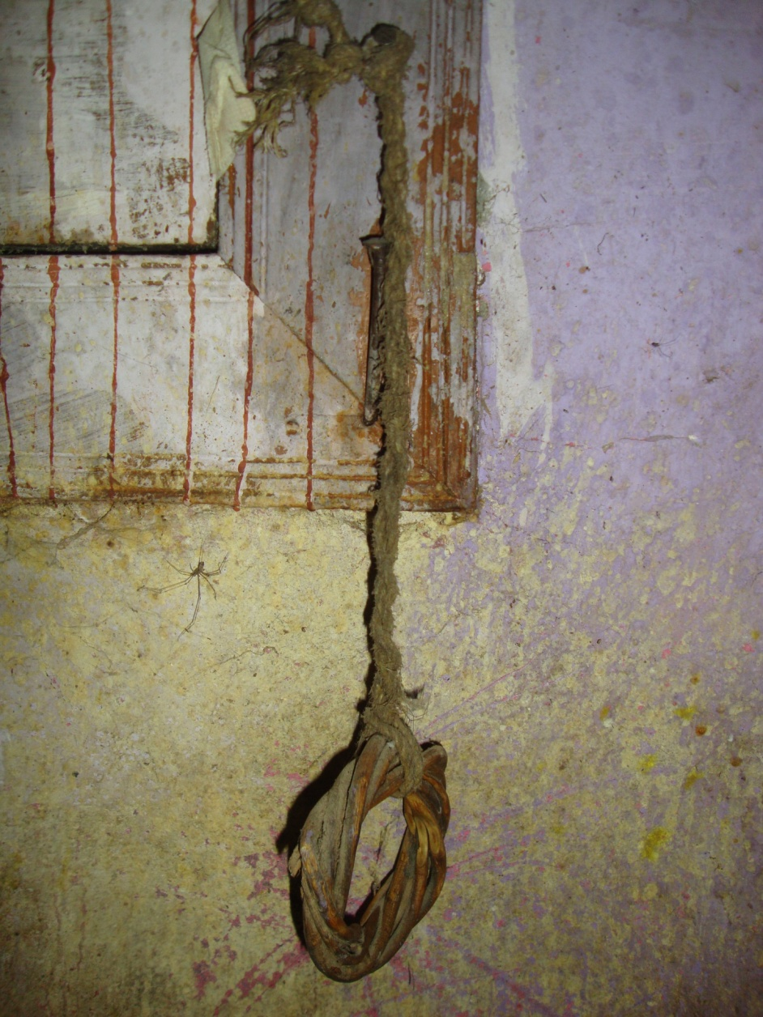

This is a wicker hoop attached to a wall with a length of rope; it is used to keep /tshaenpu:/ in position while churning milk.

/ts^{h}a:pɖi/

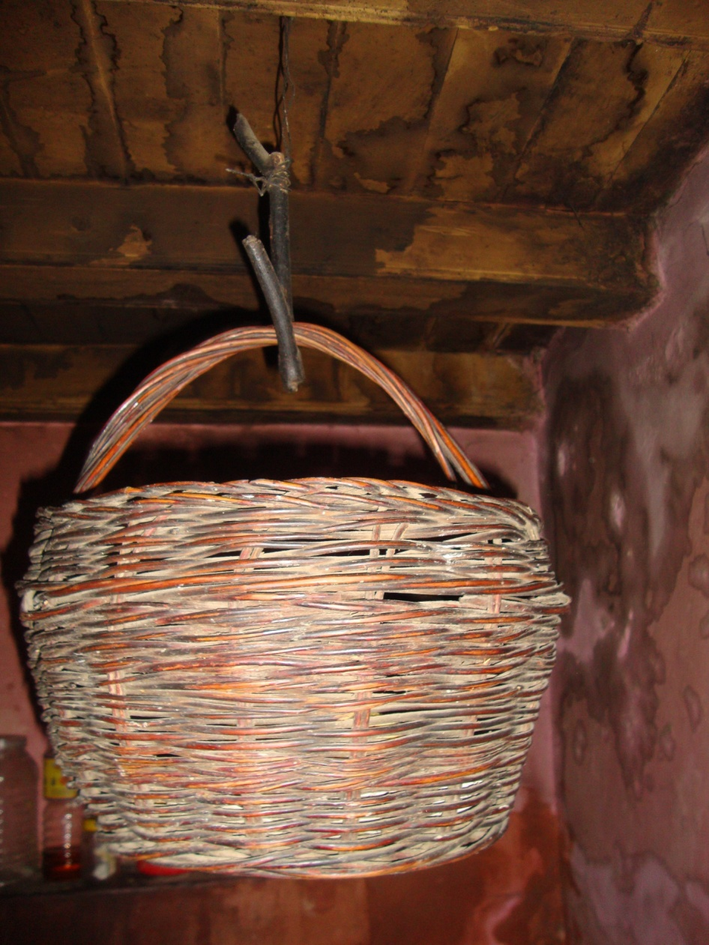

A roughly barrel shaped, round bottomed wicker basket with a semi-circular handle. It is used to store dry food material like bread and spices. It is usually hung from the ceiling of the kitchen to keep the food material inside it away from the reach of rodents and insects.
/tsul/ and /d̪amku:ʈ/

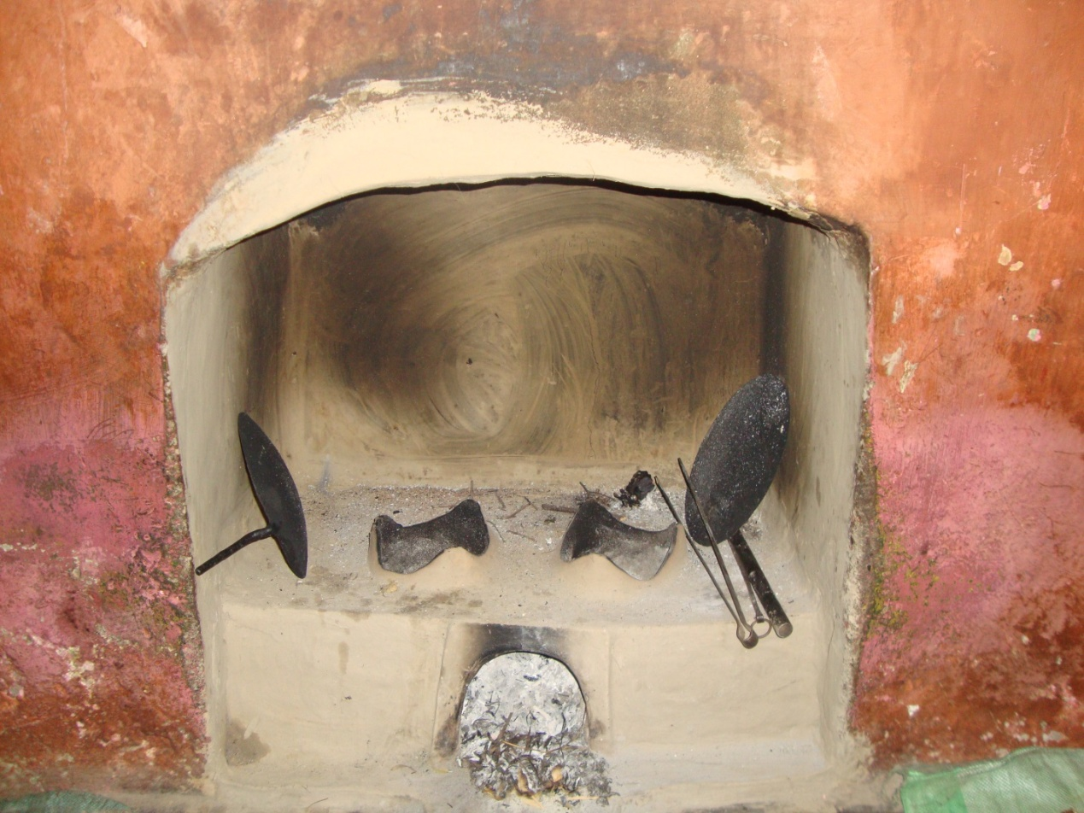

An earthen stove( a chula) with an opening in front for fuel (usually dry twigs which people gather from their land) and two more openings at the top, each of which is equipped with three equal-sized bulges equidistant from each other to support a vessel. It is built in an opening at the base of a chimney. The chimney is called as /d̪amku:t/ in the language under investigation.

/uɡɡuː/

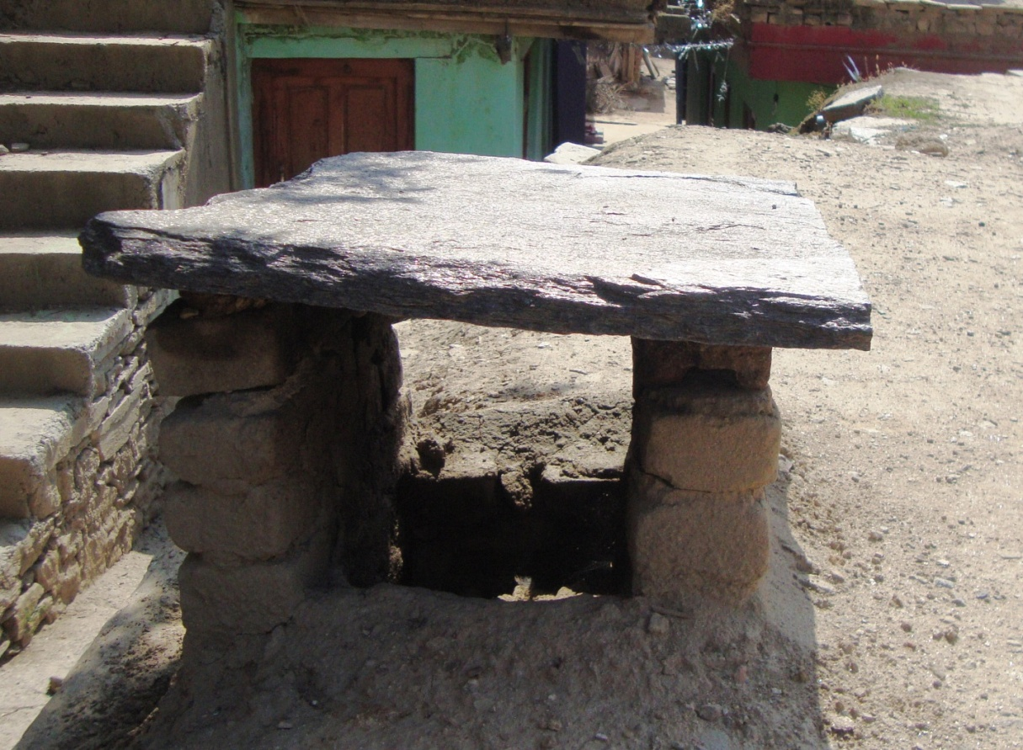

The vent of the kitchen chimney on the roof; it is covered with a flat piece of stone resting on a couple of supports which may consist of two similar but vertical pieces of stone, or some other material, such as bricks.

