Project Report

Scheme for Protection and Preservation of Endangered Languages
khash

Principal Investigator
Dr. Aejaz Mohmmed Sheikh

Resource Person
Rahila Safdar
Rayees Ahmad Mir
Danish Bashir

Department of linguistics
University of Kashmir

Submitted to
Central Institute of Indian Languages
Mysore

Personal Profile of the informant
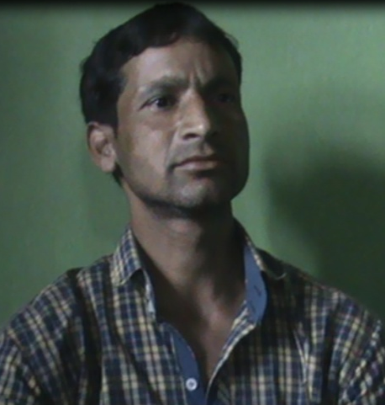
- Name of the respondent: Shri Kaka Ram Padihaar
- Sex: Male
- Age: 41 years
- Education: M.A Sociology & B.Ed.
- Occupation: Teacher
- Address: Aaru village

Residence/name of the settlement: Deryan
Place of work: Primary school, Dalano

- Marital status: Married
- If married spouse’s name: Smt. Chander Mala
- Whether the spouse belong to the same community or other community :
Other community
- Spouse’s education: B.A
- Spouse’s occupation: Teacher
- Parent’s name:
Father: Shri Swami Raj
Mother: Smt. Ratna Devi
- Parent’s occupation: Farmers

Name of the brother/sisters of the respondent: Shri. Om prakash

Doda
Doda is a district in eastern part of the Jammu province (J&K) of the Indian country. Doda is the third largest district in area after Leh and Ladakh in J&K state. Doda had come into existence in the year 1948 when it was separated from Udhampur and its Headquarter is located at a distance of 181 km From the Jammu, the winter capital, and 222 km from Srinagar, the summer capital of the state. Doda district Lies in the outer Himalayan range in J&K State and falls between 32° 53´ and 34°21´N latitude and 75°1´ and 76° 47´E longitude and has mostly a hilly terrain. The district of Doda is surrounded by Anantnag district of Kashmir division in its north, Kishtwar district in the north-east, Chamba area of Himachal Pradesh in the south, Kathua district in the south, Udhampur district in the south-west and Ramban district in the west.

Doda is located at 33.13̊N and 75.57 ̊ E (geo-coordinates). It has an average elevation of 1,107 meters (3631 feet) above sea level. Doda doesn’t have a uniform climate due to its varying physical features. The total area of district Doda is 11,691 sq. km.

Short History

In an ancient time, one Raja of Kishtwar whose dominion extended beyond Doda was persuaded by one utensil maker who was a migrant from Multan (Pakistan) to settle permanently in his territory. He after obtaining permission from the then Raja of Kishtwar started residing there and established a utensil factory as well. The name of migrant was Deeda. The time went on and the place/village he used to dwell became popular day by day after his name i.e. Deeda. With the passage of several years the name Deeda distorted to Doda and became popular by that name for time to come and since then till date the distorted name is popular i.e. by the name of Doda.

Demographics

The population of the district Doda as per census 2011 was 4.10 lacks out of which 2.14 lacks are Males & 1.96 lacks are females. The density of the population of district as per census 2011 is 46 persons per square kilometer. Out of the total population of the district 92.06% people live in the rural areas and 7.97% lives in urban areas.

As per census 2011 the sex ratio was worked out to be 919 which are higher than the state ratio of 889.

The schedule caste population in the district is 53408 i.e. 13.00 % against 7.4% of the state as per census 2011.

The population of the scheduled Tribe in the district is 39216 (9.6 %) against the 11.9% of the state as per the census 2011.

The total numbers of households in the district are 79636 of which 6719 are in urban areas and 72917 in rural areas.

According to the census 2011, 219083 (64.68%) of the population was enumerated as literate. This is less than 67.2% for the state. It is higher 78.4% for males and lower (49.7%) for females. It is higher 85.6% for the urban areas and lower (62.7%) in rural areas.

Doda city

Doda city has a population of 25,527. Males constitute 64% and females 34% of the total population. Doda city has an average literacy rate of 5% higher than the Indian national average of 59.5%. Male literacy rate is 85% and female literacy rate is 61%. 10% of the population is under 6 years of age. 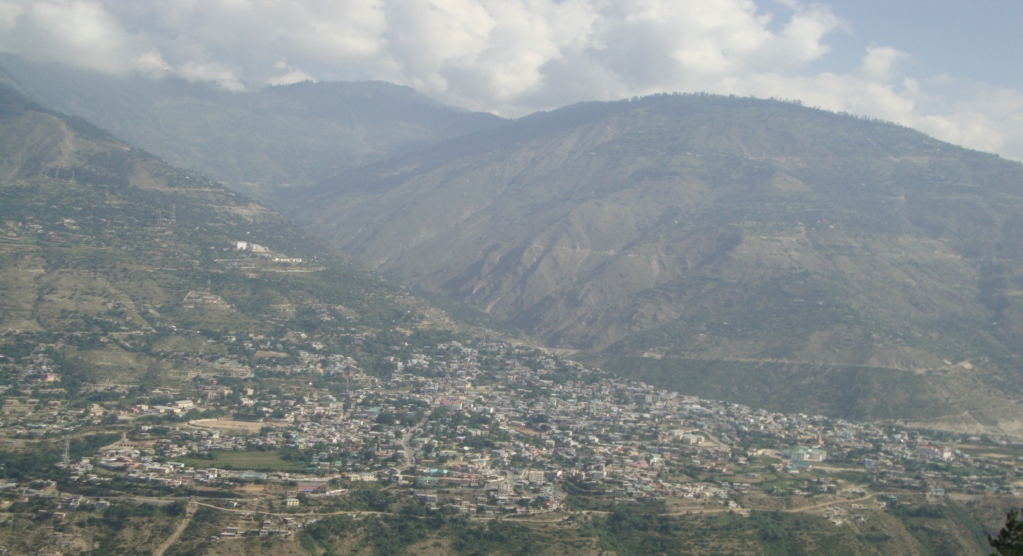

Language

The district Doda has a mixed culture and the people of the Doda speak Kashmiri. Because of its connectivity with Srinagar, Jammu, Himachal Pradesh and Ladakh the people generally speak Kashmiri, Ladakhi, Dogri and some pehari languages like Bhaderwahi, Kishtwari, Serazi, and besides these regional languages there are other languages being spoken in different areas, these are Pogli, Paddri, Punjabi, Khash, Meshabi, Badralium etc.

The official language of Doda is Urdu.

Administration

Administratively Doda has 406 villages, three being un-inhabited. Doda district has been divided into sub divisions viz. Doda, Bhaderwah. It has four tehsils Doda, Bhaderwah, Thathri, and Gandoh. There are 08 rural developmental blocks comprising Bhaderwah, Ghat, Doda, Thathri, Gandoh, Bhagwah, Assar, Marmat and Gundana. The number of panchayats is 232. There are four colleges in the district, Bhaderwah, Doda, Thathri and Gandoh. Inspite of that there are 707 primary schools, 415 middle schools and 146 lower/high/higher secondary schools. There is 1 district hospital and 2 sub-district hospitals.

Sarsi-Deryan

Sarsi is a village panchayat located in the Doda district of J&K state of India. The village is situated in the southern fringes, about 40 kilometers away from the Doda city and is located at 33̊ 05’ N and 75̊ 32’ E (geo-coordinates). It is a hilly and mountainous downtown track leading its path from the uphill town of Doda. It’s partly connected to Doda by a jaunty road which ends halfway before reaching its sparsely populated community hub. The road leaves off at an outskirt bridge which leads its way through Sarsi woods. It is almost 4 km uphill track to reach the centre of the Sarsi community, which is located at the highest point of hillock in the rugged mountainous range of the Himalayas. The village is located in the UTC (Universal Time Coordinated) 5:30time zone and it follows Indian standard time (IST). The sunrise time varies 27 minutes from IST.
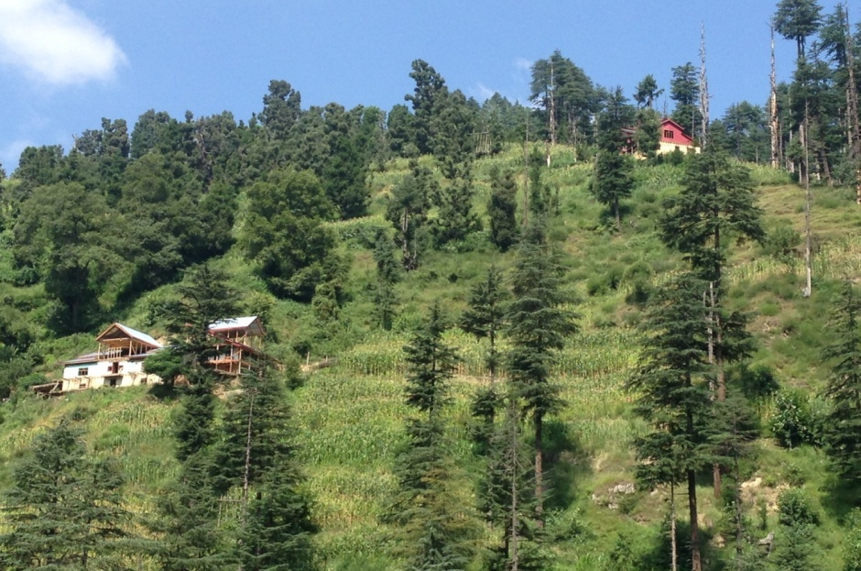
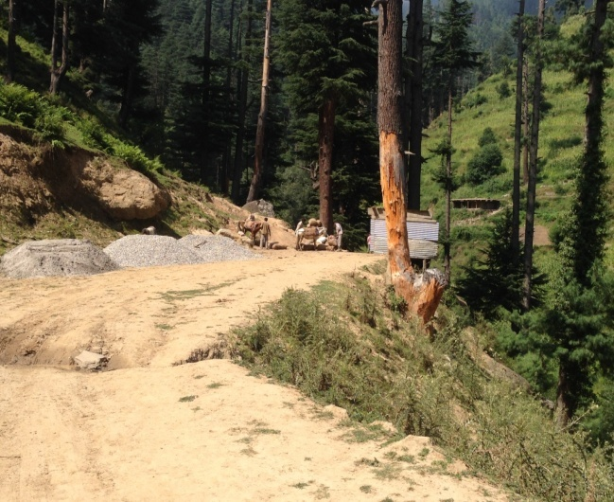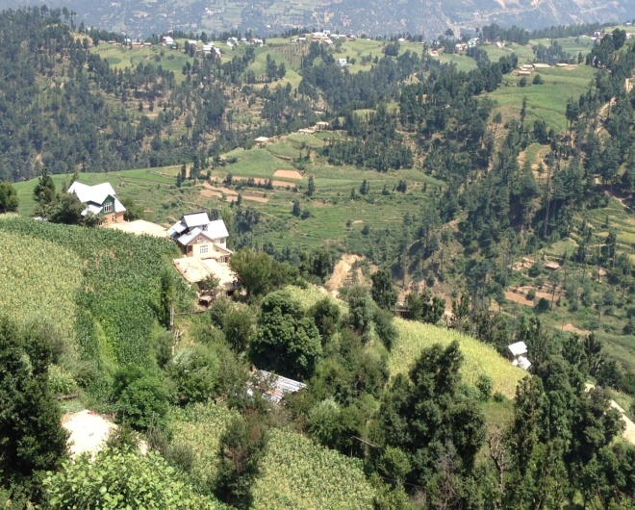

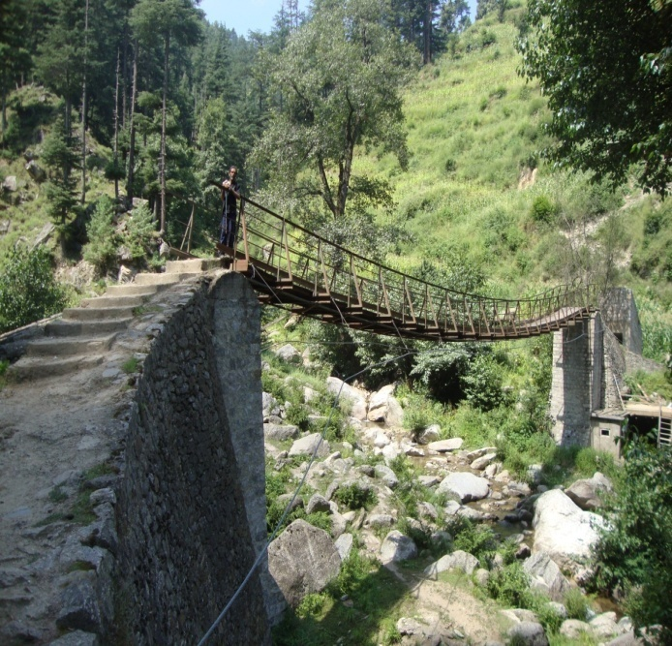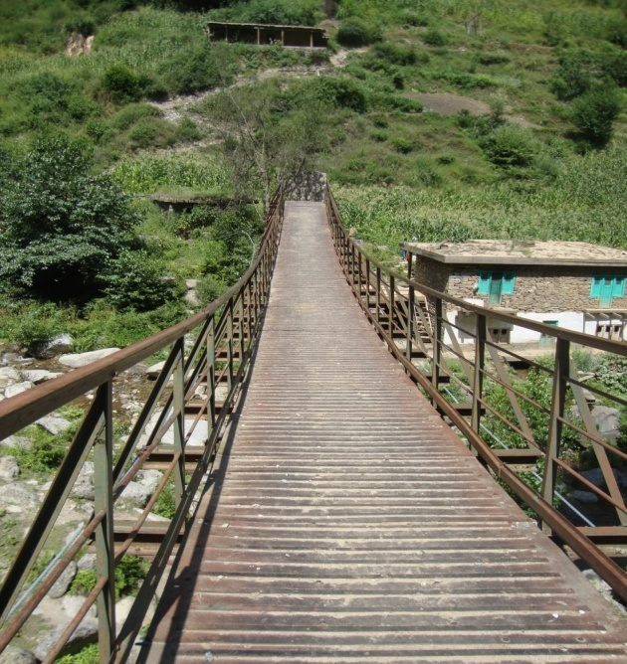
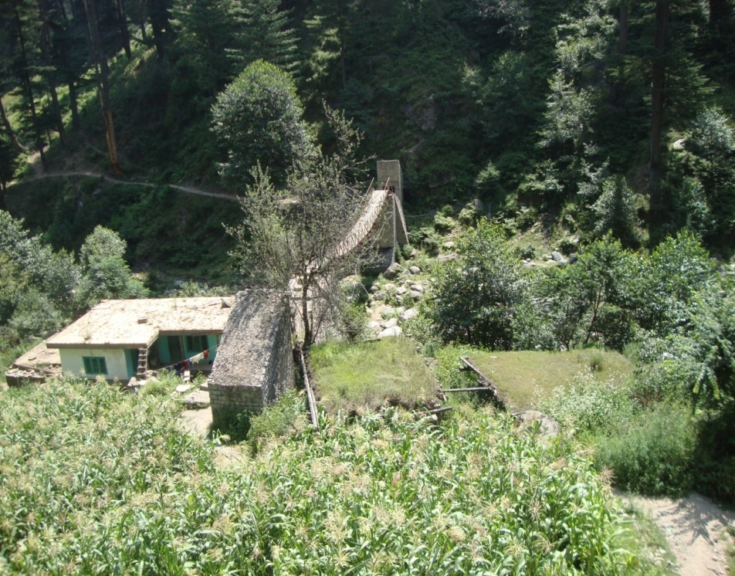

Demographics

Sarsi has a population of 1100 approximately. Out of the 1100, 700-750 people are Muslims and the rest of 400-450 are Hindus. Of the total population 1100 (app.) 600-650 are on the voter list. The village is known, not only for its cultural heritage and ethnic values but also for its secularism and religious tolerance.

Administration

It comes under the tehsil Doda and block Marmat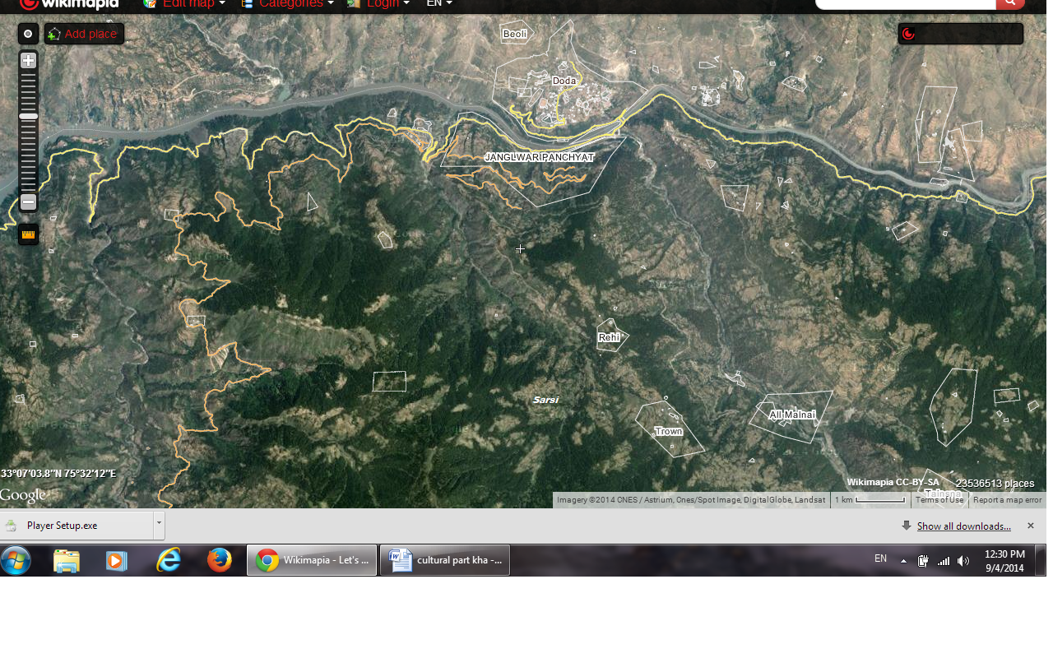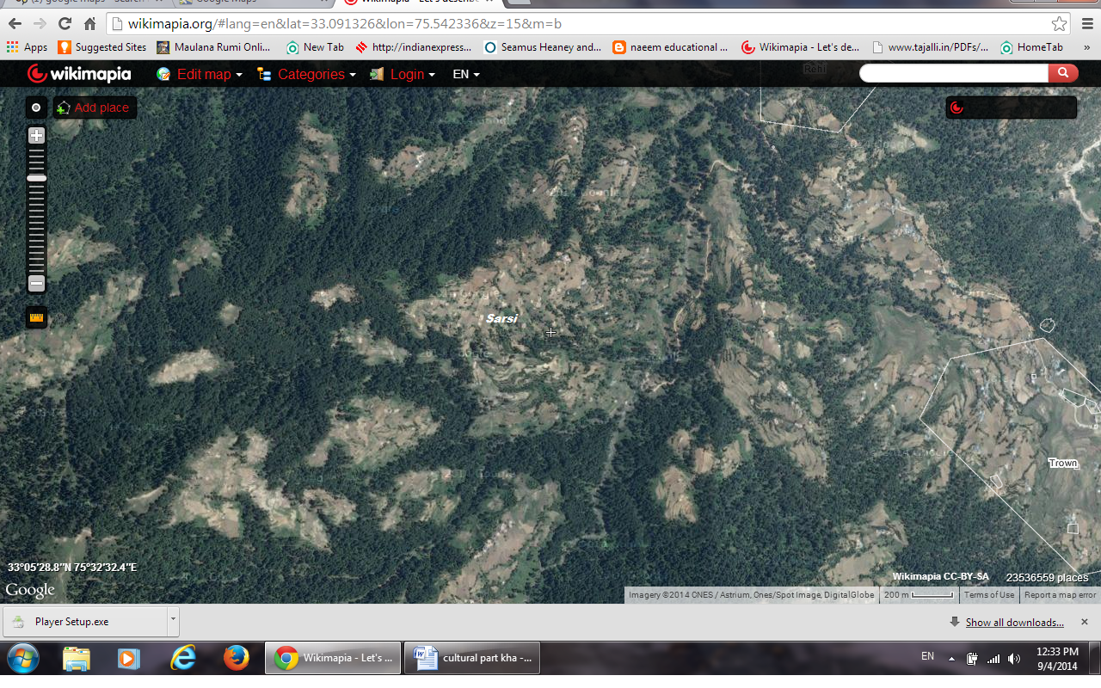
Administratively Sarsi has 7 wards viz.
- Syed Sarsi (comprising of two lower Sarsi and upper Sarsi),
- Bacha
- Dalano
- Kukdas
- Tanasar
- Deryan

Language

The village panchayat Sarsi has a rich cultural heritage. The languages used in this village panchayat are mostly Kashmiri which is spoken by Muslims and Khash which is spoken by Hindus, irrespective of that both the communities know and use it when talking to each other. Other than Kashmiri and khash, the people know Urdu and Hindi as well. Urdu is the lingua-franca of the area.

Soil

The soil in the Sarsi and its wards is generally loose and sandy with very low moisture. The incidence of soil erosion is very high and blockage of road is frequent during the rainy season. The damage to roads and households is prevalent and cause inconvenience.

Education

There are three schools in the Sarsi village panchayat, viz. 1 primary school, 1 middle school, 1 high school. Besides there is 1 RT (Rehbar-e-Taleem) school. Inspite of these schools the education in the village is very poor and most of the elderly people i.e., the age group of 35 and above are uneducated. The people of the village prefer to send their children to another village having a better high school infrastructure, so that the education of the children may not suffer.

Khash
Khash is a language spoken by a minority community living in the village named as Sarsi (divided in to upper and lower Sarsi) which is located in the Doda district of Jammu and Kashmir. Sarsi village comprises six wards among which five wards are dominated by Muslim population and one ward has majority as Hindus.
The area where Khash is spoken is dominated by Hindu majority and is known by the name Deryan which is about 40 -45 kms away from main Doda. The total population of the Sarsi village is about 1100 among which about 20% population is of Hindus, and Khash is mainly considered to be the language of Hindu population but because of the close association among both the religious communities in term of trade and other sociolinguistic factors, the language is spoken by most of the Muslim population as well.
The language has no script and is not taught in any of the local schools……. There is no available literature of the language but the language is rich in oral traditions, folk songs and folk lore. Other languages spoken in the area are Kashmiri, Hindi and Urdu.
Following table shows the location of Khash speaking community:
State | Jammu and Kashmir
District | Doda
Tehsil | Doda
Block | Marmat
Area | Deryan

Oral History

The origin of the speakers of ‘Khash’ dates back to the era when the community was inhabited in Himachal Pradesh. They are self-claimed Rajputs by origin that migrated to Khileni which is about 30 kms away from Doda because of unclear reasons. Khelani was called as the village of Khash which included both the Hindu and Muslim population. The people of community would serve the Lord of the area as serfs; they use to carry lord’s stuff which includes the livestock, food and other utilities from one place to another without any wages being paid to them. More than a hundred years ago Khash community ran away from Khelani and got settled in to the woods of Sarsi in search of a better life and to save their future generation from slavery.
There is a mythical origin associated with the community which has its roots in the migration of a saint from an unknown place to Sarsi-Parihaar area. The saint got married to a woman who used to help him to do his daily work in nick of time. The woman had some mystic powers and was a fairy according to the narrator of which the saint was unaware. This fairy is called by the people of Khash community by her spiritual name “Khol”. Somehow the man discovered her secret powers, and came to know that all her powers were hidden in the wooden comb in her hair. He planned to curb her powers because he wanted to lead a normal life with her. One day when both of them were working in the fields he took away her comb tactfully and hid it under the soil somewhere in the woods. The fairy was bounded not to take out the comb herself but someone else should do it for her. Time passed away and she was a grandmother now. One day one of her grandchildren enquired about her frizzy hair. She told them about the comb that their grandfather took away from her and asked them to get that comb for her so that she can get her hair in shape. Her grandchildren got her the comb and the moment she started comb her hair she disappeared forever.
Khash community is believed to be the decedents of the same woman. Till recent times whenever the community faced any trouble they would call up on their grandmother “Khol” and get helped out of trouble. There is a place in upper Sarsi where sacrifices are made in her name. Some people from older generation still claim to hear cries of “Khol”. As per mythical point of view this is how the community came in to existence and Khash’s claim to be the decedents of a fairy- the Padihaars. The male decedents from this family claim unusual pattern of hair growth on their bodies and perceive it as a sign of spirituality.

Settlement pattern

The community numbering around 1100 persons lives in the area of Doda called Sarsi which is divided in six wards and the ward comprising village Deryan has most of the Khash speakers as the ward is dominated by Hindu members, though the Khash speakers can be found scattered all over the Sarsi area. The cultural differences among the wards are totally based on the religion rather that cast and class. Hindu community has Khash as their mother tongue while as the Muslim members claim Kashmiri as their mother tongue, but most of the members of the area speak at least two languages, which are Urdu and Khash for Hindu population and Kashmiri and Khash for Muslim population.

Construction
The community is settled on the outskirts of the town Doda. Most of the houses are made of wood, mud and rocks. Both men and women take part in construction of the house, not because of any traditional or social aspect attached to it but because of poverty. People, who can afford to hire masons, get it both from their own community and from outside as well, depending up on the availability Most of the houses are constructed in traditional style, with flat roof. They get the material for construction mostly from woods and randomly collect it from other places as well.
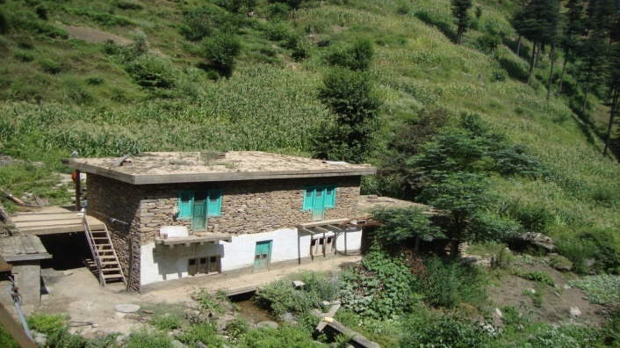
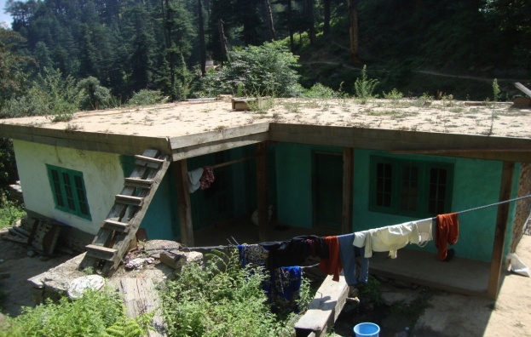

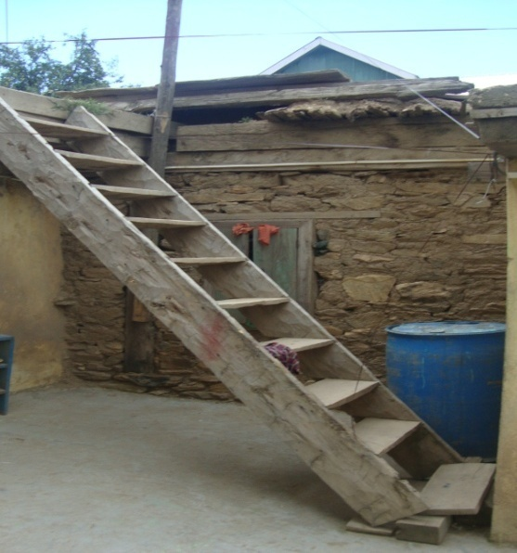
Transportation of material is done with the help of horses as no other modern mode of transportation is available because the area lacks proper roads.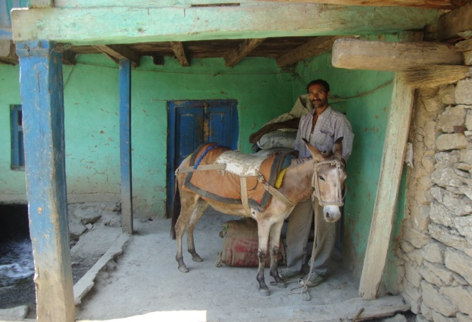 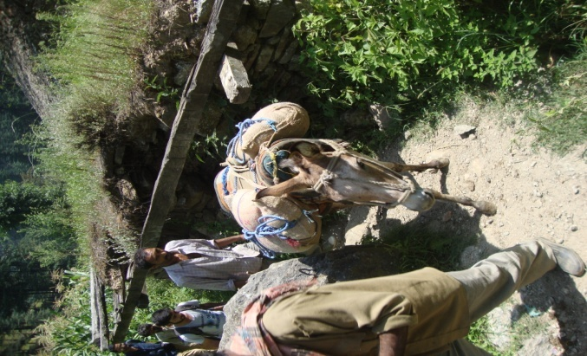

A typical Khashki house is mostly single storied and the ones who have another floor lack stair case inside the house, in all the houses first floor has its approach from outside only.

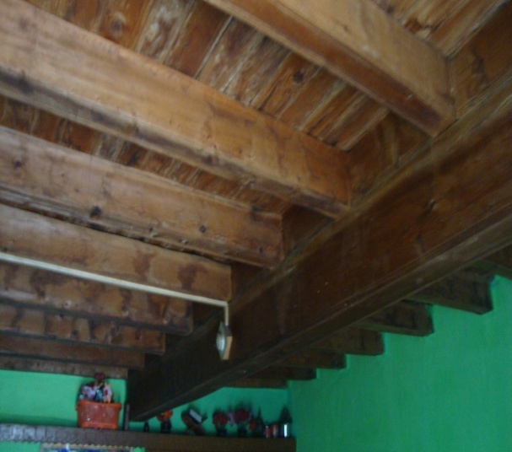
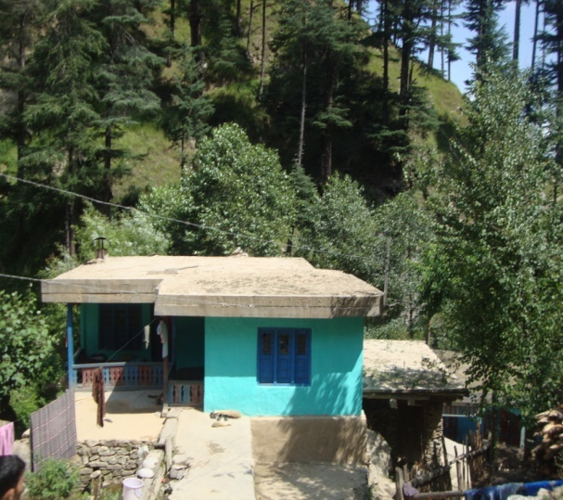
Most of the houses have their main doors facing towards North i.e., downwards. The direction facing the main door is technically oriented rather than of any religious or superstitious belief. An average house has a minimum number of four rooms, which have their doors arranged towards the corridor. An average house has a drawing room, a living
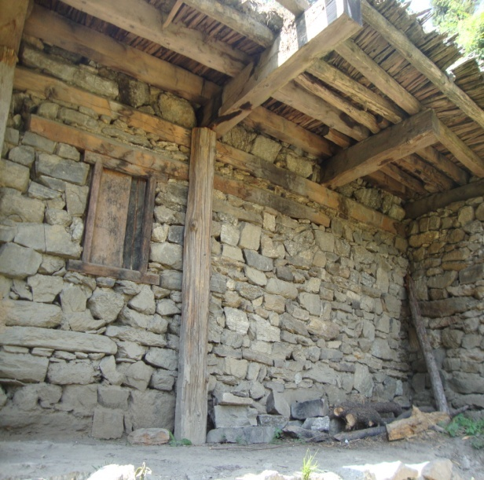
room which is also used for sleeping, a master bed room and a Kitchen. Kitchen of the house is not just used for cooking but the entire family eats and sits mostly in kitchen. There are long shelves in kitchen which are used for keeping different utensils and other articles used in kitchen. The drawing room which is furnished with clean sheets and cushions is used for special guests. The ceiling of rooms is made of wood, with parallel wooden planks serving as support. Walls in all the rooms are painted with different colors, and are decorated with multi colored wall hangings, posters etc. Every house has bathroom outside the house, fitted with a toilet seat and a wash basin. The room used for storage of domestic articles is not found in every house, and the ones which have it make use of it as a personal granary and call it “Kothari”. The storage of grains in the particular room is entirely personal to the family which owns it and there is no community granary available in the village. The number of rooms each house has largely depends up on the financial status of the family rather than the size of the family. Looking at the interior of houses in the Khashki community one can see that the women of the community are fond of decorating the interiors with various types of colored posters and other articles, that they make themselves with stitching and knitting techniques, and buy from market as well. But none of these items has any religious or cultural significance attached to it, but in older times the community use to keep a broken earthen port on roof of the house to save it from the evil eye. Similarly the use of white stone called as chito goad in Khash was considered as an ill omen in the community hence, the use of white stone was prohibited in any sort of construction or use in any other thing for that matter. The practice of avoiding the white stone for any purpose still exists in community.
There are no isolated houses households in the area and the head of the community “Sarpanch” lives in the same area where the other people live. There is no division for the area of living on the base of caste and class.

Caste and Class

The community lacks cast stratification. The main casts among the Hindu members are Thakkar, Padihaar, which are considered equal in all respects. Similarly Muslims mostly have their casts as Bhat, Malik, but they consider Sayeds to be more superior because of the religious history.
As far as the class stratification is concerned, the whole community falls under lower middle class. There is no class and cast stratification based on the profession as the ancestral profession of the whole community be it the Muslim members or that of Hindus was to serve the Lord of area as serfs. Nowadays most of the population has agriculture as their occupation, though the youngsters are getting educated and switching their profession to teaching and other jobs. The only class stratification made in the community is the one based on financial condition of family.

Characteristics of the people and the place (experiences and perceptions)

