Consolidated Report of the project on Ethnolinguistic sketch of Khana of Chamalvas

Scheme for Protection and Preservation of Endangered Languages

From 2014-2016

LANGUAGE : KHANA
DISTRICT : RAMBAN

SUBMITTED TO

Central Institute of Indian Languages
(Ministry of Human Resource Development, Govt. of India, Department of Higher Education)

Manasagangotri, Mysore – 570 006 (Karnataka).

Principle investigator:Prof. Aadil Amin Kak
Resource persons: 1. Dr. Humaira Khan
2. Javaid Ahmad Lone
3. Sumia Tariq

Table of Content | Page No.
Over view of the Community  Architecture  Economy and Occupation  Men-Women Engagements | 5  8  14  17
Leisure time activities | 19
Food and drinks  Physical Features and Dress  Family Setup  Judiciary  Religion and festivity  People and Religion | 23  29  36  37  38  41
Beliefs and Superstitions | 42
Language attitude use and prestige | 43
Language and Identity  Language Use  Patterns of Language Use  Language Attitude | 7  44  45  51
Rites and Rituals  Birth Rites and Rituals  Death Rites and Rituals  Marriage rites and Rituals | 55  55  55  63
Folklore and culture  Folk Tales  Riddles, Proverbsand Folk Songs | 72  73  79
Ethno Medicines  Kinship System  Modes of Address  Ethno Medicine  Color and Culture  Pictorial description of various items used in the community | 123  84  112  130

PersonalProfileof the Informant

PersonalProfileof the Informant
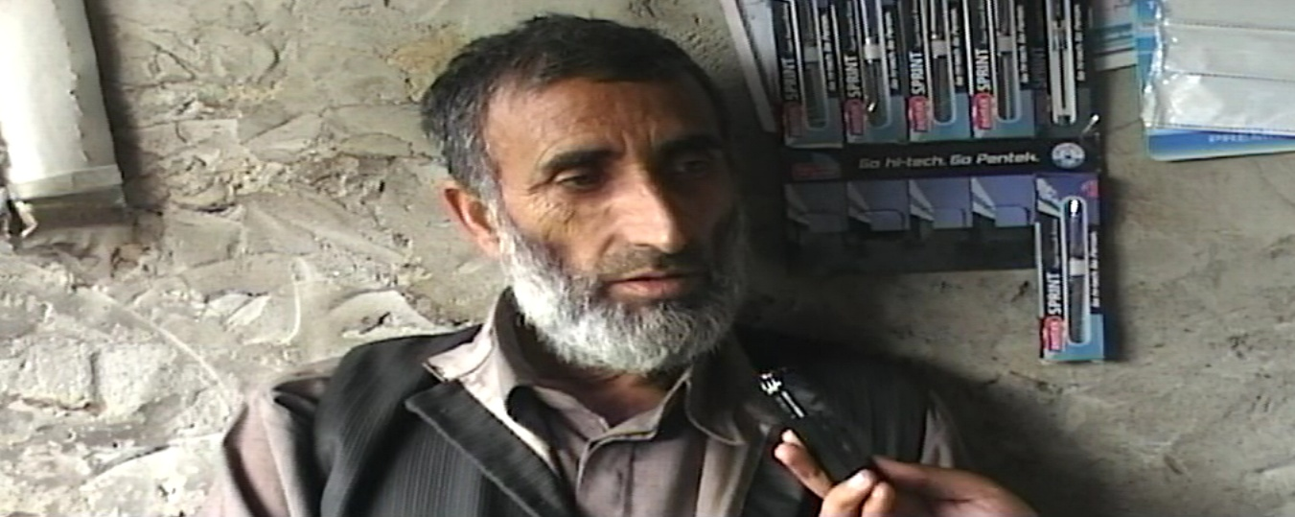

1. Nameoftherespondent : Abdul Rehman
2. Sex : Male
3. Age : 55Years
4. Education : Illiterate
5. Occupation : Labour
6. Address : Chamalvas
Residence/NameoftheSettlement : Chamalvas
Placeofwork : Chamalvas
7. ParentsNativeVillage : Neel-Chamalvas
8. ParentsFirstLanguage : Khana
9. Maritalstatus : Married
10.If married,spouse’sname : Fareeda
11.Whetherthe Spouse belongs tothesame communityortheothercommunity:
She belongs to the same community (Khana /Chamalvas).
12.Spouse’sEducation : Illiterate
13.Spouse’soccupation : House-wife
14.Parents’name : Father : Ab.Raheem
Mother : Jana
15.Parents’education : Father : 8th standard
Mother : Illiterate
16.Parents’occupation : Father : Labourer
Mother : Housewife
17.Numberofbrothers/sistersof therespondent: 4 brothers and no sister.
18.Whatisthenameofthe community/mother tongue? : Chamalvas/Khana
Namegivenby Insiders: Khana
NamegivenbyOutsiders: Kha

Overview of the community
Khana is the language primarily spoken in the hilly area of Chamalvassituated in District Ramban,tehsil Banihal. The area is situated in the central Himalayas on the eastern side of the National Highway which passes through the Banihal Pass.

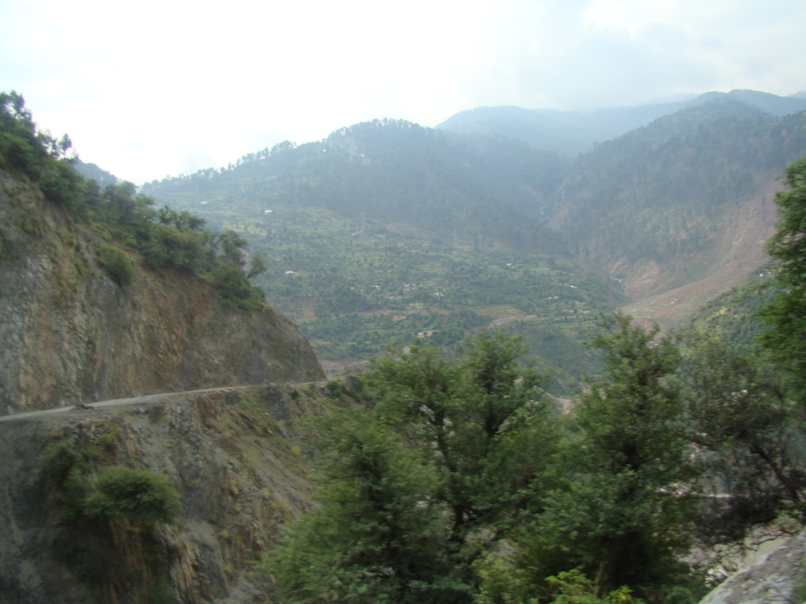 .
Chamalvas is a small village located at a distance of about 30 kilometers from Ramban district properTehsilBanihal. It is situated at a high altitude on a mountain top called Hansraj Mountain, which runs along with Pir-Panjal mountain range of Great Himalayas. The main land mark in the area is a rivulet popularly called Badda-Naalah which is joined by another rivulet called Bichellary in Ramsoo area of Ramban district, whose way uphill leads to the area of Neel. On its North lie Kapran and Hallansedaar areas.
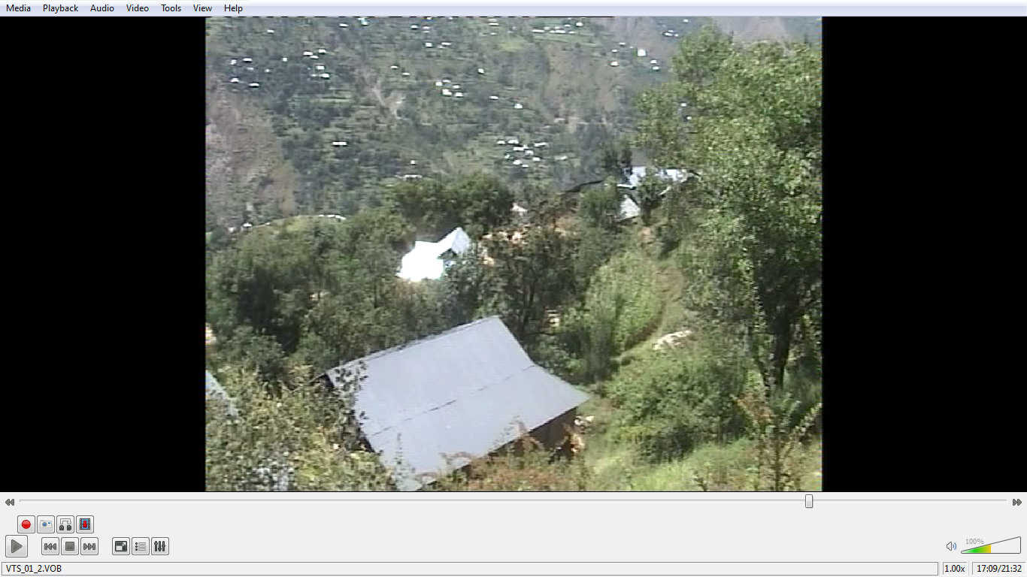

About 60 families reside in this village. Some families have a history of about 100 – 200 years of residing in this area.A chunk of Khana speaking population is scattered in Neel Chidous area as well which is a few kilometers away from Chamalvas.
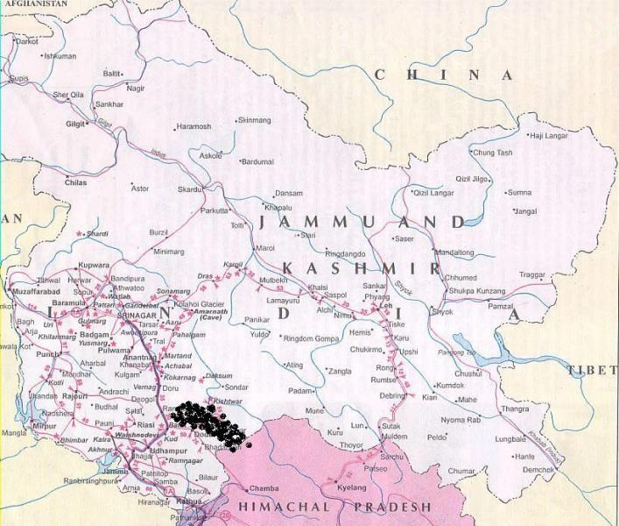
Map of Jammu and Kashmir
The dotted area roughly shows the location of Khana speakers
The District is known, not only for its rich cultural heritage and ethical values but also popular for its age-old traditions of secularism and the spirit of tolerance, which have been since times immemorial, binding the people together. Khana is the mother tongue of about 500-600 persons. The native speakers reported that they are living in this area from several generations. According to the oral tradition in this region, people of this area are descendants of people who had migrated to this place from the several other places and settled here. At present, the people have developed a unique sub-culture different in many respects from the rest of the state, as well as a unique sense of identity towards their mother tongue.
According to the local residents of district Ramban and tehsil Banihal,the Khana speakers were given the name Khah by the Kashmiris of Banihal.As per the local knowledge the word ‘Kha’ means ‘mountain dwellers’ and was used by Kashmiri speakers in derogatory sense for the people of that area, which showed that Khana people probably had a lower status. When these people used to visit the market of Banihal city for various purposes, they used to get noticed by their dressing pattern and their way of talking, etc. They used to wear multi colored clothes (i.e shirt and trousers of two different colors and turban of differentcolor)so they were also known as du reng (bi colored) by the Kashmiri speakers. They looked entirely different from Kashmiris who took them as backward, uncivilized and mountain dwellers speaking some different language and hence gave them the name Khah/Khana.Poguli speakers consider Kha speakers inferior to themselves. According to them, Kha speakers were originally brought there as labourers to work on their fields. Later they got settled there.
Some families are said to have migrated from Batmaloo area of Srinagar district to Neel and then from Neel to Chamalvas. The reasons of migration may vary from person to person but no common reason has been stated by the people.Population consists of Kashmiris and Gujjars and they have friendly relations with each other
Language and Identity
The language spoken in this region is Khana. It is locally known as Kha. It is spoken by almost 500-600 residents and is the main medium of communication in this area. Neighbouring languages include Kashmiri, Poguli and Dogri. Khana is the main language used by the people in their homes, fields and other informal situations. Children also speak Khana in informal situations. Apart from Khana, Kashmiri and Urdu are spoken in the region, but the Urdu spoken here resembles Pahari. Hindi is also spoken to some extent. As far as the schools are concerned, Urdu and Kashmiri are used. So it can be said that these two languages are formal where as Khana is informal. In mosques and religious meetings conversations are held in Urdu /Kashmiri as the speakers of languages other than Khana can come together and exchange views. Religious hymns and songs are recited in either Kashmiri or Urdu.
Regarding their language and their identity, their elders believe that this language is their virasat i.e. their inheritance which has to be carried on by every new born childas well. This multilingual nature can probably be attributed to their daily needs of communication with other people at their employment sites,etc.
The older generation seems to prefer adherence to this important cultural component whereas the younger generations do not feel that this has any importance. The reason why the older generation prefers to adhere to this cultural component is probably because of some emotional bond by which they wish to be identified.
Khana has no ancient written document or literature. Not even a single radio or TV program is broadcasted and no newspapers are printed in Khana, which means the language is not used in media.
The language used while communicating with people outside community is determined by the language of the person concerned i.e. Kashmiri with Kashmiris, Dogri with Dogris, Urdu with people other than themselves. Even though the medium of instruction in schools is English but their proficiency in it is poor. Though these languages are also spoken with ease, Khana continues to be the widely used language. Being a multilingual society switching from one language to other is common.
Architecture
The culture of a community is reflected in its style of architecture(structure of houses,artifactsused,etc.)
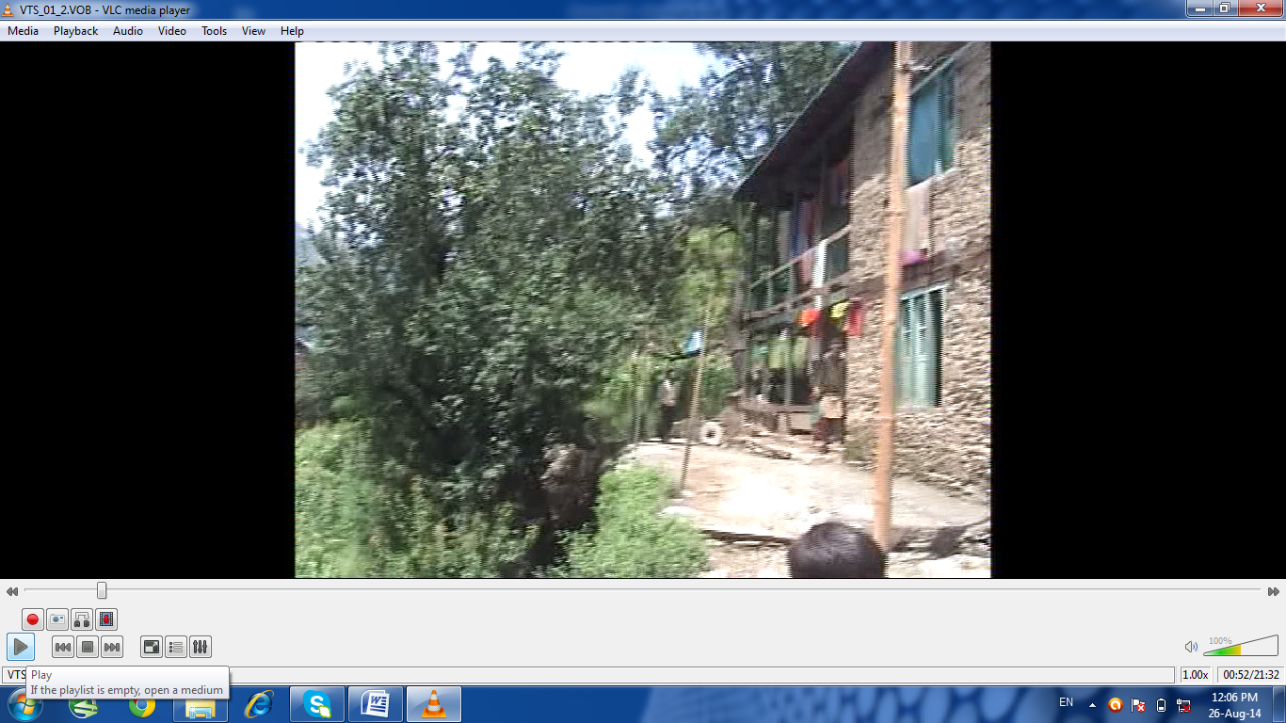
The houses of theKhana community are located in a scattered manner on the slope, sometimes forming groups of not more than four. These houses are approached from the road and connected to each other by rough and steep tracks. The slope is covered by woody shrubs and long grasswith a terrace here and there, either occupied by a house or houses, a cowshed or a patch of corn or vegetables.
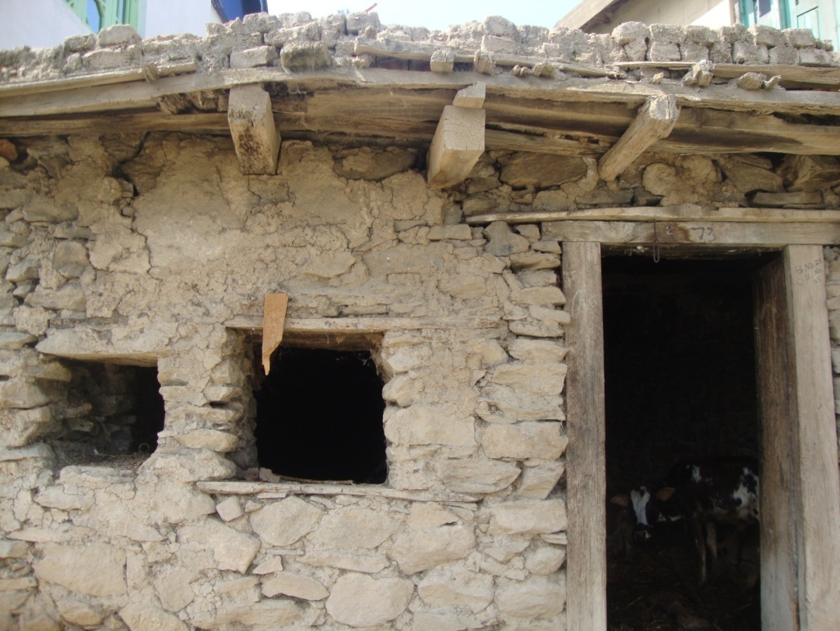
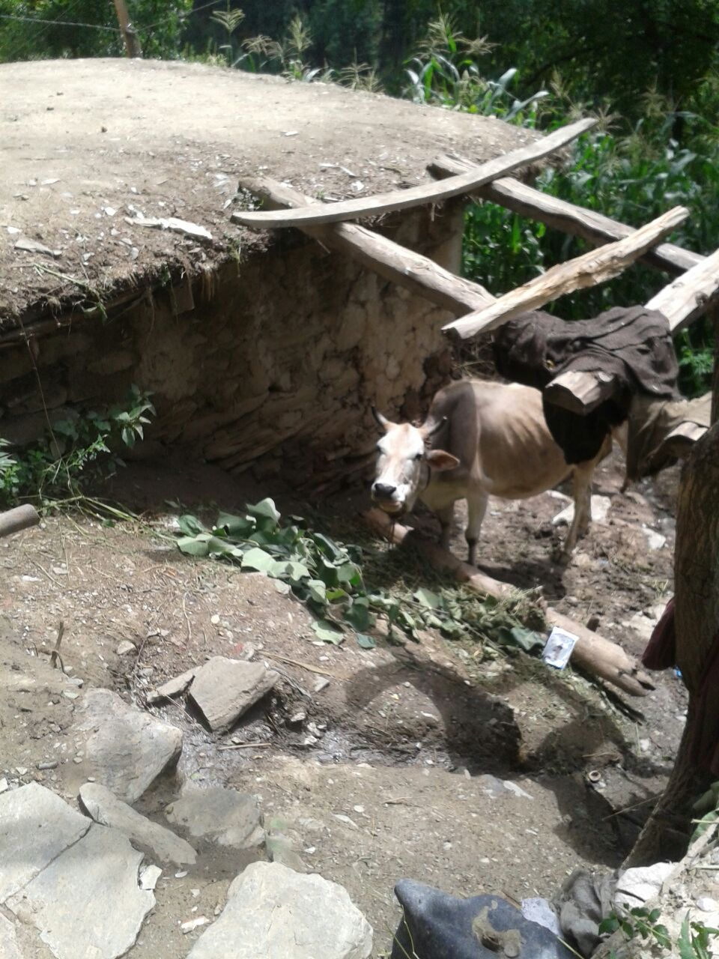
Acowshed

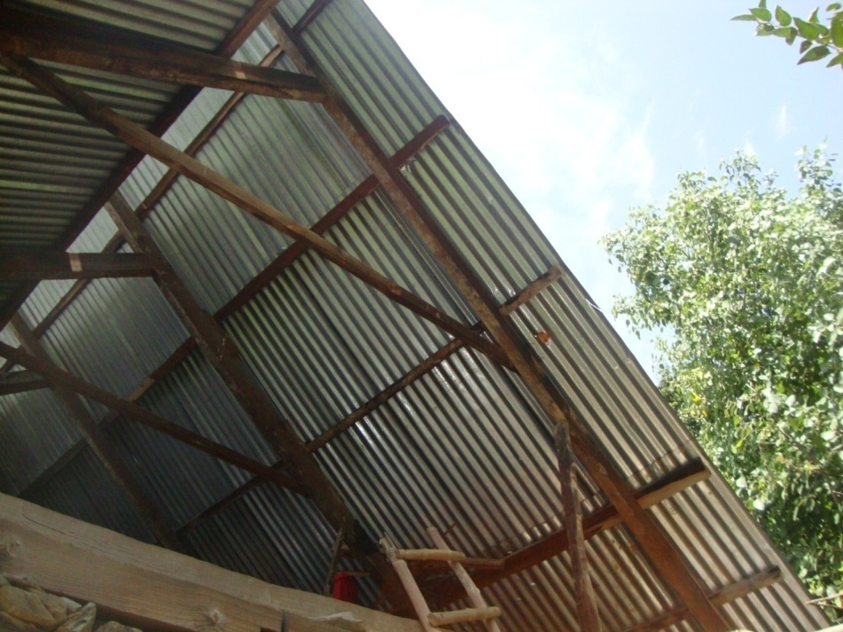
Traditional slantinɡ roof
The houses are made of timber and flat stones much larger than bricks held together by clay. The roofs are made of tin sheets supported by timber. In olden days they were roofed with straw and mud.

Traditional wooden ceilinɡs

The houses are single or double storied structures with more than half of the length and less than half of the breadth of the lower story occupied by a verandah.
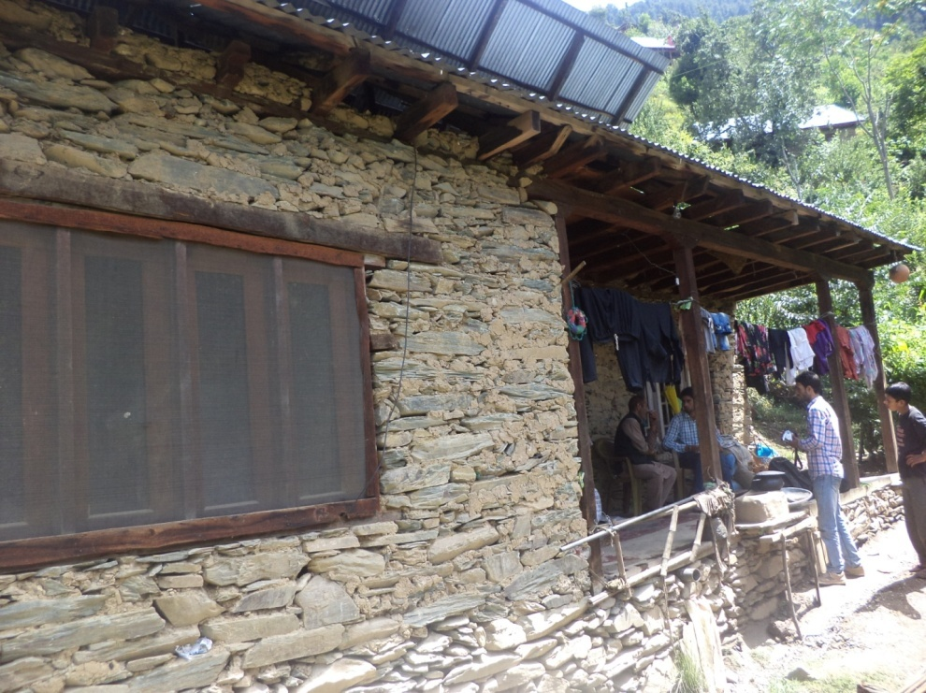
A traditional house with balcony made up of stones and clay
This verandah is accessed by a short flight of steps from the outside, if it is on a level higher than the ground or one simply steps into the verandah, if it is level with the ground. The interior of the house opens onto the verandah by means of a single wooden door. The door leads into a narrow hallway. Three rooms open onto this hallway, one on the right and two on the left. The right one is a sitting room. Out of the other two rooms, the one furthest from the entry is a kitchen, the floor of which is furnished with a single mat of grass. The remaining room is a bedroom.
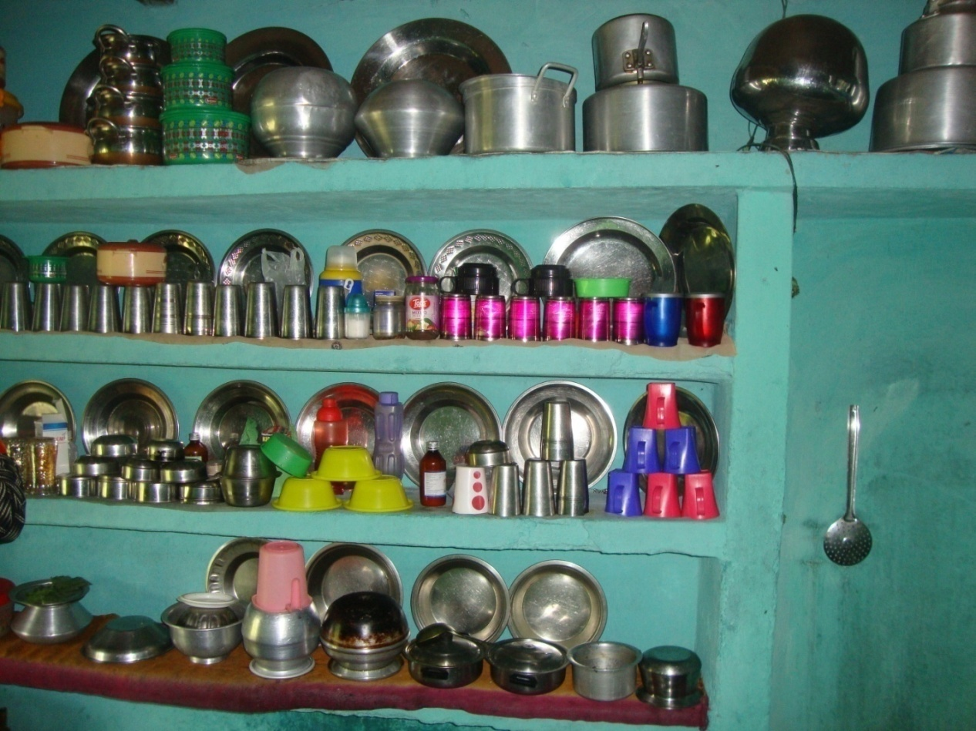Kitchen and utensil
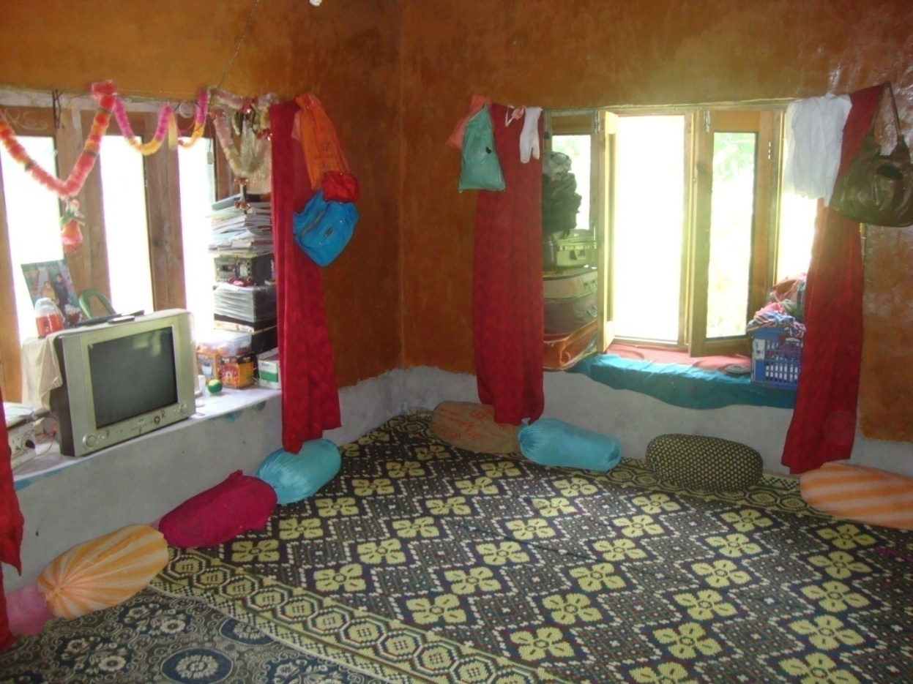
Drawinɡ room
The upper story is accessed by a woodenstaircase and has the same number of rooms as the lower story. These are arranged in the same manner as the ones in the lower story, but all of them function as bed rooms and the hallway is reached from the opposite side by the staircase.
There are no walls or fences round the houses. The spaces in front of the houses are very small and cannot be called yards.
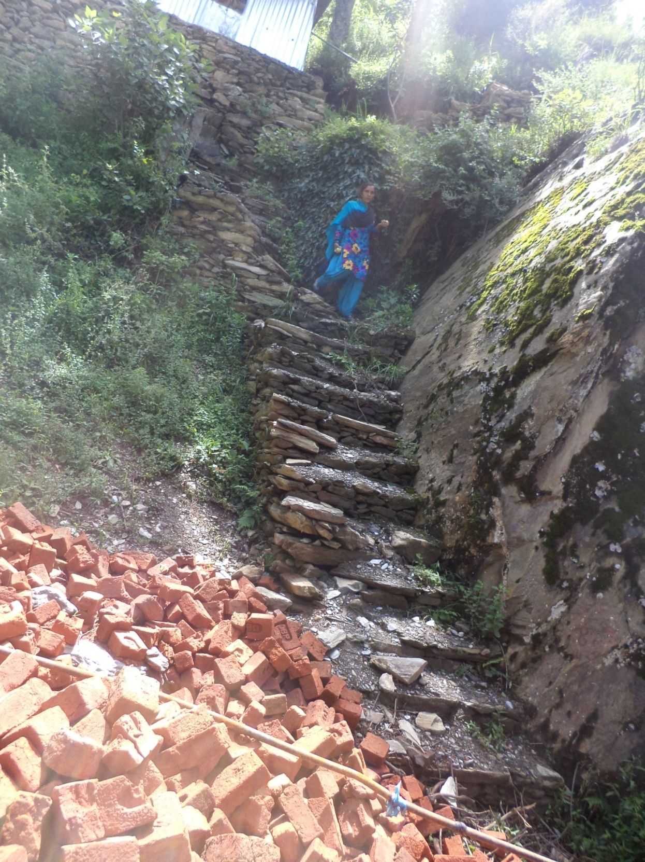
Stairs and bricks
Economy and occupation
Economically speaking, people here in general belong to middle class and lower middle class. Most of the people in this region are illiterate, poverty being the main reason. The people residing here earn their living by farming and labor. Men work outside the homes while women are mostly engrossed in household activities. Water is supplied from a spring which is about 1km far from the village. There are no rivers found here.There is only one hospital located at a distance of 2kms from the village but it is deprived of basic facilities and is not in a good condition. It is under construction yet. In the recent past rice was also being cultivated in the area but because to scarcity of rain rice cultivation stopped. Furthermore, some fruits are also grown. Trees, which produce nuts, are also observed in the area
A significant proportion of the community population is involved in that occupational economic activity which gives them significant income. This income only caters their day to day needs. They do not have a fixed occupation as such but people are mostly self-employed like contractors,carpenters,masons, butchers, grocers, and drivers as well.
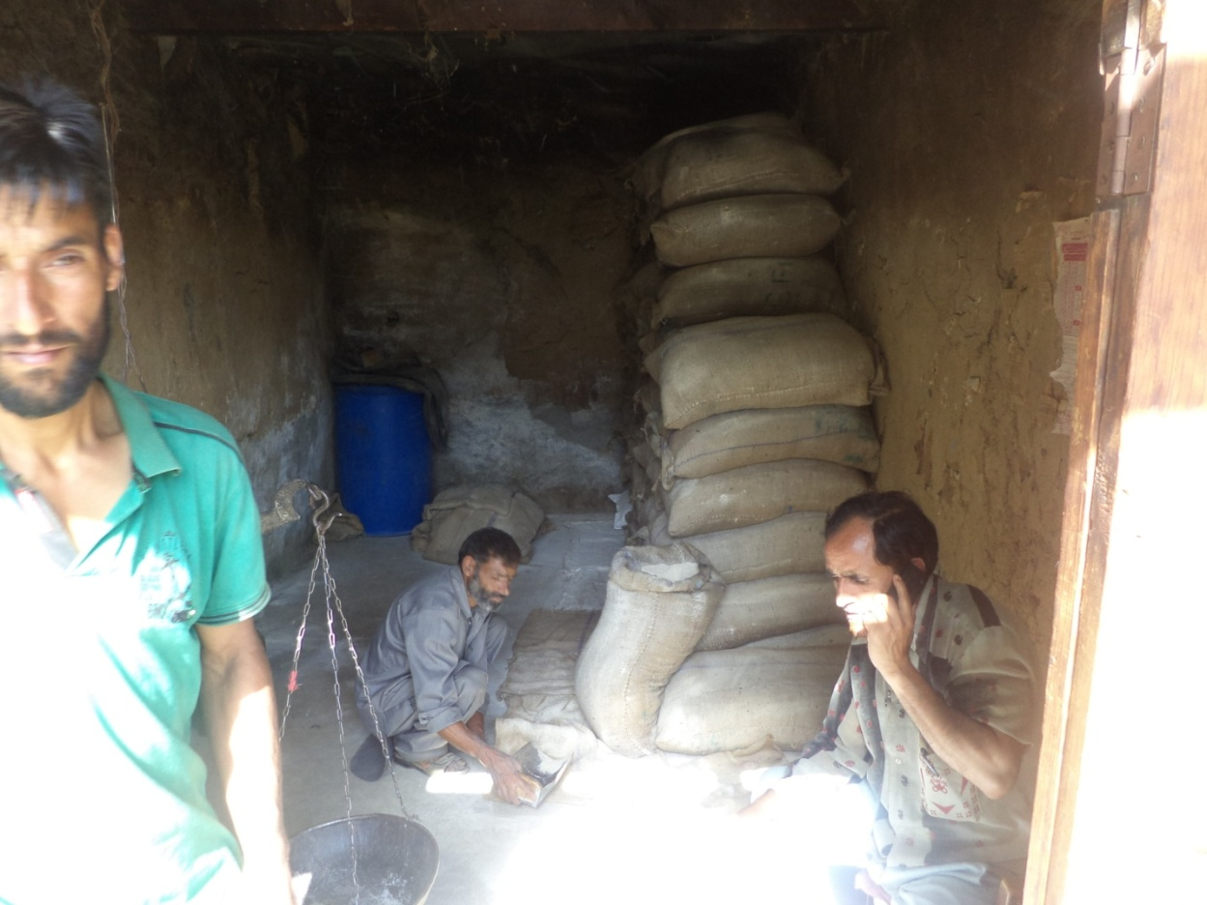
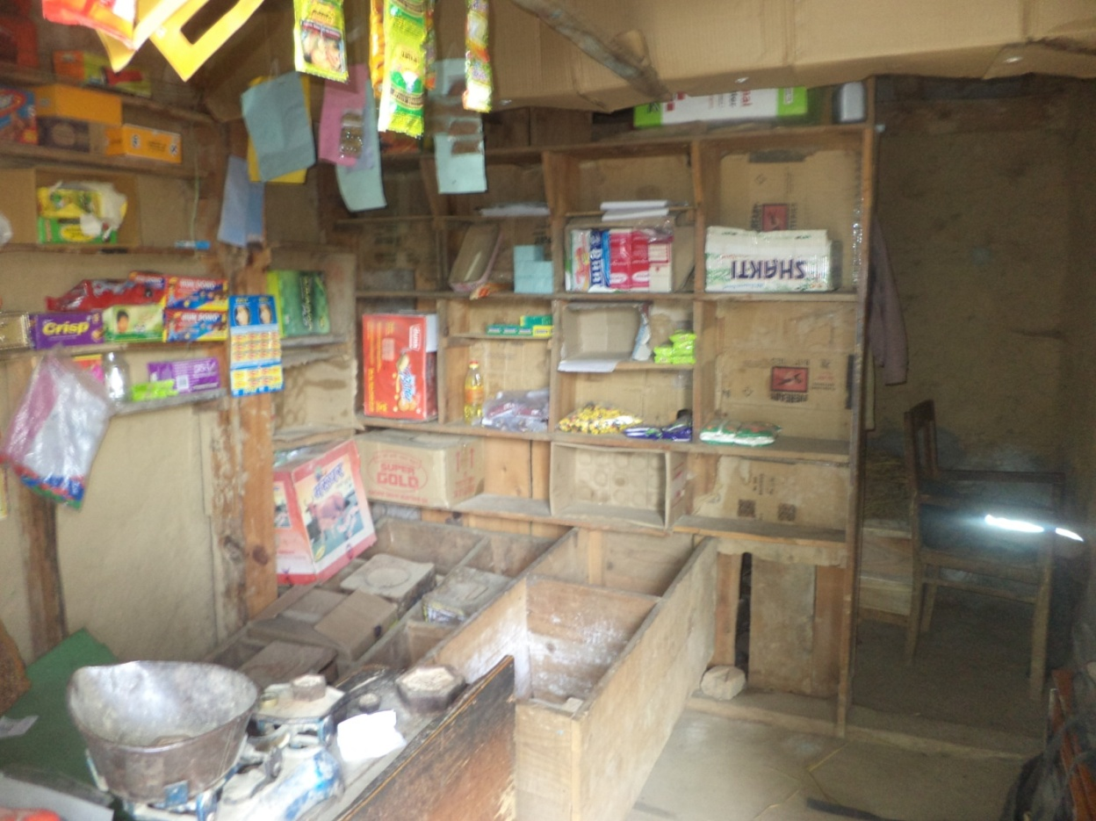
Qrocery shop in the community

These jobs have been passed from one generation to another since ages and have now become their family occupation. In the broader functional framework these occupations provide the basic sources needed for human survival in the community.
Most of the people mainly subsist on labor. Agriculture is only the secondary source of subsistence.
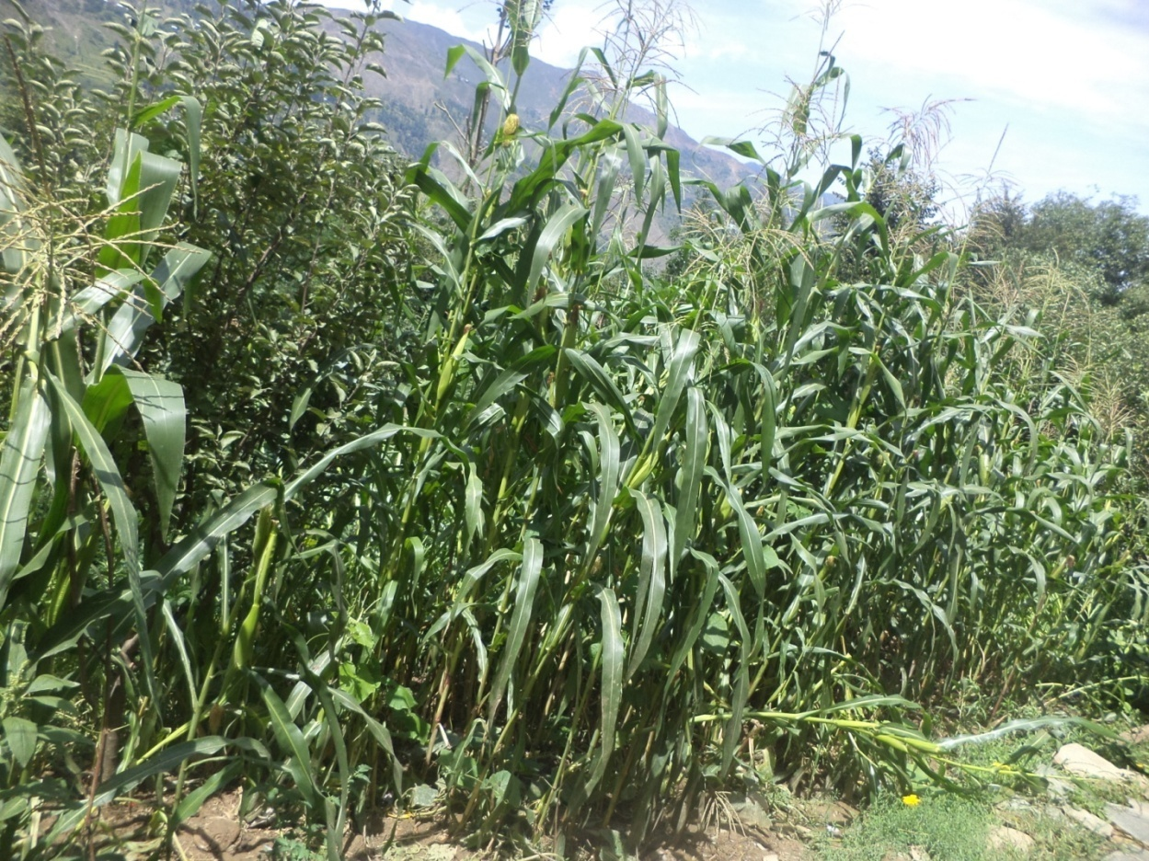
Maize fields
People maintain kitchen gardens and cultivate corn on small terraces cut into the steep mountain slope. There is a dilapidated school nearby which apparently has made no difference over the years, judging by the fact thatalmost all the men who provide for their families areundereducated (below the 8th standard on an average). Women receive no education and work at home.Government jobs are, therefore, rare.
Men-Women Engagements
People spend their spare time in farming. Men and women can work together sometimes but kitchen is managed by women only. Women fetch water for the family. Winters are harsh and women have to face a lot of difficulties in fetching and boiling water by burning wood. Family occupation does not necessarily pass on from generation to generation.
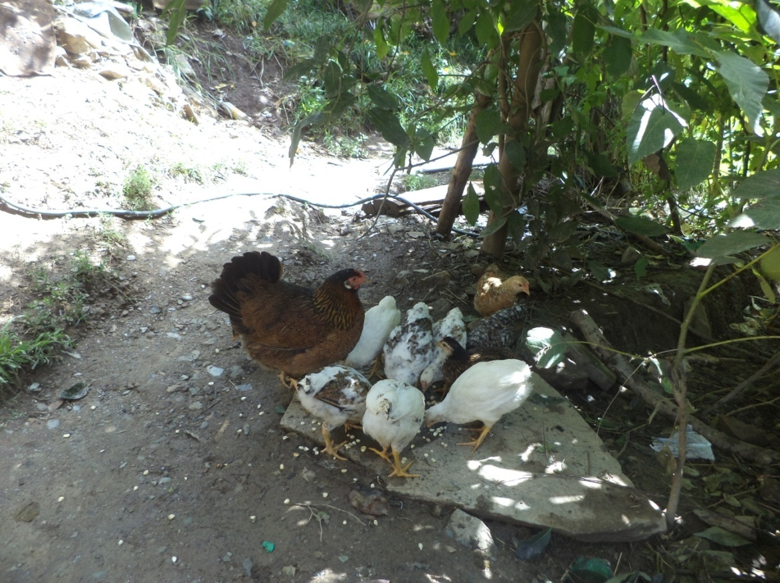
Domestic activities (hen rearinɡ)

A list of some main social activities of men and women separately upheld by all the community members is as follows:-
Female Activities | Male Activities
All domestic work | All non-domestic work
Cooking food | Shopping
Care of domestic animals | All occupational work
Handicraft work | Handicraft work(occasionally)
Visiting relatives(frequently) | Visiting relatives(occasionally)
Preparing food for family members

It may be seen that, in the content of above mentioned sex based division of labor there exists a pre-determined traditional framework in which women carry out works with in the family and perform the out family activities .The above mentioned social activities of males as well as females are ideal – typical in nature. But, in practice, certain deeper and wider changes have been experienced in the community.As a result, a serious and significant, derivation from there predetermined social activities is observed in the community.
But, as far as the family issues and decision are concerned, girls/women are not given full preference to speak and to make their own decisions. Keeping in view the guest –host relationship; the interaction of the locals within them and with the outsiders is good. The locals at their own level have intimate and friendly relations and they are very hospitable with the outsiders. Visiting neighbors is not frequent but, they have developed a string of community consciousness and the degree of solidarity. At the same time, they usually show high regards to the outsiders and treat them as honorable guests and provide them all they need.
Leisure Time Activities amongthe Natives of Chamalvas
Leisure time is the time that we use for our pleasure and relaxation after the day’s work is over. Leisure activities include all those activities that we do in our free time. These may vary from person to person, or community to community. Some communities prefer to play their traditional games in their free time. Whereas, others may enjoy playing modern day games like table tennis, cricket, volley ball, basketball, chess, carom board etc.
The people of chamalvas differ from other urbanized communities who spend their leisure time in various recreational activities like going out on holidays, picnics, etc. Men spend most of their time earning for their livelihood and women in their domestic course. It was seen that men usually spend their time by sitting in groups usually outside shops, near mosques etc. They discuss about politics, religion, occupation etc. Young men may also prefer listening to music. Women usually spend their time by visiting each other and gossiping.
In Khana community, people spend their free time mostly in playing games. Almost 70% of the free time is spent in playing games. Both outdoor and indoor games are played, but volley ball is highly preferred. However, games, in this community, are meant for only men. Men between the age group of 16 years to 40 years play games. Although, volley ball is played with a lot of enthusiasm, some traditional games are also enjoyed in this community. Cricket is also played here but it is given the second preference. There are however no special trainers. Experienced people come forward to teach the game to youngsters.
As far as women are concerned they don’t get the permission to play. It has a derogatory connotation in this community. They spend most of their free time in their homes. However, girls below 10 years of age might play indoor games like carom, or traditional outdoor games like:
- /ɖabdʒoːl/
Volleyball holds a lot of importance in this community. Mohammad Rafiq Malik, currently working as a government employee, is the volleyball expert in this area. In fact, he is the person who has initiated the trend of playing volley ball here. He is highly respected by the youth of this area. He teaches volley ball to the youngsters. Small volley ball tournaments are organised by the locals. Teams are invited to play and entry fee is collected from them. The entry fee is Rs. 600 per team. This money is utilized in the purchase of sports goods and in getting shields, cups, and trophies for these teams. The winning team gets the biggest shield. Runner-up teams are given smaller ones. Cups and trophies are given to the man of the match in every game.
The history of sports and games in Chamalvas village is perhaps as old as the Khana community itself, and the types of sports found here are in tune with geographical topography of the place.
Some traditional games played by the people in this area are:
- /telibaː/
This is a volley ball-like game played by children. This game has rules similar to that of volley ball. It is played with a handmade ball. This ball is made by stitching small pieces of cloth.
- /tshiptshẽːɖeː/
This is an indoor game played by very small kids with their parents. In this game the child hides somewhere in the house and the parents are supposed to find him.
- /kabaɖi/
This is a popular game of Indian origin. This game is played mostly by children however, adults enjoy playing it too. This game has two teams each consisting of seven players. One player from a team keeps on chanting ‘kabaddi….kabadd….”. He enters the opposition’s half and tries to touch at least one player of the opposition and tries to go back to his own half, safely. The members of the opposite team try to stop that player by trying to grab him and keep him under their control till he loses his breath. If a player returns to his half safely after touching some member of the opposite team, then not only the player whom he has touched is given out, but also a member of his own team, who has been declared out previously, is given one more chance to play.
- /ɖabdʒhol/-
/ɖabdʒhol/ is played by little girls in the compounds of houses. Six stones are kept in line, one after the other. The girls are supposed to hop on these stones with one leg. Once a girl falls the next girl is supposed to take the lead and cross the level of the previously playing girl.
- /ʈĩkən/
It is a game played with small roundish pebbles or small marbles. Usually two pieces are thrown by a player and then after picking one up cleanly throws it up in such a way that he gets the time to pick the grounded pebbles one by one cleanly without touching the other. Marbles are picked one by one; and each time a piece is thrown up and then caught on the palm. At the end all the five marbles are picked together, they are then kept on the upper side of hand, thrown up and caught by the palm in one go. If the player touches (another) grounded pebble or fails to pick the grounded pebbles as per the rule, or fails to gather the pebbles thrown up in the process, he/she is declared as “out”.
- /Langoja/(hopscotch)
This game is played by younger generation especially girls. A rectangle of about 8/12 feet is drawn on flat ground which is further divided length wise into two equal parts. Each half is further divided into three equal parts. In this way rectangle consists of six equal squares. Two teams of one or more players play the game after the toss. The winner of the toss plays with a small earthen disc, or flat stone or a rubber (dia two to three inchs) called “Saz:e”. The player stands on one leg and pushes the “saz:e” generally with the toe of his grounded foot. He has to push this “saz:a” from square one to square six at the last box. The game progresses with throwing the saz:eto the next box after successful completion of each set of steps. The player is deemed to be out if he is unable to push the “saz:e” from one compartment to another in a single attempt or if his foot falls on the demarcating lines. In that case another teammate starts the game from the point where his partner is ruled “out. When all the players of a team are given out, the opposition starts its innings. The team completing the whole process in the minimum attempts is declared as winner.
- /bãnɖən həsa ɡɪ̃nd tʃʰɪ məkan bənaja/
This sport is very popular among small children upto the aɡe ɡroup of ten, especially small girls. They usually get some colored waste-cloth pieces and sew them into doll like shapes of different sizes. They also make utensils from the clay Now-a-days ready to use dolls and toy utensils are available in markets in abundance. The children play with the toy utensils, perform “doll marriage” and other social rituals with these toys and entertain themselves by copying different modes of behavior of their elders.

- /kuʃtiː/
/kuʃtiː/ is also an Indian game. It is actually a form of wrestling. It is played by males between the age group of 15-40 years. It is played in an /akha:ɖaː/ ‘ring’ which is made by the locals. Here one person is supposed to throw his opponent on the ground and not allow him to move until he gives up.
- /toːlijaː/
This game is played by young men. It is played with a small towel ball. In this game there are two teams, each consisting of seven players. A stone is placed at a distance of one foot from the player. Six plates are to be collected by the players of one team. These are to be placed on the stone kept at a 1 foot distance. The members of other team stand in the field and hold the towel ball in their hand. They are supposed to throw this towel ball on the player who is collecting the plates. Once the towel ball touches the player he is declared out. When all the team members are given out the members of other team come to play and the previous team supposed to field.
Apart from these games people also play kho kho and tug of war. Modern games like table tennis, badminton, etc, are not played. However sometimes children may play badminton in their house compound. There is no special game for marriages or child births. Games like /antaːkʃiriː/are played on these occasions. In this game one player sings a song and the other player is supposed to start a song with the last alphabet of this song. This is how, people of this community refresh themselves after a tiresome time of work and labor.
These traditional games and sports constitute an important aspect of the socio-cultural side of traditional Khah life.It was observed that these traditional games have undergone a rapid and substantial change due to the increasing exposure to the world outside through a variety of means like electronic media, cable networking, internet . These games and sports have lost ground in the society since younger people are no longer exposed to them at impressionable age, they have turned to modern games of cricket, football, athletics etc.
Food
Rice is the staple food of the people of Chamalvas. They take rice with side dishes that are prepared from vegetables, mutton and beef (beef is consumed more than mutton in this area), and chicken. Some of the combinations are:
- sion tɨ maːz
- tsaːman tɨ maːz
- krʌm
- krʌm tɨ maːz
- daːl tɨ maːz
- daːl tɨ tʰuːl
- danɖɨ tɨ əːlvɨ
- ɡuɡul tɨ maːz
- gugul tɨ kəkur
- kəkur tɨ raθvãːɡa
- baɖvãgan tɨ raθvãːgan
- raθvãːgan tɨ gaːɖ
- gaːɖ tɨ muli
- sion tɨ gaːɖ,etc.

Chutnies/ceʈniː/ are also the part of their food, chutnies like:
- aːluː ceʈniː
- ɡanɖɨ ceʈniː
- ɡaːzər ceʈniː
- oːtsʰuɖ ceʈniː
People of Chamalvas relish Nun chai and kahwa. Nun chai is prepared by boiling the Kashmiri green tea leaves in water for hours together and then adding milk and salt to it. Nun chai is served in a traditional flask made of copper called Samawar. Kashmiri bread called mandʒɨ, kulcɨ voɖ and lava:s is served with nun chai while kahvaː is served with kulcaː, muʈʰ kulcɨ. Different types of kahva are served in this area like dɔdɨ kahvɨ, milk blended with cardamon, sugar and flavoured, koŋ kahvɨ, prepared by adding saffron (zafraan) to boiling water and crushed cardamom, daːlchiːn kahvɨ, mild Kashmiri green tea blended with cinnamon, cardamom and sugar and caːj kahvɨ. People of Chamalvas use chaːj kahvɨ as medicine to cure cough and vomiting. It also helps in the digestion, relieves headache and maintain fluid levels too.
They eat vegetable and roti and drink tea (Nun caːj) in breakfast. For their lunch they eat rice with veggies and same for the dinner. The food is cooked on daan, a furnace made of mud and stones, voθ ɔkʰtsɔr, an iron furnace which is covered inside out with a thick layer of mud. Fire-wood and cow-dung cakes are used as fuel in these furnaces. The women of the village go far away in the jungle during day time to collect wood for cooking. Now-a-days, people are also using modern technologies like kerosene stove, gas stoves and electric heaters to cook food.
They use copper, steel and aluminum utensils like patilaː, manjoːlaː, diːci, təːv etc. for cooking food. Water is stored in earthen pots, as it helps to keep the water cool and not, a copper pot with a narrow neck. For serving purpose they use utensils made of copper, silver and even ceramic ware.
They eat food on floor around a big sheet of cloth called dastaːrkʰan. They wash hands on a copper basin called taʃ and water poured from a jug called nəːr. All the members of the family (men, women, and children) sit together and eat, followinɡ the sayinɡs of the reliɡion. Food is served by women and utensils are also washed by them. There is no such custom in Chamalvas which prohibit a daughter-in-law to sit or eat in front of her father-in-law, which is usually found in the adjacent areas of this place. People of Chamalvas are very liberal in this respect.
Chamalvas has a very fertile land, variety of vegetables, herbs and shrubs are grown in this region. Vegetables like:
- krʌm(krum)
- baɖvãgan (Brinjal),
- haak(ɡreen)
- gugul(Turnip),
- ɡaːzri (Radish),
- raθvãgan(tomatoes),
- paːlak(Spinach),
This area also has wheat, maize, fodder, oil seeds, pulses (largely grown on small patches of land which includes:
- raːdʒmaʃ
- mɔ̃ɡ(green pea)
- canɨ(chick pea)
- musur (lentil) etc. and are very well known for their quality.
Orchids (apple, walnut, almonds, pear, cherry, queen apple, etc.) and saffron cultivation is also done here. Numerous herbs having medicinal values are also grown in this region and ɡreatly used by the people.
Winters are very harsh in this region, cultivation is not possible. Vegetables are imported during winters and they usually relish dried vegetables like:
- ɡɔɡdʒi aːr (fresh turnips cut into slices and dried in sun during summers),
- gɔgdʒi mais ( The leaves of fresh turnip are washed and sewn into a ɡarland, which is then dried in the sun),
- hokʰ baɖvãɡan ( brinjal is cut into two vertical halves or even four and then hung on a rope and dried in sun),
- al haci ( bottle guard is cut into slices and spread on a piece of cloth or newspaper and dried in sun),
- raθvãɡan haat (tomatoes are cut into thin slices and spread on some board and then dried in the sun),
- cʰuk traθ, jungle food is dried in sun and consumed during winters.
Ethno Medicines
People of Chamalvas make use of various folk medicines to cure their diseases.
- Turmeric (haldiː) is used as anticeptic and is also used to cure various diseases and injuries. It is added to warm milk to cure cramps in stomach and is applied on wound along with oil.
- In case of snake bites or dog bites, kacʰ- a grass like herb, green in coloris used. Halijaːn, a small seed is used to cure eye disease. Both Kach and Haliyan grow in the jungle of Chamalvas.
- Other herbs like: isboɡul is used to cure constipitation,
- katiːr is used to treat stomach heat,
- ʃaŋɡər, is used to treat dry cough.
- praŋtsolan a grass like herb is crushed and mixed with oil and applied on the wounds.
- ədrak, a ginger like herb which is collected from the jungles of this place, is crused to extract its oil and this oil is applied on the tooth to get rid from the tooth ache.
- droːd, leather like thing sold by retail shopkeepers is boiled in the water and then placed on the fractured bone; it gives relief to the sufferer.
- marci phekʰ is used to cure soar throat, it is a solution made by crushing black pepper and mixing it with sugar and water.

Food Served During Special Occasions:
During wedding or other special occasions, a special, traditional meal called wazwan is served. For wazwan the commonly dish served is rista, a dish preparedwith fried meat-balls in gravy.
- meθiː, intestines and stomach of sheep cooked with fenuɡreek leaves.
- kabaːb, finely beaten meat rolled on slim iron rods and roasted on fire.
- roɡan dʒoːʃ, mutton with deep-red spicy curry.
- The menu of wazan ends with ɡəʃtaːb, big mutton balls cooked with fried curd called jakʰniː.
- pɔlaːv,is also served, it is prepared by frying boiled basmati in ghee and dried fruits like rasins (kiʃmiʃ),roasted almonds(baːdaːm),cashew nuts(kadʒuː),chopped coconut (kʰuːpʰərɨ) are added to it.
- They also serve vegitarian dishes like maʈar tɨ tsaːman, kremand number of chatnis prepared with əːlvɨ, ɡaːzɨr etc.
- The feast ends with a sweet dish like halwa, pʰirni, ɡaːzɨr halvɨ or icecream.
vastaː or waza is the head of the cooks who excel in the art of cooking wazwan and is supported 5 to 10 wazas depending upon the number of guests to be served in the occasion. They have a uniform to wear which has a white cotton pheran and shalwar. Waza cooks in large copper utensils on fire wood spread over 5-10meters commonly known as weur. The prepared dishes are served on large carved copper plates called farəʃtraːmi which is shared by four persons by sitting on a sheet of cloth called dastarkʰaːn
Food During Festivities
People of Chamalvas are the follower of number of saints. There are various shrines which are constructed in the names of these saints. People of the community celebrate and remember them on their birth/ death anniversaries. These celebrations are known as urs.During these days people relish masal lavas, ɡuir masal, kruhun masal etc.
Food Given To Pregnant Women
The food of pregnant women is highly nutritious, rich amount of proteins, vitamins, calcium and iron is given to her. She is mostly fed with milk, fruits, meat (usually beef) and ghor. ɡoːr, is homemade ghee. Milk is churned in an earthen pot to make butter and this butter is then churned to make ghee. It takes less than a day to prepare ɡoːr.
The expecting mother is not allowed to consume pineapple, papaya, peach, sprouted potatoes, sesame seeds and brinjal. Pomegranate is avoided during the first trimester of the pregnancy, as all these foods are believed to be hazardous to both mother and the fetus and can even lead to miscarriage.

Food given to lactating mother
The diet of the lactating mother is same as pregnant women, that is her food is highly nutritious but she has to avoid eatables which are sarɨd because they may affect the baby’s health.
Food Given To New Born Child
The new born baby feeds on mother’s milk for minimum time span of six months to a year time and in addition to that he is also given formula milk which is easily available in the market of Chamalvas. When the child is eight months old he is given banana, egg, soup and kahwa. And when the child reaches the age of year, year and half the he is fed rice and other things as well. The amount of food is increased as per the requirement of the child.
Food Served During Condolence
When anybody dies in this area the family of the dead does not cook for four days, they are having committees known as mojat kameeti. Food arrangements are made the members of the community. Dal and simple vegetables are cooked; they donot serve meat or any other non-vegetarian food to the bevered family. Fruit and milk is also given to the family members. Nun chai and Kashmiri bread mandʒi is served throughout the day to the guests who come for condolence. On the fourth day of condolence suji halvɨ is cooked and distributed among the people.
Food Served To Guests
When a guest visits the people of Chamalvas they serve them tea with variety on confectioneries. Two to three dishes are served to the guest. They cook meat, chicken, cheese, fish and vegetables for guests. Guests are served in copper, silver and fine crockery.Sweet dishes like halvaː, firniːm are also served to the guests.
Drinks
There is no special drink associated with Chamalvas but people relish lassi, a yougurt based drink, sharbat, babribioːl treːʃ, basil seeds are soaked in water over night and milk, sugar, coconut, rasin and cashew nuts areadded to it, babribioːl ləs. Alcohol is prohibited in this area.
Physical Features and Dress
The people of the Khana community are easily distinguishable from the rest of the Kashmiri urban population, but resemble with the rural Kashmiri people in terms of their dressing sense, food habits, etc.
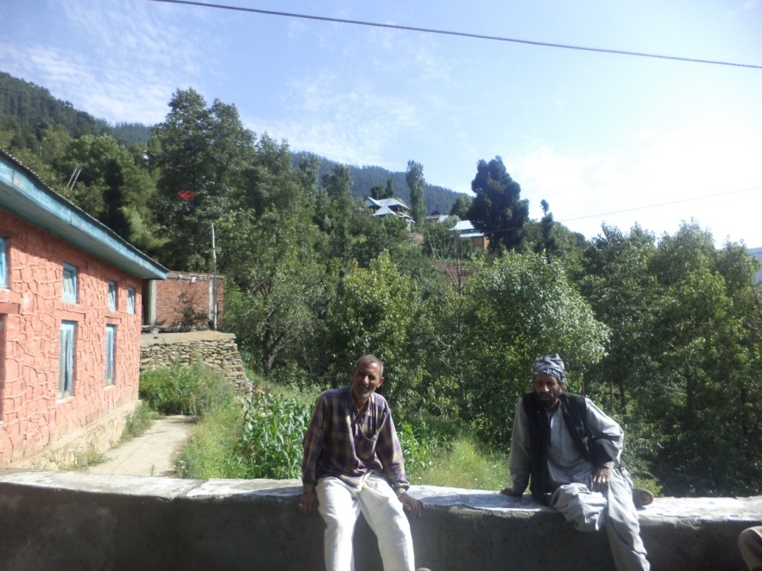
Male members of the community
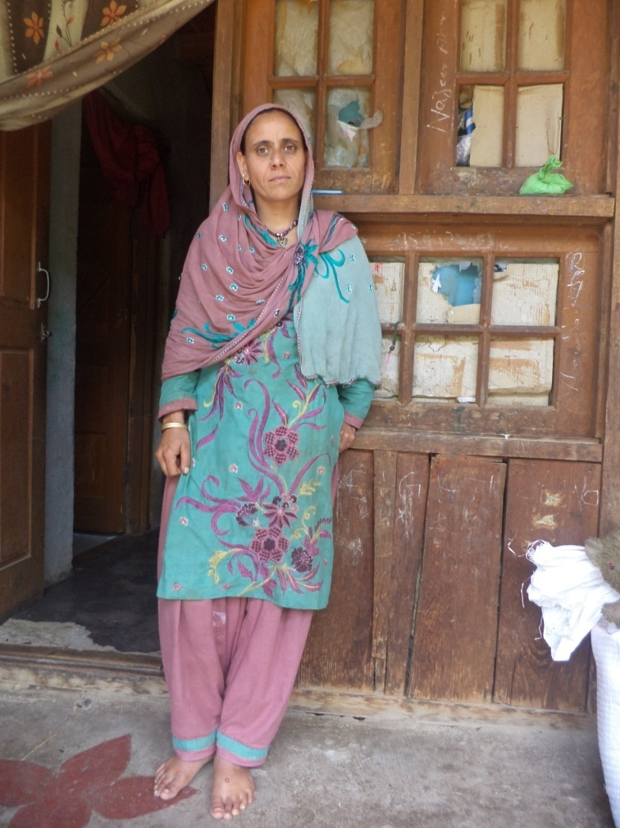
A native khana woman
They have a slightly darker complexion than Kashmiri’s and they also differ in their style of living, dressing patterns, and other facial features, etc. The slightly darker complexion may be due to the higher intensity of sunlight on the mountain slopes. Men usually wear Khan dresses and sadir (waist coat) with turban and most of them have long beard (Muslims). with the changing time and impact of modernization the younger generation has adopted the modern dressing pattern, i.e. pant-shirt, etc.(only males).Females still follow the same old dressing pattern of salwaar suit with their heads usually covered and nose pierced, usually in elder women.
Dress
Dress is one of the basic needs of humans, besides bread and home. Dress, keeping in view the basic need, should have been a common pattern universally but the fact is something else and the fact stands with a lot of empirical evidence that there prevails no uniform pattern of dresses in the community under study. Actually, different factors have given rise to different patterns of dress in the community.
These factors of primary importance include sex, age, occupation/profession, economic position, social status/stratification, modernization and weather conditions.
The dress pattern of the people on Neel chamalva has a close resemblance with the dress pattern of the people of the Kashmir valley. The dressing of the people of this is area is simple. Pheran is a prominent dress of the community. Men and women usually dress themselves in pherans but the pherans of men and women vary in design. The pherans worn by men are loosely fitted robes with full sleeves and open slits whileas the pherans worn by the women are embroidered and have half cut sleeves at elbows that are folded backwards. Women usually cover their heads.
Children of the community dress like the children do in the far flung area of Kashmir valley. Even a girl child has her head covered.
The details about the common dress among the males, females and children in Neel Chamalvas are as under:-

Dress Patterns of Male and Female Children
Male children |  | Female children
Summer | Winter | Summer | Winter
/pent-buʃaet/  (Pant shirt) | /pent-buʃaet/ (woolen) | /ʈem fira:kʰ / (firaakh shalwar) | /fira:kʰ suθan/ (kameez shalwaar)
/ʈiːʃerʈ/  (T-shirt) | /dʒiːnәz penʈ/ (jeans trousers) | /dʒel/  (long scarf) | /ɖupʈI/  (long scarf)
/dʒiːnәz penʈ/ (jeans trousers) | /binjaːn/  (woolen sweater) |  | /sika:rof/  (scarf)
/ʈem kameez/  (Khan dress) | /taepɪ/  (cap) |  | /koaɖta/  (phiran)
 | /dʒa:kat^{h/}  (jacket) | /mozI/ | /binja:n/  (warm sweater)
/mOzI/  (socks) | /mOzI/ (woolen (socks) |  | /mOzI /  (woolen (socks)
/capnI/(slippers)  /bu:ʈ/ (shoes) | /bu:ʈ/  (warm shoes) | /chapnI/(slippers)  /bu:ʈ/ (shoes) | /bu:ʈ/  ( warm shoes)

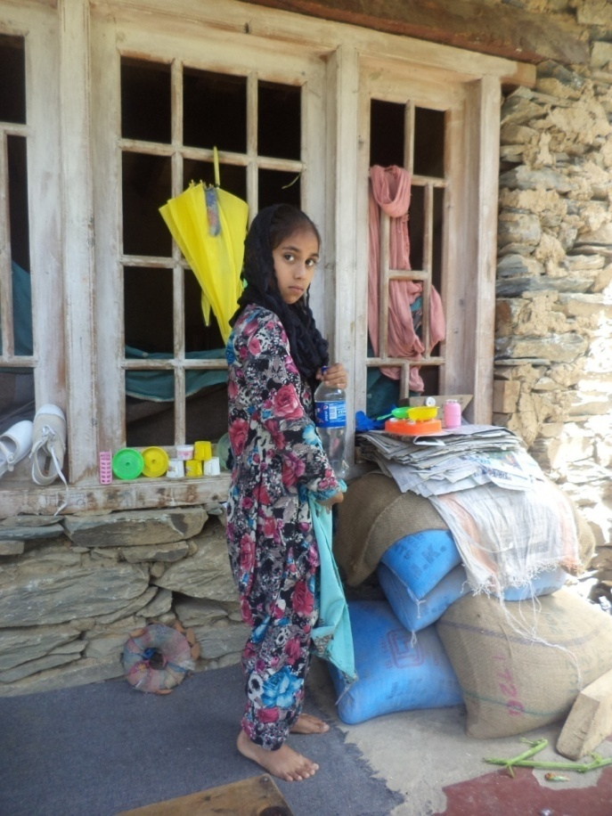
A girl child of the community

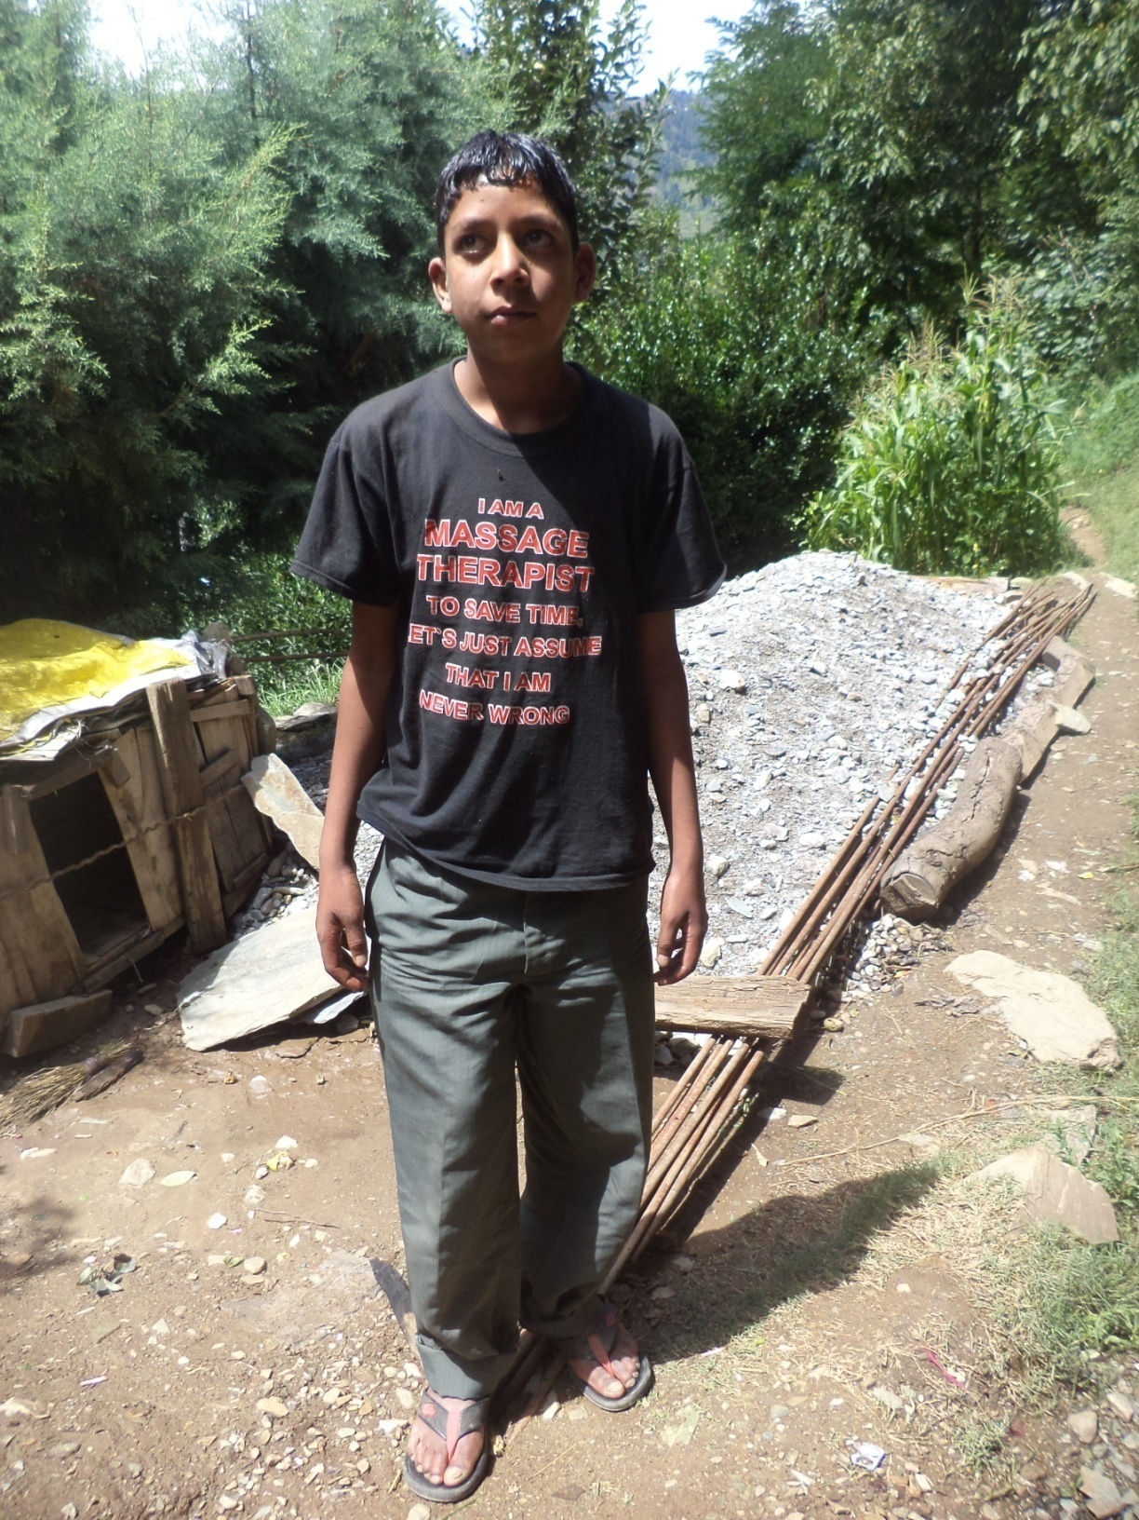
A young boy of Neel Chamalvas

Dress Patterns of Male and Female Adults
Male adults |  | Female adults
Summer | Winter | Summer | Winter
/ʈem kamiːz/ shalwar kameez  (Khan dress) | /ʈem kamiːz/ shalwar kameez  (warm) | /ʈem fira:kʰ / firaakh shalwaar | /munul ʈem fira:kʰ/ munul firaakh shalwar (warm)
/tepI/ (cap) /dastaar/ (turban) | /banjaːn/  ( woolen sweater) | /dʒel/  (long scarf) | /dʒel/  shawl  (warm long scarf)
/pent-buʃaet/  (pant-shirt) | /munul tepI/  (warm cap) |  | /banjaːn/  ( woolen sweater)
 | /munul/  Phiran  (muslims only) |  | /munul/  Phiran  (muslims only)
mOzI  socks | mOzI (warm)  socks | mOzI  socks | mOzI (warm)  socks
/chapnI/ (slippers)  /bu:ʈ/ (shoes) | /bu:ʈ/  (warm shoes) | / chapnI/ (slippers)  /bu:ʈ/ (shoes) | /bu:ʈ/  ( warm shoes)

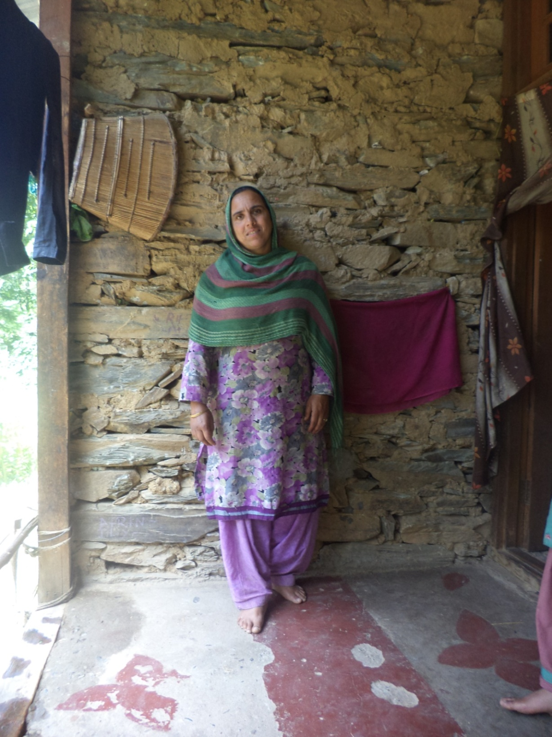
A woman of the community
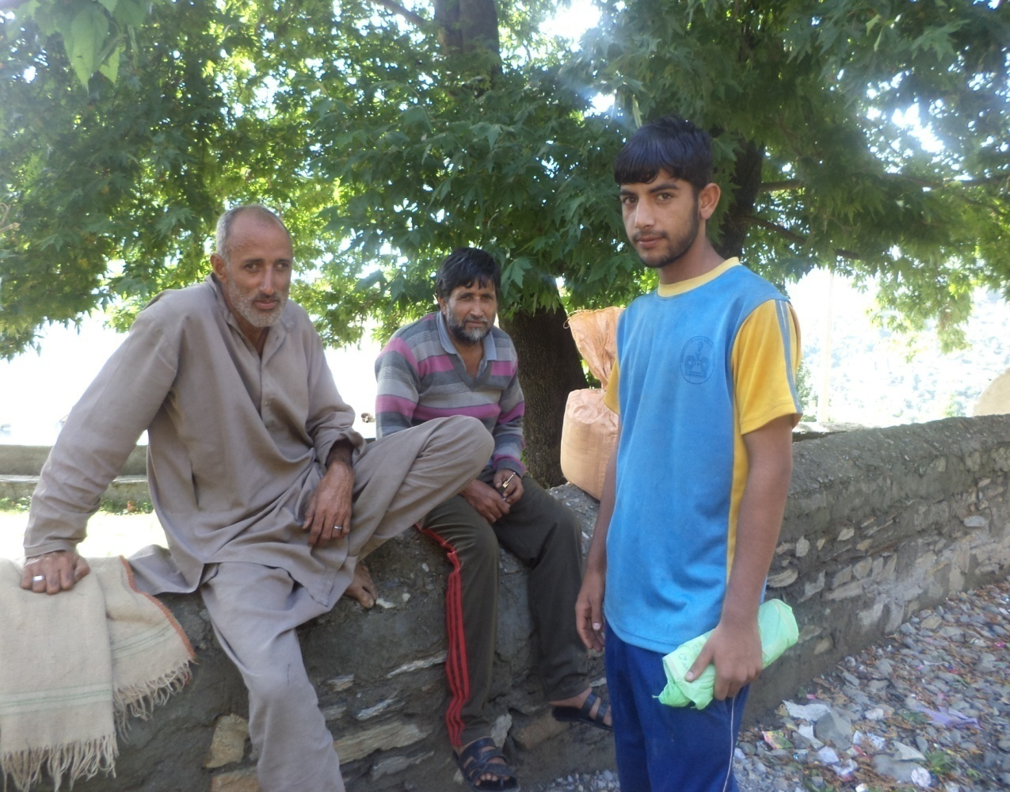
Male members of the community
Ornaments
Ornaments in Neel Chamalvas are ɡenerally made of ɡold and silver. The design on the ornaments it’s distinct and easily distinguishable from other parts of world. /dʒiɡni/ and /ʈikka/ are worn on forehead and generally are triangular, semi-circular and circular in shape. These are made of ɡold and silver and are fringed with hanging pearls and ɡold leaves. The jewellery of this area is unique in design and is minutely worked. /sõear/ is the local goldsmiths of Neel Chamalvas. The various types of jewellery such as earrings, necklaces, bracelets, amulets (/taːviz/), rinɡs, and rosary (/tasbiː/) are all delicately made by them.

The ornaments worn by the women of Neel Chamalvas are:
- Ornaments worn on the Head: /dʒiɡni/ and /ʈikka/, worn on the forehead are generally of triangular, semi-circular and circular shape. These are made of ɡold and silver and have hanɡinɡ pearls and ɡold leaves
- Ornaments worn on Ear: /balɪ/, /duːr-hor/, /alcahor/, /kenduːr/ and /dʒumkɪ/ are the ornaments worn on ear. /balɪ/ is studded with turquoise with a frinɡe of hanɡinɡ ɡold leaves and balls and /dʒumkɪ/ is a bell shaped earinɡ. /kenduːr/ is especially worn by younɡ ɡirls. These are made of ɡold and silver and are studdes with red and ɡreen stones or pearls.
- Ornaments worn in noseː /nahtuːel/ (nosepin)is the ornament of the nose worn by the women of this area.
- Ornaments worn on Neck: /halqa-band/, /kantʰi/ and /maːl/ are the ornaments worn on neck. /halqa-band/ is sometimes studded with pieces of mirror. The necklaces are ɡenerally trianɡular in shape and are made of silver and ɡold.
- Ornaments worn on Wrists: These are /benger/, /gunus/ and /ɖul/. They are made of solid ɡold and silver. Bangle /benger/ is often studded with coloured stones while /gunus/ and /ɖul/ are not. /benger/ is made of solid ɡold while /gunus/ and /ɖul/ are hollow.
Family Setup
In the study of social interactions one of the most important aspects is family type. Family type controls various types of social interactions of an individual e.g. it is observed that the out of community marriages are mostly done by nuclear families as compared to joint families. The children brought up in joint families speak Khana more fluently as compared to children brought up in nuclear families.It is found that the main structure of family in the community is of two types.
A joint family system is preferred over nuclear family. Elders of the family are respected. Males and females are given equal rights. Mothers raise children as the males of the family are usually engrossed in earning bread and butter for the family.
Majority of the households have nuclear family structure where in two generations of parents and their un-married children live together. The increasing number of nuclear structure of families is one of the major causes of their children not learning ‘Khana’ language .On the other hand, minority of households have joint family structure wherein three or more than three generations (i.e. .was observed that the number of ‘Khana’ speaking children is greater in joint families as compared to nuclear families.

Judiciary
Conflict is the part of life. In human society’s crimes, conflicts, issues, problems are very common and hence arises the need of some power who resolves these conflicts.
The crime rate in Khana community is very low. On the scale of 100, it is only 5-8%. Major crimes found in Chamalvas area are the theft of cattle and forest wood. The conflict among the people is on drinking Alcohol and illegal encroachments in the private property. Land disputes are more common in this region.
According to the Informants of Khana, the law and order in the village are governed by a mediation which is called ‘panchayat’. The members of the panchayat are elected by the people of the community. There are 5 main members in the Panchayat. The head of the panchayat is known as ‘sarpanch’ and other members are called ‘panchs’. There is a specific building for panchayat in the Chamalvas village called ‘Panchayat Gah’, here all the governing bodies of panchayat sit together for solving dispute in the village. This panchayat gah can accommodate almost 200 people in it. The caretaker of panchayat gah is sarpanch’s sectary, who holds the key and other authority of panchayat gah. In panchayat system the hearing is oral, there is no writing system i.e no files are maintained as is done in the courts. Cases are heard orally and sarpanch gives his decisions and orders orally. The medium of communication during the trail is Khana.
There are no fixed rules and laws. The matters are resolved on spot by the sarpanch according to the situations and the decision of the panchayat are respected and accepted by the people. Beside, disputes, conflicts and issue, all other local village decisions are taken panchayat like road, drainage, water issue. The sarpanch is considered to be a great personality, whenever any ceremony of importance is held in the village like religious ritual or harvesting of new crop, Sarpanch is given a great importance even the foundation stone of important building, roads or wells are laid by him. Although all the problems and disputes in the village are solved by the panchayat but there may be some cases where panchayat might fail and such cases are forwarded to the higher authorities like police and courts. The local disputes are solved by panchayat while as the law and order situations of the whole district of Ramban are controlled by police and other defense agencies of the India as shown in picture.
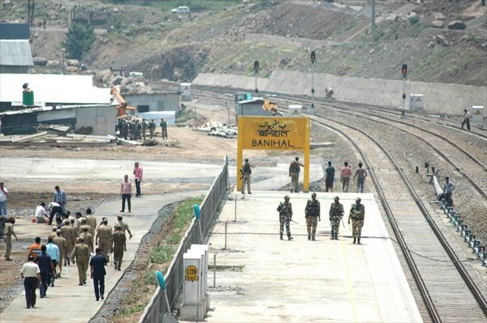
There are some people in the community who give preference to law over panchayat system. But major issues are resolved in Panchayat itself as the solution is quick and economical as well.
Religion and Festivity
Community of Khana has had a tradition of festivals from the time immemorial. From national festivals to social, people come closer, forget their differences and enjoy. Festivals are always helpful in breaking the regular schedule of day-to-day life and inspire us to promote love and brotherhood. Khana community comprises mostly of Muslim and has specific festivals to celebrate. Festival celebrated here are:
- Navroz: This festival is celebrated by the Shia sect of this community. Navroz is the first day of the spring. This festival dates back for more than 3000 years old and there are records of it being celebrated way back in 6th century BC. Those days the Iranians were homogeneously Zoroastrians and hence it was celebrated as the Persian New Year. In Khana community it is celebrated on the first day of the spring i.e. 21st March of every year. Special dishes are prepared on this day which includes: /ɡaːɖɨ tɨ nadər/ fishes and lotus stem, /paːlak tɨmaːz, kɔkur/spinach and chicken /mutton/beef, /ɡuɡul tɨ tɨ maːz/ dried turnip with mutton/chicken/beef, kabbabs, rista, roganjosh, etc. People visit their relatives and wish them navroz, kids are give money as gift on this day, in other words it’s known as Shai Eid in Khana.

- Eid-ul-Fitr: In Khana community the festival Eid-ul Fitr is celebrated with religious fervor and gaiety. This festival marks the end of Muslim holy month of Fasting (Ramadan). During Ramadan, people observe fast. They wake up before the dawn and eat a pre-fast meal called /sahar/ Sahar. There is a person in the community called /saharas tol nɨ voːl/ who roams in the locality banging his/ɖoːl/ drum to awaken the people for Sahar. The food is to be eaten before dawn, once the sun starts rising people stop eating and offer the first prayer of the day. Fast is observed during the day time till the dusk. They open their fast at the time of dawn which is known as /iftiaːr/ iftar with /khozur/ dates and relish /babri bioːl/, a drink in which basil seeds are soaked in water over night and milk and sugar is added to it. After breaking the fast people go for their Magrib prayers, the fourth of the daily five prayers. People seek forgiveness and guidance from almighty God during Ramadan. In addition to five times nimaz they also reciet /nimazi taraːvi/ at night. Not all the members of the community offer this nimaz as to popular belief, they are not compulsory. People recite it to follow the sunnat al-Mu’akkadah, a salaat that was performed by Prophet Muhammad (PBUH).
All this teaches an individual virtue of humanity and patience. While a person is fasting during Ramadan he has to strive to maintain pure thoughts and avoid obscene scenes and discussion. One has to maintain the purity of tongue, heart, brain, i.e. all the body parts including the soul.
All the days of this month have equal importance but some are celebrated with more zest and zeal. One such day is Laylat al-Qadar. It is also known as the Night of Power or Night of decree. This night is considered as the holiest night of the year. The first revelation of Quran was sent down to Prophet Mohammad (PBUH). It is considered that this night is better than thousands of month. It is believed that this night occurred on an odd-numbered nights during the last ten days of Ramadan, i.e., 21st, 23rd, 25th, 27th or 29th. Khana Community celebrates it on the 23rd night of the month.
A day before Eid, authorities announce the festival after crescent of another Islamic month called Shawal is seen. On the day of Eid-ul-fitr people/muslims wear new clothes and offer Eid nimaz. All the members of the community including young children and women gather together in prayer ground /eg: iːd ɡah camalvaːs/ and their nearby mosques to offer this nimaz then they greet their friends and families. Pocket money and gifts are given to children and special food and delicacies are prepared for the day. Wealthy people of the community distributed money /zakaːt/among poor and needy on Eid. Years back there was a tradition in which women of the community would gather in any open compound to sing and dance. A specific dance was performed known as rouf on Eid and songs associated to Eid were sung. One of the famous songs is /iːd aːji rasɨ rasɨ iːd ɡah vas vəj/. Even today some of these songs are broadcasted on air and shown onTV’s all round Kashmir.
- Eid-ul-Adha: It is also known as Bakra Eid. Khana community celebrates this festival with passion and enthusiasm. They sacrifice sheep, goats, cows or bulls and share the meat with relatives, neighbours, friend, family and poor. This Eid occur after two months later during the month of Zil-Hajj. Eid-ul-Azha is a festival celebrated to commemorate the willingness of Ibrahim (AS) to follow Allah’s command to sacrifice his son Ismail (AS). This festival is incorporated in the great pilgrimage to Mecca which should properly be made during this month but it is also observed by the Muslims all over the world at the same time. In this area sacrifice is usually performed by the people who are economically well. The underlying importance of this festival is the spirit of sacrifice /kurbaːni/ in the memory of Ibrahim (AS’s) great act of faith many centuries ago. On the day of Eid all community members wear new clothes and gather together in the prayer ground /mosques, wish each other and offer their Eid nimaz. After nimaz /kurbani/ is performed. Eidi and gifts are given to children and poor. Special dishes are prepared and all the things are done the same way as done on the festival of Eid-ul-Fitr. The only difference between the two Eid’s is the act of sacrifice.

- Eid-i-Milad: This festival is celebrated by the Muslim community all over the world. This day is celebrated in Khana community on the 12 Rabee-ulawal. This is the day when Prophet Mohammad (PBUH) was born. The whole Khana community gathers, in order to send salutation to the Prophet (PBUH), give charity to the poor /sadkah/ and remember the birth and virtues of Prophet (PBUH). People recite holy Quran for the whole night and pray for the wellbeing of their nation, families and friends.
People and Religion
The religion of the community is Islam.TheKhana community is mostly inhabited by the Sunni Muslims with moderate beliefs. They follow certain beliefs and practices like the belief in the AlmightyAllah,finality of the Prophet Muhammad(pbuh), sacrednessof Holy Quran,praying five times a day and performing Hajj ifpossible.The basic religious practice of fasting among Muslims is normally followed by majority of the Khana Muslims very seriously. In this practice people keep fast from dawn to dusk (rozdaeri). Almost all the community members the males, females and children do fast strictly during the month of Ramazan. Such beliefs and practices shape the social patterns of the life of community people.
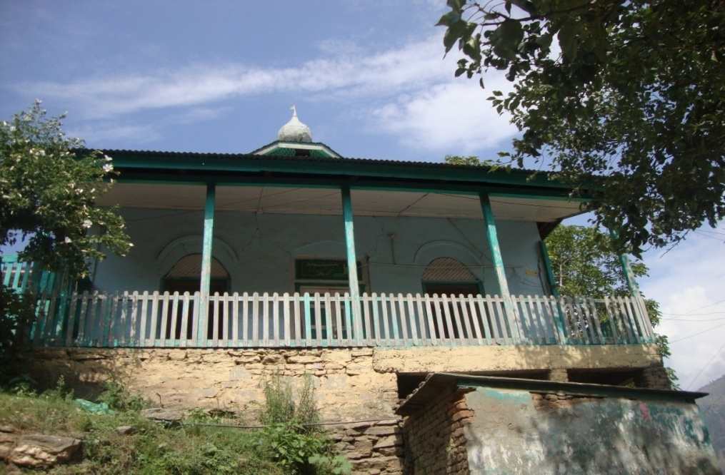
Community masjid
The younger generation is taught to carry forward these beliefs, customs and traditions. They are always guided by their elders to remain oriented towards right path.The whole life in the community is dominated by the religion. In fact the life-pattern can be characterized as the "religious way of life".Every walk of life and every matter was viewed in terms of religion,itspermission,restrictions and objections for both the sects in their own ways. In actuality Islam stands as the most-referred point (for Muslims)in the community. Thus all the community members practice the ideas and ideals of religion and avoid everything which religion has prohibited and considered undesirable and they want their children to follow them. Khana peopleoften visit shrines to get their needs and aspirations fulfilled. For this purpose they perform the rituals like cloth fixing (dash) on the windows and doors of the shrine(s). Such rituals are performed when the need of the person is fulfilled.
Beliefs and Superstitions
The beliefs related to superstitions also exist in the community.
If a person while leaving from home is called back is considered inauspicious
- If a person goes out in dark to the jungle or some isolated place,he/she may be possessed by evil spirits(jins,fairies)
- It is also believed that adults should not sit under a walnut or deodar tree with children, as these trees are possessed with evil spirits. It is believed that their superstitions are in fact scientific in nature. It is said that both walnut trees as well as deodars release carbon dioxide instead of oxygen and hence growing children are especially dissuaded from playing under these trees. Children are also told that it is not safe to go near springs and other water sources. Some people claimed that the superstition comes from the fact that snakes are often found near springs in hot weather as they are cold blooded creatures and need to cool down near springs and other water bodies.
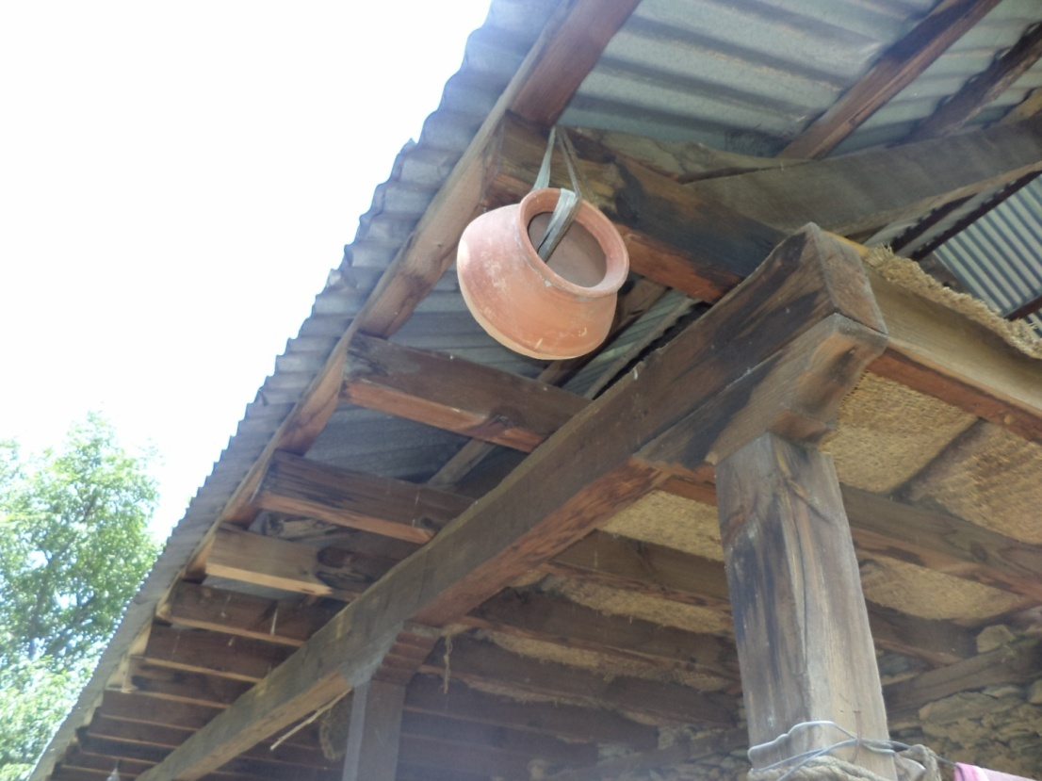
Broken old pot hanɡed on roof top to prevent evil eye
The presence of superstition is revealed by the fact that they hang some ugly thing(such as an old mangy shoe, a broken pot etc.) at one of the outside front corners under the eaves of their houses to safeguard their homes from the evil eye.
Languageattitude ,use and prestiɡe
Khana is the language spoken in Neel-Chamalvas area of district Ramban of Jammu and Kashmir. It is locally known as Kha. It is spoken by almost 400-500 residents, and is the main medium of communication in this area. Neighbouring languages include Kashmiri, Poguli and Dogri. Khana is the main language used by the people in their homes, fields and other informal situations. Children also speak Khana in informal situations. Apart from Khana, Kashmiri and Urdu are spoken in the region, but the Urdu spoken here appears to be a mixture of Urdu and Pahari (Pahari-Urdu). Hindi is also spoken to some extent.
Khana has no official status. In Jammu and Kashmir, Khana is recognized as a minority language and the outsiders have no idea about its existence, they perceive Khana people as the Pahari speaking people.Khana has no script of its own and has no written texts. It is an unclassified language.
Khana belongs to the Dardic language family. Its closest major relatives are Poguli and Kashmiri and these languages are spoken in the same belt of Ramban area surrounded by Sargili Mountains. Khana shares quiet a number of words with Kashmiri and Poguli. The cultural characteristics along with the language intelligibility strengthen the view that all Kha speakers belong to a common ethnic group. Khana is the identity of the Khana people which separates them from other people and makes them ethnically different as language reflects the thoughts, ethnic background and other cultural features of a society.
Language Use:
Apart from their indigenous language Khana is also known as Kha. The Khana people are also proficient in other languages as well and hence show multi-lingualism. They are proficient in Kashmiri and Pahari-Urdu. This multi-lingual nature is due to language contact. Kashmiri (dominant language) is acquired from the Kashmiri speaking people, who live in the immediate neighbourhood. And Urdu is learned either from schools,mass media or from thePahari speaking people. Khana people are surrounded by various other communities who speak different languages like Kashmiri,Poguli and Pahari –Urdu, etc. In order to communicate with different people they use many languages like Kashmiri with Kashmiri people and Pahari-Urdu with Poguli and Dogri people. They also code- switch and code-mix while conversing. They have passed on their language to the younger generation and even their children are quiet proficient in Khana and interestingly they have a good attitude towards their mother tongue.
Language/Name | L | S | R | W
Khana | Yes | Yes | No | No
Kashmiri | Yes | Yes | No | No
Pahari-Urdu | Yes | Yes | No | No
English | Yes | No | Yes | Yes
Fig: language use

In the table given above ‘L’ stands for Learning, ’S’ stands for Speaking, ‘R’ stands for Reading and ‘W’ stands for writing.
As shown in the table above Urdu is the language used for two activities i.e. for learning and speaking although it is used by the younger generation of the community for all the four activities (learning, speaking, reading and writing).This is mainly because it is a part of their educational curriculum. Khana being the mother tongue is used in two activities (learning and speaking) as such there is no written script of Khana,so its speakers can neither write nor read the language. Kashmiri is the language usually used for communicating with strangers. The Khana community can speak and learn this language but cannot read or write it. The older generation does not know English at all but the younger generation shows affinity towards it as English is taught in schools, even though it is not the medium of instruction. However, proficiency in English is limited as they can read and write in English but cannot comprehend and speak it. It was also observed that due to impact of education the younger generation borrows and makes use of some English words and phrases in their language.
Patterns of Language Use
The patterns of language use in different domains with different interlocutors gives an overall idea about the status and pattern of the language use and choice in the different domains of behaviour, and the situation of communication where a particular language dominates the other. Taking into consideration the gender of the interlocutor ,i.e. if the interlocutor is a male or female, domain of discourse place whether home, office or social gathering, and topic whether formal or informal. It also includes the speaker's pattern of language used in his or her very personal domain including the language used with God, language used for asking for something(from God, people), dreaming, thinking, language used with best friends, Languages spoken with strangers and for naming days of the week. It also includes the language in which they remember most of their songs and stories and the language which they prefer in the place of worship, Medium of instruction at schools, languages spoken at markets and shops, etc.

- Language used in home
This domain refers to the language used within the family.
 | Mother  Tongue | Dominant  language | Other  Language
a. Withparents? | Khana | Khana | Kashmiri
b. Withgrandparents? | Khana | Khana
c. Withspouse? | Khana | Khana
d. Withchildren? | Khana | Kashmiri | Urdu
e. Withgrandchildren? | Khana | Khana
f. Withsiblings? | Khana | Kashmiri
g. Withancestorswhohave passedaway? | Khana
h. Withpetsandlivestock’s? | Khana
Fig: Language used in home
At home, people use their mother tongue i.e. Khana to communicate with the family members and for other activities like petting or calling animals and saying prayers for the ancestors who have passed away. Sometimes the family members may switch to Kashmiri or Urdu in the presence of strangers in the family.

- Language used in the neighbourhood
There are many other linguistic groups living in the vicinity of Khana people in the same mountainous belt. They are Poguli, Kashmiri, Siraji and Pahari speaking people. Within the broad framework of settlements based on language and religion people belonging to same caste, religion and place of origin tend to cluster together. This fact is reflected by the settlement pattern of Khana community who migrated a long time back from various places to the undulating mountainous region of Kashmir valley. The language used with outsiders i.e. Kashmiri speaking people is Kashmiri and Urdu with a lot of code switching and code mixing with Kashmiri and sometimes Urdu as well. With immediate neighbours i.e. within the colony, the language used is Khana.

- Language used in schools
 | Mother  Tongue | Dominant  language | Other  Language
a.Withtheteacherintheclassroom? |  | Urdu | Kashmiri
b. Withtheteacheroutsidetheclassroom? | Khana | Urdu | Kashmiri
c. Withfriendsintheclassroom? |  | Urdu | Kashmiri
d. Withfriendsoutsidetheclassroom? | Khana | Urdu | Kashmiri
Fig: Language used in schools

In the state of Jammu and Kashmir, from an educational perspective, Urdu is being taught from nursery level to 10th class. Kashmiri has not been a language of the curriculum upto 2002 and is acquired by interaction with the surrounding Kashmiri community. Khana community in Kashmir functions in three languages i.e. Khana, Kashmiri and Pahari-Urdu, but all the three languages are distributed along different domains. Children belonging to Khana community are enrolled in Government schools. The medium of instruction in these schools is Urdu. The language used in schools is Urdu both with the teachers and with other classmates but they also use Khana and Kashmiri for communicating with their fellows. Urdu and sometimes Kashmiri is the dominating language inside the classrooms whereas outside the classroom Khana is used with teachers and friends. Thus, Urdu is a formal and Khana is an informal language. Young males claim greater proficiency in Urdu than old males whereas they claim low proficiency in Khana language as compared to old males.
- Language used in markets
This domain involves the use of language in markets, with shopkeepers while buying and selling goods etc. If people are purchasing something from a shop in the vicinity they will use Khana but outside their vicinity the language used for communicating with the shopkeepers and people in the market is Kashmiri. Urdu is also used occasionally.

 | Mother  Tongue | Dominant  language | Other  Language
a. Withthemerchantofthesametribe/community? | Khana
b. Withthemerchantoftheothertribe/community? |  | Kashmiri | Urdu
c. Withan acquaintance? | Khana | Kashmiri
Fig:Language used in markets

- Language used for worship
This domain involves the use of language while praying, during religious sermons and discussions, etc.
 | Mother  Tongue | Dominant  language | Other  Language
a. PrayingtoGod? | Khana |  | Arabic
b. Recitingorperformingrituals? | Khana |  | Arabic
c. Singingreligioussongs? | Khana | Pahari-Urdu | Kashmiri
d. Whenget possessed? | Khana |  | Pahari-Urdu
e. Talkingwithotherworshippers? | Khana | Kashmiri | Pahari-Urdu
f. Forreligiousdiscussionsat theplaceof worship? | Khana | Kashmiri
Fig: Language used for worship
At places of worship different languages are spoken. For example while praying to God or when someone is possessed, Khana is used. For performing rituals or religious discussions both Khana and Kashmiri is used. Arabic is only used while reciting the prayers and for formal Friday sermons.
- Language used in health centers
There is one small health centres located in the vicinity. For major health issues Khana people have to visit district Ramban which is a multilingual hub. The use of language in hospitals or health centres depends on the language used by doctor who usually uses Urdu or Kashmiri with code-switching or mixing. Khana speakers usually express their problems in Kashmiri and sometimes in Urdu as well while the response from the doctor is usually in Urdu and Kashmiri which is intelligible to them. But the elder generation especially females face a problem as they are only proficient in Khana.Khana as such was not observed to be used solely in these interactions.
- Language used in media
There is neither any programme in Khana language which is broadcast in Radio or telecast on T.V nor is any newspaper published in Khana. Thus, Khana is totally absent in mass media. The Khana speakers do not have much exposure to media as the elder generation is illiterate but nowadays younger generation is getting access to education and hence to media as well. In their leisure time they usually prefer to watch Urdu and Kashmiri programs. Most of the people listen to audio cassettes in Khana and Kashmiri language.
- Language used in community meetings
The meetings which are held in the community are headed by the community headman and are always within community. The use of language in these gatherings depends on the mother tongue of the people attending the meeting. If the meeting is organized by the village head (sarpanch) to discuss some legal matters etc. within the community the language used is Khana. However if the meeting involves non Khana speakers as well then mostly Kashmiri is used.
- Language used with strangers
The language used with the strangers is determined by the language of the stranger himself. If he/she speaks in Kashmiri then Kashmiri is used, and if he/she uses Urdu then Urdu will be used. Code mixing and code switching is also used while speaking with strangers.
Conclusion
Khana is mostly spoken as a primary native language by all the members of the Khana community, irrespective of the age group or gender to which they belong. The following points are noteworthy:
- All the members of the community speak Khana the most. This is followed by Kashmiri and Pahari-Urdu.
- Old females use Khana language maximally and usually it is the only language they know.
- Middle aged females to a greater extent follow old females in using Khana and rank second.
- However, young females show the opposite trend in duration of the use of Khana. They rank lowest after middle aged males (MM) and young males (YM) in terms of the duration of use of Khana .These findings can be accounted in terms of the fact that young females are comparatively more mobile than their older counterparts and interact more freely with Kashmiri-majority community.
- Among the males, old aged males are the greatest users of Khana followed by young males. Middle aged males are the lowest ranking in terms of the duration of the use of pure Khana language .This anomaly can be accounted by the fact that middle aged men have more exposure to Kashmiri and Urdu due to their greater mobility in the majority Kashmiri society because most of the middle aged males do jobs outside their community .This is followed by young males. Old and young males are comparatively confined to their own society and consequently they use Khana for maximum duration middle aged males.
- Therefore it is clear that the use of Kashmiri exceeds Urdu among all age groups in both the sexes.

Fig.Proficiency of Khana,Urdu and Kashmiri in males and females

Language Attitude
Language attitude refers to the thoughts and feelings of people towards the language they speak or some other language which is present in their own community. People may have positive as well as negative attitude towards a language.
Attitude towards a language is one of the important factors which determine the future of a language in a particular speech community. Language attitude is not inherent in humans. It is a social construction which is in turn determined by some other socio-political factors. The status and prestige of a language in a society can determine the attitude of its people towards the language.
Though attitude towards a language is an individualistic judgment, but an individual is bound by the community and he/she derives his social behavior from his society or community. Attitudes are acquired by individuals through the process of socialization.
Attitude towards a language can be determined through the behavior of people that is how they treat the speakers of a particular language, what prestige do they associate with the language, desire to learn other languages or to give importance to their own language. The desire to mix with a language indicates a positive attitude towards that language while to avoid or diverge indicates a negative attitude. Language attitude also gives an idea about how speakers of one language view the social status of speakers of another language or of the same language.
Attitude of Khana speakers (in Neel Chamalvas area of district Ramban, Jammu and Kashmir) towards Khana in general is positive. The present study of language attitude of Khana is based on the field study carried out in the Junior Resource persons. The research techniques employed for investigating attitudes were questionnaires, personal interviews and participant observation.
After analyzing the data it was found that Khana speakers have a positive attitude towards their mother tongue. They use their mother tongue in almost all the domains of life and this attitude is relatively uniform throughout the entire community.
Attitude towards Khana
Khana is the main medium of communication in Neel Chamalvas. The inhabitants of this area are proficient in Khana and use their mother tongue in almost all the domains of life. It was observed that all the generations of this community show an extremely positive attitude toward their mother tongue.
The questions asked to the respondents in order to determine their attitude towards their mother tongue are:
- What language do you speak usually?
- What is the language of emotions?
- In which language do you think/express your dreams?
- In which language do you pray to God?
- Which language is used to speak or send blessings to the ancestors who have passed away?
- Which language is used while taming animals?
- Which language is used in schools?
- Which language is used in markets, religious gatherings or meetings?
The answer obtained to the above mentioned questions give us the idea about the attitude of Khana Speakers towards their language.
Language used in Social gatherings
They use Khana in markets, in religious gatherings or meetings. But in situations when members of any community are from other speech communities any other language (Urdu, Kashmiri etc) may be used depending upon the language of the person(s) involved in meeting/conversation.
Language used in Education
The official medium of instruction in schools is Urdu and English. But Kashmiri is used by the teachers if the students are from different communities. Kashmiri at times act as lingua-franca for them. Outside classrooms and for informal communication Khana is used. It is therefore the language with which people are more comfortable.

Language used for expression of feeling and thought
The speakers usually express their thoughts and thoughts in Khana. They use Khana in the occasions of happiness like marriage, festival, singing, etc and on the occasions of sadness like death, pain, illness etc.
Women are more comfortable with their mother tongue Khana and use it for the expression of thoughts as they often stay indoors and have a little exposure to outside world. Men, on the other hand, may switch to some other languages (usually Kashmiri, Urdu etc.) besides Khana for the expression of their thoughts as they are more influenced by other neighboring languages in different conditions like that of markets, work place, religious gatherings, meetings etc.
Education also has an impact on the use of language. Most of the inhabitants of Neel Chamalvas are illiterate or have very less education and hence are not influenced too much by education. The younger generation is more educated than the older. But instead of the influence of education they often prefer using their mother tongue for expression of their thoughts. At times they may switch to other languages.
Code Mixing and Code Switching
The languages which are in contact with Khana are Kashmiri, Urdu, Dogri and Poguli. Being a language of less dominance and surrounded by many dominant languages, it is quite a natural phenomenon to borrow elements from the surrounding environment.
The majority of the members of Khana speech community are multilingual. They are proficient in Kashmiri, Urdu, and at times in English besides their own mother tongue. In such situations it is quite obvious that code-switching and code mixing is a natural phenomenon in such a situation. They therefore mix and switch codes while in conversation.
Language used in writing
Khana has no special script of its own and therefore use persio-Arabic script for writings which are very rare in this language. Literature is mostly oral. According to 2001 census Khana is an unclassified Language but is in the category of lesser known Languages. Khana is altogether absent in media both electronic and print. But the native speakers of Khana showed their wish to develop a standard writing system for their language so that it can be used for learning and reading purpose. They expressed a strong desire to learn to write their language, if given an opportunity to do so as it will help in the preservation of their language.
Language use in other activities
School
Language plays a pivotal role in the curriculum design and development. The medium of instruction in schools in this area is mainly Urdu, Kashmiri and English. In schools Khana is an informal language among peers. When asked whether Khana should be taught in schools, different responses were obtained. Some informants highly supported Khana being taught as a subject in schools. This according to them will help in the revival of their mother tongue. While others were of the opinion that children are already proficient in Khana therefore focus should be on the other languages because it will help them to interact with the world outside Neel Chamalvas.
Business/market
The majority of people in Neel Chamalvas are either farmers or labourers. They give preference to their mother tongue and use other languages only if the need arises i.e. when they have to interact with the people belonging to other speech communities.
While in the market inhabitants come across people speaking different languages. In order to interact with each other different languages are used. With the person(s) belonging to other community/language Kashmir, Urdu or any other language which is intelligible to both the speakers is used and with local inhabitants, Khana is preferred.
Rites and Rituals
Encyclopedia Britannica defines ritual as
“Ritual, the performance of ceremonial acts prescribed by tradition or by sacerdotal decree. Ritual is a specific, observable mode of behavior exhibited by all known societies.”
Just as language is present in every society, ritual is also present in every society. Also just as a language is based on arbitrary rules and regulations, so the rituals are based on arbitrary rules. Rites and rituals are associated with various aspects human life. Birth, marriage and death being universal and very important events in almost every human being’s life, are associated with a wide variety of ceremonial acts differing from one culture to another. The community under study has got its own set of rites and rituals.
Following are the various rites and rituals which accompany the above mentioned three important stages of a human being’s life in the community under study.
Birth and death rituals
Birth and death are the two universal events in the lives of human beings. The former is a joyous occasion and the later is a mournful event. Just as language is present in every society, ritual is also present in every society. Also just as a language is based on arbitrary rules and regulations, so are the rituals based on arbitrary rules. Rites and rituals are associated with various aspects human life. Birth and death being universal and very important events in almost every human being’s life, are associated with a wide variety of ceremonial acts differing from one culture to another. The community under study has got its own set of rites and rituals.
Following are the various rites and rituals which accompany the above mentioned three important stages of a human being’s life in the community under study.
Birth Rites and Rituals
Birth is an occasion for celebration and merriment in the community regardless of the sex of the baby. It is an occasion for monetary donations to mosques and the distribution of alms among the poor and needy. Neighbors and relatives flock to the house of the parents to felicitate them and bring sweets and gifts.
Food for the expecting mother
The mother is given healthy food. Fresh fruits, vegetables and milk are included in the diet for the healthy development of the baby.

Delivery
Because the community is located on a steep mountain slope, it is usually not possible to move the women about to deliver a baby to hospitals in the nearest town (Banihal). So, the women are aided in the process of delivery by some local women. These women are called as /ga:jgedʲ/ or /d̪a:ji/. These women hold a position of respect in the society. The birth of a child usually takes place at its fathers’ home. The pregnant women do not go to their maternal home.
Azaan (The Muslim call to prayer)
The newborn baby is welcome into the world by reciting Azaan,(God is great, there is no God but Allah. Muhammad is the messenger of Allah. Come to prayer.) The Muslim call to prayer, in its right ear minutes after it is born. This is done to ensure that the very first words that the baby hears are those that assert the oneness of God and the prophethood of Muhammad. These words are whispered into their babies' right ear.
First food of the baby
The first thing a newborn child tastes should be something sweet, often this is a mashed date or date juice. After this the baby is fed with mother’s milk for the first six months and after that semi solid food like banana is also given to the baby.

Naming
A name is chosen for a newborn baby by its seventh day of life. The name chosen should be meaningful. Often parents choose to name their children after pious member of the Islamic community
(zaɖɨ kaːsẽ)First haircut
If a family member knows haircutting, he gives the baby his first haircut. If there is no one who knows haircutting in the family, then a barber is called. This ceremony is performed in the compound of the house. A special beverage called kehwa is prepared on this special occasion.

Aqiqa
The ceremony of Aqiqa is performed seven days after the birth of the baby. This involves the sacrifice of an animal, usually a lamb. The meat of the sacrificial animal is distributed among the neighbors and the relatives. This ceremony is performed as a token of gratefulness to God. People give away Niya:z ( alms) at this occasion.
/bimalman/ (circumcision)
In case of male children, circumcision is a very important event. It is performed when the child is old enough to tolerate the process.
The word literally means “to make (someone) sit down”. Kashmiri has a word for circumcision which also translates into “to make (someone) sit down”. This might be because the child after getting circumcised remains most of the time confined to a bed for several days. This also provides the relatives and neighbors with an occasion to visit and bring gifts, fruit, sweets and the like for the child.
Status of the mother
The pregnant woman is called by the name laus. When she gives birth to a baby she still retains the name. The process of parturition by a woman is called as laus pɨ:.A laus, usually, after the parturition, stays in bed to have rest for twelve days, after which she is allowed to take a bath. This twelfth day is called as bahamI dus.But it is also customary among the community keep a laus at rest upto forty days. This is because in the former case the women belong to economically weaker sections or of nuclear families as compared to the later where in there are joint families and are economically good. But a laus starts its normal household jobs after forty days only. No matter what the conditions are, for a period of forty days a laus is being fed specially, and it is only for her that the usual cookery gets a twist.
A special kind of rice (batta) is made for her and that is called as bazz batI. bazz batI is a special kind of rice made from Basmati Rice, Ghee, Turmeric and orButter. A laus has to have her meals separately on the bed she lies on. Some utensils are kept specially for the cooking of food for a laus.

Purification bath of the mother
The mother takes bath 12 days after giving birth. Disinfectant like dettol is mixed with the bathing water. The bedding is also changed.
Other Ceremonies
On the day of the parturition, the maternal family of laus is informed of the auspicious day by distributing sweets at their home. A nice collection of cookies, dry fruits and chocolate varieties are distributed there. Then after some time a date is fixed on the day of which the maternal parents visit their daughter (laus) taking with them a box-full of suits, dress and other cloth especially for laus and the child.
Desire for a male child
On listening to the informants, we draw out the conclusion that if the baby born is a Boy then it’s there a natural happiness and joy in the entire environment but if it is a girl child then a sort of veiled sadness is observed. It is possibly because they think that they will have an heir in case of a Boy and in case of a girl they will not.
Death Rites and Rituals
Death is but natural. It is a universal truth that the death knocks at the door of everyone. So, it leaves none. Someone’s death is an occasion of great sadness and gloom for the community. The deceased is called as mout. The death of the person is called as guzrot for men guzraet for women. When someone dies, the family informs the brotherhood, and people begin to flock to the deceased’s house to pay their final respects and sympathize with and condole with the kith and kin of the deceased. Wails of women can be heard for days after all the formalities consequent upon someone’s death have been performed. The men also mourn the death but they usually do not cry and wail. All the neighbours, nears and dears take part in the mourning
/ɡusul/ (The Bath)
The body of the deceased person is kept on their death bed for several hours so that the relatives and friends get a chance to see his face for the last time. The body is then given a thorough bath in accordance with the religious specifications. Water is placed in a couple of large round metal containers and heated on fire to make it lukewarm. The body is then placed on a mass of paddy stalks (/praːl/). /praːl/ is also used to form rings which act as the lids of the containers containing water and as a cushion under the dead person’s head during the bath.Then every body part of the corpse is washed by the lukewarm water. The bath (/gusul/) is given to the corpse by someone who is well versed with the above mentioned specifications. This usually turns out to be the Imam of the local mosque. A person usually baths all the dead. He is called as sra:n daen vol.
/dʒinaːz/ (The funeral ceremony)
The body is then dressed in a white cloth and placed on a bier called as /kʰaʈ/ and covered with a clean piece of cloth. It is made of a wooden frame and jute threads which are interwoven together in the space enclosed by the wooden frame. The body is then either carried directly to the graveyard or to some open space where a Moulvi or someone well versed with the religious specifications performs a special prayer over the body which is called as /namaːzi dʒinaːz/. Before beginning this special prayer the person in charge of the ceremony extolls the virtues of the deceased, asks forgiveness for their sins and transgressions, and reminds the congregation of the transient nature of human life illustrating his point by various examples from Muslim scripture.
/kabar/ (The grave)
After performing the above ceremony the body is finally lowered into the grave. The grave is dug beforehand. Digging a grave is a simple affair: a ditch is dug which is covered over by several flat and long stones after the body is placed inside it. These stones are locally available in abundance. Then earth is poured over these stones until it forms a small mound. No elaborate gravestones are used. The graves are simply marked by a nearby lying stone.
The Mourning Period
Earlier the mourning used to continue for months because news travelled from one place to another very slowly especially given the mountainous terrain the community occupies, because the only means of transport was on horses or by foot. It also happened that the distant relatives came to know of someone’s death only if they decided to pay a visit to the deceased’s home for an entirely different purpose. Thus every time a distant relative came to know of someone’s death and came to offer his condolences or decided to pay a visit to the family and came to know of someone’s death, the mourning started all over again at the deceased’s house. This continued for months. But nowadays because of the improved system of transport and the cell phone network, news travels very fast. This considerably shortens the period of mourning from a matter of months to a matter of a couple of days.
Another factor that has contributed to the limited mourning period is the influence of a religious reform movement called as Ahli Hadith movement or Salafi movement which specifies that the mourning should not exceed three days. Earlier the fourth and the fortieth days used to be special days of mourning when there used to be a feast at the deceased’s house. The practice has decreased under the above mentioned religious reform movement. However in some families, after forty days another niyaz is performed that is called as tsa:limu. Sometimes it is also a custom to make a last niyaz after a year. But this is not common.
The mourning period of a widow lasts for four months. After four months, she can remarry. The widow is not bound to wear dull or white clothes.
The neighbours come to immediate help of the family of deceased by serving them with the meals. A committee has been made for serving the family of the deceased with meals. This committee gathers rice and some money by visiting every house in the neighborhood. Then they decide what to serve and when. This process of serving meals remains till three days. Then on the third day the family of the deceased gives away alms and cook at their own home to host all their relatives, friends and neighbours. This is called niya:z.
Thus the community has got a rich and varied set of rites and rituals which are heavily influenced by the religion of the community: which is Islam. The rituals also show evolution according to the developments in the world in general.
Concept of marriage and family:
Marriage is an occasion which provides the people of the community with an opportunity for celebration and merriment. Marriage is called kha:dar in Khana. Marriages are usually arranged by the elders of the family and youngsters do not have a say in this matter. The elders of the family who decide the matter of marriage include the head of the family and an elderly woman.
The concept of family among Kha is similar to that of other communities. The bride and the groom live together after marriage in the grooms’ house. The bride is expected to live with her in laws but sometimes the circumstances may not favor this setting. So families can be joint or nuclear depending upon the environment of the house. If the bride and her in-laws are able to adjust with each other then they live together. If not then the husband and wife live separately. Like other communities, joint families comprise of father, mother, sisters, brothers, wife, and children. Nuclear families only have husband wife and children.
Endogamy and Exogamy:
Exogamy refers to the rules (of a particular sect) for marrying outside a certain group of kin. Exogamous marriages are more common in Kha, but marriages are usually arranged. The interests of the family are strong among this community. All the negotiations are handled by the family of the prospective bride and groom and for all practical purposes the decision of whom one will marry is completely taken by the parents or other influential family members. Love affairs are not supported. Elope marriages are less frequent. Though these may be accepted but they are not celebrated or taken heartily. Marriage is a very important decision and must be decided by the elders, though the consent of the boy and the girl plays an important role.
On the other hand, endogamy refers to the rules for marrying within one’s own group. Cousins are usually the first priority for marriage among the Khana. Khana people have the tradition of fixing marriages in childhood but there is a provision of reconsidering the decision if need arises. The most important thing is that, marriages are only fixed in childhood but the actual wedlock is tied only after 18-19 years of age. Sometimes the girl and the boy may not be interested in marrying each other even if the marriage is fixed in their childhood. At that time the decision can be changed without any problem. But there is no tradition of fixing the marriage before the birth of the child as it is in some cultures. Marriages can be fixed only after the child is born. This custom is not very popular though.
Caste is a major consideration when it comes to marriage. Marriages usually take place between the members of the same caste; the people belonging to other castes particularly scheduled castes are not considered for marriage. Marriages between kins (cross cousin marriages) are common.
Monogamy and Polygamy
Monogamy means having only one spouse at a time where as polygamy is the practice of having more than one spouses at a time, for men. Monogamy is more common than polygamy. Men usually marry only one woman. However in the olden times polygamy was a normal practice. Men used to marry more than one woman. But now things have changed completely and polygamy is less frequent. Though polygamy is accepted but it is not respected.
Polygyny:
It is the practice where a woman can have more than one spouse at a time. Polygyny is not seen among Khana people.
Marriage Rites and Rituals
Choosing a Bride
The whole process of marriage starts with the most important and crucial step of choosing a bride. There is a clear division between the castes of the community which becomes apparent when the process of choosing a bride for a young man of the community begins. Marriages among Kha have a peculiar characteristic. Marriage is allowed only between the members of the same group of castes. Maliks will always opt for a marriage in other Malik family of the same language. They would not go for other castes. There are two groups of castes:
(1) (2)
/mu:tʃ/ /sɔːhil/
/tʃaːn/ /malik/
/kʰaːr/ /baːli/
/kraːl/ /na:jak/
Hardly any marriage happens between any two groups of castes. Love affairs are not approved of in general and between people from separate caste groups in particular. The bride is chosen either by the elders of the prospective groom’s family or by a matchmaker within the above mentioned caste based restrictions. This step is followed by talking to the girl’s parents.
/kat̪ʰ karam/ (Talking to the Girl’s Parents):
This is the stage when the choice about a particular girl of the community as the bride for a young man of the community has been made by the elders of the latter’s family. The elders of the family or a matchmaker
minzim jo:r goes to the girl’s family on behalf of the groom and ask for her hand in marriage. If the girl’s family consents to the union, the next stage of marriage follows. This person sets the RishtI(relation) between the two. After this the rituals of the marriage begin. The rituals performed in the said community at the marriage ceremonies are as follows:-
traem patʰ pains tra:vun /sala:m tha:li path tra:vun – The literal meaning of this term is ‘to pour some money in a plate’. The parents of the boy keep some money in the plate that was used serve the tea. Normally just a cup of tea at the girl’s home is had at this time. It resembles the Kashmiri custom of khOda rasu:l. This is more common a ritual among Kha. The two families meet each other, talk and spent some time together. But the boy and the girl who are going to get married are not a part of this ceremony, only the family members meet up.
/pətsʰil/ or /katʰ karan band/- In literal sense /pətsʰil/ means “ being a guest” and /kʌt̪ʰ karʌn band̪/ means “ to culminate the talk”. It is in this ceremony that the girl and the boy get engaged to each other.
This is when the relationship is finally sealed. It is done by the groom’s family by going to the house of the bride’s family with gifts like a gold ring, a watch, expensive clothes, ornaments ‘ja:da:d’, etc. for the bride. In the olden days only the groom’s family had to go to the bride’s family bearing gifts to seal the relationship, but nowadays the bride’s family reciprocates and pays a visit to the groom’s family with gifts for the groom. Kashmiri wa:zva:nis served to them and before their arrival, the bride(ma:rain) is decorated by her friends and relatives of the bride are asked to sit with the guests and interact. Moreover, the match maker (minzim yo:r) also comes to the bride (ma:rain)’s home and gets hosted with others. Some songs of Kha are chanted on this occasion by the women. A dholak, and a dhapli is used to create musical beats and glorify the occasion. Now, after some time the guests from the bride(ma:rain) ’s home reach the groom’s home and same process is practiced, but often from the bride(ma:rain)’s side the ritual is ommited. Among Kha the practice of engagement (pitchil) is only a one day long process wherein both the families meet together at a ubiquitously decided place and share the ornaments, gift items and sweets.
This is also usually the stage when the decision about the period of time up to the main marriage ceremony is taken. Sometimes the decision is taken some time after this ceremony.
/d̪uːz ɡaʈʰnɨ/ (Fixing the date):
A few weeks before the period decided upon in the above step draws to a close, the date for the main marriage ceremony is fixed. The elders of the family of the groom visit the house of the bride’s family and both the parties decide the date of the marriage ceremony according to their convenience.
Earlier on the occasion of fixing the date a /pi:r/ ‘holy man’ used to have the main say, but nowadays the date is decided upon without the assistance of a holy man.
dapni gatsʰun /sa:l karun - After fixing of the dates for marriage ceremony and before some 10-15 days of the marriage relatives, friends, and neighbors are invited to grace the occasion. In olden days, the trend of sending invitation cards was not a part of Khana culture. In those days the invitation was given by family members, relatives, neighbors and friends of the families. Even nowadays, this tradition has not completely vanished. Even these days for inviting close relatives and in some cases neighbor’s personal visits are required. The process of invitation is now a day’s common among Khanavia invitation cards. These cards are considered necessary for the relatives and friends but the neighbors are invited traditionally.
Preparation for the main marriage ceremony
The preparation for the marriage ceremony includes: the long term preparation and the short term preparation. Long term preparation consists of buying jewelry and expensive clothes not only for the bride and groom but also for the kith and kin of the bride and groom.
The short term preparation begins immediately after the actual date of the marriage ceremony is fixed. In this both the families are helped by neighbors and relatives. The preparation involves the following:
- Gathering Firewood
- Preparing the rice and spices for cooking.
Firewood is cut and gathered from the nearby woods by the men of the community. Rice is winnowed and the spices are prepared for the feast by the women. These preparatory activities are usually accompanied by singing and music on the part of women.
/luat vatsrun/
Literal meaning of the term is ‘to open a plait’, it refers to the practice of opening the plaits of the bride, washing her hair and applying perfumed oil to it. The hair is kept unplaited until the marriage ceremony. This is done a couple of days before /mæ̃z raːt̪/ (Henna Night). The maternal and paternal aunts of the bride perform this ritual. After the hair of the bride has been opened up, she remains confined to her house until the marriage ceremony is over.
/mæ̃z raːt̪/ (The night of henna)
In the afternoon of the eve of marriage the cooks /va:zɨ/, which have been hired before hand, come and begin preparing food for the feast on the next day. The night that follows is called as /mæ̃z raːt̪/ “Henna Night” because it is the night when both the bride and the groom are given a bath and henna is applied on their hands. The groom either goes to the barber’s shop for a haircut or the barber is brought home, to give him a haircut. In case of the bride the henna is applied to hands, arms, feet and legs. Whilst in case of the groom the henna is applied either to the right hand or just to the little finger of the right hand. This process is performed by the maternal uncles of the bride and groom. Both the bride and groom go personally to invite their maternal uncles who bring expensive clothes and jewelry for the bride and the groom on the Henna Night. By the morning of the next day every dish is ready for the feast.
Nikah:
The Muslim marriage contract called as Nikah, is usually performed in the morning. This involves asking the consent of both the bride and groom for the union in presence of the witnesses of the elders of both the families. nikkah or the wedlock is the main marriage ceremony headed by a Maulana who recites khutba-nikkah. khutba-nikkah is read out in Arabic and is actually a compilation of Quranic verses
Nikkah is a ceremony by which the two marriage partner’s union becomes perfect on the Islamic laws. At the time of nikah few hadith [(sayings of Prophet Muhammad (Pbuh)] related to nikkah are also recited. After this the consent of both the bride (ma:rain) and the groom (ma:ra:z) for being each other’s life partner, is asked. The consent is taken by a very close relative (usually Uncle) called vakeel (lawyer) in presence of two other persons called gava:h(witnesses) who too are close relatives of bride(ma:rain) or groom. While giving the consent, the bride (ma:rain) or groom has to say ‘kabool chu’ (yes, I accept) three times to prove his/her will for the marriage. After taking the consent of groom, these three persons leaves for the bride’s (ma:rain) house. They usually take dry dates (k^{h}azr) or sweets (shIraen) with them to the bride (ma:rain) ’s house to seek her consent for the wedlock. Before seeking the consent of the bride, this ceremony involves a promise on the part of the groom to pay a sum of money in accordance with his means to the bride. This sum of money is termed as /mehar/. This ceremony takes a couple of hours and takes place at the house of the bride’s family. The groom and several elders of his family come to the place of the bride’s family for this ceremony. Then the consent of bride (ma:rain) is taken by her close relatives in the same way as that of the groom’s. Afterwards the maulana confirms the satisfaction from both partners for nikkah and gives it orthographic shape on a paper called (nikkahna:ma). It is to be prepared for both sides, so that it remains as an authentic report for nikkah. After the completion of this ceremony, all the people related to the nikkah including the maulana are served with tea (tsa:jI) and other drinks; then bread (ts^{v}ut) with varieties of dishes of wa:zwa:n. the case of nikkah is common in Muslims as it is in accordance with the religious rulings.
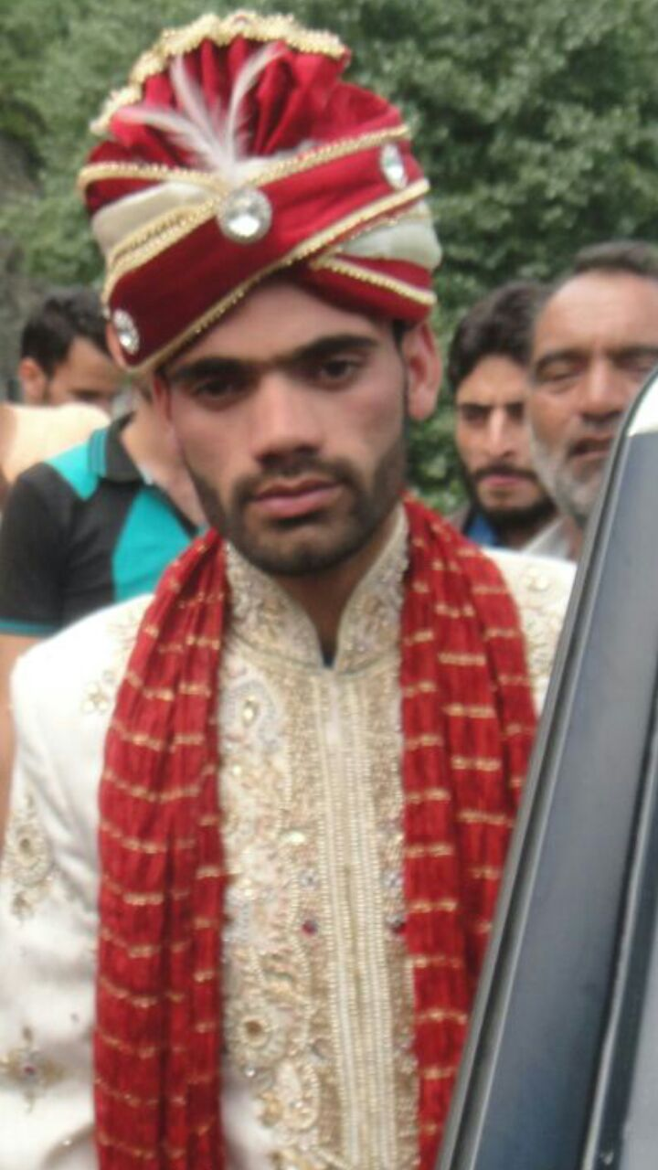
/varta:v/:
Before serving the feast to the relatives, the bride and the groom are made to sit in their own respective houses, with all the relatives. The relatives then one by one come to greet and bless them and give gifts or money as a token of love. This money or gift received by the bride or the groom is called varta:v and is coomon ritual among Kha as it is in Kashmiris. The basic concept of giving money as varta:vis that the relatives show their concern for the parents of the bride and groom and try to help them financially as marriages in the community are quite expensive. So varta:vis a kind of financial assistance to the bride’s or the groom’s parents.

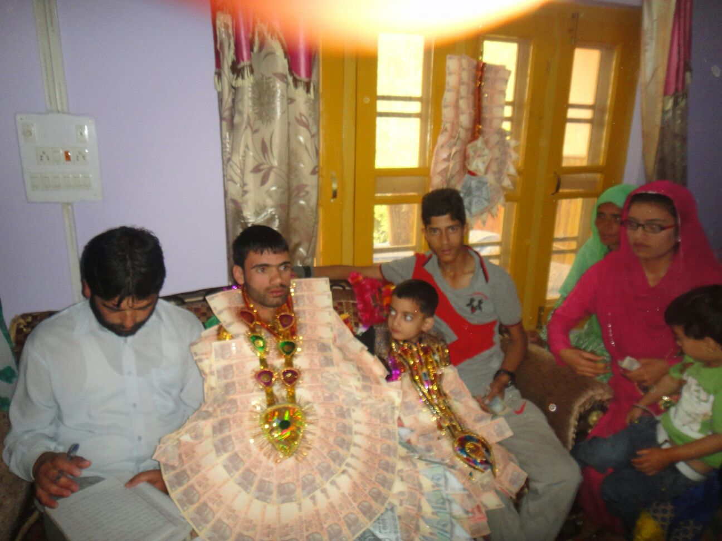
/vanvun/:

While the ritual of varta:vis going on the other women of the family gather around the bride or the groom and sing various songs. This is a very important and common practice. The women usually sing Khana songs. However sometimes Kashmiri songs are also sung by them. This is because of the influence of Kashmiri culture as Kha have been in constant contact with Kashmiris, since a long time.

/saːl/ (The feast):
The feast that is prepared overnight both at the bride’s place and the groom’s place is given in several stages called as /sabɨ/. There are three types of /sabɨ/:
- For neighbors
This is considered the least important type of /sabɨ/.
- For relatives
The quality of food provided in the stages for relatives is better than that provided for the neighbors. The number of courses may also be more than the stages for neighbors.
- For the groom the people accompanying him:
This is only given at the bride’s place. The number of courses given in this /sabɨ/ is more than in other stages and the quality of the dishes is the best of all the stages.
There is also the segregation of sexes within each type of /sab/, which means that men and women are served the feast separately. The difference in quality referred in the above stages usually involves the difference between beef and mutton, with beef considered inferior to mutton.
Bridegroom’s Means of Conveyance and Headgear:
The groom usually rides a horse to the house of the bride’s family. He also wears an ornamental turban wrapped on a cap which is called as a /kula:/. The bride groom is gifted with a special kind of Money-garland, along with some flower garlands. It is a common practice in this region. The amount of money in the garland is not fixed. It can vary form few hundred to thousands of rupees. The garland is not only a token of love but also a mark of respect for the groom.
/pʰirvənʲ/ː
The concept of rukhsati is similar to that of Kashmiris. After the ceremony of Nikah is finished, and the groom and the people accompanying him have had the feast at the bride’s house, the bride accompanies the groom and his people to his house. A goat or a hen is sacrifices when the bride reaches the grooms house but it is not necessary. The custom may or may not be followed. When the groom reaches his house along with the bride, the feast begins at the groom’s house. The feast is termed as /pʰirvənʲ/. Some women closely related to the bride stay overnight with the bride and provide her guidance.
/ɡulɨ mʲu:t^{h}-/ when the bride reaches the groom’s home, she is being kept among women and seen by them. The women who raises her veil gives some money to her and this giving of money is called as gulI mʲu:tʰ.
mohar-it is just as the gulɨ mʲu:tʰ but here the mother-in-law (shah) of the bride gives her some money.
/vatɨ pʰjur/ː
On the first day of marriage the bride goes to her husband’s house but she returns to her parents’ house the next day along with the groom. The practice is termed as /vatɨ pʰjur/, the literal translation of which is “retracing the path”. Both the bride and the groom stay there overnight. On the third day they return to the groom’s house. Some friends and relatives of the bride may also accompany her. The bride spends the night with her friends and relatives. They are served wazwan in the grooms house. Finally, on the fourth day the relatives and friends of the bride return to their homes and the bride stays with her in laws afterwards.
p^{h}uirɨsa:l
This is the feast hosted by the relatives, friends and neighbors for the newly married couple. The couple is generally invited and is served va:zva:n. This is common practice.
Concept of divorce and widow remarriage:
The concept and the procedure of divorce is similar to other communities particularly Kashmiris. After divorce the divorcee can marry again. Widow re-marriage is also allowed among Khana people. Levirate and sororate marriages are possible. Levirate is the custom whereby a widow is expected to marry the brother or a close relative of her dead husband. Usually any children fathered by the woman’s new husband belong legally to the dead brother rather than to the actual genitor. Such a custom both serves as a social security to the widow and her children and preserves the rights of the husband’s family to her sexuality and future children.
Similarly the custom of sororate comes into play when the wife dies. It is the practice of the widower’s marrying the sister or some close relative of the deceased wife. In this community, widow can marry her brother-in-law, so can a widower marry his sister-in-law. There is a specific period after which a widow can remarry particularly among Muslims. This period is known as iddah. The widow can marry after four months of her husband’s death. In Khana community this rule of iddah is not violated, a widow marries only after four months of her husband’s death. Polygamy is totally acceptable in the community. A man can marry more than one woman.
Dowry
The concept of dowry is there. Dowry is given and accepted. Various things of daily use can be given to the bride as dowry for her in laws. These may include kitchenware, utensils, TV, fridge, things used in bedroom, etc. In many cases a piece of land or cattle (goat, sheep, etc.) may be given. These are given as security to the bride in case the marriage does not turn out to be successful. Cash or gold may also be given, though giving these things as dowry is rare. It depends upon the economical status of the parents of the bride.
Folklore and culture
Folklore is an amalgam of folktales, legends, fables, myths, and practices and beliefs that have passed from generation to generation over hundreds of years to the present members of a community through word of mouth and by example.
According to William A. Wilson:
“Surely no other discipline is more concerned with linking us to the cultural heritage from the past than is folklore; no other discipline is more concerned with revealing the interrelationships of different cultural expressions than is folklore; and no other discipline is so concerned …with discovering what it is to be human. It is this attempt to discover the basis of our common humanity, the imperatives of our human existence that puts folklore study at the very center of humanistic study.”
According to Jan Brunvand:
“Folklore comprises the unrecorded traditions of a people; it includes both the form and content of these traditions and their style or technique of communication from person to person.
Folklore is the traditional, unofficial, non-institutional part of culture. It encompasses all knowledge, understandings, values, attitudes, assumptions, feelings, and beliefs transmitted in traditional forms by word of mouth or by customary examples.”
Thus folklore embodies both the worldview of a community and their beliefs.
Folk sayings, riddles proverbs, stories, etc. not only refer to a particular psycho- social impulse of the given human society; it I stead carries in its fold the entire mental make-up of the society. When a riddle is narrated, it does not only mean to puzzle an individual with linguistic obscurity, but through the puzzle, a society and a linguistic community aims at examining the intellectual level and collective mental alertness. Sometimes a riddle carries in its fold the secret of invisible historical past.
This report will confine itself to the legendary tales, beliefs, songs, proverbs and riddles of the community under study (Khana).
Folk Tales
Much like in any culture and society, storytelling has been the favorite pastime of children and usually the stories are preferably narrated by the grand parents or elderly members. Most of the tales narrated are usually about the extraordinary people who are still remembered for their heroic acts.
For example, the first tale is about a person named Gunki who slays a cruel and debauch king and the second one is about a person named Amir who fights a leopard. These tales fall under the category of legends, because legends are tales about human beings who surmount great difficulties in their lifetimes and thus become famous.
There are tales like the last one below which are about supernatural beings like jinns. These fall under the category of fairytales, because fairytales are tales which involve supernatural beings and magic.
Following are some of the tales and narratives that were elicited from the members of Khana speaking community of Chamalvaas:
STORY 1
Gunak singh was a brave man who belonged to Sohil clan. His maternal uncles lived in Khadi. Khadak Singh was the ruler of the Khadi at that time. Gunak Singh wanted to marry a girl in Khadi. He asked his uncles if he can do so. But they refused on the pretext that he does not belong to this place and Khadak Singh would not allow the wedding to take place. Gunak Singh said that Khadak Singh had promised him that he won’t harm him since he was Khadak Singh’s slave. He further said that Khadak Singh would not break his promise. So he was allowed to marry the girl he wanted. On the day of wedding, when the guests reached the field along with the bride and the groom, the other king Chander Singh stopped them and said that he would take away the bride and Gunak Singh must follow the norm that Chander singh had set his people i.e. the bride has to spend the wedding night with Chander Singh.
Eventually Gunak Singh plotted against Chander Sih. Chander Singh’s palace had a network of secret underground tunnels. Gunki blocked all the channels except for one. He invited the king to the tunnel which was open, for a public meeting. When Chander Singh came there, Gunki held him, cut his testicles and put them in his mouth and then he killed him. Chander Singh’s wife, who was pregnant at this time, managed to escape. She fled away to Runigaam. Gunki went in her search with an intention of killing her too as he did not want their offspring to come in to this world. He beared in his mind the fear that this child may take revenge of his father’s death when he grows up. The relatives of Chander Singh’s wife stopped Gunki and advised him not to kill the lady for she was innocent. They promised him that they would allow him to kill the child if it is a baby boy.
After sometime this woman delivered baby. It was a baby boy. At the same time her brother’s wife also gave birth to a baby girl. Gunki came there to kill the baby but the ladies exchanged their babies and told Gunki that Chander Singh’s wife had delivered a baby girl. So Gunki left without killing the baby.
Eventually, he came to know that he had been lied to. He got angry and decided to kill the boy. But the villagers stopped him. A meeting was held between the heads of the village and it was decided that Dharma would be done. Dharma is a ritual in which two people are made to drink milk with jaggery, after which they become brothers. Then Chander Singh’s son named Yusuf sih drank milk and jaggery with Gunki and they became brothers. Thus the prevailing hostility ended then and there.
This is a tale which revolves around the themes of lust, deception, gory revenge and reconciliation. It further brings to light the custom of Dharma by which Yusuf Sih and Gunki become friends.
STORY 2
Abdul Karim was the richest person known in this place. He had seven brothers. One of his brothers was named Amir. He was a well built young man. One day Amir went out on a hunt with some companions. On their way they saw a leopard. Amir followed the leopard to his cave. When the leopard went inside Amir made a snowball and threw it at the cave. The leopard came out and Amir started to fight with it. He fought very bravely and received some injuries. He kicked the leopard on the chest and threw it off a cliff. Thus, he set an example of bravery and courage. Since then he is known as Amir Shal by the villagers.
This tales extols fearlessness in the face of extreme danger as a great virtue.
STORY 3
/jeti ɔːs akʰ raːdʒuː antaːtioːs tsandar siː oːθus naːm su oːs baɖɨ zəlim su oːs karti jav ti jeː nɨ ɡɨnoːv pehleː mahraːniː tiː panni raːdʒvoːɖas manz su jaksiraːt cecɨ aːs tɨ aːs tɨ neːriː neːriː calti calti patnuastɨ ji akʰ bahadur asviː koːmas manz ɡunkɨ tẽsuːdis jeː lati uneː raːt kicanjasniːn jasaj kuɖmeːn su voθ tɨ tem keː tihind sikiːm leːs ʈanlɨ anruːniː zamiːn sind saːraj band kərit sirif jihind akʰ dʒaɡah jeri su raːt ti oːθ panni raːdʒvaːɖas manz bulaːv tɨ patɨ aːsav ɡunkɨ jus ni aːz cʰe peːr aːmut jus kiː cʰu aːsan tajaːr ti jablɨ juː tsandɨr siː aːv jaθ labun su voθ tɨ tem leːj tasaːj pʰiːɖiː tseʈ tɨ raːʃuʃniː eːʃaʃ manz su ɡov pʰeʈ tiːriː maːtan ten baːd kor jaː sa ji dunjaː tiː aːraːm tɨ jab lɨ taːmat cʰɨ jɨ mahʃuːr kahaːnuiː ki tsandɨr cʰi paːm tasiː kʰaːndaːnas ki tsandɨr saːb ciɡreːʈ pijoː/
Once upon a time, there used to be a Rajwada Ruler named Chander Sih. He was very cruel. He would take away the brides on the first wedding night and force them to sleep with him. He had made this a custom. This cruel custom continued until one day a brave man from the Sohil clan decided to go against this custom. He plotted against the cruel ruler and blocked all the tunnels that led to his palace. On his wedding he called Chander Sih in one of the tunnels which was open. He had decided to punish him brutally. Gunki castrated him and put his testicles in his mouth. Thus he freed the people of this cruel practice and brought relief to his people.
This is a shorter form of the first story elicited from a different informant along with the Khana version transcribed as spoken by the informant.
STORY 4
There was a sage, Jahar Sahab, who lived in Neel. He was known for his spirituality. He reared a flock of cattle and went from place to place with his cattle. He would light fire where ever he stayed. He would wander around and would not eat for days together. Whatever he said or predicted came out to be true. The leopards would follow him where ever he went. They would behave like his slaves and would guard his cattle. The leopard would even take his cattle for grazing and bring them back to him in the evening. It is believed that ghosts and spirits also respected him and guarded him and his cattle when he slept.
He was known to have a connection with God. His grave is in Kherwaan. There is also a cave in Sherbibi, where he used to sit. Some say that there is a big rock on which he used to pray. He would pray there for hours together even when it was snowing. Now a mosque has been constructed on this rock.
This is a narrative about a man of God who had tamed both the supernatural and natural forces with which the people of the community have to deal with on a daily basis.
STORY 5
/asaj cʰu hun tomut prenan praːnan buzarɡan labɨ kiː asanu picavi akʰ tem keː ʃaːpɨtɨ sənd dʒepʰ kɔlis manz tuksu tseːr ɡaːnɨ kudatɨ eːkioː ʃaːput patpejoː diːpaj puθur dab dab kardiː kardiː ɡeːv veːv kʰaːsi əkis din dʒəriːban patraʈ tensind teːr kan kan rəʈ kər hotsʰ liːnijas bəz əs cecas niː hos bəz tɨː pat keːsəhiəz lat ti liːn peʈʰ koːlun darɨl panun paːn bacaːv tin ʃaːtus lab/
The narrator’s forefathers have told him a story. It is the story of bravery and courage of his uncle. It is said that he once climbed a tree, without noticing that a bear was already sitting on the same tree. As soon as the bear saw this man, he started hitting him hard. Both of them fell down on the ground. The bear hit him on his arm and broke it but he did not give up. He fought bravely and fearlessly against it. He held the bear by its ear, kicked it and threw it off a cliff. Thus he saved himself from being killed by the bear.
This again is a legend extolling fearlessness and bravery.
STORY 6
/zama:n sund ja kʰanraːt chi jablɨ ti mudʒuːd vanti jaːsaː voːtuː jiaːkʰ hiond vaːti raːdʒvoː tes vantaj tsandɨr siː kʰaɖak sindun aːv laːd tenasaː eːs atruj ʈanal baneːv mits su oːs ɡats tuj teːr patɡov jiː asɨl zamiːndaːr ɡiakʰ dʒavaːn teːr kul tsaʈniː tsaʈtiː tem kul tem sund ʈajim oːs laɡbaɡ marnuk tɨ tsaʈtuː tem kul kul jel tsaʈtin tɨ tes ɡov anɡoʈ əcʰen ter kulaː əcʰ baɖɨ mɨʃkilan voːt su ɡiː ɡiː jel voːt tes ɡov ki paːɡal panzan ɡoːsuː patran ɡilɡan tɨ pareːʃaːniː su oːs tuːtaː zoːr kartiː dah dah kɔj ʈal oːs su jakaːjat tulti tsoːr tsoːr kɔjʈal jat ni kihiːn tamiːz ti əːs avku kar cʰus pat hasaː bulaːv tanu piːr pat hasaː boːl tɨ tem dʒin dzinan aːv sa hiond pathav ʈʰikaːnaj jam hasaː tsoʈtu kul jem mieːn bacas ɡardan tseʈʰ ti batɨ ditus piːr kis raʃvaʃ tɨ pat ɡoː su ʈʰiːk ɡəs lab tɨ sɨ cʰu moːdʒuːd su eːrijaː hasaː cʰu jablɨ ti asi sund puːrə ɡaːm ehtijaːt karti toːr cʰunɨ ɡatsi ti kəsti buθ vaɡeːraː cʰi jablə tɨ teːr toːn kʰanɖ raːt/
There are remains of Chander Singh’s palace in this place. This palace is believed to be haunted and people avoid going there in any case. One day a young man went there to cut a tree. It is said that as soon as he fell down the tree he came under the influence of a djinn. He felt a sort of light illuminating in front of his eyes and then suddenly he started losing his sanity. On seeing this, his family members got worried. None of them could sleep that night. He was able to lift things weighing almost four quintals with his bare hands. Even 10 people found it hard to control him.
There was a sage (peer) named Baaji, who lived somewhere around this place. He was known to have control over djinns and spirits. This man was taken to Baaji for treatment. Baaji talked to the djinn that had possessed this man. The djinn said that the man had cut the throat of one of his children, who lived inside the tree. That is why the djinn had kept him under his possession. Baaji pleaded the djinn and convinced him to forgive the man as he was unaware of the presence of the djinn’s child inside the tree. A religious ceremony (Niyaaz) was held and then the jinn freed the man of his possession.
This narrative brings to light the beliefs of the people about possession and its treatment, a religious ceremony called Niyaaz. Niyaaz is a ceremony in which one usually sacrifices animals to ward off something evil. The idea is that one offers an animal or animals to take the place of a human being as the recipient of some calamity. In the above example, the jinn were offered the life of a sheep in place of the life of the possessed man.
Value System
The moral standards of the community come through very clearly in the above tales. Thus in the first tale Chander Singh is a negative character, the embodiment of evil, because he forces his lust on the women of the people he rules. Gunki is good because he rises against the abominations committed by the morally degraded ruler and kills him humiliatingly. Although Gunki initially wants to kill the son of the ruler, he eventually makes his peace with him.
The virtue of bravery is also extolled in the tales. Thus Gunki is brave and, therefore, good because despite the fact that Chander Singh is powerful he rebels against him. Similar are the cases of the boy who wrestles with a leopard (story 2) and the man who tackles a bear(story 5).
Belief System
The belief system of the community is reflected in the above folk-narratives. It is clear from story 6 that the people of the community believe in jinns, powerful invisible beings who can assume any shape they like and inhabit the bodies of human beings. These creatures are supposed to live in derelict areas and human habitations that have been abandoned since a long time ago. These, according to our informers, are harmless as long as they remain undisturbed by humans. Thus, the jinn in story 6 lived in the ruins of Chander Singh’s palace, an abandoned human habitation and a derelict area. He entered the body of the man who accidentally killed his son.
With belief in possession comes the belief in people who have the power to treat any one suffering from it. Thus, the stories feature people like Baaji and Jahar Sahab who can talk and control spirits and jinns. It is believed that these powers come to them because they shun the affairs of this world and dedicate themselves to prayer and worship. Thus, Jahar sahib is believed to go without any food for days. He also prays at such places as caves and rocks without regard for his personal safety from the forces of nature.
There is a practice called /matralti/ which involves saying words from an obscure jargon on someone. This is usually used to cure little ailments like a cough, tooth ache, stomach ache, sprains etc. Very few people in the community possess the necessary knowledge to perform this practice.
Their present belief system has an Islamic basis, which is amply illustrated by belief in such things as jinns and the power of peers (holy men who, besides being guides in spiritual matters, supposedly possess the ability to control jinns and other supernatural beings). Until recently, the version of Islam that was dominant in the community had a profound influence of the local culture. Hence, the belief that if you visit a bereaved family on Sundays, something evil might befall you, and the belief that one can pray to the deceased ancestors of one’s family, were widely held. People also used to visit the tombs of seers and holy men and pray there. People used to mourn their dead for months. However, the number of people with such beliefs has diminished greatly over the years for two reasons:
- The introduction of the Ahli-Hadees version of Islam, which lays a lot of stress on self-educating oneself in religious matters rather than relying on a select few for religious guidance.
- Increasing Literacy.
Riddles, Proverbsand Songs
Encyclopedia Britannica describes proverbs and riddles in the following manner:
“The proverb that expresses in terse form a statement embodying observations about the nature of life or about wise or unwise conduct may be so much an oral tradition as to serve in some preliterate societies as a sanction for decisions and may even be employed as lawyers employ court precedents. In literature it dominates certain books of the Old Testament and is found even earlier in Sumerian writings…
While the proverb makes a clear and distinct statement, the purpose of the riddle is usually to deceive the listener about its meaning. A description is given and then the answer is demanded as to what has been meant. Among examples in literature are the riddle of the sphinx in Sophocles and the Anglo-Saxon riddles, based on earlier Latin forms. In oral literature the riddle may be part of a contest of wits. But even if the answer is known, the listeners enjoy hearing them over and over. In Western culture the riddle is especially cultivated by children.”
Every culture in the world has its share of songs which range from songs which have rhythm and rhyme, but whose words have little meaning (usually meant to be sung by children), to the ones whose rhyme and rhythm are as delightful as their words are heavy with meaning.
Here are some riddles, proverbs and songs that were elicited from the members of the community under study:
Riddles
- /teːr peː tiːn ɡilkan/
You felt it on one side and your family felt it on the other side.
Meaning: Sleep/ Slumber
Explanation: This riddle is used for the members of the family when they fall asleep in their respective rooms. It signifies sleep.
- /ke:n kɔkɖiː kɔdvalalti/
A blind hen digging the soil.
Meaning: Rain
Explanation: This riddle implies rain seeping through the roofs of the houses. The basic connotation behind it is that a blind hen cannot see the grains on the ground and goes on pecking the soil unknowingly. Likewise when rain falls from the sky it blindly oozes through everything including the roofs.
- /kre:h ni gəb θam fiʃti/
A black sheep licking the pillar.
Meaning: Carving axe
Explanation: This riddle implies a carving axe. The front part of the axe which is used for carving is compared to the tongue of the sheep and licking is compared to carving. The carving axe repeatedly scratches the wood like the sheep licks the pillar.
- /jak səj doːrɨ baːhat braːɖɨ/
A single window and twelve hundred cats.
Meaning: Beehive
Explanation: This riddle implies a beehive. The connotation behind the riddle is that if twelve hundred cats try to come in from a single window it would be quite overcrowded like a beehive (a beehive accommodates a large population of bees).
- /hiŋɡun ɡəb mĩŋɡun tsaːpti/
Meaning: grinding wheel
Explanation: This riddle implies a grinding wheel. The grains are compared to the droppings of the sheep and the grinding wheel is compared to its mouth. The connotation behind it is that the grains are crushed in the wheel in a lazy manner like a sheep chews its droppings.
Proverb
/ɡaːmas raʃniː jakiː suθun/
Meaning: A person who keeps everyone happy by lying.
A person who gets friendly with everyone.
This proverb is used to either for a person who keeps everyone happy by lying and diplomacy, or for a person who gets friendly with everyone. It is used in both positive and negative senses.
Songs
- /tuːr pãcsan teːsiːran kɔdrat sindh teːmiːr niːl ʈapkan naɡrak tsaːcen tsomlas zan kaʃmiːran/
This song has been composed by Farooq Nadim, a famous poet of this area. The poet seems to be impressed by the beauty of Kashmir and he is trying to metaphor Chamalvas with Kashmir.
In this song the poet describes all the attributes that make Chamalvas beautiful and serene. He says, “The cold waters of this place have a soothing effect. Here nature is at its best. When I look at this valley from Neeltop, I feel that Chamalvas is more like Kashmir. I don’t know whether everyone would feel the same but if you ask me I would say that Chamalvas looks like Kashmir. Some people call me Farooq; some others call me Nadim. If at all you feel that you need me, come to Zanchos. It is here that I reside”.
- /θoːroː likʰchut naːm θaː keːɖan jen vaj piːɖan divriheːjaː/
This song has been composed by Farooq Nadim. He has written almost 500 songs in this language. In this song the poet says that I have engraved my name on the barks of these trees so that the coming generations of my people would know that there was a poet named Farooq Nadim, who lived here.
./baːl baːl roːtas ɛcʰ ɡəj me heːriː van hus tɨ me bakʰeːriː cʰ/
He further says that my eyes have strained watching the nights and days passby. Could someonetell me whether my beloved is fine.
- /aːv harud taj kɔl ɡəj zəːniː kəːtsan pʰoːlan ɡeːv vaj rəːniː poz cʰu əːkʰir dunjaː vaːloːbakiː alaː alaː huː/
These verses have a religious implication. In these verses the poet says that it is autumn and there is no greenery. There are no leaves on the trees. There are no flowers to be seen. They have faded away. Everything is dry and lifeless. It seems that death has overtaken everything .What remains behind is the name and being of the Almighty Himself. His existence is what will remain forever. All other things are going to vanish.
- /hoː o:
pəʃtum bahaːras manz ɡulaj siː poːʃeː caman bəːt
pəʃtum bahaːras manz ɡulaj siː poːʃeː caman bəːt
akʰ sarajharadiː jel ləɡ zazurav poːʃ ɡasunzeː
kas naːzə poːʃaʃ daːd poʃtum taːzɨ poːʃan manz
jɨ cʰɨ poːʃ nij kulsəj zakʰam loɡmut tɨ poːʃ ɡomut cʰu ɡəːb
utiː nuːrɨ pʰolun taːzɨ ʃabnam bəːli pətran pãːt
cʰek mɔktɨ buhaːras unjav jasav diːdaːr koman kəːv
vani dunjaː paːtaː sasnaː kut ibaːdat
vani dunjaː paːtaː sasnaː kut ibaːd
In this song the poet wants to say that in the spring the flowers bloom and make the gardens look even more beautiful. But with the commencement of the autumn the flowers start withering and shed all their beauty. The poet says that the beauty of the flowers does not last forever. It rather depends upon the tree. If the tree gets bruised or wilted the flowers also shrivel.
The dew makes the leaves look fresh and green. The drops of the dew shine like pearls on these leaves. We should be thankful to the Almighty for giving us all this. Nothing is going to last. It is only His name and His being which will remain here forever. So we should bow our heads and praise his creation.

William A. Wilson. The Deeper Necessity: Folklore and the Humanities. Journal of American Folklore 101:400, 1988.
Jan Brunvand. The Study of American Folklore: An Introduction, 2nd edition. New York: W.W. Norton, 1978. Kinship System Among the Khana People Of Chamalvas Introduction Man is social by nature .He establishes many types of relationships with a number of persons. The most important of these relations is Kinship and the relationships based on either marriage or blood relations are known as kinship relations. Kinship helps in acknowledging the relationships among the community members Anthropologists study kinship because it is the relationship between people through marriage, family, or other cultural arrangements. The two types of kinship which exist are consanguinial (related by blood) or affinal (related by law/marriage). Through kinship there is a transmission of goods, ideas and behaviour. Kinship is defined as a sense of being related to a person or people through descent, sharing or marriage. This provides the base for an examination of different styles of partnership, community and reproduction across the globe. In anthropology, kinship is the web of social relationships that form an important part of the lives of most humans in most societies, although its exact meanings even within this discipline are often debated. Anthropologist Robin Fox states that "the study of kinship is the study of what man does with these basic facts of life – mating, gestation, parenthood, socialization, siblingship etc." Human society is unique, he argues, in that we are "working with the same raw material as exists in the animal world, but [we] can conceptualize and categorize it to serve social ends." These social ends include the socialization of children and the formation of basic economic, political and religious groups. Kinship can refer both to the patterns of social relationships themselves, or it can refer to the study of the patterns of social relationships in one or more human cultures (i.e. kinship studies). Over its history, anthropology has developed a number of related concepts and terms in the study of kinship, such dawasdescent,descentgroup,lineage,affinity/affine,consanguinity/cognateandfictive kinship. Further, even within these two broad usages of the term, there are different theoretical approaches. Broadly, kinship patterns may be considered to include people related by both descents – i.e. social relations during development – and by marriage. Human kinship relations through marriage are commonly called "affinity" in contrast to the relationships that arise in one's group of origin, which may be called one's descent group. In some cultures, kinship relationships may be considered to extend out to people an individual has economic or political relationships with, or other forms of social connections. Within a culture, some descent groups may be considered to lead back to gods or animal ancestors (totems). This may be conceived of on a more or less literal basis. Kinship can also refer to a principle by which individuals or groups of individuals are organized into social groups, roles, categories and genealogy by means of kinship terminologies. Family relations can be represented concretely (mother, brother, grandfather) or abstractly by degrees of relationship (kinship distance). A relationship may be relative (e.g. a father in relation to a child) or reflect an absolute (e.g. the difference between a mother and a childless woman). Degrees of relationship are not identical to heir ship or legal succession. Many codes of ethics consider the bond of kinship as creating obligations between the related persons stronger than those between strangers, as in Confucian filial piety. Kinship and culture Kinship is the relation by the bond of blood, marriage and includes kindered ones. It represents one of the basic social institutions. Kinship is universal and in most societies plays a significant role in the socialization of individuals and the maintenance of group solidarity. It is very important in primitive societies and extends its influence on almost all their activities. A.R Radcliffe Brown defines kinship as a system of dynamic relations between person and person in a community, the behavior of any two persons in any of these relations being regulated in some way and to a greater or less extent by social usage. Each society classifies its kin according to a set of cultural rules that may or may not account for biological factors e.g. in some kinship system, both father’s brother and father’s sister’s husband are referred to as uncles, even though the former is a blood relative and the latter is not. Like other societies, the people of the Khana community also refer to father’s brother and mother’s brother by different reference and address terms. Not only this, they are also expected to behave very differently towards the two kins. Thus it can be seen that the way different societies sort and categorize kinship relations is as much a matter of culture as it is a matter of biology It is very common to come across brothers and sisters in a village who are not the real siblings but become brother and sister on the basis of rituals. Adoption [maŋɡtɨ] is also a form of contracting ritually blood relationship. Whether ritual or actual such relationship plays a pivotal role in kinship system. Primitive societies are woven around kinship. Various social foundations use kinship terminology as (brothers and sisters) to refer to their members. Kinship terms like [meːʃ] mother’s sister and [ma:m]mother’s brother are used in general, to refer to non kins showing an affectionate relationship. These examples show that it is possible to have kinship like relationship without having an actual biological or marital connection. Kinship Terms In day-to-day interaction with our relatives, we use certain words to address them and certain other words to refer, identify and categorise them. These various kinds of words are collectively known as kinship terminology. For example [muoːl] father,[me:l]mother,[kʰandaːrin/ zanaːn] wife, [kʰãːvãnd] husband , [maːmɨn]maternal-aunt,[cecɨ]paternal-uncle,[da:d]grandfather,[da:di] grandmother and so on. These kinship terms help us to understand the inter-relationships between various members of a family and their status and role within the family. The term’ kin’ gives us an idea about the type of family, its rule of residence and its rule of descent and other aspects of social organisation. Kinship terms are not merely linguistic in nature, but are also sociological, meaning related to an individual’s status and behaviour. Like some honorific interjection like səːb etc is used while referring or addressing to the son in law, father- in-law etc. - On the basis of linguistic structure kinship terms have been classified into three types. Elementary Terms: Elementary terms in kinship are the basic relationship terms which cannot be further reduced into simpler words. Some of the elementary kinship terms in Khana are: father, mother, brother, sister, paternal uncle, maternal aunt, etc. Elementary KinshipTerms English Gloss muo:l Father me:l Mother ba:ran Brother Ben Sister cecɨ Paternal Uncle cecɨn paternal Aunt ma:mɨn Maternal Aunt Derivative Terms: These kinship terms are formed by joining suffixes or prefixes to the elementary kinship terms. Examples of derivative kinship terms in Khana are: Mother’s Brother’s Daughter, step-father, elder brother, younger brother etc. Elementary KinshipTerms English gloss ma:mtɨr ben Mother’s Brother’s Daughter avruː muoːl Step Father avruː meːl Step mother pɔfaːtur baːran Father’s Sister’s Son bɔɖ baːran / lɔkci baːran Elder brother/younger brother tuːdʒ baːran Father’s brother’s Son Descriptive Terms: These kinship terms are formed by combining two or more elementary terms .For example: Father’s Brother’s Son, Father’s Brother’s Daughter mother’s brother’s son, Mother’s Sister’s Son etc. English Gloss Descriptive Kinship Terms in Khana Father’s Brother’s Son tuːdʒ baːran Father’s Brother’s Daughter tiːdʒ ben Father’s Sister’s Son pɔfaːtur baːran Father’s Sister’s Daughter pɔfaːtɨr ben Mother’s Brother’s Son maːmatur baːran Mother’s Brother’s Daughter maːmatur ben Mother’s Sister’s Son maːʃutur baːran Mother’s Sister’s Daughter maːʃutur ben Unlike English, it was seen that Khana has single elementary terms for relations like wife’s sister [sa:l], sister’s son [beɖav],daughter’s husband [zamtur],mother’s brother [ma:m], father’s sister [pof ],etc. This shows the intimacy and affectionate relationship shared between these people. - On the basis of mode of use ,kinship terms have been classified into two types: Terms of Address: Kinship terms which are used for addressing the kins or relatives are known as terms of address, for example the terms of address in Khana are [ əbba] father, [amma] mother, [kaːk] brother, elder brother [laːl dʒi], [ben] younger sister, etc. Terms of Reference: Kinship terms which are used for indirectly referring to a person are known as kinship terms of reference. In Khana the examples of terms of reference are [muo:l] father, mother [me:l], [ba:ran]brother, [ben]sister,etc. - On the basis of range of application the kinship terms are of two types depending on the range of the application of the terms: - Denotative/isolative/descriptive term: The term which applies to only one particular kin category is known as descriptive/denotative/isolative term. For example, the term [muo:l] father, [me:l] mother is applied to the parents only and to no one else.(zana:n/kʰãndarin) )wife,( kʰãːvãnd ) husband is applied to one’s spouse only. - Classificatory term The term which applies to persons of two or more kinship categories is known as classificatory term. For example, the term cousin in English is used for referring to father’s brother’s son as well as to mother’s brother’s son. Similarly uncle refers to mother’s brother, father’s brother and father’s sister’s husband. But this type of classificatory kinship terms are not seen in Khana community as there are separate terms for different relationships like father’s brother’s son is known as [tuːdʒ baːran] while as mother’s brother’s son is known as[maːmatur baːran]. Also paternal and maternal uncle’s have separate terms with different roles ascribed to them. Mother’s brother is known as [ma:m] and father’s brother is known as [cecɨ].Sometimes classificatory kinship terms may be used for non affinal kins. For example father’s friend or a neighbour may be addressed as [cecɨ] or [ma:m], a friend’s sister may be addressed as[be:n] ,an old lady may be addressed as [meːl/meʃ/cecɨn] depending upon the level of intimacy shared. - Kin related by blood/partial blood - OWN GENERATION English Gloss Khana Kinship Terms Brother (elder/ younger) bɔɖ baːran / lɔkci baːran Sister (elder/ younger) bəɖiː ben / lɔkci ben Father’s Brother’s Son tuːdʒ baːran Father’s Brother’s Daughter tiːdʒ ben Father’s Sister’s Son pɔfaːtur baːran Father’s Sister’s Daughter pɔfaːtɨr ben Mother’s Brother’s Son maːmatur baːran Mother’s Brother’s Daughter maːmatur ben Mother’s Sister’s Son maːʃutur baːran Mother’s Sister’s Daughter maːʃutur ben - FIRST ASCENDING GENERATION Kinship Terms In Khana English Gloss muoːl Father cecɨ Father’s Brother cecɨn Father’s Brother’s Wife Pof Father’s Sister pofaːj Father’s Sister’s Husband meːl Mother maːm Mother’s Brother maːmɨn Mother’s Brother’s Wife meːʃ Mother’s Sister maːsuː Mother’s Sister’s Husband - SECOND ASCENDING GENERATION Khana Kinship Terms English Gloss daːd Father’s father daːdi Father’s mother naːnɨ Mother’s father naːnɨn Mother’s mother - FIRST DESCENDING GENERATION English Gloss Khana Kinship Terms Son nukʰ Daughter kuɖ Brother’s Son baːrɨn səndʰ nukʰ Brother’s Daughter baːrɨn səndʰ kud Sister’s Son beɖav Sister’s Daughter beɖaj - SECOND DESCENDING GENERATION English Gloss Khana Kinship Terms Son’s son poːturuː Son’s daughter poːtɨri daughter’s son doːturuː Daughter’s daughter doːtɨri - Kinship By Marriage Khana Kinship Terms English Gloss Kʰãːvãd Husband ʃuhur Husband’s Father ʃah Husband’s Mother deːr Husband’s Brother drẽːɖ Husband’s Brother’s Wife Zeːn Husband’s Sister zaːmij Husband’s Sister’s Husband kʰandaːrin/ zanaːn Wife ʃuhur Wife’s Father ʃah Wife’s Mother Hohar Wife’s Brother Hehrin Wife’s Brother’s wife saːl Wife’s Sister saːl bʰaːjiː Wife’s Sister’s Husband Nuh Daughter-in-law zaːmtur Son-in-law - Kinship By Adoption/Affiliation Khana Kinship Terms English Gloss maŋtɨ Adopted son Maŋti Adopted daughter - Kinship By Gender Khana Kinship Terms English Gloss ləɖkaː Boy ləɖkiː Girl(unmarried) marɨd Man jẽːlɨvəːl / kuɖmeːn Married Woman marɨɖ Married man Compound Kinship Terms Khana Kinship Terms English Gloss par daːdaː Great great grand father daːdaː Great Grand father par naːnɨn Great Great Grand Mother naːnɨn Great Grand Mother puːdʒ baːran Father’s Brother’s Son piːdʒ ben Father’s Brother’s Daughter maːmatur baːran Mother’s Brother’s Son maːmatur ben Mother’s Brother’s Daughter pofatur baːran Father’s Sister’s Son pofatɨr ben Father’s Sister’s Daughter maːʃutur baːran Mother’s Sister’s Son maːʃutur ben Mother’s Sister’s Daughter avruː muoːl Step Father avruː meːl Step Mother avruː baːran Step Brother avruː ben Step Sister Relationships Khana Kinship Terms English Gloss ben baːran Sister-brother baːrɨn Brother-brother meːl kuɖ Mother-son meːl kuɖi Mother-daughter din vaj meːl paθɨr Father-son meːl paθɨr Father-daughter marɨd kuɖmeːn Husband-wife Types of Kinship In any society, kin relationships are based either on birth (blood relations), or marriage. These two aspects of human life are the basis for the two main types of kinship in society. Family is the point of departure for studying kinship. There are basically two types of kinship within a family: - Affinal Kinship - Consanguineous Kinship Affinal Kinship This type of kinship is based on marriage. The relationship between a husband (kʰavãnd) and a wife (kʰandarin/zanaːn)is the most primary example of affinal kinship found among the Khana people. The relation if seen in its extended form includes parents and siblings of both sides and their spouses and children. Hence the relationship between a son-in-law [zaːmtur] and a father-in–law [ʃuhur] is an example of affinal kinship. Similarly, ones brother-in-law [hohar] and his children are also examples of affinal kins. Consanguineal Kinship The type of kinship based on descent is known as consanguinial Kinship relation, commonly known as blood relation .The relationship between children [ʃʲuir ] and his parent [muoːl-meːl ] and also the children of same set of parents between uncles[cecɨ], nephews [bʰaɖo] and nieces[bʰɛɖej ] are examples of consaɡuineous kinship. Blood relationship or consanguineous kinship is based on biological fact of genetic relationship between parents and children. The relationship between mother [muoːl] and child [ʃʲur ] is the starting point of consanguine kinship, which in its extended form includes the child’s father [muoːl] ,grandparents, uncles, [cecɨ] cousins[maːmtur baːran], [maːʃutur ben], [puːdʒ baːran],aunts [cecɨn)], and so on. Patrilineal and Matrilineal Kins Reference Term for Patrilineal kins English Meaning Reference Terms for Matrilineal kins English Meaning [cecɨ ] Father’s brother (elder) (younger) [ maːm] Mother’s brother [ cecin ] Father’s brother wife [ maːmin ] Mother’s brother’s wife [ pofaːj ] Father’s sister’s husband [ meːʃ ] Mother’s sister [ pof ] Father’s sister [ maːsuː ] Mother’s sister’s husband [ daːd ] Father’s father [ naːnɨ ] Mother’s father [ daːdi ] Father’s mother [ naːnɨn ] Mother’s mother Kinship Terms for Patrilineal and Matrilineal Kins The people of Khana community categorise their kins on a very comprehensible distinct line. Different address and reference terms are used for their patrilineal and matrilineal kins. E.g., Father’s Brother is referred to as [cecɨ] while as Mother’s Brother is referred to as [maːm]. Father’s sister is referred as [pof],while as mother’s sister is referred as [meːʃ ] ,also there are separate terms for father’s sister’s husband [pofaːj] and mother’s sister’s husband [maːsu].There are separate terms for maternal and paternal cousins, for example mother’s brother’s son is[maːmatur baːran] while as father’s brother’s son is [puːdʒ baːran] .father’s sister’s daughter is [pofatɨr ben] while as mother’s sister’s daughter’s is [maːʃutur ben].The level of intimacy shared and the expected behavior is also different towards the two kins. For example, on the niɡht of henna it’s the maternal uncle [ma:m] who applies the henna on bride’s hand. It is a ritual of auspicious significance. While as after the Purification bathing ceremony before Nikkah it is the maternal Uncle’s daughter [maːmtir ben] who takes the bride to the [masnand] (a special sitting arrangement for bride). [ma:m]maternal uncle or [ba:ran] brother also visits the bride on the next day ofthe wedding with a gift. This ceremony is known as [kʰair kʰəbar]. Similarly roles are defined for paternal and maternal aunts as well. The purification bath before Nikkah is given by the bride’s maternal aunt [mami]. Degree Of Kinship We can also categorize the kinship relationships on the basis of degree of closeness into following types: Primary Kin Primary kins or first degree kins are those who are directly related to each other. These kins may belong to the family of orientation that is the one in which one is born and brought up. For example father (muoːl), mother( meːl), brothers (baːran), and sisters(ben) form the primary kins because there is a direct relation with them through blood or genetic ties. Husband-wife (marɨd kuɖmeːn) relation is an example of primary affinal kins. It was observed that a person may have seven types of primary kins viz. Mother( meːl),father (muoːl), son( nʲuk),daughter (kuɖ ), brother( baːran), sister( ben), husband(kʰavãnd )or wife(zanaːn ). Secondary Kin The primary kins of the first degree kins form the secondary kins. These kins are not directly related to us but through primary kins. Some examples of secondary kins in the community are: Father’s father i.e. paternal grandfather (daːd), mother’s father i.e. maternal grandfather(naːnɨ), wife’s brother(hohar), husband’s brother(deːr), wife’s sister (saːl), and husband’s sister(zeːn) and so on. Tertiary Kin The primary kins of our secondary kins or secondary kins of the primary kins form the tertiary kins or third degree kins. For example, one’s brother-in-law (hohar) is the secondary kin and his wife (saːl) or children(sʲuir), who are his primary kins become the tertiary kins. Various examples of tertiary kinship are: Father’s brother’s wife (cecin), father’s sister’s husband (pofaːj), father’s mother’s brother (ma:m boɖ), father’s mother’s sister(nɛnʲ) and so on . In this way the degree of kinship can be extended to fourth, fifth, sixth to nth degree. The primary kins of our tertiary kins are called fourth degree kins and so on .Such kins may include all those with whom even a remote consanguineous or affinal ties are shared. They are classified as distant kins. Functions of Kinship Kinship is significant in a general sense for an individual as well as a group. Kinsmen are expected to provide support and security at every moment in a person’s life; it also gives him identity as a member of certain kinship group. The kinship group assigns an individual certain status such as that of father [muoːl], mother [meːl], brother’s wife [kaken], sister’s husband [bemɨ], and so on. They are also assigned with certain roles through which they fulfil their duties towards society at large. In the moment of crisis, it is the kinsmen who rush to a person’s help. Similarly, ‘in hours of joy they are there to share the happiness. The presence of these kinsmen is a source of psychological support and strength to a person. Kinship relations define the mutual relationships of various members of the family. The expected mode of behaviour is clearly defined, thereby making everyone in the group ware of it. The kinsmen are treated as brothers [baːran] and sisters [ben].They cooperate with each other as one family and provide the support of men and material as and when required. Their support is a source of emotional and psychological strength to individuals. The system of kinship has two essential functions in the society, horizontal and vertical function. The vertical function is to bind and unite a number of successive generations. Along with this bond it is also responsible for passing on the traditions from generation to generation. While as the horizontal function kinship system strengthens the societal bonds across a single generation through marriage. For example: - [kʰavãnd ] Husband, [deːr] Husband’s Brother, Husband’s Brother’ Wife, [drẽːɖ], Husband’s Sister [zeːn], Husband’s Sister’s Husband [zaːmij]. - Wife [Kʰandaːrin/ zanaːn],Wife’s Brother [ hohar],Wife’s Brother’s Wife [ hehrin],Wife’s Sister, [saːl] Wife’s Sister’s Husband [saːl bʰaːjiː] The kinship group such as family (ʈəbɨr) and (kʰandan/dʒad) lineage play extremely significant roles in regulating the life of their members in traditional societies as well. Family members belonging to one lineage participate together in family functions such as birth rites marriage and death rites. Kins belonging to the same lineage share a sense of oneness i.e. a feeling that they belong to the same family and hence must uphold the family tradition and family name. In a traditional society like Khana community, the kinship groups known as the clan are also very significant since they are relatively larger group of kinsmen who trace their origin to a fictional ancestor [dʒad]. Their day to day cooperation and strong bonding is very much evident. These kinship patterns among the Khana people also helped in studying the lineage system and descent for example, the lineage (grandfather-grandson), their unilineal descent and tracing their ancestry patrilineal i.e. they trace their descent through the father’s line). The generation depth of this ancestry unit extends into several generations and includes person’s siblings, cousins and distant relatives. The people of the Khana community give importance to fictive kinship as well. In order to ensure reciprocity they establish fictional bonds of kinship with each other. These kinsmen widen each other’s circle of support which would otherwise have been confined to blood marital kins. Importance of Kinship The importance of kinship for Khana community people is described below: - Importance in Land and Family Property: In Chamalvas village, the family property mainly consists of land and the share from the ancestral Property. This property is therefore related to the members of the kin. The disputes in the community people arise out of land cultivation, encroachment and division. Within the family land is divided between the sons and grandsons related by marriage and blood .One third of the share is also given to the daughters as per Islamic laws. So in an analysis of this community, kinship and property have to be related. The ownership of the land by the family kins also ascertains the status of the members. (ii)Kinship and Marriage Each group in a society has its rules of marriage, the primary being endogamy. These rules apply to all the kinsmen. The people of the Khana community marry their girls within the community or within their caste. Cross cousin marriages are also seen. - Rituals Related To Lifecycle: The importance of kins lies in the closeness with which they are related to the family. The role of kins can be seen on occasions of birth, betrothal, marriage and death. For instance it is the maternal uncle’s daughter [ma:mtir ben] who takes the bride to the tent on the night of henna. It’s the maternal uncle [ma:m] who takes care of the wedding arrangements, etc. The birth of a child takes place at the lady’s parents place usually [malʲun].At the time of death of a female both her in-laws and family participates equally in the rituals and ceremonies. The close kins are required to observe mourning for all the three days On the occasion of marriage the close relations are expected to offer their gifts which are defined by the customary laws and are also rewarded accordingly. The depth also brings certain obligations on the kinsmen. Basis Of Kinship Differentiation of kinship relations on the basis of various factors like sex, gender, age group, forms the basis of kinship. Kinships classify relatives into certain categories; refer to them by different reference and address terms. They are expected to behave towards them in a particular fashion. The way a particular society categorizes relations depends on which principle of classification is used. Various kinship systems use a number of principles to group certain relatives together while separating others. Famous Sociologist H.M. Johnson identified six important bases of kinship which are described below: Sex or Gender Kinship relation is separated in each and every society on the premise of sex. The term ‘brother’ and ‘sister’ shows the sex of blood relations. Among the Khana people kin categories brother [baːran], father [muoːl], uncle [cecɨ], nephew [baːrɨn səndʰ nʲukʰ], son [nʲukʰ] and grandfather [daːda] are always males, while sister [ben], mother [meːl], aunt [cecin], niece [baːrɨn səndʰ kuːd], daughter [kuːɖ] and grandmother [naːnɨn] are always females. Unlike English, the Khana people also distinguish gender at cousin level where both males and females occupy different kin categories. For Example Kinship Terms for Masculine Gender Reference Kinship Terms in Khana English Gloss [muoːl] Father [baːran] Brother [cecɨ] Father’s Brother [puːdʒ baːran] Father’s Brother’s Son [daːda] Grand Father [maːm] Mother’s Brother [maːmatur baːran] Mother’s Brother’s Son Kinship Terms for Feminine Gender Reference Kinship Terms in Khana English Gloss [meːl ] Mother [ ben] Sister [naːnɨn ] Grand Mother [meːʃ ] Mother’s Sister [maːʃutur ben ] Mother’s Sister’s Daughter [pof ] Father’s Sister [pofatɨr ben ] Father’s Sister’s Daughter Generation Kinship tie is built up between the persons in relation to generation. The term ‘father’ and ‘son’, grand-father and grandson show the relation between two generations. - Own Generation Reference Kinship Terms in Khana English Gloss [bɔɖ baːran / lɔkci baːran ] Brother (elder /younger) [bəɖiː ben / lɔkci ben] Sister (elder / younger) - First Ascending Generation Reference Kinship Terms in Khana English Gloss [muoːl ] Father [ cecɨ ] Father’s Brother [meːl ] Mother [maːm ] Mother’s Brother - Second Ascending Generation Reference Kinship Terms in Khana English Gloss [daːd ] Father’s Father [ daːdi] Father’s Mother [naːnɨ ] Mother’s Father [naːnɨn ] Mother’s Mother Close Relations or Intimacy It alludes to connections through marriage. It is not in light of blood relations. The intimacy or relationship with son-in-law and father’s sister’s husband is based on close relations or intimacy. The following table represents the close intimacy of Kinship relations among Khana’s. Reference Kinship Terms in Khana English Gloss [kʰãvãnd ] Husband [ʃuhur ] Husband’s Father [ʃah ] Husband’s Mother [ deːr ] Husband’s Brother [Kʰandaːrin/ zanaːn ] Wife [ʃuhur ] Wife’s Father [ʃah ] Wife’s Mother [hohar ] Wife’s Brother Blood Relations The kinship in light of blood relations is partitioned crosswise over two lines, lineal and guarantee. Close blood relatives in an immediate line of drop are called lineal relatives. Grandfather, father, son and grandson are the example of lineal relatives. Other descendants of one’s lineal kin such as uncle and their children refer to collateral relatives. The below table represents the Lineal and Collateral Kinship systems among the people of Khana community of Chamalvas: Lineal Kinship Equivalent for Males Reference Kinship Terms in Khana English Gloss [par daːdaː] Great Grand Father daːdaː] Grand Father [muoːl ] Father [nʲukʰ ] Son [poːturuː] Grand Son Collateral Kinship Equivalent for Females Reference Kinship Terms in Khana English Gloss [naːnɨn ] Great Grand Mother [ daːdi/naːnɨn] Grand Mother [meːl ] Mother [ kuɖ] Daughter [doːtɨri/ poːtɨri ] Grand-Daughter(dauɡhter’s daughter/son’s daughter) Division This base of family relationship depends on division and sub-division. All family relationship relations are separated into two sections, maternal and paternal kinship. For example father’s father i.e. paternal grandfather and mother’s father i.e. maternal grandfather. Similarly brother’s daughter and sister’s daughter, son’s son and daughter’s son are two types of relations. Paternal Kinship Ties Reference Kinship Terms in Khana English Gloss [pof ] Father’s Sister [pofatur baːran ] Father’s Sister Son [cecɨ ] Father’s Brother [piːdʒ ben] Father’s Brother Daughter [ daːdiː] Father’s Mother [ daːdaː] Father’s Father Maternal Kinship Ties Reference Kinship Terms in Khana English Gloss [naːnɨ ] Mother’s Father [naːnɨn ] Mother’s Mother [maːm ] Mother’s Brother [maːmatur baːran ] Mother’s Brother Son [ meːʃ] Mother’s Sister [maːʃutur ben ] Mother’s Sister Daughter Binding Thread Family relationship ties are associated with a linkage. The affinal relatives or a consanguineous relative goes about as binding thread. At the end of the day the binding thread of these relations is close or personal blood relationship. For instance the relationship of father-in-law depends on the connection tying string both of the spouse or that of the wife. The following table represents the kinship ties of binding thread among the people of Khana community. Consanguine Kinship Terms (Husband’s relation) Reference Kinship Terms in Khana English Gloss [ʃuhur ] Husband’s Father [ʃah ] Husband’s Mother [ deːr ] Husband’s Brother [zeːn ] Husband’s Sister [ drẽːɖ ] Husband’s Brother’s Wife [zaːmij ] Husband’s Sister’s Husband Consanguine Kinship Terms (Wife’s relation) Reference Kinship Terms in Khana English Gloss [ hohar] Wife’s Brother [saːl ] Wife’s Sister [saːl bʰaːji ] Wife’s Sister’s Husband [ʃuhur ] Wife’s Father [ ʃah] Wife’s Mother [hehrin ] Wife’s Brother’s Wife Rules of Descent Rules that connect the individuals with a particular set of kins because of known or presumed common ancestry are called the rules of descent. These rules vary from society to society. Individuals are affiliated to a set of kins by these rules. Social organisations and groupings are also based on rules of descent. The rules of descent are broadly categorised into two types: - Unilateral Descent Rules - Bilateral Descent Rules (i) Unilateral Descent: Unilateral descent rule traces the descent of a person through his/her father or mother’s line. It can be further sub-divided into two types: (a) Patrilineal Descent: In Patrilineal system a person belongs to the kin group of his father .A man’s son (nʲukʰ/necʲu) inherits his Status, name and property. The people of Khana community follow patrilineal system of descent (i.e. they trace their descent through the father’s line).The generation depth of this unit extends into several generations and includes person’s siblings, cousins and distant relatives. (b) Matrilineal Descent: When the descent is traced through the female line it is called matrilineal descent. In this type of descent the children of both the sexes belong to their mother’s descent group. Although a woman’s sons and daughters are all the members of the same descent group but, only her daughters can inherit her name, status and property, and can pass it on to her daughter. Such type of matrilineal descent is not seen among the people of Khana community. They trace their descent Patrilineally (i.e. through their father’s line) (ii) Bilateral Descent: Many societies give equal importance to kins of both father’s and mother’s side. The transmission of property rights and descent is through both the father and the mother in a manner which either emphasises both lines equally or does not emphasise either line. The term ‘Kindered’ describes a person’s bilateral set of relatives (both paternal and maternal) whomay be invited to weddings, funerals, or other ceremonial occasions. However the transmission of property and descent among Khana’s is through the father’s line only, but both paternal and maternal kinship relations are considered important at the time of weddings, funerals, birth rituals and other ceremonial occasions. Kinship in itself is not a group but is one of the strongest basis for group formation .These kinship groups consist of persons who are genealogically related to each other through descent or marital ties.The feeling that blood is thicker than water binds the kinsmen to each other in several kin groups which may be close-knit and small like family and lineage or may be loosely knit like clan, phratry and moiety.family forms the smallest kinship group .It is basically made up of man, his wife and their unmarried children.while the man and his wife are related through marriage , the children and parents are related to each other through descent or blood ties. The children are related to each other through the kinship link of siblingship and common descent i;e blood tie. Some of the important groups based on the principles of unilateral descent are as follows: Lineage: Family is bilateral but lineage is a unilateral descent group.It consists of all the consanguineal blood relatives who claim their descent from a known common ancestor or ancestors who existed in reality in the known past.The ancestor is not a myth as is the case with a clan. It is a unilateral descent group,which implies that a lineage includes all such family members who belong to the father’s line alone.As the ancestor is a male figure in the Khana community, the lineage is known as patrilineage and the descent is traced in the male line from father (muoːl) to son(nʲukʰ). Lineage members may or may not share a common residence. In the past times generations of Khana people use to live together in joint families but now the trend has changed to nuclear separate families. Clan: A clan is also a unilateral descent group. It includes a set of kins whose members believe themselves to be the descended from a common ancestor, but the actual genealogical link may not be demonstrated .The members of a clan consider themselves to be blood relatives of each other as they believe in common descent or blood tie. But unlike the other communities in the nearby surroundings like Siraji’s, some Pogli’s and Dogra’s who belong to Hindu communit, Khana people are endogamous. They can marry in their own lineage with their paternal and maternal cousins. Kinship Behaviour Kinship behavior or usages refer to definite and comparatively stable patterns of behavior of different members of a kin group. These behavioral patterns may be verbal or non-verbal. Some of the kinship usages in the community are as follows: - Avoidance It is a type of usage through which some restrictions are imposed on close interaction of certain kinsmen. Among the Khana muslims, as a result of such restrictions, certain relatives avoid talking to each other directly, and maintain minimum social interaction with each other and so on. For example [nuh]Daughter-in-law, [deːr] husband’s elder brother, [zaːmtur]son-in-law, [ʃah] mother-in-law, [zaːmij] husband’s sister’s husband, [hehrin] wife’s brother’s wife, or [kaːkɨn]younger brother’s wife etc. - Joking in relationship Unlike avoidance, the kins share a free bond with each other. The relatives are free to crack jokes at each other’s expense .The relatives under this category are expected not to take offence or to mind each other’ conduct. Among the Khana speakers such type of relation is shared between the male kins like male paternal cousins [pofatur baːran] Father’s Sister’s Son, [maːmatur baːran] Mother’s Brother’s Son, [puːdʒ baːran] Father’s Brother’s Son, but there are some restrictions younger cousins do not prefer to joke or share a free bond with the elder cousins or brothers as a mark of respect. Male and female kins maintain a certain kind of distance in relationship when they grow up, too much intimacy and joking is restricted .However a joking relationship is generally found between a brother in law(sa bʰajiːl) and his wife’s sister.(saːl) Such relation is also shared between a women a and his husband’s brother [deːr]. - Teknonymy In this type of kinship behavior, the two kinsmen do not address each other directly rather through a third person or a symbol. This practice is common among the people of Khana community. It was seen that Women (kuɖmeːn) do not utter the names of their husbands (kʰavãnd) or elderly in-laws. Women refer to their husbands as the father of their child [nʲukʰ sund muoːl]. This shows the shy nature of Khana women. Modes of Address Address forms are a social phenomenon. Modes of address in Khana are important for effective and successful communication and have long been considered a very salient indicator of status of relationship. One can use different forms of address to get other persons attention. In addition to this address forms have other important social functions, such as to show respect, to show intimacy, to honor or to humiliate others. How to address people appropriately needs the taking of several factors into considerations, such as the social status or rank of the others, sex, age, race, family relationship, occupational hierarchy, transactional status, race or degree of intimacy. General Rules Of Forms Of Address A Khana speaker may address a person by his name, his title name in addition to his name or by nothing i.e. by no naming form. Name Examples Full name /dʒaːveːd loːn mehar baːniː kartiː tuhaː saː kiː meən madat kərit/ ‘Javaid Lone can you please do me a favour?’ First name /dʒaːveːd kitaːb cʰa ʈebəlas pãːt/ ‘Javaid, book is on your table.’ Nick name /dʒaviː mioːn kaːr kor θaː tuː/ ‘Javi, will you do my work.’ Title Examples Title concerning family /saːreː nikɨ hasaː panni meːl sun kaθ manun/ ‘All the children will follow their father.’ Title of occupation /ɖaːʈar ãv hasaː cʰunɨ ʈʰiːk kehti/ ‘Doctor, I am not feeling well.’ Title of rank /mieːn maːlaː tuhasaː cʰu bilkul ʈʰiːk/ ‘You are right, landlord.’ Honorific /dʒinaːb ãv hasaː ɡioː hujeː ‘Sir, can I come in?’ Title plus name /profesar aːdil amiːn kaːk saːhab/ ‘Professor Aadil Amin Kak’ No-naming /helo/ ‘Hello These address forms are found in daily communication of the Khana speakers. A proper understanding of the social-cultural patterns of the society and people who use these modes of address is important. The native speaker of Khana comprises of Muslims surrounded by other Hindu- Poguli. Social status in Khana is generally determined by economic, educational and professional factors. The head of the village is addressed as /mokdam seb varpeth chiv/.A wise elder lady /ded/ in the village is addressed with great respect and regard. Types of Modes of Address Modes of address in Khana includes any word, such as a name, title, kinship terms, interjection, nickname, terms associated with profession, pronoun and second person pronouns of address. Following are the main types of forms of address used in Khana: 1. Interjections of address 2. Kinship terms of address 3. Second person pronouns of address 1. Interjections Of Address: In khana different interjections are used to get someone’s attention. Interjections are the words or sounds that express a feeling. These are broadly classified into two types: a. Non-honorific and b. Honorific or polite These agree with the addressee in number, gender and status. a. Non-honorific: It is used in the informal situations by Khana speaker for example: while conversing with friends, younger or same age group relatives. These are different in case of gender and number. Below are the few examples of non-honorific mode of address: Masculine Feminine Singular Plural Singular Plural / jusaː/ / jusaː/ / jej/ / juvəj/ ‘You come here’ ‘You come here’ /hej juhur jusaː/ /hej juhri jusaː/ ‘come here’ ‘come here’ /juhur jej/ /juhur jej/ b. Honorific: Honorific form of interjection is also known as polite form of interjection. Khana speakers make use of honorific interjection in formal situation or to show respect for the addressee. Masculine Feminine Singular Plural Singular Plural /disaː/ /dosaː/ /dive:/ /dive:/ ‘Give me your pen’ ‘Give me your pen’ /me disaː /me dosaː panun pen/panun pen/ ‘give me your pen’ ‘give me your pen’ /me dive: /me dive: panun pen/ panun pen/ Honirific terms like /dʒi:/, /sa:hib/, /la:l/ and /jina:b/ are also added to the names of addressee. These forms of address are used in office, schools, markets, professions and for elders. Use of these form determine respect to the addressee. /haʃmatulah saːhib/ Mr. Hashmatullah /dʒaːveːd saːhib/ Mr. Javaid /humeːraː dʒiː Miss Humaira /maːsʈar dʒiː/ Teacher /doctor saːhib/ Doctor /vəki:l sa:hib/ Lawyer /dʒadʒ saːhib/ Judge /idʒiːnar saːhib/ Engineer /campoːɖar saːhib/ Chemist /paːpaː dʒi:/ Father /kaːkaː/ /la:l dʒi/ /toːʈʰaː/ Elder brother /diːdiː/ /baːdʒiː/ /aːpaː/ Elder sister /caːcaː dʒiː/ Uncle /maːm ɡul/ /maːm ʈoːʈ/ maːm dʒiː/ /maːmaː/ Maternal uncle /dada / /daːd dʒiː/ /baːbaː/ Grandfather 2. Kinship Terms Of Address: In Khana number of terms of address is formed by adding honorific terms to kinship terms. For e.g: Kinship term /paːpaː dʒi:/ Father /kaːkaː/ /la:l dʒi/ /toːʈʰaː/ Elder brother /diːdiː/ /baːdʒiː/ /aːpaː/ Elder sister /caːcaː dʒiː/ Uncle /maːm ɡul/ /maːm ʈoːʈ/ maːm dʒiː/ /maːmaː/ Maternal uncle /dada / /daːd dʒiː/ /baːbaː/ Grandfather 3. Second Person Pronoun Of Address: There are both singular and plural types of second person pronoun of address in Khana which can be honorific as well as non-honorific. For example: /tion kaːpiː/ ‘your copy’ /tion lariː/ ‘Your car’ /tion dʒaːj/ ‘Yours house’ /tion zəmiːn/ ‘Your field’ /tion kulhaːɖiː/ ‘Your axe’ / tion baːɖ/ ‘your fence’ /tion sanɖɨ/ Your bull’ The usage of modes of address in Khana depends upon the situation and the dyadic relation between the addresser and the addressee. In second person pronouns of address, the non- honorific forms are generally used in informal situations to address close friend, relatives, spouse, youngsters and those who have low status in the society. These forms are also used to address elders and those who are not respected. The honorific forms of address are used for addressing elders, friends, spouse, and those who have high status in the society. It is used in the formal situations or while showing extra love, affection or also in the situation where the addressee is being sarcastic. Dyadic Relations: Khana speakers also express the relation between the individuals as they relate one to other and these relations are known as dyadic relationships. Dyadic relation comprises of three main relations: - Social dyadic relations - Professional dyadic relations - Familial dyadic relations - Social Dyadic Relations The socio-cultural, economic and religious patterns of the society bring different people and families together. When two known people or strangers come in contact with each other social dyadic relation is built. These contacts result in interaction and development of interpersonal relations like teacher-student, master-servant etc. Modes of address in Khana under this domain are as under: Teacher – Student 1 /savaː sun dʒavaːb di/ ‘Answer the question.’ 2 /meher baːniː kor jes liːɖaras kitan kor ceːr/ ‘Please clap for the leader.’ 3 /meher baːniː karsaː din kursiː pẽʈʰ/ ‘Please sit on the chair.’ Student – Teacher 4 /asaː dun savaː sun dʒavaːb/ ‘I will answer this question’ 5 /asaː reː dʒaː nɨ peːpəras pãː daskat/ ‘I will get my paper signed tomorrow.’ 6 /asaː kursiː peː bimut/ ‘I am sitting on the chair’ Master – Servant 7 /eː rãv niɖi nisaː saːf kərit/ ‘Please clean the floor.’ 8 /miʈʰaːj ɖabɨ an ɡin baːzaːr manziː/ ‘Buy a box of toffees from market.’ Servant – Master 9 /meher baːni kərit disaː me peːs/ ‘please give me money’ In examples 3&7 teacher and master make use of honorific forms of address for addressing the student and servant respectively but here the usage is sarcastic and it shows the anger of the addressee. In Khana when a teacher is addressing his student or master is addressing servant they usually may make use of non-honorific form of address and always get the reply in the honorific form of address from the addressee. - Professional Dyadic Relations: There are different ways in which professional dyadic develops. Interaction between the people belonging to same or different profession is very common. Professional dyadic relation can be of two type official and non-official which includes doctor-patient, lawyer-client, shopkeeper-customer, etc. - Official: When two official Khana speakers communicate they address each other by first, second name or surname plus honorific terms like / dʒiː/, /sə:b/, /meɖam/, /saːhib/. For example: /haʃim dʒiː/ ‘Mr. Hashmi’ /sabijaː dʒiː/ ‘Miss Sabiya’ /sha:ista: meɖam/ ‘Miss Shaista’ /kaːk saːhib/ ‘Mr. Kak’ /shahis sə:b/ ‘Mr. Shahid’ - Non-official: In Khana non-officials usually addresses the addressee using honorific addressing forms, the addresser may receive polite or non-polite replies in return. For e.g.: Non-official-Official /tuː kiaː pasand kar sas/ ‘What would you like to have?’ /ʈʰiːk cʰu saː/ ‘How are you?’ Official – Non-official /meːreː aːfisas menz jin pehleː aːsi mesit raːbtɨ karti/ ‘fix an appointment before coming to my office’ /meher baːniː karis ti kampɨniː peː barosɨ/ ‘kindly, have faith in the company’ In Khana when an official addresses a non-official person he can get both polite and non-polite replies. Patient – Doctor /me cʰu saː bukʰaːr cʰu/ ‘My fever is not stable.’ /əkis ʈajmas kəs camcɨ davaːj nun/ ‘How many spoons of medicine do I take at a time’ Doctor – Patient /neːdʒː jeː ʈesʈiː kərit/ ‘Get these tests done by tomorrow’ Customer – Shopkeeper /əkis dardʒan kelas kiː tis cʰu/ ‘what is the rate of one dozen bananas?’ /me suːʈas manz karsa keh canseːʃan/ ‘Give me some concession in this suit.’ /ba saː cʰus ji beːɡ tabaːd li karnɨ cʰus/ ‘I want to exchange this bag.’ Shopkeeper – Customer /kelɨ cʰɨ dardʒan hatas ropjas/ ‘Rs. 100 for a dozen of bananas.’ /ji seːl cʰi sirif dahan dohan hindeː/ ‘This sale will last for 10 days.’ /me cʰus nɨ saːsas ropjas cejdʒiː/ ‘I am not have change for Rs. 1000/-. Lawyer – Client /jel eksiɖant ɡoː tel oːs kʰa tsi teːr haːzir/ ‘Were you present there at the time of incident?’ /biras ceːn keːsas kʰajaːl/ ‘I will take your case.’ /ji maslɨ tsɨ me praːj traːj/ ‘Leave this matter for me.’ Client – Lawyer /meher baːniː karit kar meː əkis haftas manz mioːn keːs kʰatəm/ ‘Kindly get my case solved this week.’ /mioːn nik cʰu maːsuːm/ ‘My son is innocent.’ - Familial Dyadic Relation: Familial dyadic relation involves a network of related families on both paternal and maternal sides. The mode of address in this type of relation depends on the type of relationship and age of the participant. Familial dyadic relation involves father- son, father- daughter, mother- son, mother -daughter, sister- brother, sister- sister, husband- wife. Following are the examples of the above said relations: Father – Son /kiʃan tu ɡosaː aːz skuːl/ ‘Kishan are you going to school today?’ /soː ceːp kuoːr cʰu/ ‘where is my champ?’ Son – Father /paːpaː, meher baːniː kərit medit hat ropji/ ‘Papa, please give me Rs.100/-’ /paːpaː as cʰi dʒim ɡatsʰnuk cah zeː/ ‘Dad, i want to join gym’ Daughter – Mother /məmiː reːʃ disaː meː firaːk di/ ‘Mother can you buy me a frock tomorrow?’ /maːdʒiː meher baːni kərit panun pʰal kar kʰatɨm/ ‘mother finish your food, please’ In Khana people address their father and mother using terms like /abaː dʒiː/, /papa dʒiː/, /mummy/, /məmiː dʒiː/,/amaː/ etc. Addressing terms depends on the intimacy of child with his/her parents. Sister – Brother /kaːkaː ʈiːviː sun rimoːɖ diːho/ ‘Bhaiya/brother, give me TV remote’ /kaːkaː panən kitaːb di me/ ‘Give me your book, brother.’ Brother – Sister /meher baːniː kar keː meːreː kapɖũː ko pres karoː/ ‘Sister/ didi, please iron my clothes.’ /saːjimaː me diː paːj ɡilaːs akʰ/ ‘Saima, give me a glass of water.’ Sister – Sister /me di panun ozlu siʈuːl/ ‘Give me your red stole’ /ambriː tuː ɡinsaː mesət/ ‘Will you play with me Ambreem.’ In Khana wife and husband address each other both formally and informally. Older generation usually address each other with their elder child’s name eg. /dʒaːveːdun moːl/ (Javaid’s father) or /dʒaːveːdən meːl/ (Javaid’s mother) where as the new generation address each other informally i.e. by name but to show respect in front of elders they may also address them formally. Ethno Medicine Flora has been of great help to mankind to alleviate various diseases since ancient times. People in all the ages have had some knowledge of medicinal plants. The system of ethno medicines is very safe and at the same time it is a low cost therapy for treating various diseases. Jammu and Kashmir is a well know place where various medicinal plants grow and are being used. Chamalvas is one such area of Jammu and Kashmir where people have been making good use of various medicinal plants to overcome their sickness. Although with the passage of time people have shifted to English medicines and the usage of ethno medicines has narrowed to some extent but still it hasn’t lost its existence. The old traditional healers of this region have greater knowledge of ethno medicinal plants than younger traditional healers. This may indicate that the native medicinal plant use knowledge was declined among the younger generation, which could be attributed to the low interest of the younger generation to inherit and use ethno medicinal knowledge. Various ethno medicines used to cure ailment in Chamalvas include: Ethno medicine Significance /haldiː/ (Turmeric) - It is used as antiseptic and is also used to cure various internal and external diseases and injuries. It is added to warm milk to cure cramps in stomach and is applied on wound along with oil. 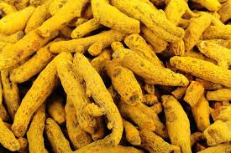 /Pʊdno/(mint) - It is abundantly available in Chamalvas. The leaves of the herb are mixed with onion and eaten for appetite. It is also used to cure sore throat; dried leaf powder is mixed with curd and taken. /Pʊdno/(mint) 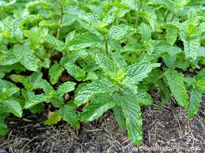 /kacʰ-/ - In case of snake bites or dog bites, kacʰ- which is a grass like herb, green in coloris used. This herb grows in the jungles of Chamalvas. /katiːr/(agar agar) - It is used to treat stomach heat. Kati:r is soaked in water over night, which turns it soft. It is then taken with water or milk. /halijaːn/ - It is a small seed which is used to cure eye disease. Haliyan is found in the jungle of Chamalvas /isboɡul/ - It is used to cure constipation and other digestion problems. It is taken with curd during diarrhea and with milk or water during constipation. /isboɡul/ 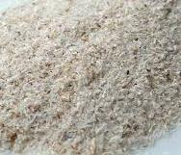 /ʃaŋɡər/ - Decoction of the root is taken to treat cough. It is boiled in water till it starts turning the water yellow. It is also given to children in case of cough and cold. 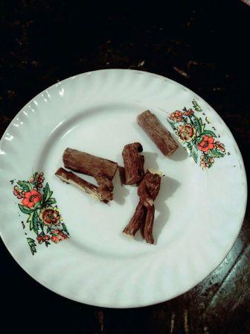 /lasun/(garlic) - It is either eaten raw or in the form of pickle by the person suffering from hypertension, stomach problem and is used to decrease the cholesterol content in the body. It is also used to overcome the hair growth problems. It is crushed and mixed with mustard oil and directly applied on scalp. Its regular usage helps in growing new hair and also helps in retaining them. /lasun/(garlic) 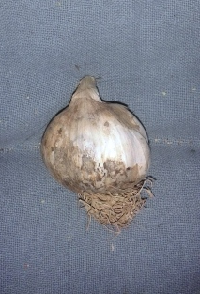 /Praŋtsolan/ - This herb is used to cure wounds. It is a grass like herb which grows in Chamalvas, it is crushed and mixed with oil and is applied on the wounds. /meth-danɨ/(mustard seeds) - These seeds are used to cure hypertension. These are boiled in water and sugar is added to it as per the taste of the person. /ədrak/(ginger) - a herb collected from the jungles of this place, it is crushed to extract its oil and this oil is applied on the tooth to get rid from the tooth ache. It is given the name adrak because the herb resembles ginger in shape but the values of this ethno medicine are much more than those of ginger. /ədrak/(ginger) 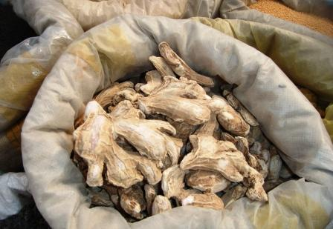 /droːd/ - a leather like thing sold by retail shopkeepers of Chamalvas is boiled in the water and then placed on the fractured bone, it relives the sufferer from pain. /marci phekʰ /(black pepper) - It is used to cure sore throat, it is a solution made by crushing black pepper and mixing it with sugar and water. /marci phekʰ /(black pepper) 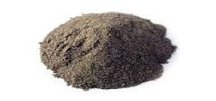 /maːcʰ/ (honey) - There are some people in the community who earn their bread by rearing bees. Honey has many medicinal values and people in Chamalvas use it to cure stomach problems. A mixture of honey, ginger juice and marci phekʰ (black pepper) is consumed during sore throat by the patient. It is also used as antiseptic. /maːcʰ/ (honey) 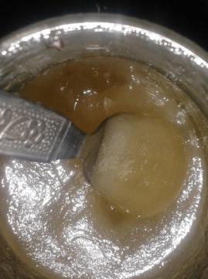 /Kõɡ/(Kesar) - It is considered to be very useful for the people suffering from low blood pressure. It is also given to pregnant ladies. /Kõɡ/(Kesar) 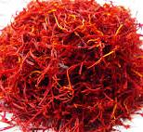 /kiʃmiʃ/ (raisins) - It is a cure to hypertension. Kishmish is consumed after frying it in ghee to cure chronic cough. It also serves as a nutritious diet to pregnant ladies. /kiʃmiʃ/ (raisins) 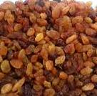 /tethwan/ - It is a herb used to cure abdominal pain, chronic fever, gout. It is also advised to diabetic patients. /kahzeban/ - Its whole plant is used for increasing lactation. The plant is boiled in water and given to lactating mother to enhance milk production. Its root extract is used in hair oils. /kʊtʰ / - Kuth is a shrub that grows to a height of about 60 cms. The roots of this plant have to be washed, dried, ground and mixed with oil. This is applied on joints to relieve the pain. /kʊtʰ / 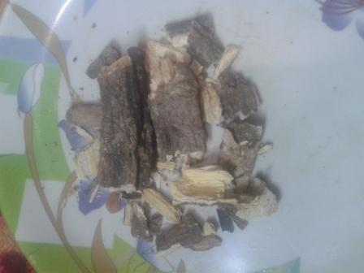 /hand/ This herb is given to mother after delivering a baby. It is also found useful in treating jaundice and dyspepsia. /hand/ 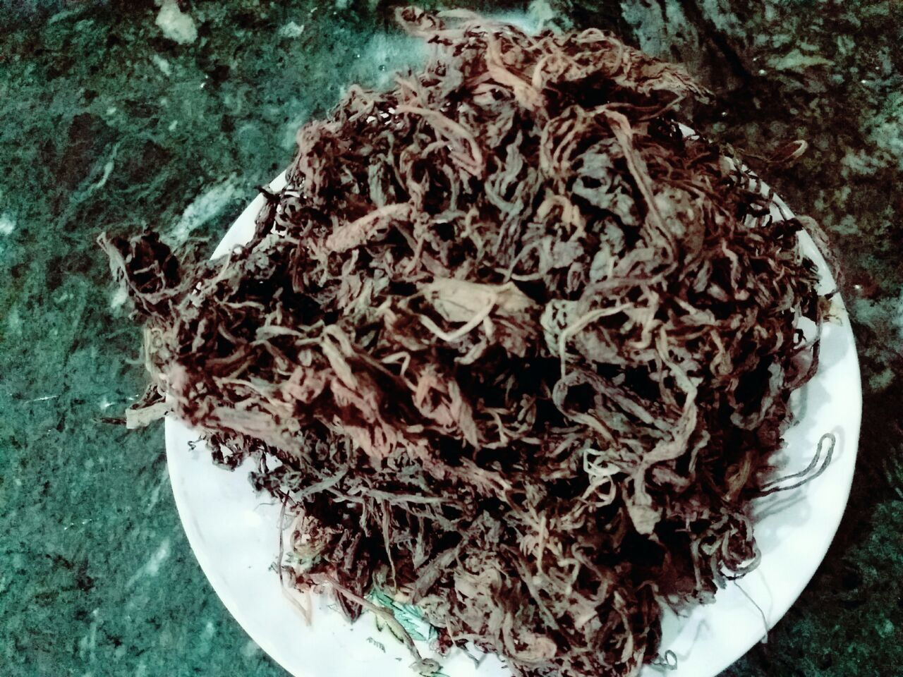 /ʃanɡɨr/ It is a herbaceous perennial, growing to 1 metre in height about 7-15 cm long, with 9-7 leaflets. It is used for cough. Its dried roots are taken with water. Also used as a mouth freshener. /rʊ̃ɡ/clove Dried cloves have analgesic properties and are used for toothache, headache, etc. They are also used in roasted, powdered form, and taken with honeyfor relief in digestive disorders. /rʊ̃ɡ/clove 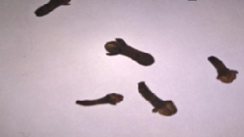 Color and Culture Linguistic Relativity and Colors According to Benjamin Whorf’s Linguistic Relativity Hypothesis a person’s language determines and limits what the person experiences. Not all concepts can be expressed in some languages. This language barrier can affect one’s perception of color. Quoting one example from the Chamalvas community, the Khana language has no words which distinguish red from pink and orange from yellow. Therefore, people fail to perceive different colors because of language limitations. When color terminology in different cultures is compared, certain patterns are observed consistently. All languages have designations for black and white. If a third hue is distinguished, it is red; next comes yellow or green, and then both yellow and green. Blue is the sixth color named, and brown is the seventh. Finally, in no particular sequence, the colors grey, orange, pink, and purple are designated. Color Theory We can see over 7 million colors. These are built from some basic building blocks: 1. Primary Colors. Red, blue and yellow are the basis of all other shades, and can’t be created by combining other colors. If all three are mixed together in equal amounts, they will make black. 2. Secondary Colors. This is the term used to describe the three colors that are created by mixing two primary colors together. There are three secondary colors: violet (made up of red and blue); orange (made up of red and yellow) and green (made up of yellow and blue). 3. Tertiary Colors. These come from mixing one primary with one secondary color. These are six: saffron (red and orange); lime (yellow with green); lavender (blue with violet); purple (red with violet); amber (yellow with orange) and turquoise (blue with green). Color Perception among Khana’s of Chamalvas Color Terms Used Krehna Black tʃʰut/səpʰed White ʊzlo Red Lidro Yellow nʲul Blue nʲul Green nʲul Purple mitʃʰɪ rɑ̃ŋ Brown ɡʊlɛbi rɑ̃ŋ Pink lɪdru Oranɡe Apart from these colors there are some other shades of colors perceived by community people like /pãj rãŋ/the color of water, /ɡolmə rãŋ/ the color of wheat,/mitʃʰi rãŋ/, the color of clay/soil,/asmani rãŋ/ the color of sky.Orange is perceived same as yellow(lidro).Blue and green are perceived as same (nʲul).Some compound formations show different shades of a color like /lidrɪ lidər/ (yellowish),/uzlo nar/ briɡht red,/ɡasus nʲul/ greenish like ɡrass,/krʊhnə zahər/dark black,/səphʰed ʃin/ (snow white) etc. Climate and Color Even the climate in which we live influences our color preferences, according to psychologist E.R. Jaensch. Jaensch‟s research indicates those who live in climates with a lot of sunlight prefer warm bright colors; while those from climates with less sunlight prefer cooler, less saturated colors. But the environment and the climate also dictate the way colors are classified, according to the relevance they have in the everyday life. For example, the Khana people live in the valley surrounded by nature; they live under the blue sky surrounded by greenery so in a wider horizon they relate both, and hence have the same term for green and blue color. They also use different words for white like tʃʰʊt ʃin, səpʰed ʃin, tʃəmkilə səpʰed, tʃʰut səpʰed, etc. applied to different snow conditions. The Meaning of Colors in Religions It is important to remember that religion is an important part of culture, and that in every religion colors have their associations. An inappropriate use of color can be perceived as offensive. For the people of the community white (səpʰed) is sacred, and is considered auscipicious. It is perceived as divine and heavenly. That forms one of the reasons why mosques are painted White and shrouds are also white in color. Green is also perceived as auspicious due to the religious associations.it is believed that the gardens of paradise are green in color and hence perceived auspiciously. Mosques and other religious structures are not painted with Red and Black colors because they are considered inauspicious and are prohibited for this use. As black is believed to be the color of darkness and evil and red is the color of Satan (devil). The Idiomatic Use of Colors in Languages Many languages use names of colors to express moods and feelings. In all languages there are numerous expressions in which color plays an important role. In most cases there is no equivalent in other languages and when translating them literally the meaning is lost. Colors are associated with certain images. For example White is associated with divine and pure, black is associated with darkness, red with anger, fire, and brightness, etc - su nʲuk cʰu zan cʰut ʃin That child is as fair as snow.(cʰut ʃin used for a fair child) - su goh zan uzlo nar He turned red. (uzlo naːr used for an anɡry person) - su muhun os kruhni ha:j That man was black like darkness (kruhni ha:j is used for a person who is possessed, it’s also used for some natural calamity and fear. Color and Context A single color can have many different meanings in different cultures. In Khana community white is a positive, the color of angels ,spiritually enlightened, pure color, while as red is the color of devil, it is not liked by community people even men are prohibited to wear red due to religious prohibitions. It is believed that red is too bright and the Prophet (PBUH) has prohibited it. Most of the women do not wear red while going into the upper reaches of the forests, as itis believed that evil spirits,jinn and other animals get attracted to them and they get possessed. Red is considered inauspicious for the bride. The bridal dress is mainly blue or green (nʲul) in color. Colors can symbolize a rite of passage (those linked to birth, weddings, and funerals). In addition to all the traditional meanings associated with colors in various cultures there are also those layers of meaning brought about by context. The connotation of black (krehno ha:j) is used if someone is possessed and the color of his/her face has turned darker or pale, as black interprets darkness and fear. White is used in a pious connotation. For example the white beard of a noble old man is considered as good.it is believed that his prayers are accepted and he has the spiritual power to heal people. Pictoral description of the various items used in the community. 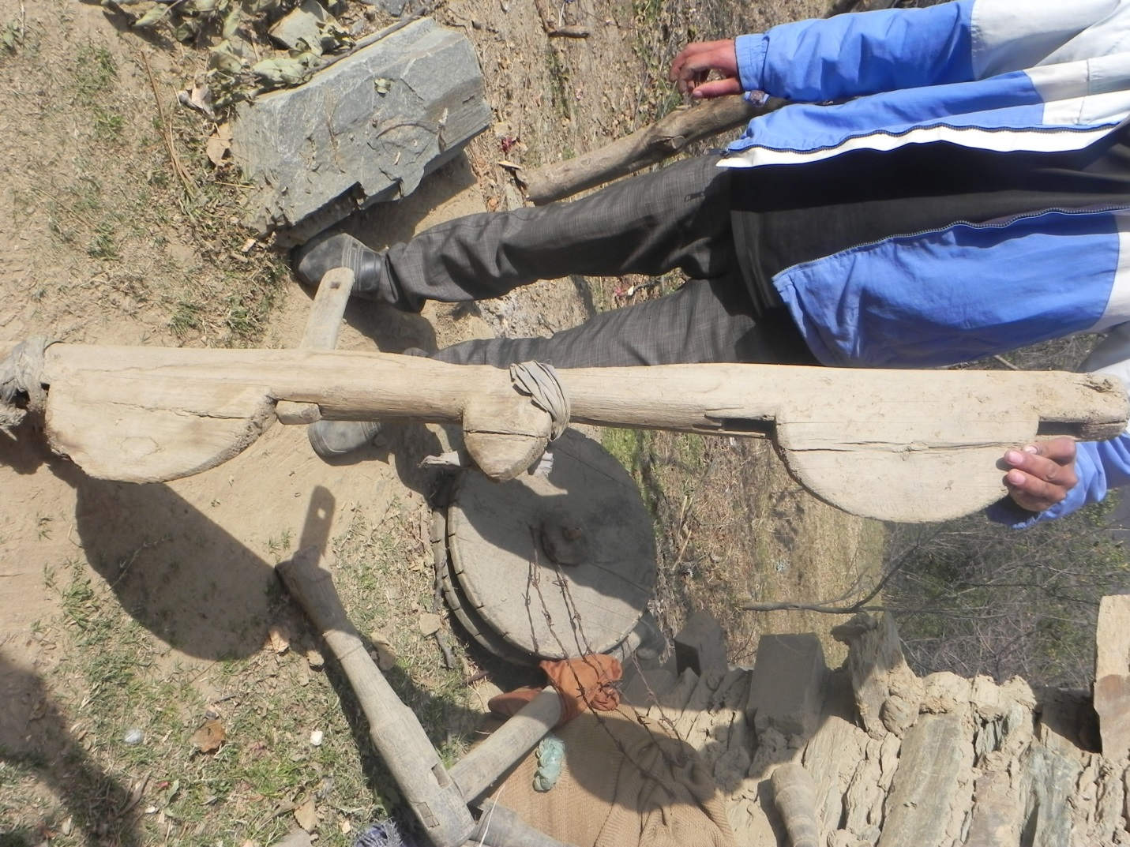 /dʒupɛt^{j}/ A wooden yokeː it is placed on the necks of a pair of oxen and secured to them by means of a pair of pegs on either side of the yoke. These pegs pass through apertures in the yoke. The pegs are thicker at one end which holds them fast in the yoke. The thinner ends are perforated. A rope or a leather strap passes between each pair of pegs under the neck of an ox at each end of a yoke. The peg is called as /hʌm/ and the rope or leather strap is termed as /kalmɨ/. There is a projection in the middle of the yoke to which any agricultural implement which needs to be pulled across a field, such as a plough, can be tied with a rope. 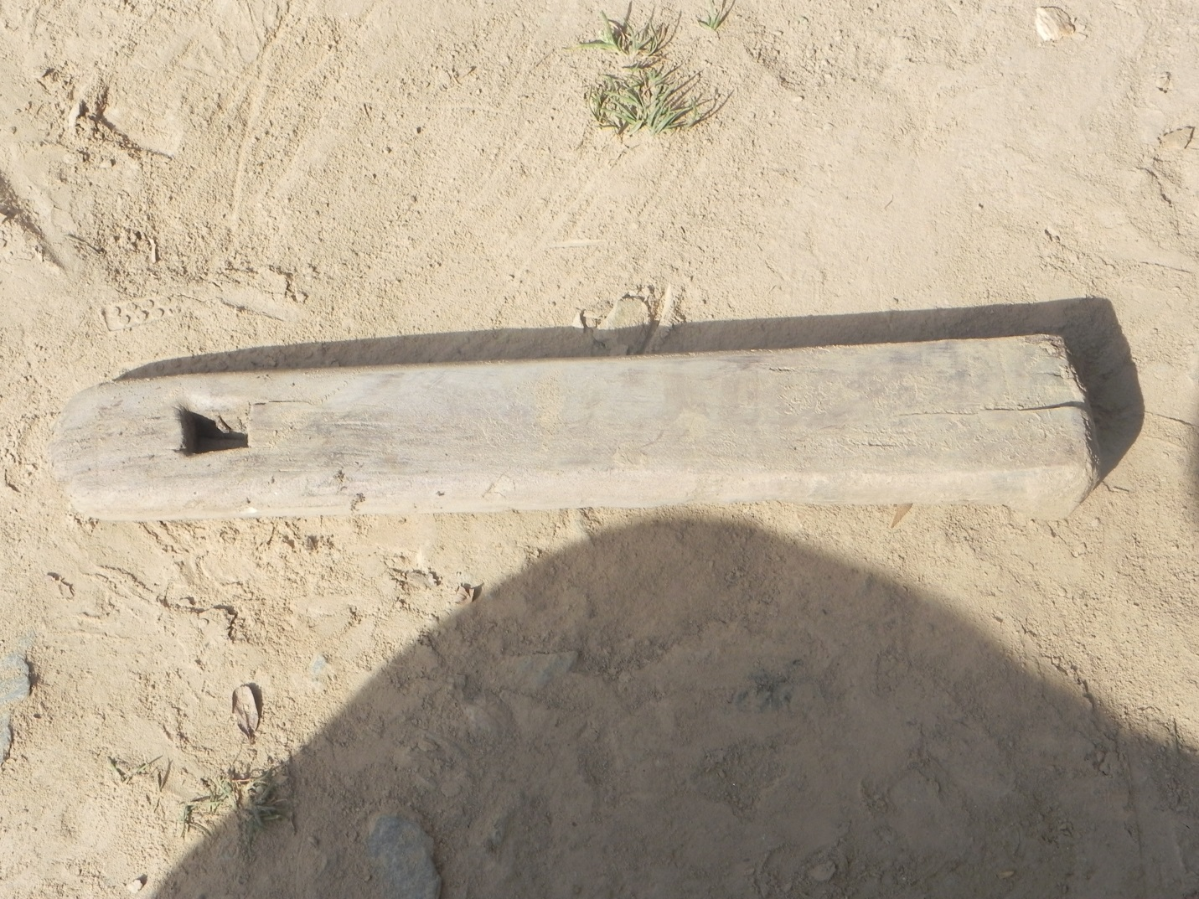 /hʌm/ One of the four pegs which pass through apertures in a /dʒupɛt^{j}/ and secure it to the necks of the oxen in conjunction with a couple of lengths of rope. It is a flat elongate tapering piece of wood perforated at its thinner end. 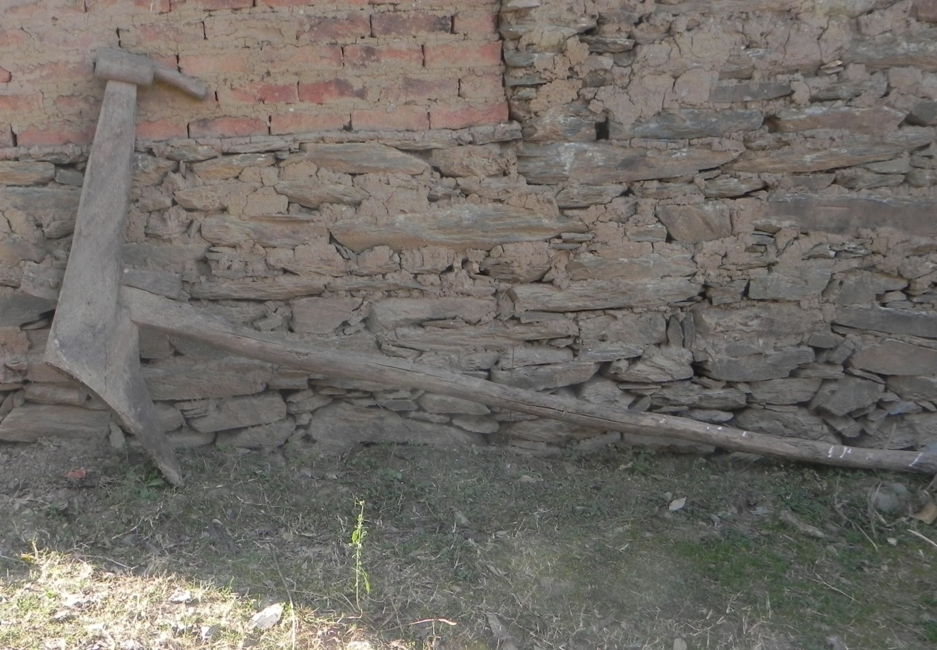 /albæn^{j}/ A plough: As is clear from the picture, the structure is quite simple. It consists of a beam which is called as /lãːz/; the body and shoe are joined into one piece which is called as /balkiːl/; the tip of /balkiːl/ (sometimes equipped with iron) which digs into the ground is termed as /faːl/; and finally the handle of the plough which is fixed directly to /balkiːl/ is called as /kukliː/.This equipment is used by farmers for tilling the land. This is useful in loosening the rocky soil layer and making the land fertile and porous. 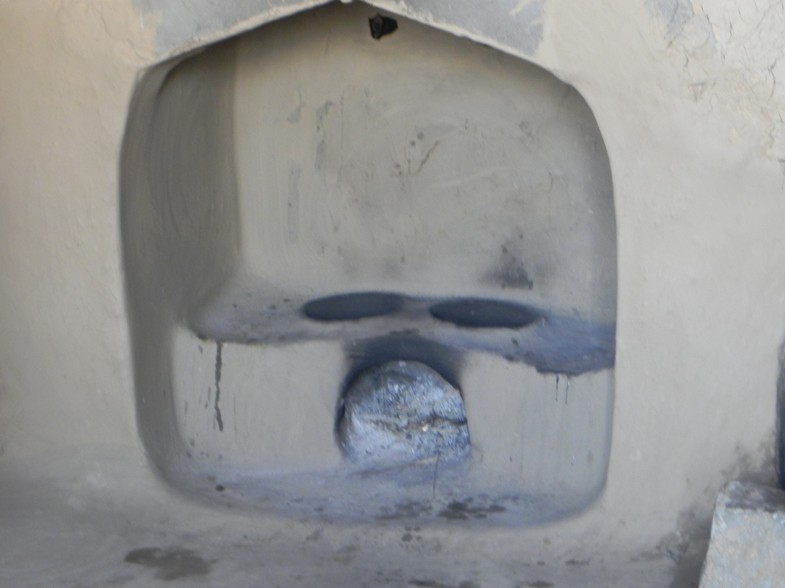 /d̪ua:n/ An earthen stove built at the base of a kitchen chimney; it consists of a semicircular opening in front, for the fuel (usually dry twigs, cow dung cakes and firewood). This opening branches off into two other circular openings at the top on which vessels can be placed. A /d̪ua:n/ can also occur outside under some shelter. A /d̪ua:n/ inside a kitchen does the additional job of heating the water inside a metal or baked clay tank placed at the back of a /d̪ua:n/. This happens due to the smoke which moves in to the hollow space around the tank through a couple of perforations at the back of a /d̪ua:n/ and then escapes back into the chimney through a perforation located higher up in the chimney. 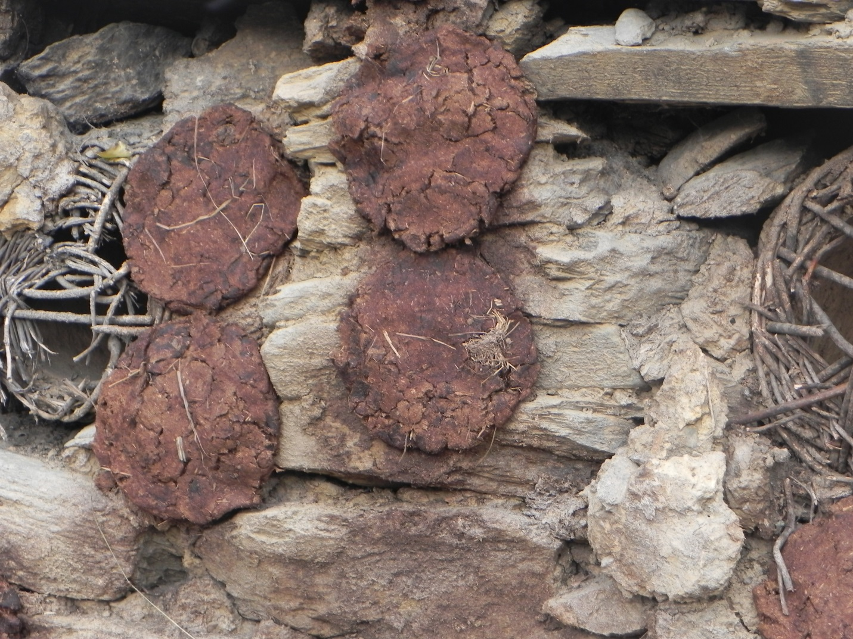 /gumpæt̪/ Cow dung cakes stuck to a wall to dry in the sun; these are later burnt as fuel for cooking in a /d̪ua:n/ and also for warmth in a /kãːɡdi/ during the winter. 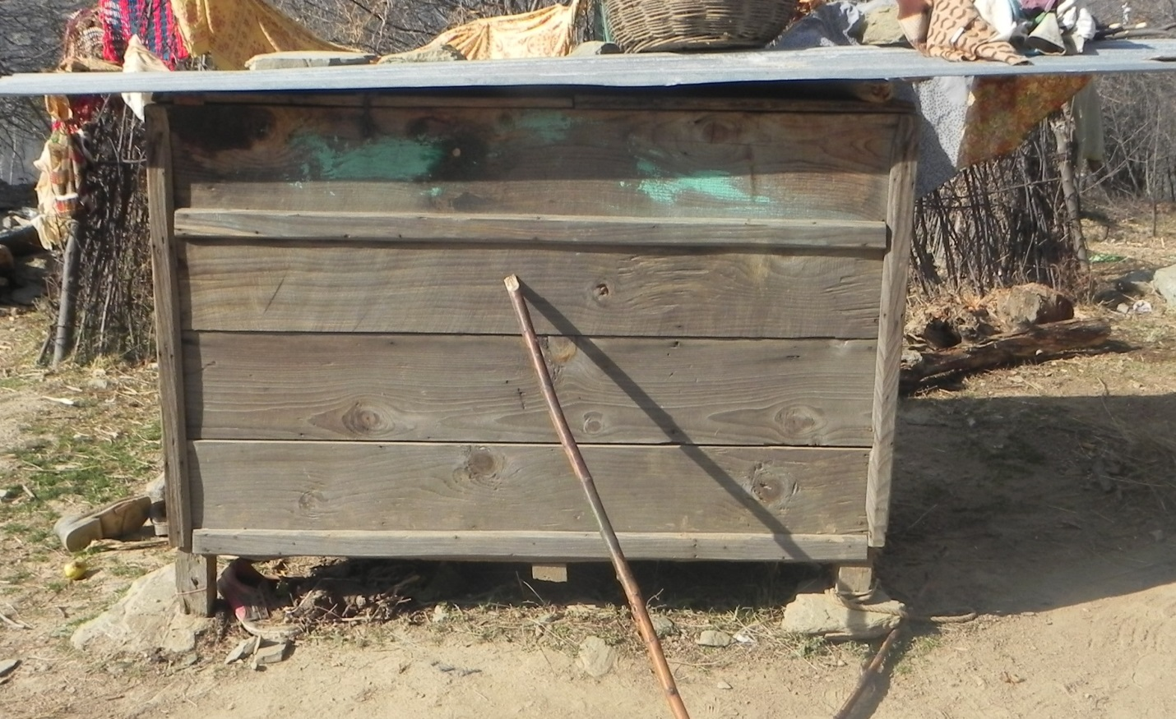 /kɔʈʰaːr/ A large rectangular box made of planks of wood and a wooden frame which holds the planks in position; half of its top is a lid hinged to the other half. It is used to store grains like paddy and corn. There is a small opening at the bottom which can be opened and closed by a small wooden shutter. 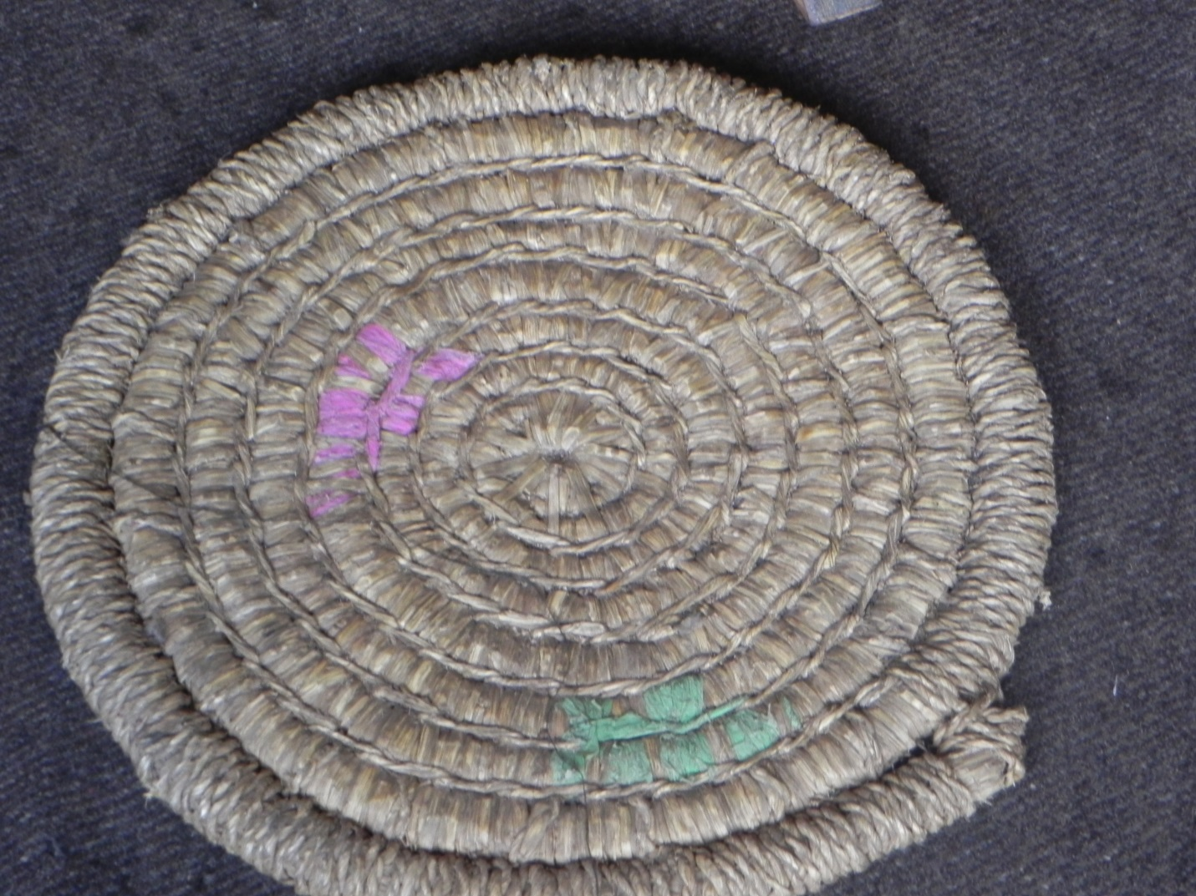 /tsa:ŋɡɖiː/ A circular mat woven out of paddy straw, usually by women; it can usually accommodate a single person at a time. It is usually used in the kitchen. It can be bedecked with something such as colored paper,thread,etc. This /tsa:ŋɡɖiː/ is also used for decorating walls ,etc. and forms and important item of art an artifact. It shows the creativity of the Khana women who have somehow preserved their culture. 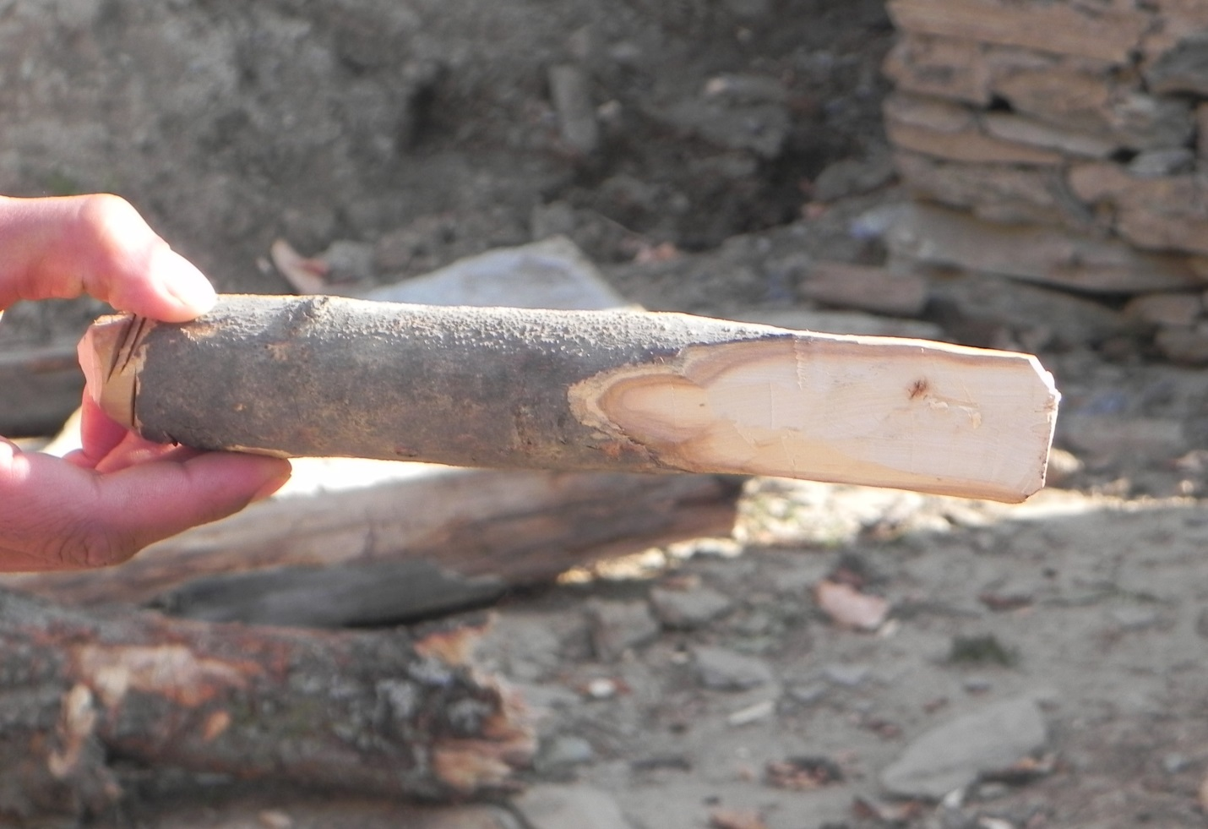 /p^{h}a:nɨ/ A wedge, used in splitting firewood; it can be made of wood/hacav pʰaːnɨ/as in the picture above or of iron This is a tool which is put to use daily because the people need split firewood every day for cooking their food and for warmth, as soon as the winter sets in. The /ʃaːhtrav pʰaːnɨ/can easily be made anywhere with a sharp tool such as an ax. 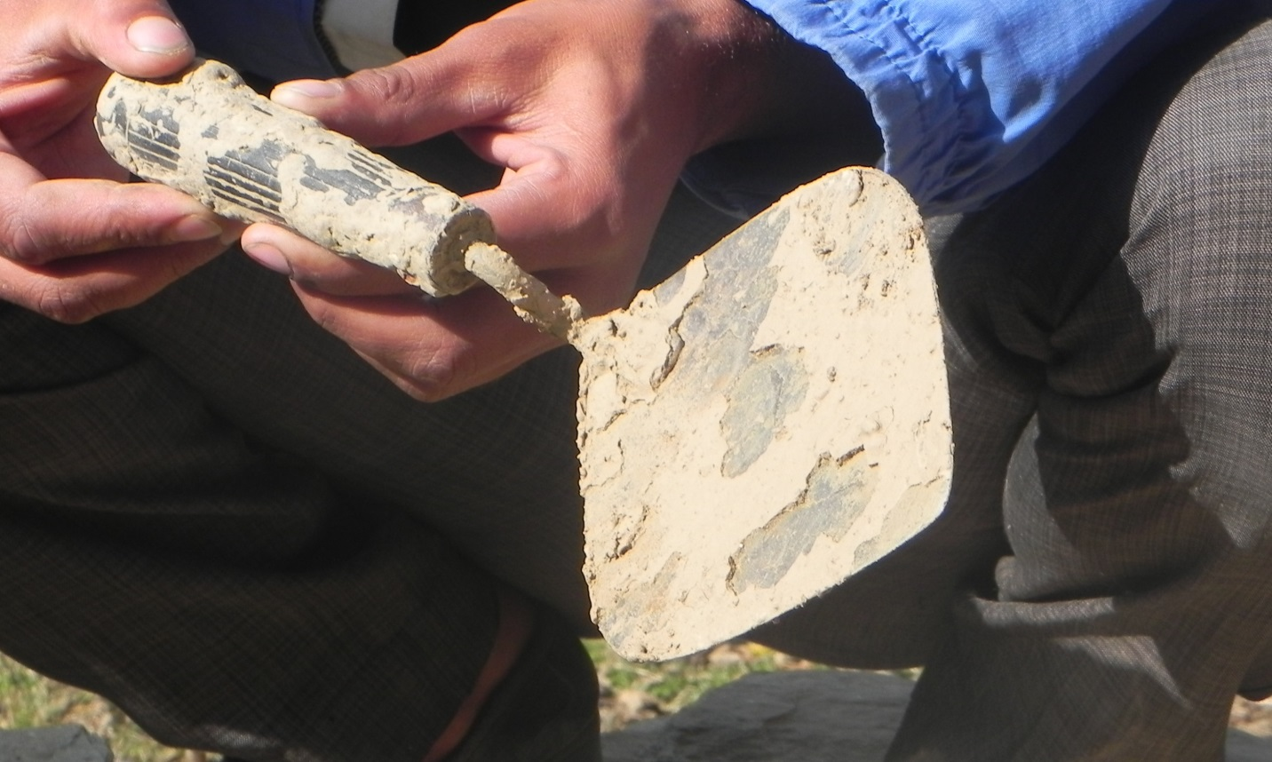 /krændi/ A trowel: The tool is made up of iron and its handle is made up of either plastic or wood. It is used to apply, spread, shape, smooth clay or cement by a mason.

