REPORT OF THE PROJECT
Scheme for protection and preservation of endangered languages
for the month of November,
LANGUAGE : PADDARI
DISTRICT : KISHTWAR

SUBMITTED TO
Central Institute of Indian Languages
(Ministry of Human Resource Development, Govt. of India, Department of Higher Education)
Manasagangotri, Mysore – 570 006 (Karnataka).

Principal Investigator : Prof. M.K Koul
Resource Persons : 1. Sanna Usman
2. Neelofar Hussain Wani
3. Mohd Syed Lone
Domain= Agricultural

Introduction: Agricultural is the main occupation of the paddar. More than 90 percent people do farming with traditional system and almost all population of paddar villages depend over it for their livelihood. The shifting cultivation and terrace (bun) agriculture are two main types of farming. Both the Rabi & Kharif crops are cultivated but only half of the agricultural land is accounted for farming due to highly diversified topography. The prominent crop of Paddar is KODRA. It is a Kharif crop grown almost in all Paddar.
Agricultural Practices: This part of the research discusses the agricultural practices and tools used in Paddar area of the Kishtwar district of the Jammu & Kashmir State. It is hilly area with varied topographic features’, right climatic conditions appropriate for cultivation of many types of crops and fruits. The soil is rich with minerals and organic matter. However agricultural, in general is handicapped due unroad connectivity, scattered land holdings, steep and primitive agricultural tools and techniques.

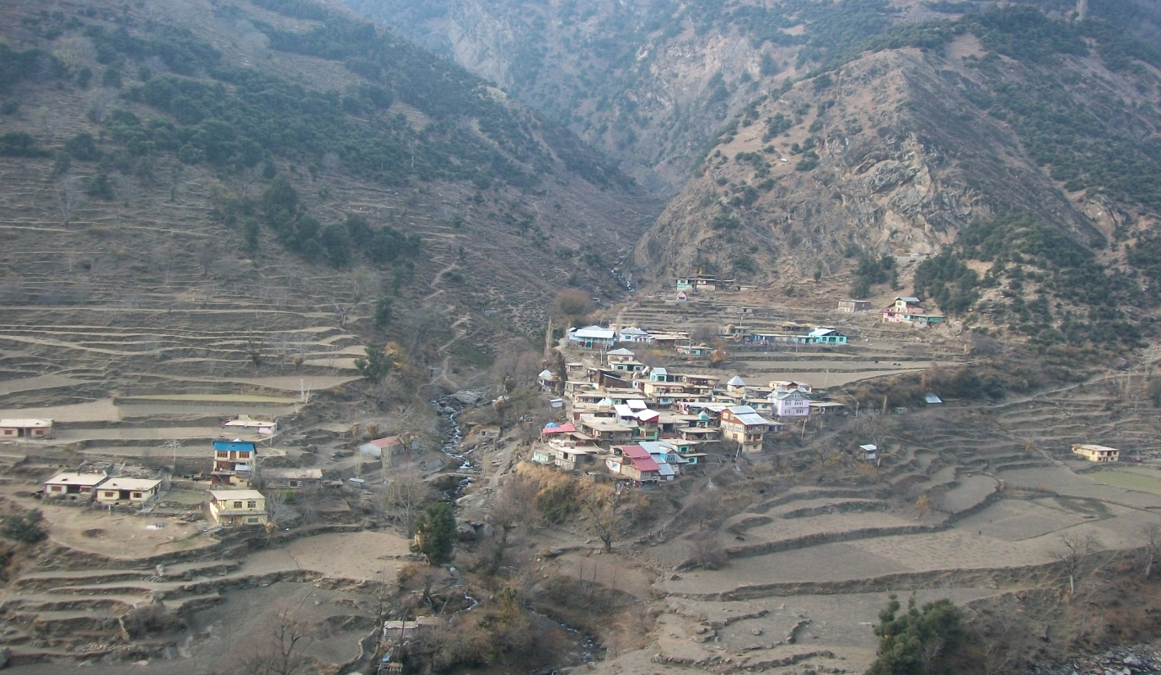
The findings contribute to the answer of the research questions like
- Is there any change in agricultural practices from grandparents to present in paddar?
- Is there any change in tools and techniques in farming from grandparents to present in paddar?
- Is there any change in crop production in paddar from grandparents to present in paddar?
- What are main crops produced Irrigation system and various crop seasons in paddar?
The data for the said domain was collected from 7 villages and 3 towns in which Massu, Garh, Machail and Sool remained prominent. The main tool for data collection was informal interview besides, observation. Both systematic and purposive samplings have been used to determine the research sample. The population was stratified by age, gender and education.
Agricultural Tools: since paddar is mostly hilly and there is little or no road connectivity among the villages. People use primitive and traditional agricultural tools for agricultural production. They use subsistence type of farming in which old methods of production, no fertilizers, no pesticides, no weedicides are brought into use. The tractors, power tillers can,t be used there due to mentioned reasons. Some of the peculiar agricultural tools used there are:
/ Laʈʰ/ Plough: It is the tractor of the paddar villages. It is the basic tool considered as the backbone of the farming. It is made up of wood easily available in the nearby forests. The wood is of some special type with the features of- light weight, durable, strong, straight etc. People used it from time immemorial with little or no modification at all. The local carpenter made it with feasible designs. It is used for tillage. It makes soil loose and fit for seed plantation & plant growth. The basic components of the plough are a shoe, a share, a body, a handle and a beam. . The Joint between the shoe and the body is purposely avoided with a view to make the plough more rigid and robust, so that the implement can work on gravely soils with stones and other obstacles which are encountered during the course of ploughing. The shoe, used in the plough, can be of different shapes and sizes. Ploughs used in dry lands have shoes which are generally of a triangular section while in wet land cultivation the shoes are of a more flat section.

Fig. 1 /Laʈʰ/
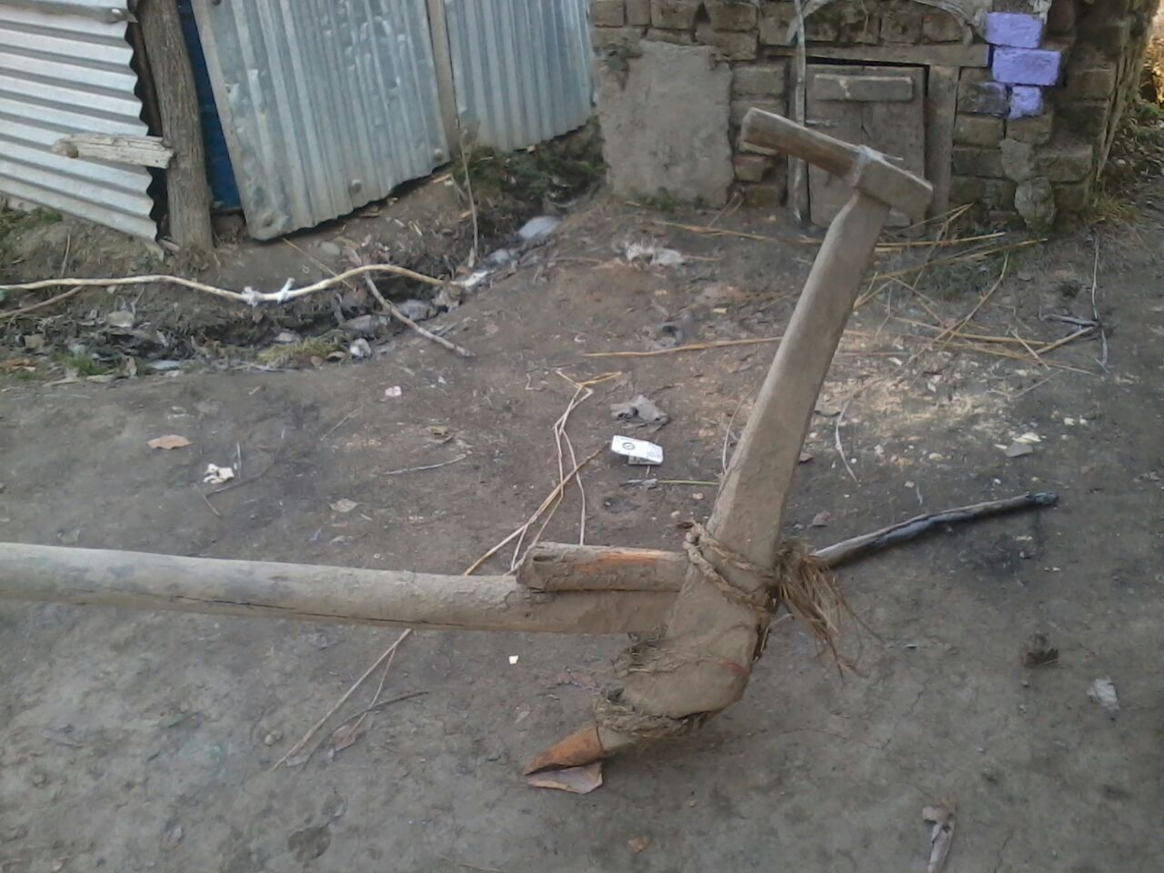

/ zũː/ Neck-Yoke: It is the agricultural tool which is used to hold bulls. It has hole usually at the centre for fixing plough by some specially designed wood. Since plough is fixed with yoke and when bulls walk, plough is also pulled. Thus soil is turned. It is also made up of wood but has ropes attached.

Fig.2 / zũː/
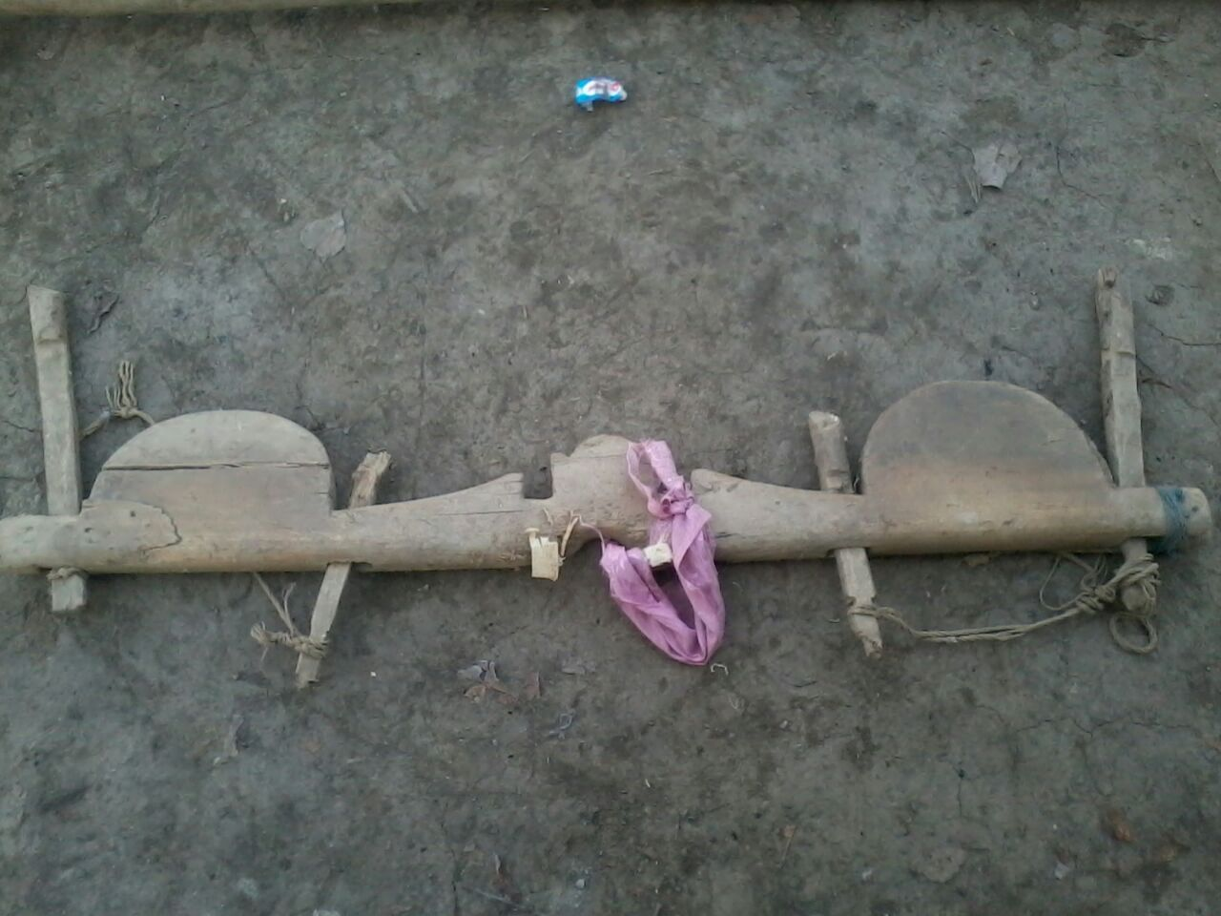
/kaŋaj/ Harrow: it has the basic design similar to the plough but instead of sharp share, its shoe contains holes with sharp strong sticks of wood fixed. Its handle is made of a branch of sturdy wood and the tool itself is made of branches of tree and is shaped like an arrowhead. It is used for uprooting of weeds. First soil is loosening by plough 2-3 times, and then only harrow can be used for removing unwanted plants. There may be 7-11 sticks of wood attached to shoe of the harrow. In some areas instead of wooden sticks iron rods are attached.

Fiɡ. ɜ. /kaŋaj/ Harrow
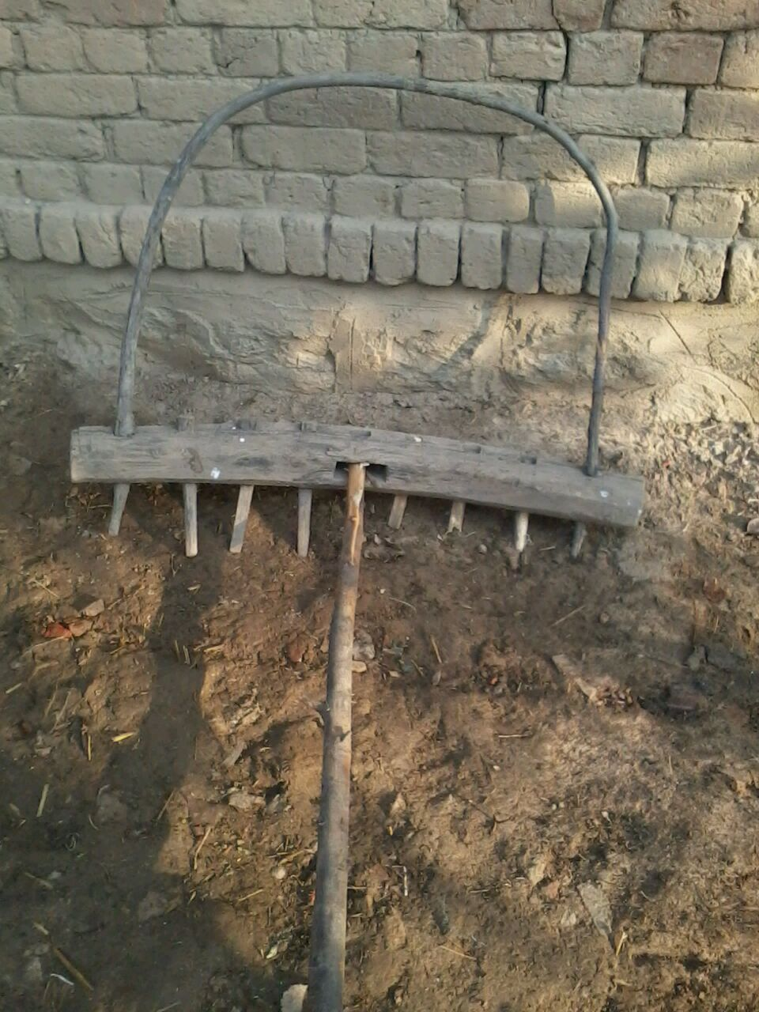

/bãɖiki/ Axe: It is the tool for cutting any type of wood, trees and other plants. To make any type of agricultural tool, role of axe can’t be ignored. It is used to clear the land from plants or dead wood or to make handles for other operation tools for farming. It has two parts one form handle made up of dry wood and other sharp part made from iron.

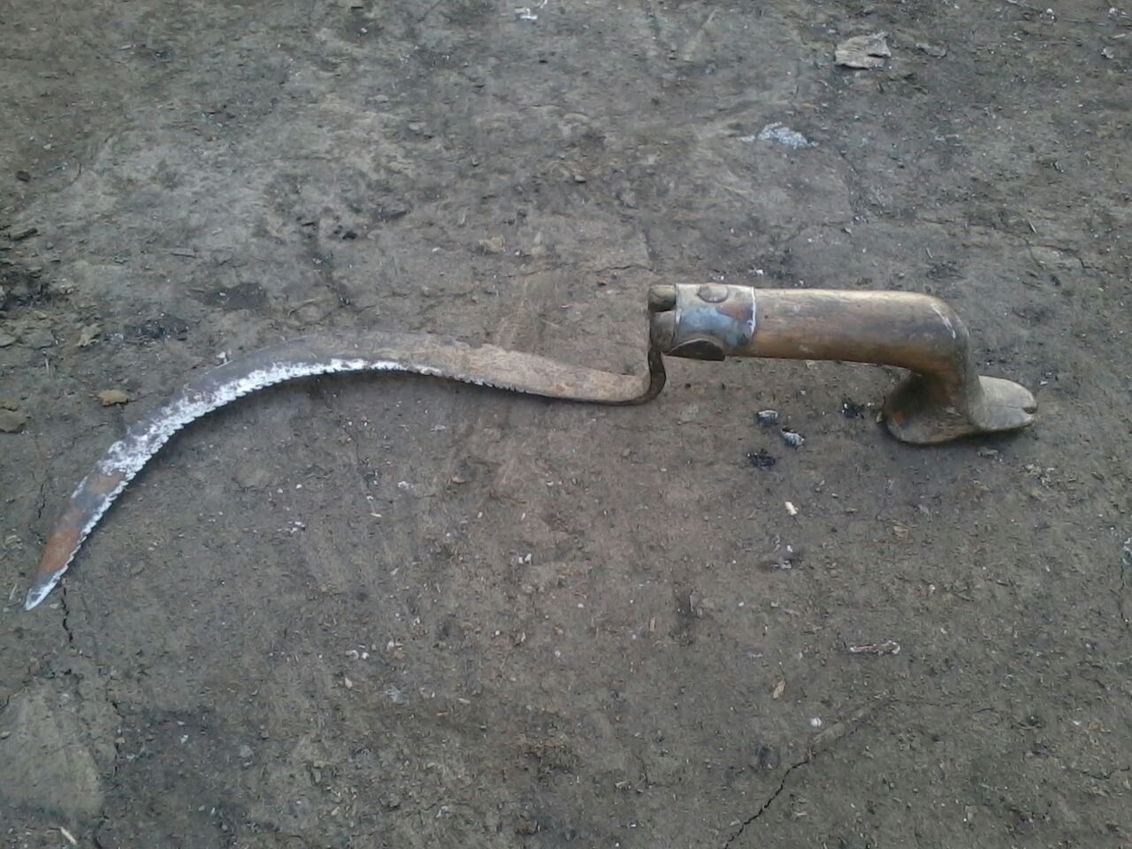
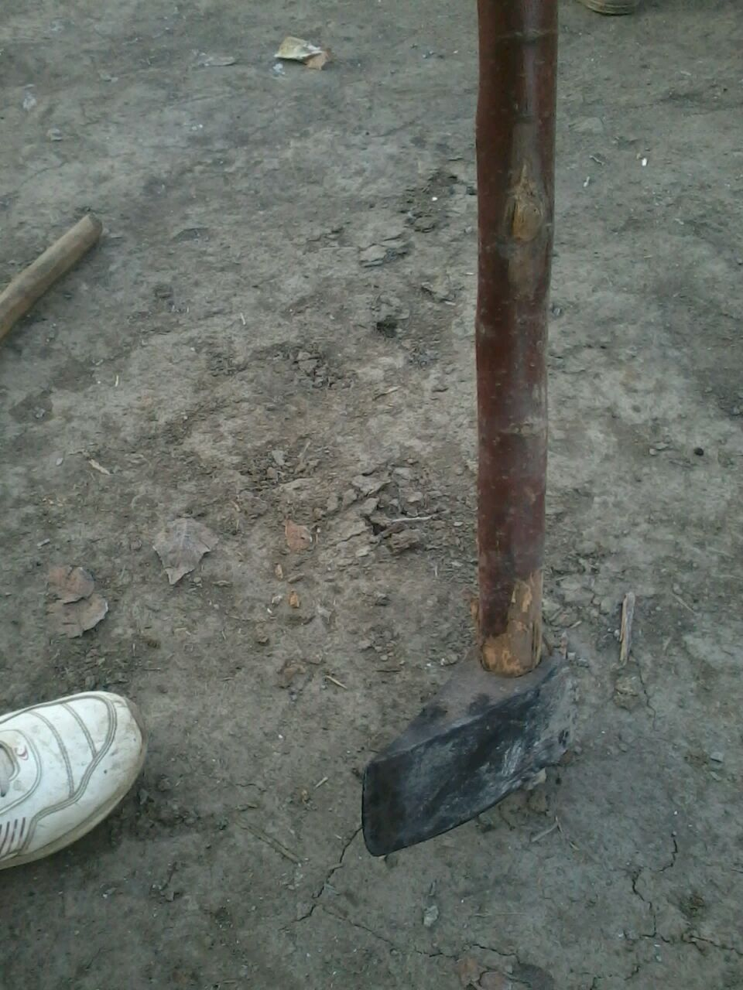
Sickle: it is the harvest tool made from iron with short handle made from wood. It is used for cutting grass for animals and crops. It has arc shape with sharp inner side. There are few kinds of sickles used in Paddar depend upon size and structure. Some are small sized and usually used for cutting grass while big ones used for cutting crops, bushes etc. Most sickles have teeth on inner side but some are without teeth and are used for cutting tree branches for feeding cattle’s.

Granary: There is no community granary generally but every house has a small structure within so called kitchen in which grains are stored. Grains are first dried in sun and they husk is removed by some traditional methods and tools. Since most of the paddar villages lack road conductivity and had no electricity facilities therefore no electric device is used to remove the husk from the grains. The traditional way unique to paddar for removing husk from grains and make them fit for eating is very complex. It requires huge manpower and some 5 persons simultaneously. The traditional husk removing device consists of many parts made mostly from wood and rest from rocks. The rocks are fine finished and cylinder like shapes are made. The traditional Rice Mill works on principle of simple machine.
/kuɖaːlʲ/ /bũɡəɖiː/ Grub Hoe: This is the agricultural tool used for digging the soil where plough can’t be used. It is commonly used tillage when land holdings are small. This is mostly used by women in their kitchen garden for cultivating vegetables.

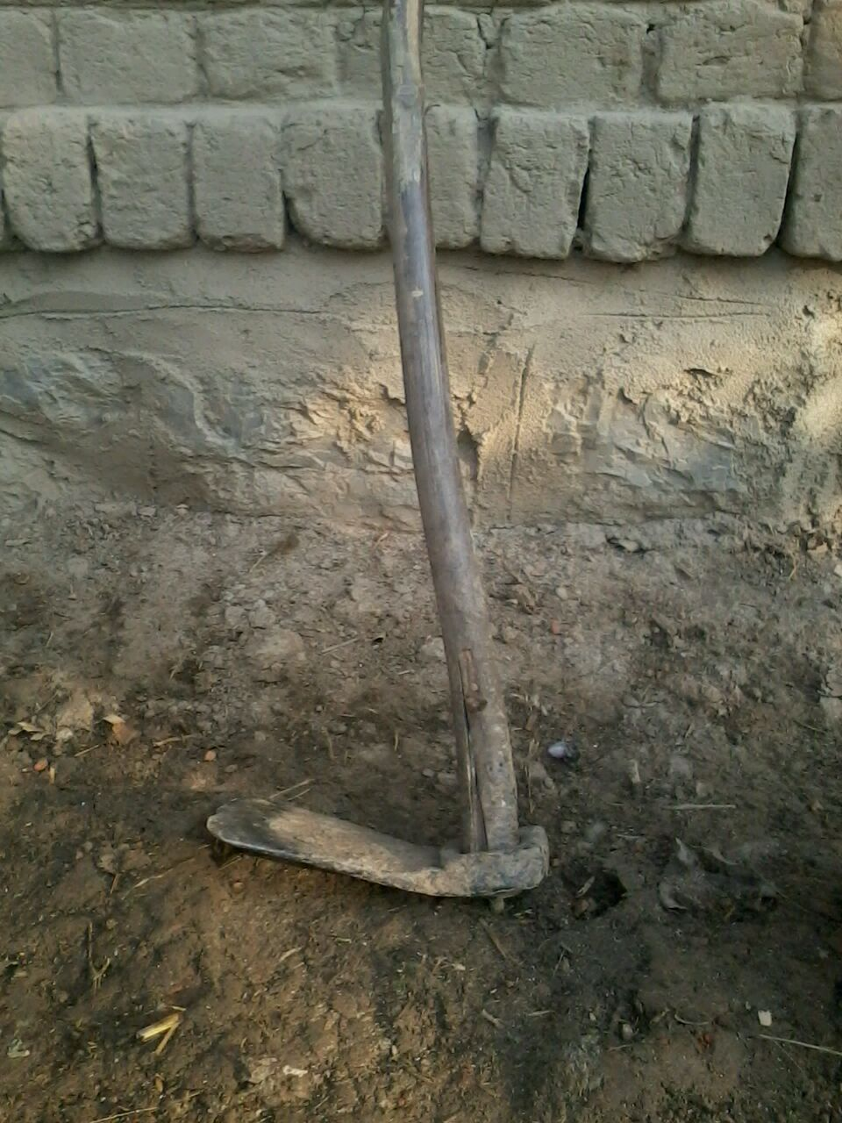
Shovel: This agricultural tool is used in for doing many agricultural operations like making holes in earth for plantation agricultural. It has two parts, one flat sharp edged iron part and other wooden beam.

