PROJECT REPORT
Scheme for Protection and Preservation of Endangered Languages

LANGUAGE : BHADRALIUM
DISTRICT : DODA

Submitted to
The coordinator
Dr.L.Ramamoorthy
Central Institute of Indian Languages (CIIL), Mysore
Manasagangotri - 570006 (Karnataka)

Submitted by
Shahid Yousuf Gilkar
Sumaiya Jehangir
Farah Aarif

Personal Invigilator
Prof. Aadil Amin Kak
Department of Linguistics,
University of Kashmir

CONTENTS
 | Page No.
Overview of the Community  - Origin  - Religion  - Places of worship  - Settlement pattern  - Structure of houses  - Means of transport  - Occupation  - Beliefs and attitudes  - Physical features  - Cultural context | 1  2  2  3  5  5  12  13  14  15  18
Clothing and Ornamemts
- Clothing  - Ornaments | 19  20
Food
- Methods of Procuring Food  - Apiculture  - Hunting and Gathering  - Animal Husbandry  - Agriculture  - Daily Schedule of Meals  - Food in Marriages  - Food for Pregnant Ladies | 23  23  24  25  26  28  30  31
Judiciary | 32
- Gram Panchayat  - Panchayat Samiti  - Zilla Parishad | 32  33  34
Pictorial description of various items used in community Folklore
- Legends  - Fables  - Belief system  - Proverbs  - Songs  - Riddles | 37  44  45  47  48  49
Fairs and Festivals
- Festival  - Fairs  - Popular Traditions | 51  52  53
Colour Terms
- Colour Terms  - Colour terms of Bhadralium  - Shades of Colours  - Myths related to different colours in Bhadralium | 82  82  85  87
Kinship
- Bases of Kinship  - Importance of kinship  - Types of kinship  - Kinship analysis | 88  90  94  96
Rites and Rituals
- Birth and death rituals  - Birth rites and rituals  - Death rites and rituals  - Marriage rites and rituals | 100  100  105  109
Language Identification
- Domains of Use  - Language attitude | 127  131

OVERVIEW OF THE COMMUNITY
The mother tongue Bhadralium is spoken by the community living in an area known as Tipri village in district Doda.Tipri is located approximately 40 km from Doda. It is perched on a rocky slope accessed by a very difficult road from the township of Thathri, located about 25 to 30 km from Doda. Neighboring villages include /zadaːnuː/, /c^{h}ibaː/, /dabraːnuː/, and /bãdikra/. According to the Sarpanch of the village the population of the village is about six thousand and forty percent of it speak Bhaderwahi. This did not appear to be borne out by what was observed. There were no more than three hundred households in the entire village with over ten members in each of them. This places the estimate of the population around three thousand. Out of these only about 40 to 50 households (almost all of which occur in a single cluster near the entry of the village by a rough road) speakBhadralium as their mother tongue placing their population at aboutfive hundred.
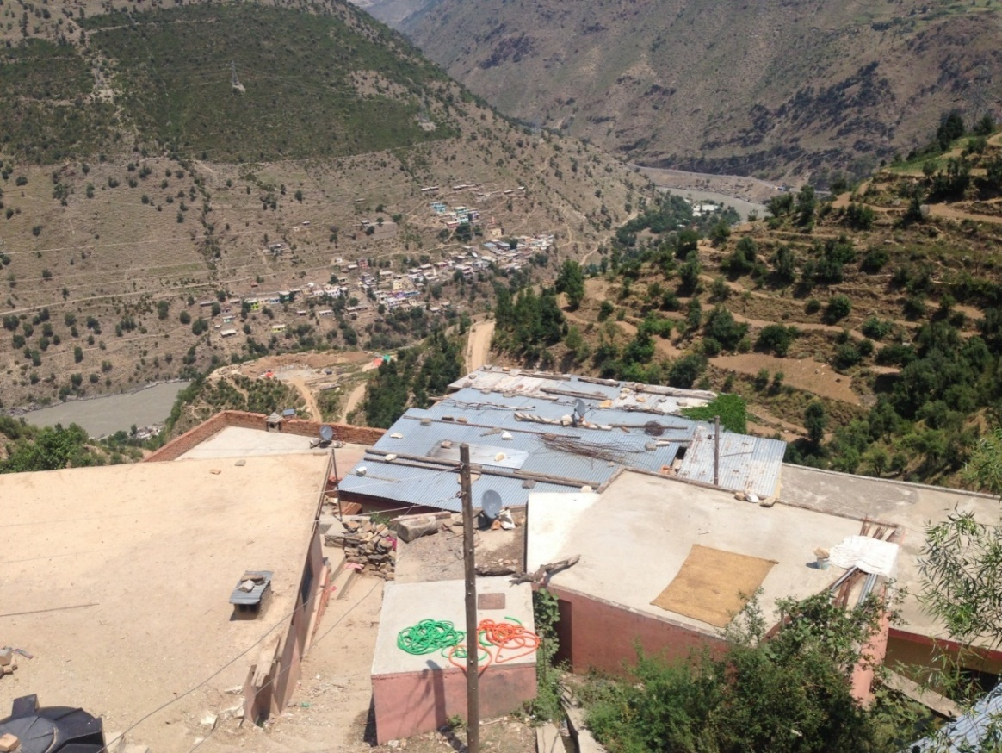
Aerial View
Three languages are spoken in Tipri: Urdu, Badherwahi (Bhadralium), and Kashmiri, with Kashmiri functioning as lingua franca.The Muslims speak Kashmiri among themselves and with the Hindus. They know little Bhadralium. The Hindu population has Bhadralium as its language, but use Kashmiri as well when interacting with the Muslims. This association of Kashmiri with the Muslim community and of a different language (in this case, Bhadralium) with the neighboring Hindu community is an interesting phenomenon prevalent throughout the mountains around Doda. In fact, to the Hindu community in a village the denotation of the term ‘Kashmiri’ includes both the language and the religion of the neighboring community.
Bhadhralium has no written texts, but quite a bit of folklore and folk songs.
ORIGIN
As far as the origin of the community is concerned, one of the informants, named Bhod Raj Sharma, claimed that they were originally the inhabitants of Rainawari, Srinagar. To escape the tyranny of the Mughal rulers of the valley, they migrated to Kishtawar and from there a man named Ramanand migrated along with his family to the place now called as Tipri due to some hostility there. He is the progenitor of the community. But this account of the origin of the community does not have any documentary evidence.
RELIGION
The religion of the community appears to be Shaivite Hinduism. The statues of lord Shiva and goddess Parvati are the most prevalent ones. The symbols of Trishul, snake and Om are prominent. These symbols are found round the doorways of houses, temples and shrines. The pictures and symbols of other gods and goddesses like Shakti or ShairoWali Mata and Lord Ganesha are also found but are not as prevalent as the statues, pictures and symbols of Shiva and Parvati.
PLACES OF WORSHIP
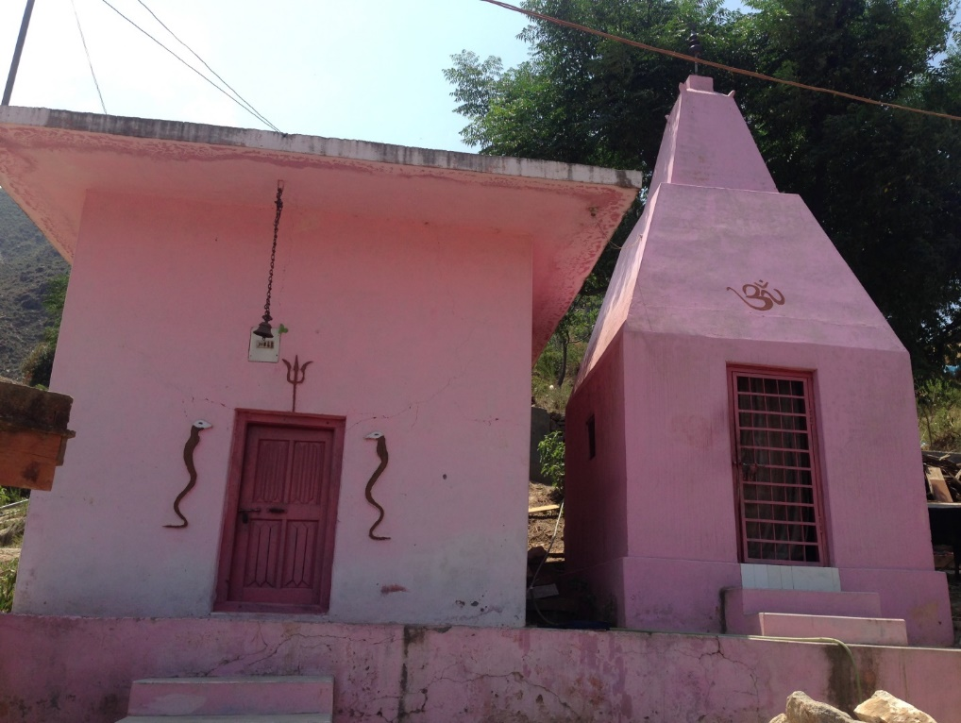
Temple in the middle of the community
There is a small temple dedicated to the worship of lord Shiva and goddess Parvati in the middle of the community.
There is a field above the village. At the edge of this field is a small shrine that houses a bunch of Trishuls and iron rods with snake heads. It has snakes painted on both sides of the opening which is towards the settlement. This shrine is called as /bi:rmandir/ (the shrine of the/ biːr/) by the community. The shrine is always located under a tree which has religious significance, called /biːrbalkiːv/ (the tree of the /biːr/). The shrine and the main village temple are painted pink and the above mentioned symbols are painted brown on this pink background. There is also a worn flat rock near the shrine with a Trishul carved into it.
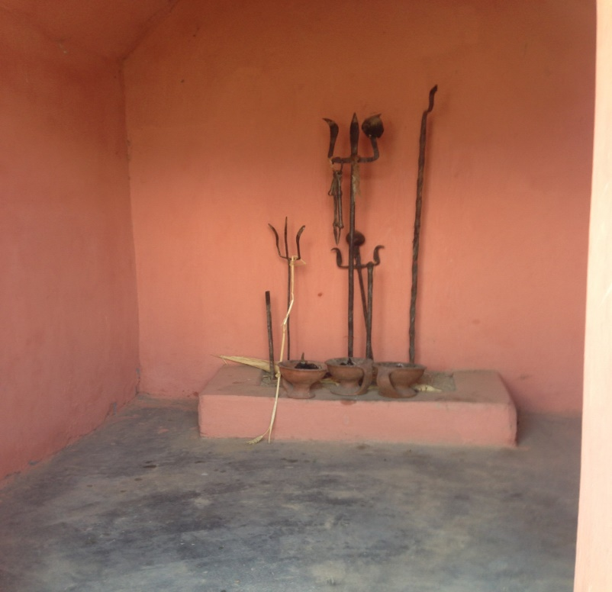
The Shrine at the edge of the village common.
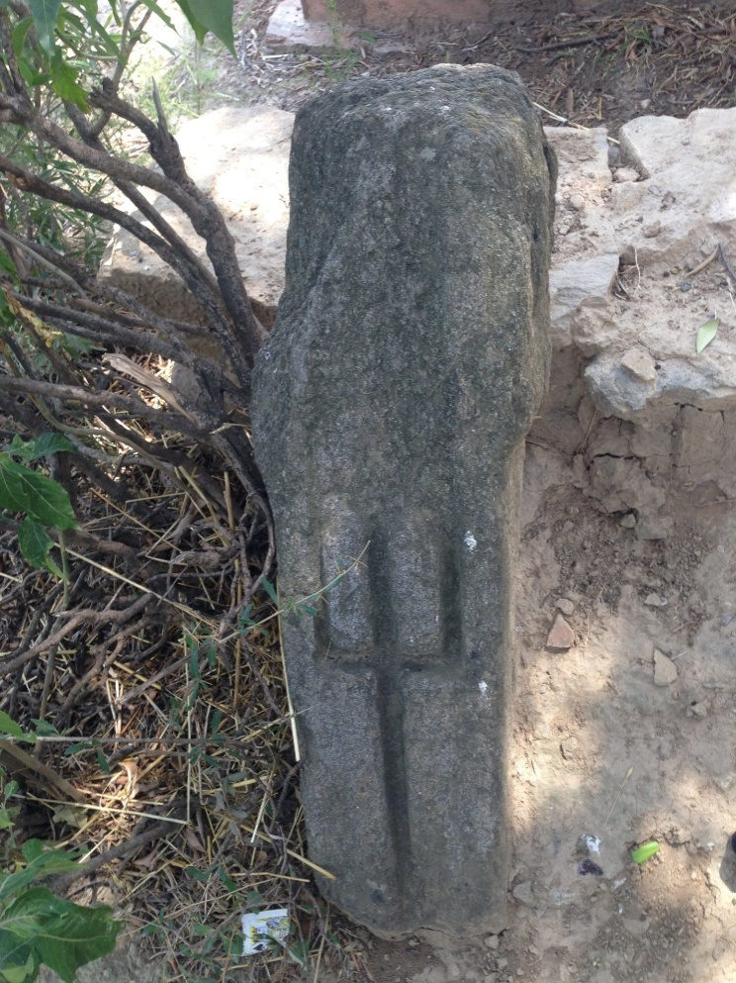
The worn flat rock near the shrine with a Trishul carved into it.

SETTLEMENT PATTERN
Houses are arranged mainly in three clusters: one located below the road and two above it. The first cluster encountered is above the road and belongs to the Hindu community. The cluster below the road belongs to a community of poorMuslim leather workers considered below their station by the other two communities.The cluster of houses directly above the leather-worker community belongs to a community of well-to-do Muslims. In addition to the three main clusters there are some houses which are located in a scattered manner some of which belong to the Hindus and some to the Muslims. It is the first community that is the focus of this study.
STRUCTURE OF HOUSES
The houses are adobe type one-storey shabby structures built close together one the mountain slope with a little kitchen garden here and there. They are juxtaposed so that one can simply walk onto the roof of a house from the yard of a house immediately above. The houses are made of bricks (baked or unbaked) or flat stones and clay or mortar. The roofs were either concrete or wooden with a foot thick layer of clay covering them.
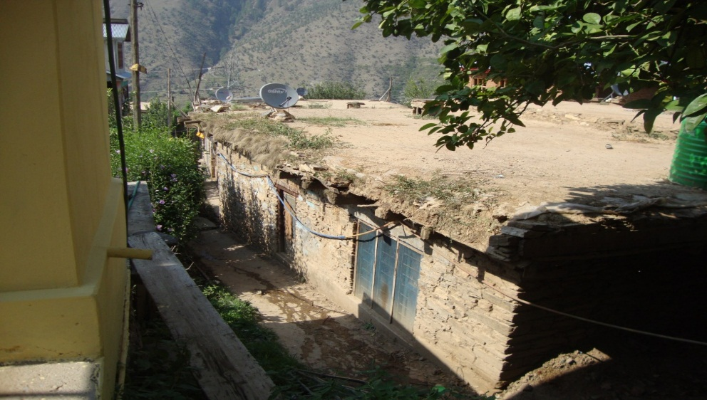
A typical house
The houses are entered through a wooden doorway leading into a small hallway. There is an Om symbol above the lintel of the door along with some artifacts engraved with shubha Lakshmi symbols hanging on the door. Some doors are carved. Some are decorated with painting while others with painted carving. The carving on the wooden door is simple and geometrical consisting mainly of parallel indentations which may be long-- tracing the length or breadth of a panel, jamb or lintel—or short-- arranged at an angle to the vertical or horizontal members of the door frame.
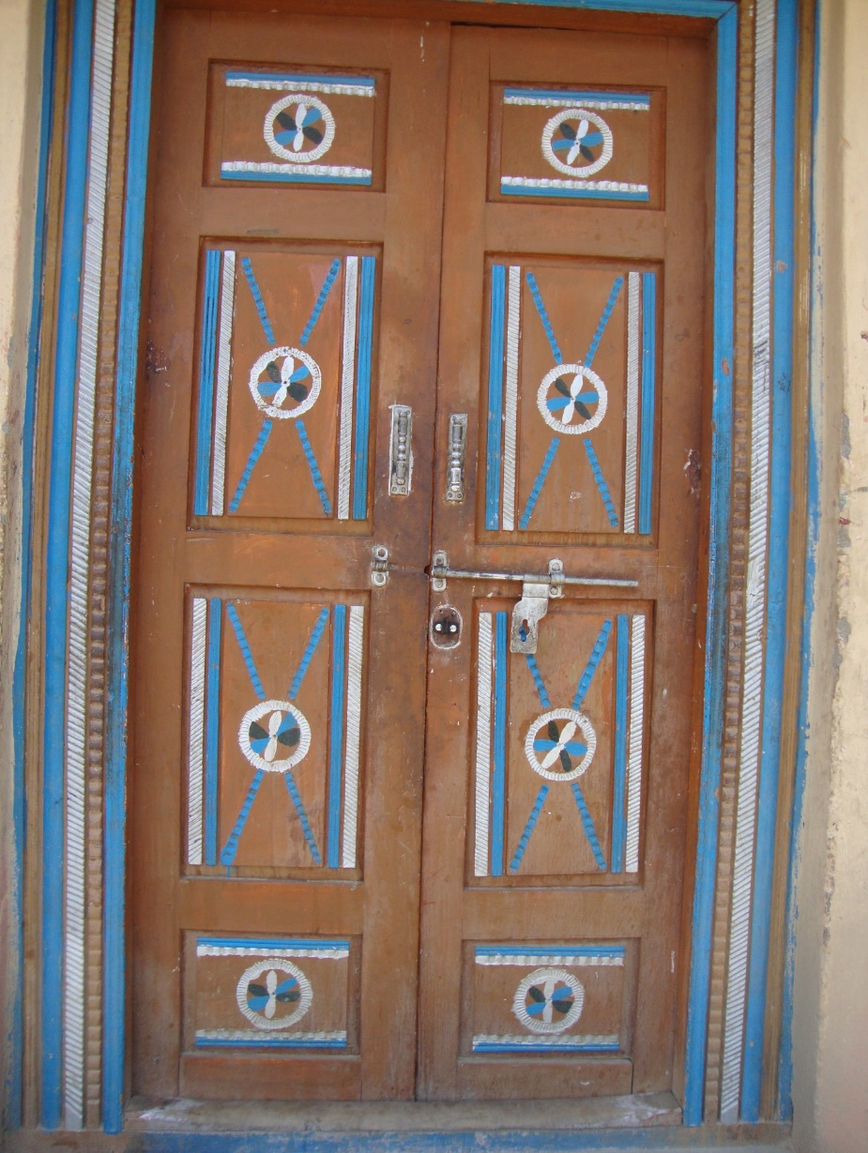
The main door of a house.

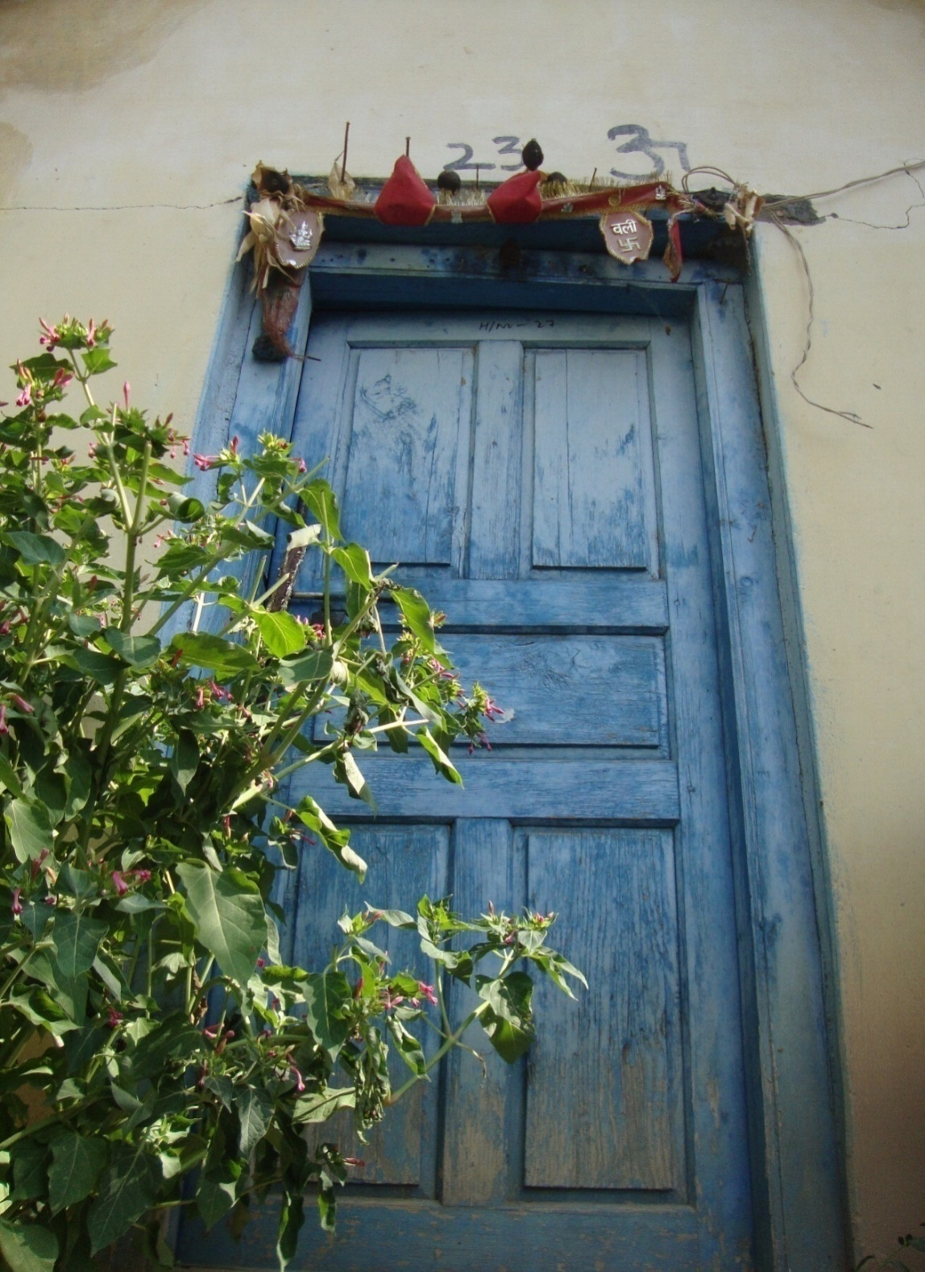
The door with ShubLakhsmi and Om symbols.

At the other end of the hallway is the /kotha:r/ (a large wooden box like structure used to store grain). It reaches right up to the ceiling of the hallway with a small opening at the bottom which can be opened and closed by a small wooden shutter.This shutter is rectangular and can be raised with a triangular handle.

Kothar (/kɔːthaːr/).
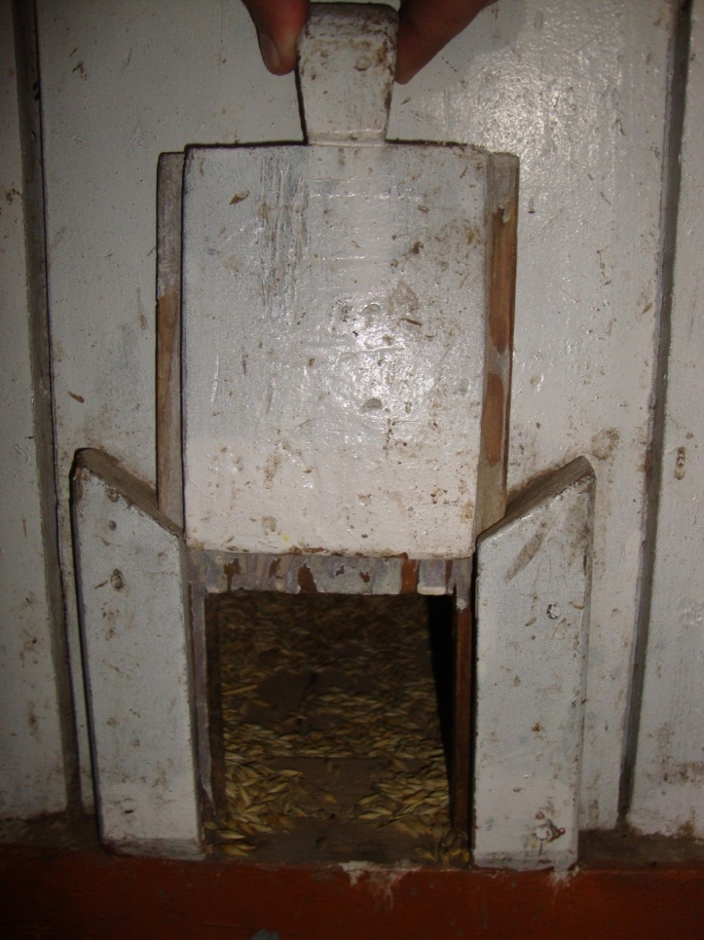
The small opening at the bottom of a Kothar with the wooden shutter
There are two rooms on each side of the hallway. Out of the two rooms facing each other at the end farthest from the entry, one is a kitchen and the other a store. The remaining two rooms facing each other near the entry are bedrooms. Inside the kitchen, there is a little shrine housed in a niche where the statues and framed pictures of gods and goddesses are kept.
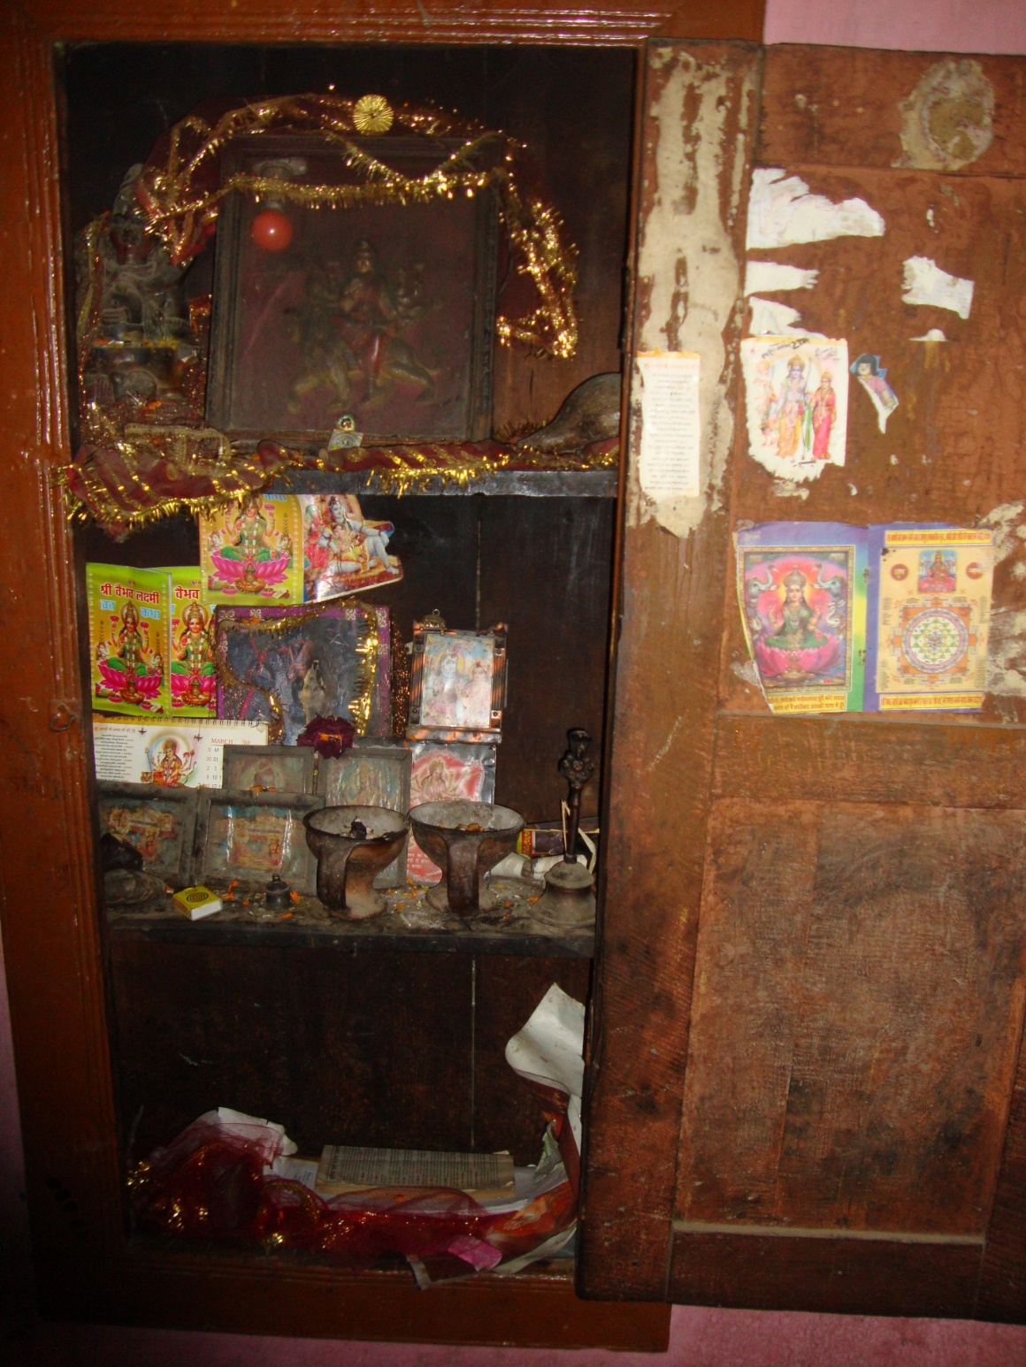
The shrine inside the kitchen
The kitchen has crude shelves for utensils and a wicker basket hanging from the ceiling to keep the food items which are not perishable such as pulses. The floor is almost bare, with a small circular straw made placed near a choolah made of clay. The smoke of this choolah escapes through a chimney built into the wall.
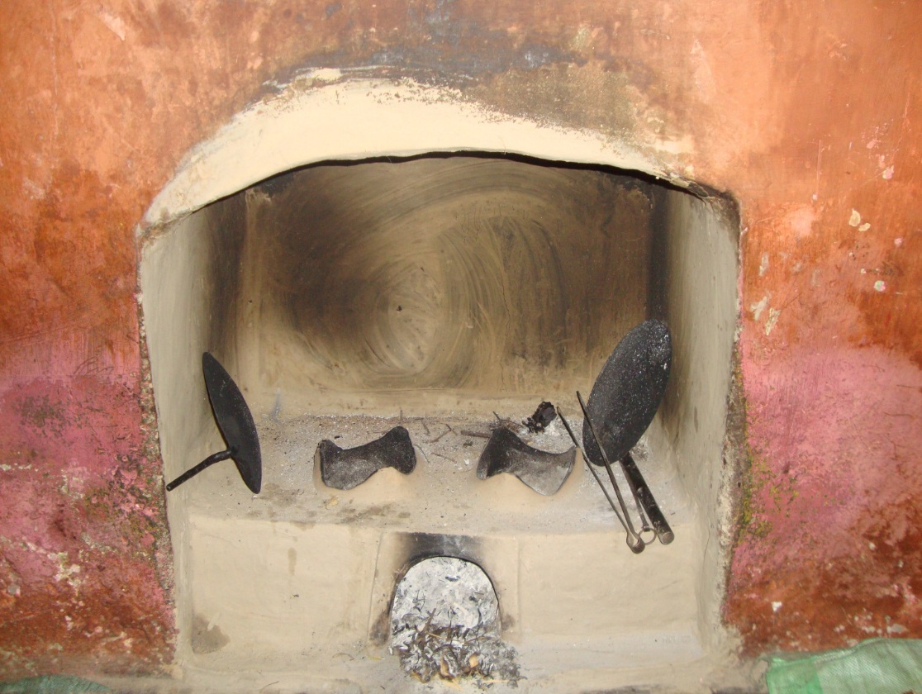
Choolah
A corner of the kitchen is reserved for washing utensils.
However, some of the houses built recently have partially or completely different internal and external structures which reflect the outside influence on the community.
The cowsheds are built on a lower level than the house. The cowsheds are made of stones held together by clay. As one enters a cowshed the half towards the opposite wall is demarcated by a series of vertically arranged parallel wooden stakes held together by two long and horizontal pieces of timber, one at the bottom and one at the top. This is where the cattle are kept, tied to the above mentioned wooden stakes.
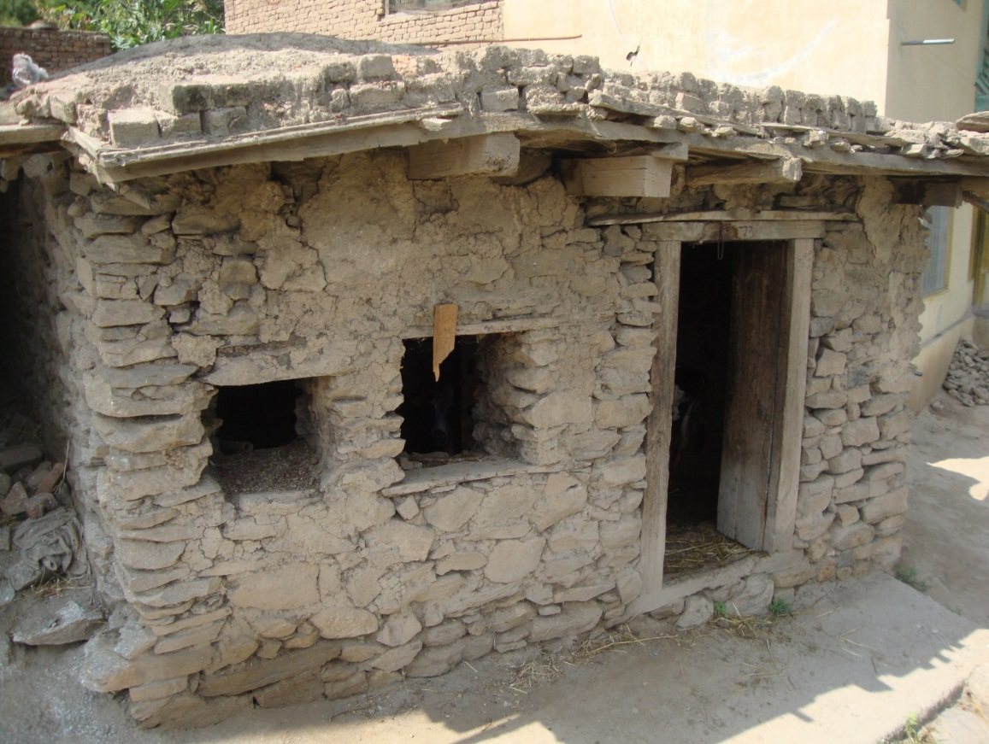
Cowshed
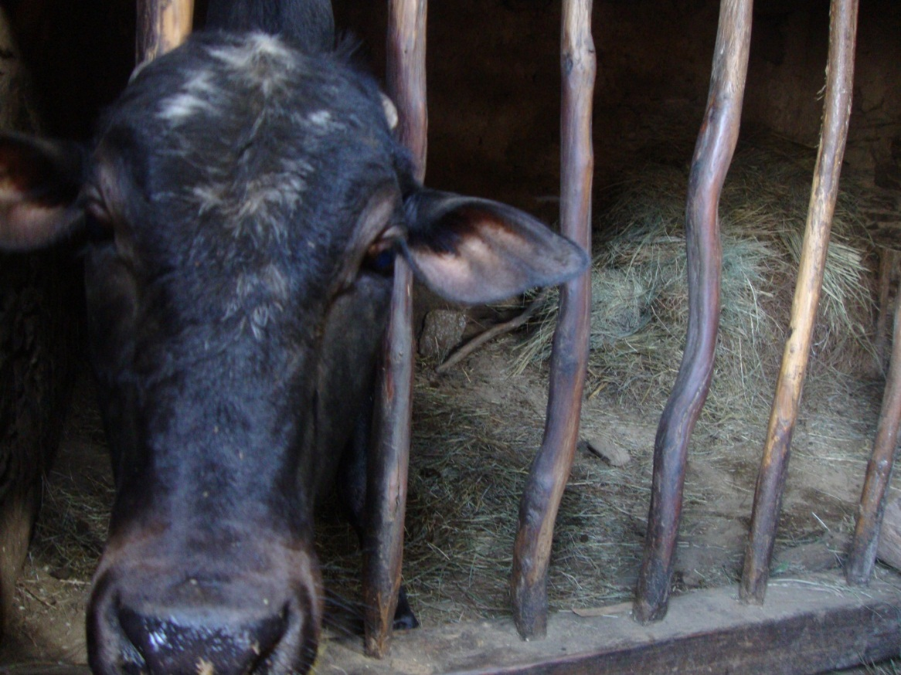
Inside the cowshed
There are no appreciable walls to demarcate the boundaries of homesteads.
MEANS OF TRANSPORT
The rough and unmetalled road winding along the slope of the mountain that leads to the village has recently been constructed.
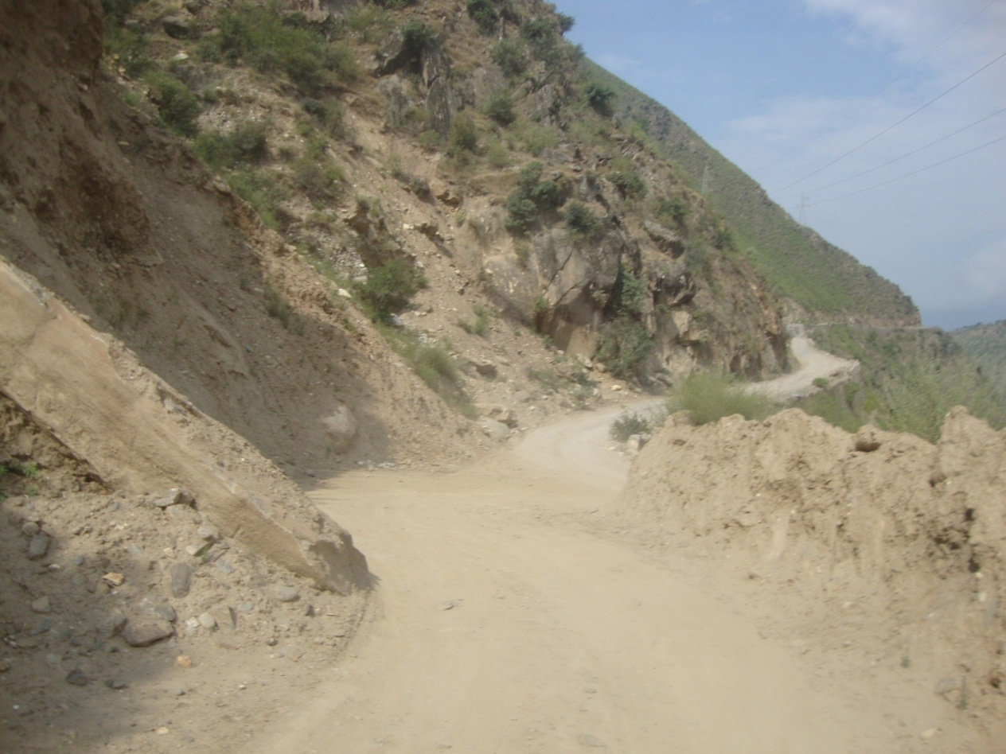
The unmetalled road
The slope that the road has been cut through is composed of a loose mixture of soil and large rocks and therefore prone to landslides. The primary modes of transport are the trails along the mountain slope and the ponies that carry the food, building and other material from the township below to the village.

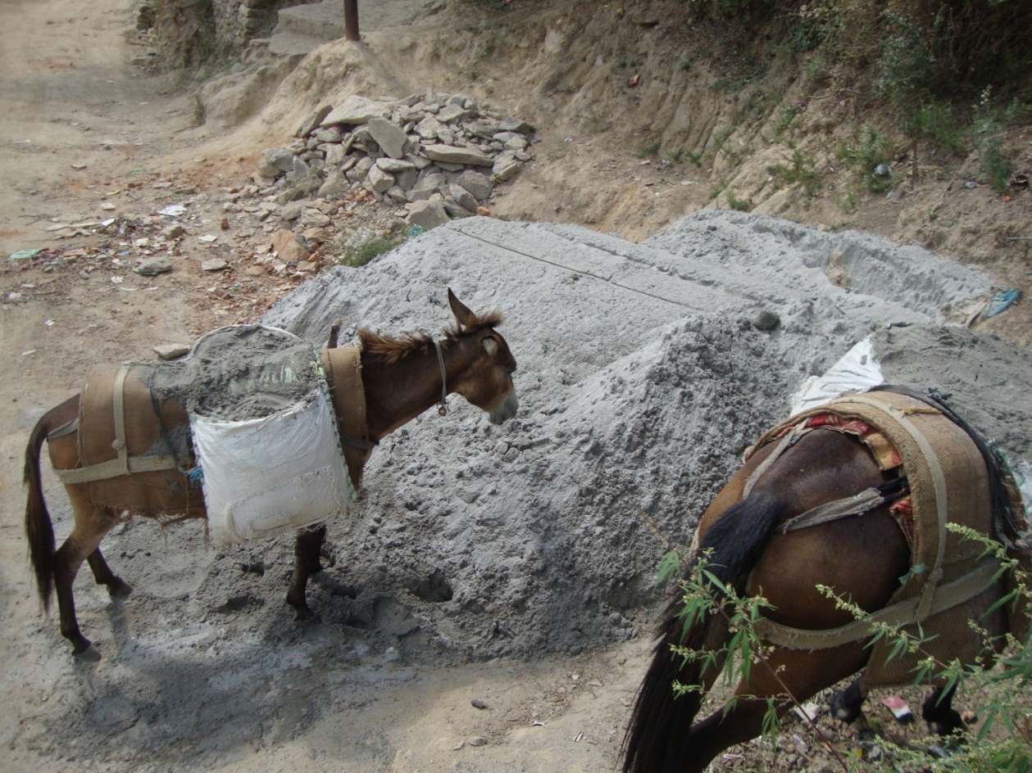
The ponies used for transporting building material
There is a spring in a ravine above the village which provides fresh and cool water to the whole village. Tap water is also available but it is mainly used to wash utensils and clothes.
OCCUPATION
The community is primarily a farming community as evident from the fields of paddy and corn around the village, farming implements lying around a homestead and a /kothaːr/(a wooden box like structure with a small square opening at the bottom) in every house used to store grain. However, some people have no land and work as laborers either in the village itself or in the township of Thathri, some 7 to 8 kilometers below the village. And some of them, besides owning land, have minor governmentjobs too. These are well-to-do compared to the other people of the community.
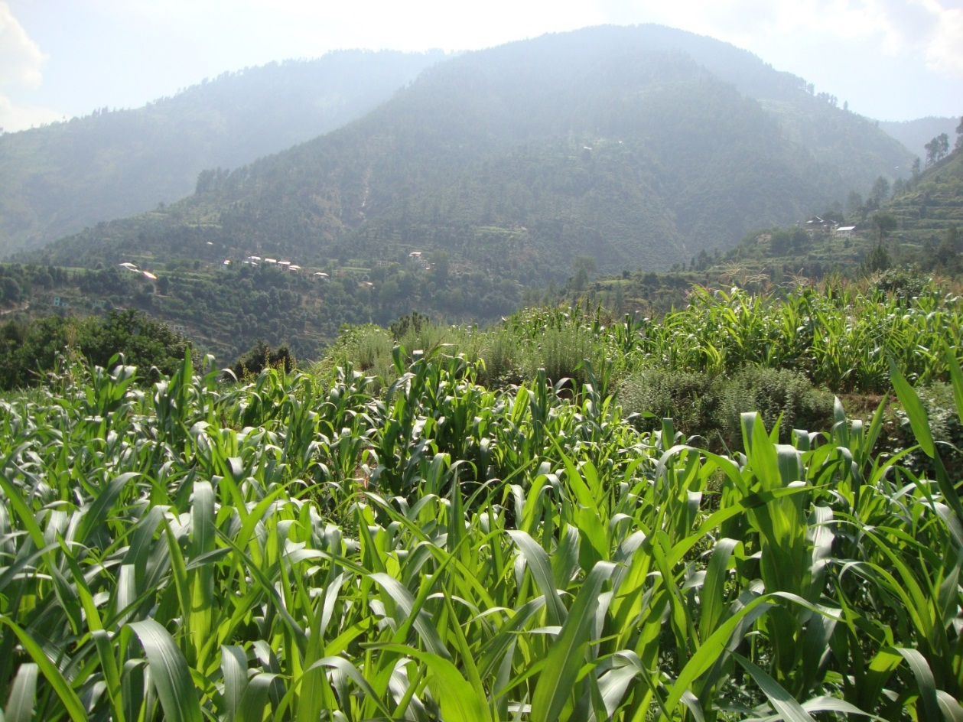
The corn crop
The people of the community are very hospitable and ready to oblige any guest. They live in complete harmony with their neighboring Muslim community.
BELIEFS AND ATTITUDES
The people of the aforesaid community follow Hinduism and their beliefs and attitudes are religiously determined. Their religious ideas and ideals are so dominant and embedded that the community can never avoid their adoption fully in relation to the beliefs and attitudes. . The concepts related to the determination of existing beliefs and attitudes among the Bhadralium people are sacredness of BhagvadGeeta(holy book), performing pooja and bhajan-kirtan in temples and other religious activitiesregularly.
The community associates supernatural beings with walnut trees, especially, after midnight. No one, especially children, is supposed to go near walnut trees after the sun sets.They also believe that there are some supernatural beings that can take the shape of any animal and prey on human beings. Our informants referred to these beings as /b^{h}u:t/.
One of the supernatural tales that was encountered interacting with the members of the community is about a ghost that haunts a place below the village where a great treasure is believed to be buried. The legend has it that an enormously wealthy man or a king (the villagers were not clear whether he was just a wealthy man or a king) buried an ill-gotten horde of jewels and gold in a vault underground. He was helped in this by a young man who was also his nephew, whom he killed and buried along with the treasure. The place is believed to be troubled by the ghost of that young man. According to our informant people have gone missing near the place. Although he could cite no recent incident to support this, he did tell us about an incident, which he simply referred to as an old tale, about a female cowherd returning late to the village. She disappeared and was never found again.
It is said that it is possible for a human being to get the treasure only if they sacrifice a daughter--if they are Muslim-- or a cow--if they are Hindu-- at the place.
PHYSICAL FEATURES
The people of the community have a whitish complexion, long faces with high straight noses and vertical foreheads dovetailed on the lower side by fairly prominent brow ridges. This indicates that they are not much different from the people living in the valley of Kashmir as far as their facial features are concerned except that on an average they may be said to have a slightly darker complexion. The slightly darker complexion may be due to the higher intensity of sunlight on the mountain slopes of Tipri. They are strong and able to climb the mountain slopes at a pace difficult to keep up with for people adapted for life in the plains.
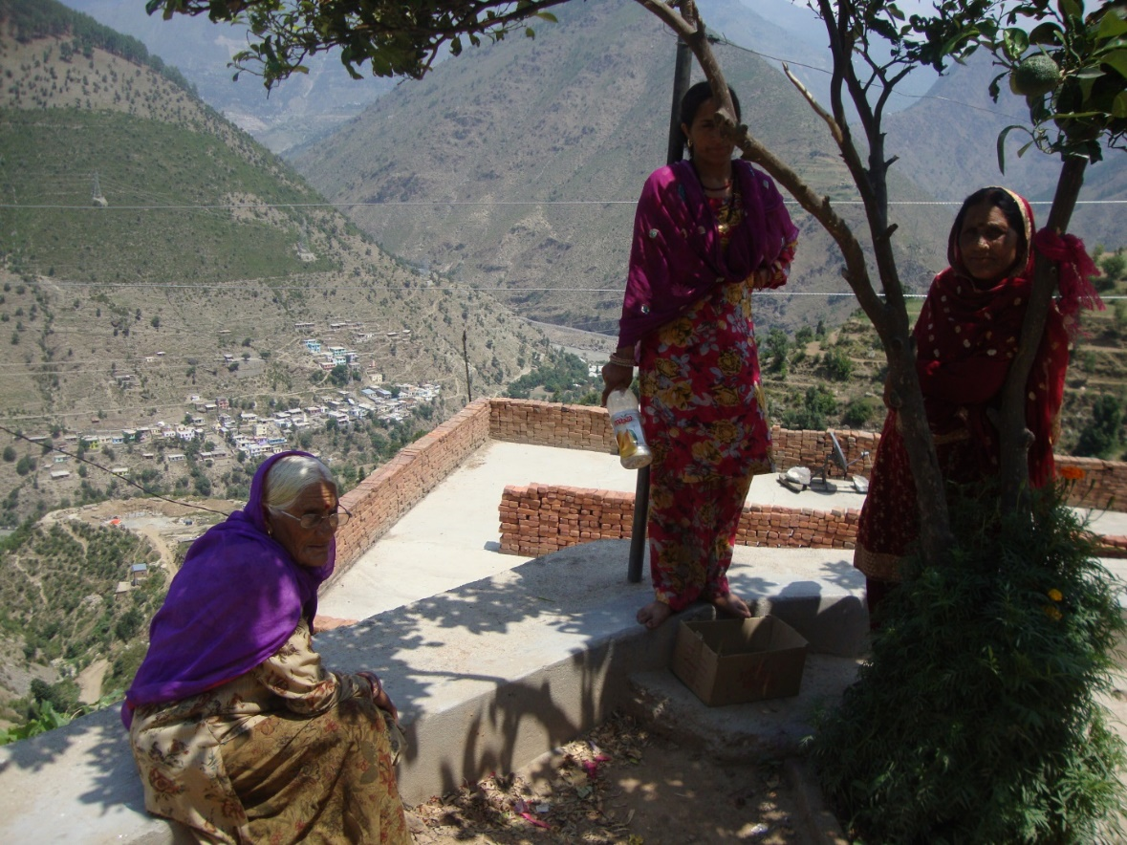
Women of the community.

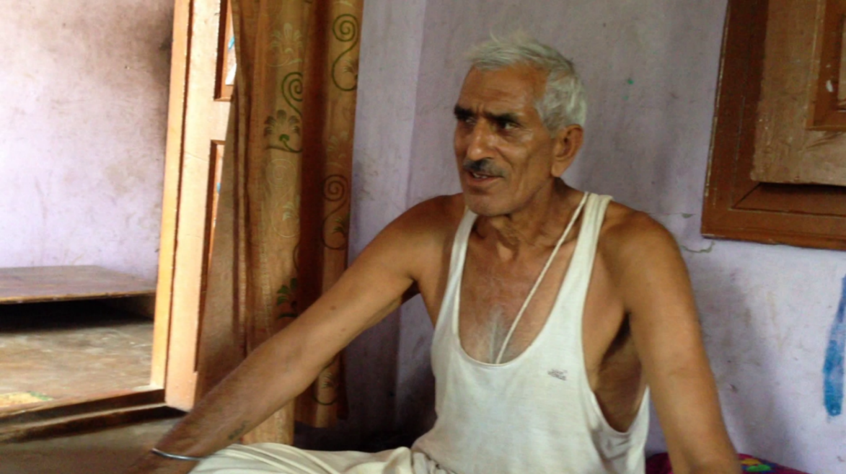
A typical man of the community.

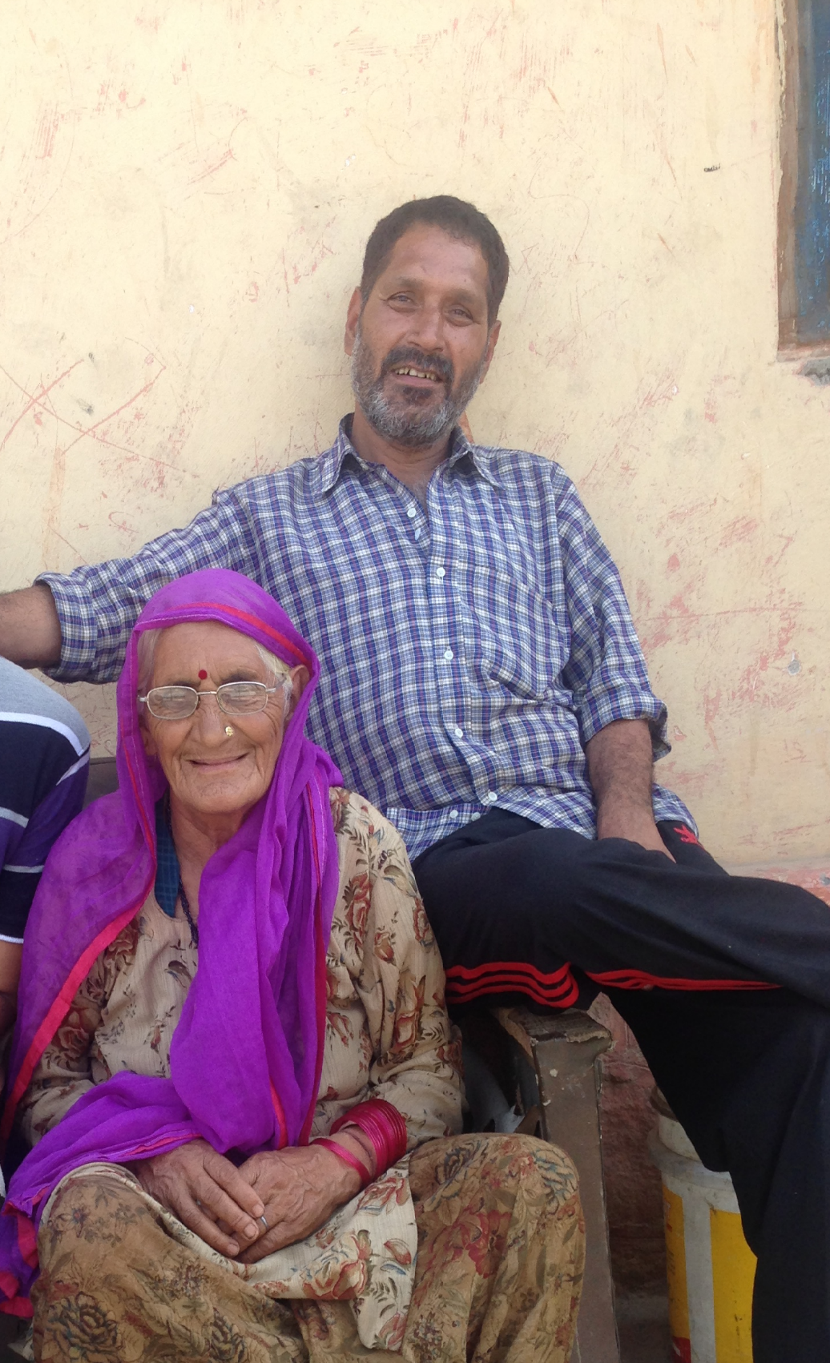
A man and his mother.

CULTURAL CONTEXT
The vocabulary items like /uɡɡuː/ (the vent of the kitchen chimney on the roof covered with a flat piece of stone resting on two similar but vertical pieces of stone) and /kɔːthaːr/ (a large wooden box like structure used to store grain) are used in almost all the languages throughout the mountains round Doda and the structures themselves remain the same. Moreover, there is a typical structure used to store hay, dry grass, dry corn stalks and the like throughout the mountains round Doda. This structure consists of a parallel vertical set of poles topped with a roof made of hay or dried corn stalks. The hay, dried corn stalks and the like are stacked between the poles. A conical structure made of ropes woven out of hay used to carry fire wood, twigs, dry grass and the like is also prevalent throughout the rural areas of Doda. The above indicates a common composite culture of which the community is a part. Furthermore, all the languages including that of the community under investigation occur in close proximity to Kashmiri.

CLOTHING AND ORNAMENTS
Clothing
The people of this area are not very particular about the way they dress. There is no special dress that could make them appear as a separate community, as such. Males and females have different dressing styles as it is in the other communities. Though there is a traditional dress but it is not worn by all the people. Young people prefer western outfits, though older ones may stick to their traditional dress. All types of clothes are available at the market and people buy clothes from there only.
Males usually prefer to wear shirts and pants. T-shirts are worn by men who go to work outside. Those who work at homes and don’t go out, prefer to wear taːmbi kəmiːz alongwith a koːti. kəmiːz is the shirt and taːmbi is the lower part. It is made by the local tailors and resembles a salwar (a part of women dressing). Koti is a kind of waist coat worn by men. So, we can say that T-shirts and pants are considered as formal dressing and are worn to offices, schools etc, where as taːmbi kəmiːz is the informal dressing and is worn to fields, shops and other places. This dress is sewn by the local tailors. It is worth mentioning that there is no effect of occupation on dressing. People can wear any dress of their choice no matter what their occupation is. taːmbi kəmiːz is preferred to be worn at home just because it is the ‘desi dress’ i.e. the traditional wear of the community andis comfortable than the other modes of dressing. Aged folk usually prefers to wear taːmbi kəmiːz. In the ancient times men wore woolen coats. These were made at home and protected them from cold. As far as the shoes are concerned, people, now a days, prefer to wear whatever shoes are available in the market but in the olden days men preferred to wear gurgaːbiː, special leather shoes made by the tʃamaːr or shoemaker. It was made from the hides of animals. Men usually don’t prefer to wear bright colored clothes. They rather choose drab colors. The most preferred colors are white, off white and khaːdi colors. Suits are worn on special occasions like attending marriage ceremonies or other formal functions. The grooms also wear suit on the day of marriage along with a sehra, which is a special turban meant for the groom. It makes the groom stand out from the rest.
Talking about the dressing of the women, there is no special dress for women also. They wear kami:z, salwa:r, and dʒu:ta. They also wear a ɖupaʈaː. It is a kind of drape, which is used to cover head and the upper part of the body. It is an important part of their dressing. Women are expected to wear a ɖupaʈaː at all times. They also wear a hijaːb, which is a kind of head scarf. Its main purpose is to cover hair and has a religious implication. Women wear bright colors. Green is preferred over other colors, though many other bright colors like red, yellow, pink etc are also worn. Brides wear tʃunni along with their dress. Tʃunni is s special kind of ɖupaʈaː meant for the bride. It is bright colored, usually red and is decorated with embroidery.
However, bright colored clothes are not worn at times of death and decease. At that time both men and women wear drab colors. The dead body is wrapped in a white cloth.
Ornaments
Ornaments are usually worn by women. Men do not wear much of them. Ornaments are made by goldsmiths found in the main market. These are usually worn at special occasions like engagement ceremonies, marriages, child births, and other occasions. There is no specific jewellery for people of different occupations and it entirely depends upon the choice of and individual and the financial status of the family. There is no tradition of giving ornaments as gifts on any special occasion like marriage or child birth, however some people may do so. Most of them usually give cattle as gift on these occasions. Ornaments are worn by women all the time, but at the time of any special occasion they wear a lot of jewellery.
The main ornaments include:
- natʰ(nosering): it is an ornament worn in the nose. It has a tar (a golden thread), which is tied to the ear. It is worn by the brides on the wedding day. This is made of gold.
- kaːnʈe (ear rings): these are made of gold and are worn in the ears. These are not only worn on the wedding day. Ladies wear them daily. However those worn on the day of wedding may be bigger than the usual ones with stone embeddings and are essentially made of gold.
- əŋuːʈhi (ring): this is a golden ornament worn in the fingers. These are also worn by the ladies on a daily basis.
- haːr (necklace): it is an ornament worn in the neck. The brides wear it on the wedding day. It can be made of gold or any other metal but the bride always wears the one made of gold.
- paːjal(anklets): it is ornament worn in the feet. It is made of silver. There is no custom of wearing gold anklets.
Food
Food is one of the three basic necessities of life. The other two are clothes and shelter. Food is also a primal need, the instinct for which is deep seated. This makes it a very important component of every culture the world over. “Tell me what you eat, and I’ll tell you who you are,” wrote renowned gastronome Jean Anthelme Brillat-Savarin in 1825. Thus food forms a part of your identity. It projects your cultural and religious background. It also shows your position within the society. Thus the food of the people on a lower rung will differ from that of the people located on a higher rung of social ladder.
Certainly, the social context for food is extremely significant. In a manner similar to how the contact with other cultures has an influence on our own language and communication styles, our dietary customs and practices are influenced too by contact with other cultures. Thus the people of the community under consideration have /kehvaː/ early in the morning which popular throughout the vale of Kashmir with whose people the community has a regular contact.They have /nuːn tʃaːj/ which is also an influence that has seeped in from Kashmiri cuture. The festival food of /kʰitʃdiː/ points to an influence from the subcontinental culture.With travel and communication as effortless as they are these days, the cultural boundaries that may have existed in the case of food are certainly not that well marked. Thus the use of bakery products like cakes, biscuits and cookies; consumption of chocolate and other confectionary; consumption of cold drinks and packets of juice; use of a beverage such as coffee points to a scenario that can be seen not only anywhere in India but also anywhere in the world.
The type of food people consume depends on the types of edibles available in the geographical area inhabited by them and their religious beleifs. There are a lot of beliefs, values and cultural taboos about what a person can eat and what a person cannot that are part of every culture all over the world.
The community under investigation here is a Hindu community. Therefore, beliefs about food have an overwhelming influence of Hinduism, which is the dominant religion on the Indian subcontinent. Thus food is largely vegetarian and the non-vegetarian food is limited to certain special occasions such as festivals and marriages. Even on the special occasions that non vegetarian food is consumed it forms only a small and limited part of the menu. Beef is strictly prohibited because of the religious significance of cows in the Hindu religion.
Methods of Procuring Food:
The community under study procures food locally by four methods: Agriculture, Apiculture, Animal Husbandry, and Hunting and Gathering. But they are not self-sufficient and have to be dependent on such means as government depots -- where rice, pulses, flour and the like are rationed out on a monthly basis – and certain locally available products produced by other neighboring communities. According to the members of the community, they had been able to produce almost all the food material within their village and only a very little amount of food was procured from other nearby communities, either on an exchange basis or simply bought.
Apiculture:
The people of the community have reared a locally available variety of bees since a long time ago. They do so in a hollowed out section of a tree trunk with lids at both sides and hole in the middle of the cylindrical surface. The lids are sealed with mud after a hive has taken possession of the structure which is called as /ɡanaːd/. When the times comes to harvest the honey one of the lids is opened and the bees driven out by means of smoke made by burning cowdung. About two thirds of the hive is taken out and honey extracted from it. The rest of the hive is left undisturbed for the bees to resettle. After the procedure the / ɡanaːd/ is resealed.
Honey may also be obtained from the wild bees’ hives in nearby forests by smoking the bees out of their hives hanging from tree branches and extracting the honey from a considerable portion of the hive which is cut down from the tree. Although this is a food gathering activity carried out by the men of the community, it has been kept under the Apiculture heading.
Honey, though not a staple food, has many uses in the community. Besides being considered a very healthful and nutritious food—used as one of the first things that the newborn babies consume—it is also used to cure burns and nettle stings.
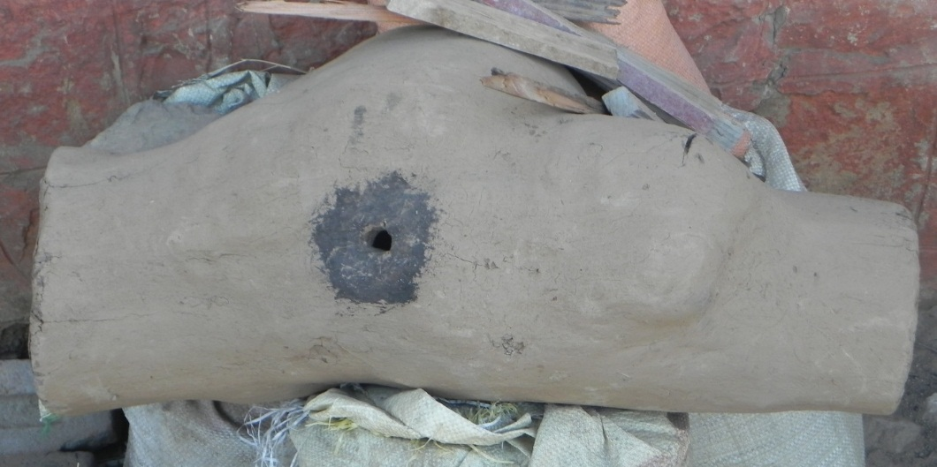
An empty /gana:d/.
Hunting and Gathering:
The women of the community gather mushrooms from the nearby woods early in the morning after a night of thunder and lightning. They also gather a green herb from the slopes of the hill they live on in the spring. It is referred to as /hand̪/ by the people. Though anyone can consume it, it is especially considered good for the pregnant ladies.
Not only the women but the men of the community are also involved in food gathering activities as mentioned above.
The children also roam the hill sides gathering some variety of wild berries and eating them in the early spring.
The informants of the community informed the fieldworkers that the men of the community used to hunt animals like deer and some wild fowl in the woods above the village, but the practice has stopped a long time ago. No trace of such animals was found in the nearby wooded area above the village by the fieldworkers. The guns used in the hunting were either double barreled or single barreled according to the informants, but no guns could such description could be found in the homes of the people visited during the course of the field work.
Because the community resides on a hill slope with no major mountain stream located nearby the practice of fishing and tools and skills associated with it are entirely absent. It does not however mean that they cannot procure fish in the market of the nearest town, Thatri, where it is readily available.
Animal Husbandry:
The animals reared by the community for food include sheep, goats, fowl and cattle. While sheep, fowl and goat are reared for their meat (which forms a part of the menu on such occasions as festivals, and marriages), wool etc., cattle are mainly reared for milk and cow dung (used as fuel). The milk obtained from the cattle is used to make first butter and then Ghee. This is done by churning the milk in an earthen pot with the help of a wooden churner which is operated with the help of a rope made of hay. This process separates the butter from the milk which floats at the surface of a thin watery substance.
Ghee is then made from butter by subjecting it to heating process.
Both butter and ghee form a very important part of the daily diet of the people in the community.Butter is consumed with tea and applied on the/fulke:/ or some other locally available bread. Ghee is used to prepare sweets prepared at home. Ghee can also be used as a substitute for mustard oil in frying on some special occasions and activities. Ghee is also used in a type religious service called as /havan/ in which ghee is poured into the fire, which is the subject of worship.
Although it is usually the milk obtained from cows which is used, milk obtained from goats can also be used in the same manner.
The community also rears chickens for meat and eggs.
Agriculture:
Agriculture practiced by the people used to meet a large part of the food requirements of the community in the past. These days, however, a large number of the people of the community have given agriculture up and moved to such occupations as daily labor and government employment. Thus, a large part of food demand is met by buying it from the nearby market in Tathri. But some people still practice agriculture though it does not make them independent of the external sources of food. They still have to buy cereals like rice and wheat from the above mentioned market (usually from government stores on subsidized rates).
They cultivate corn, and pulses like soya bean and mung on terraced fields.
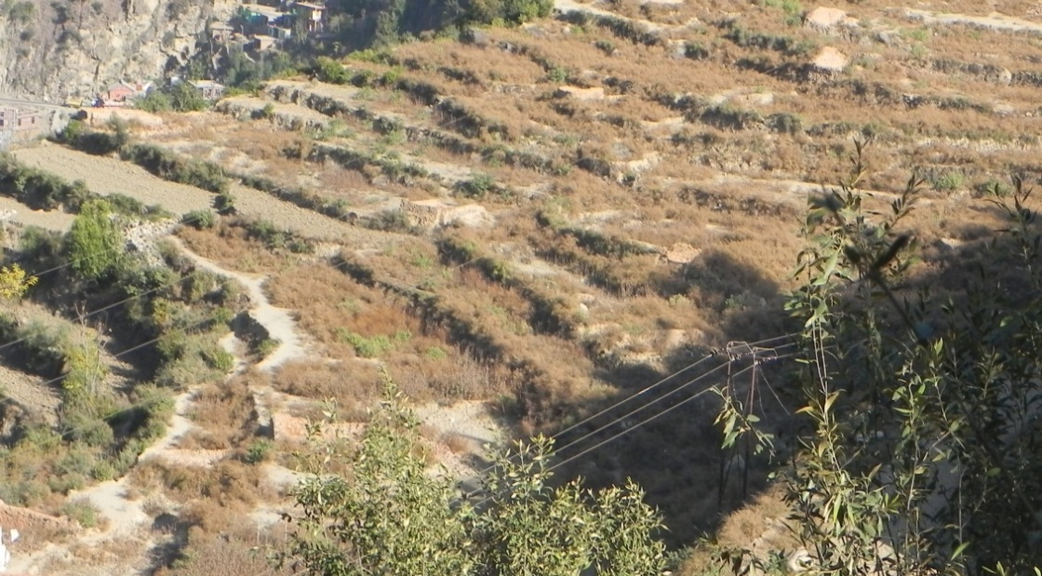
Terraced Fields Located Downhill From the Community.
With water relatively scarce in the area inhabited by the community, these crops are the only ones that can be cultivated with appreciable success. Leguminous plants (pulses) are grown in the winter months beginning from November and the corn is grown in the spring and the summer beginning from the month of April. Cultivation of these crops does not only provide food for human consumption but also for the consumption of the livestock in the form of the parts of these crops not fit for human consumption, such as husk of corn, pods and other non-edible parts of pulse crops.
Besides the above mentioned crops such vegetables as collard greens(/kadɨm/), spinach, cucumbers and gourds are in the kitchen gardens outside some of the houses in the community. These vegetables are grown only in the spring and summer months.
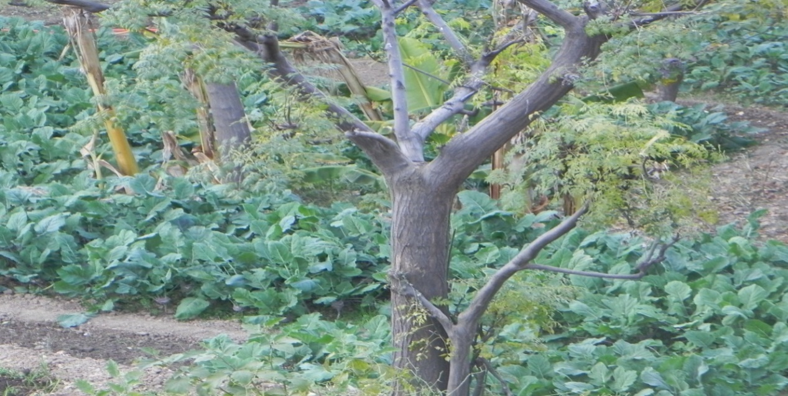
Collard Greens or /kadɨm/ in a Kitchen Garden.
In addition to the above mentioned crops and vegetables, the only fruit trees that the fieldworkers could observe were those of /kim/ --an orange like fruit which besides being used ceremonially during worship and in marriages is also nailed to or hung on the door jambs to ward off evil spirits—and walnut (/akʰrɔːt/).
Daily Schedule of Meals:
There are four main meals in a day:
The very first meal is that of kehwa, which is very popular throughout the valley of Kashmir. It is made by boiling cinnamon, black pepper, some tea and sometimes a little saffron in water, to which is added sugar. They do not consume it with any accompanying bakery.
The second meal is formed by the salty tea, which is also a very popular beverage throughout the valley of Kashmir. It is prepared by boiling milk, the extract of tea, and salt. While as in the valley of Kashmir it is usually associated with a special kind of utensil called as Samovar, in the community under consideration no such utensil is used. The composition, nevertheless, remains the same as in the valley.
The salty tea is usually consumed with some locally available bread.
A new trend is gradually catching on in the daily routine of meals in the community: that of consuming sugary tea in place of or in addition to the salty tea usually consumed. If it is in addition to the salty tea, it is consumed after it and before the main meal of the day, i.e., lunch.
The next and the main meal of the day occurs in the early afternoon. This is composed of a special type of bread called as bathora (/baʈʰɔːraː/) and a dish composed of a mixture various vegetables such as collard greens (/kadɨm/), spinach, brinjals, gourd etc. This is refered to as /lubɨd/. Cooked rice is also eaten in this meal.
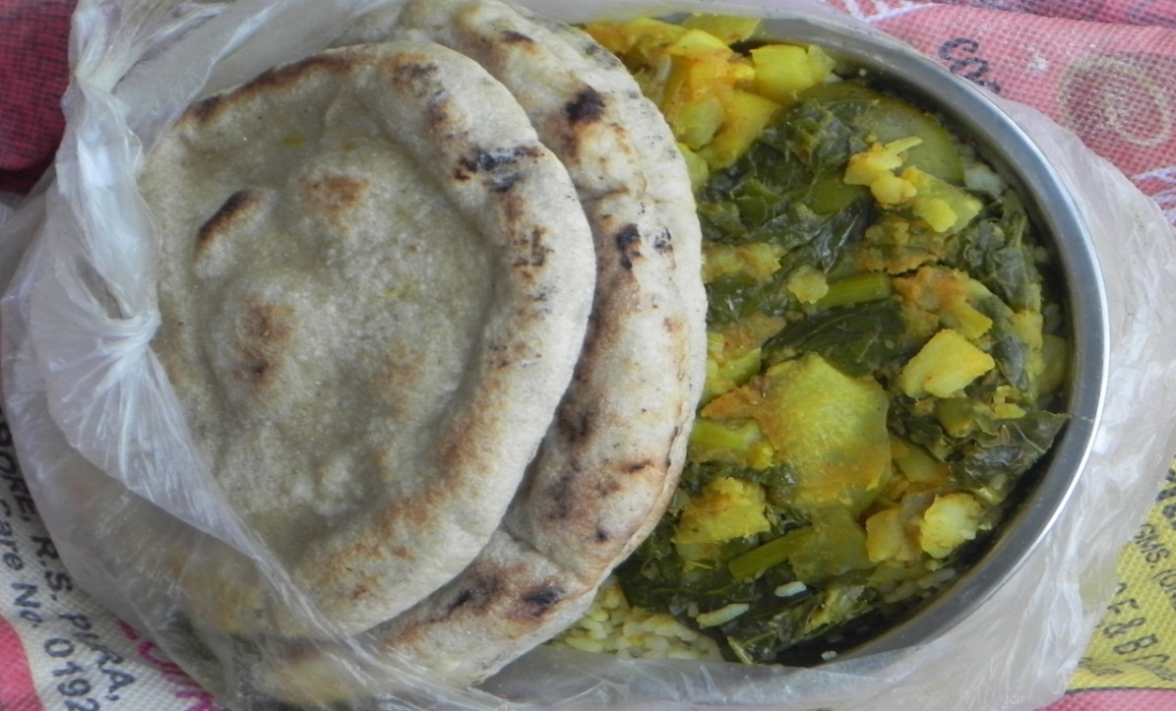
/lubɨd/ and /baʈʰɔːraː/
Pulses too can be cooked for the midday meal. The Bathora is prepared from the flour of wheat. Dough is prepared from the flour, some yeast is added to it and kept overnight. Then the bread is made from the dough next day.
There is no tradition of an afternoon tea in the community.
The evening meal is again composed of either green leafy vegetables, potatoes, a mixture of green leafy vegetables and potatoes, or pulses. But the bread is used in the evening is different from the one used in the day. It is called as Fulkas (/fulka:/). These are prepared from the floor of rice. The dough is prepared and immediately made into circular discs which are then cooked on a flat pan. A small amount of cooked rice is also the usual component the meal.
Besides the main meals of the day, people also eat fruits like apples and oranges; and dry fruits like walnuts and almonds. Walnuts are locally available, while other fruits come from the other areas of the state.

Food in Marriages:
The food on the occasions of marriage is largely composed of materials which can be consumed by both the people of the community themselves and the neighbouring Muslim community, because the people of both these communities usually take part in each other’s events of revelry and mourning. This limits the food materials available on such occasions mainly to pulses, various types of cheese, vegetables(such as collard greens, spinach, brinjals and potatoes) and three types rice based dishes (simple rice or /tʃaːval/; sweet rice or /miːʈʰeː tʃaːval/, this has colouring agents such as saffron and some condiments like black pepper, clove, cumin, etc. added to it; /pulaːv/, this has ghee and dry fruits like almond kernels, raisins, cashew nuts, and pistachios in addition to the condiments already mentioned in the case of sweet rice or /miːʈʰeː tʃaːval/.)
Because the community under investigation has a different method of killing the animals (sheep,goat and chicken) for meat, meat forms only a very small part of the food available on the occasions of marriage and is usually cooked in separate utensils at a different place to the one used for cooking the vegetarian fare.
/kʰitʃdiː/ (a dish composed of rice , mung dal and ghee) is also a common food on the occasions of marriage and festivals (for example, Lodi).
The food is cooked in large copper vats on fire, the fuel for which is collected from the nearby woods by the neighbors and relatives of the family whose son or daughter is getting married.
Unlike the practice in the neighboring Muslim community where food is served in large copper plates (/t̪rɨam/) round which three to four people can sit and eat together, they serve food individually in the usual sized plates of steel, copper or plastic.
Food for Pregnant Ladies:
Pregnant ladies are given food that will keep them healthy and strong. This usually includes eggs early in the morning and milk with almond kernels and raisins added to it at the time of going to bed. Cooked rice with ghee and /kʰitʃdiː/ is also given to them in day and evening meals. Moreover, a herb called /hand/ is considered beneficial for them.
Pictoral description of the various items used in the community.
/gana:rdzot/
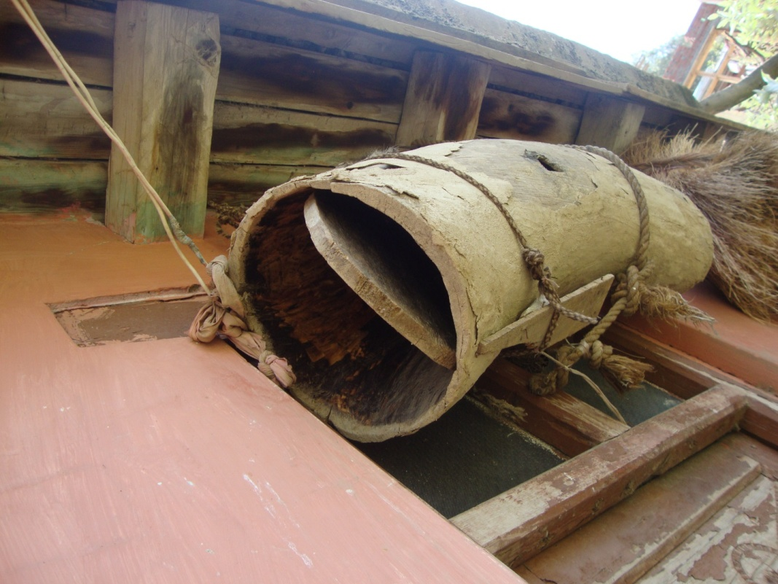
This is part of a tree trunk hollowed out to house a /gan/ (a swarm) of wild bees. It has a circular lid on each side and a hole in the middle of its length for bees to get in and out. It is hung anywhere on the outside of a house, except the front side. This shows that the people of the community possess the knowledge of bee rearing (apiculture).

/tshaenpu:/
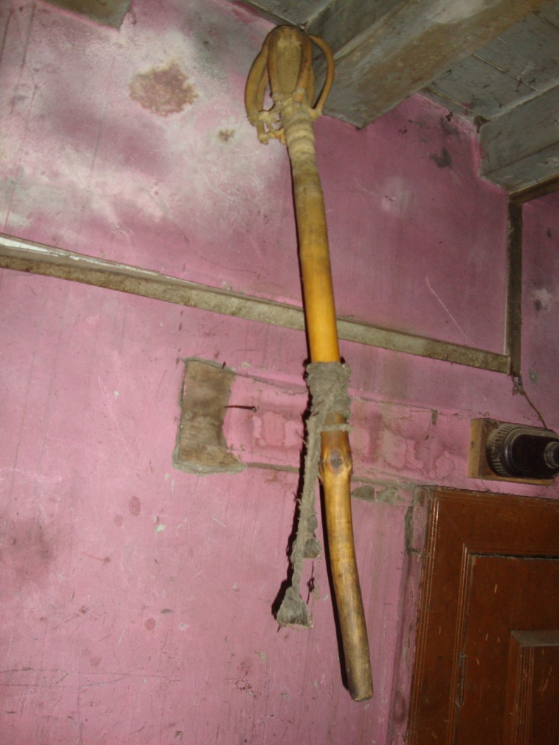

This is used to churn milk. It is made, apparently, from a part of a stem of some plant, the branches of which-- which grow in whorls—are hacked off except on one side, where they are cut at a distance of about six inches from the stem; the parts of branches still attached to the stem are then turned back on the stem and tied to it.

/kada/
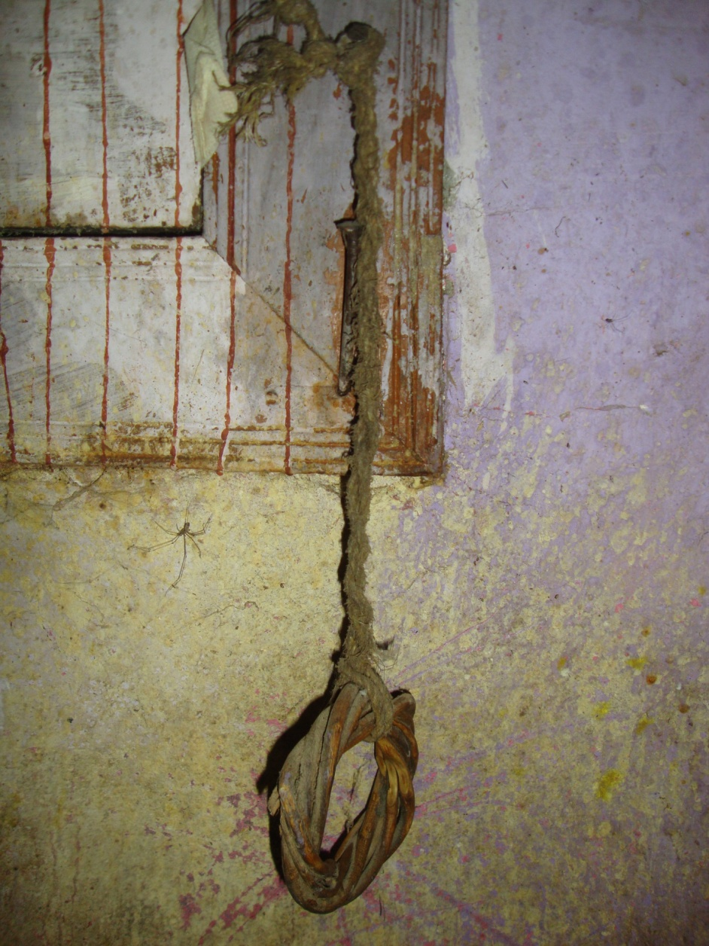

This is a wicker hoop attached to a wall with a length of rope; it is used to keep /tshaenpu:/ in position while churning milk.

/ts^{h}a:pɖi/
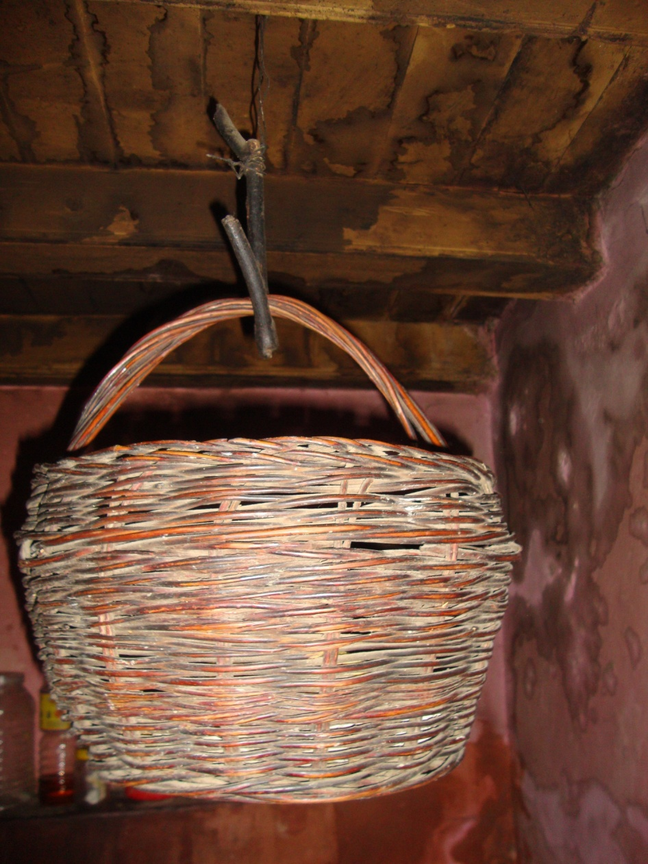

A roughly barrel shaped, round bottomed wicker basket with a semi-circular handle. It is used to store dry food material like bread and spices. It is usually hung from the ceiling of the kitchen to keep the food material inside it away from the reach of rodents and insects.

/tsul/ and /d̪amku:ʈ/
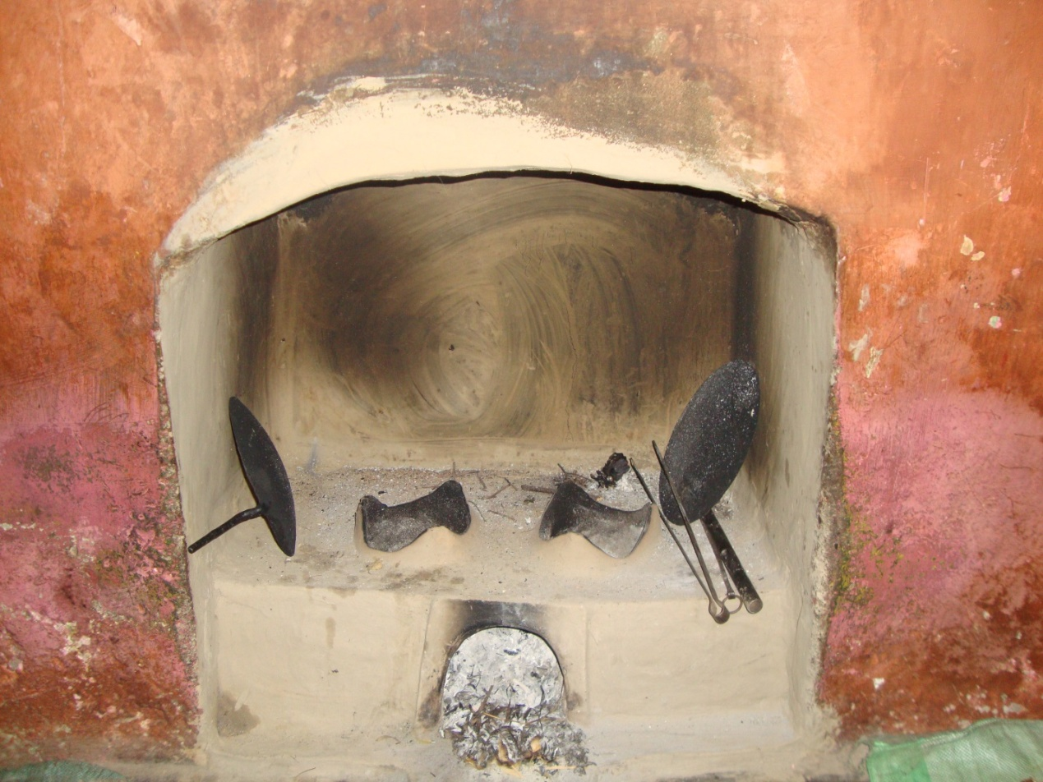

An earthen stove( a chula) with an opening in front for fuel (usually dry twigs which people gather from their land) and two more openings at the top, each of which is equipped with three equal-sized bulges equidistant from each other to support a vessel. It is built in an opening at the base of a chimney. The chimney is called as /d̪amku:t/ in the language under investigation.

/uɡɡuː/
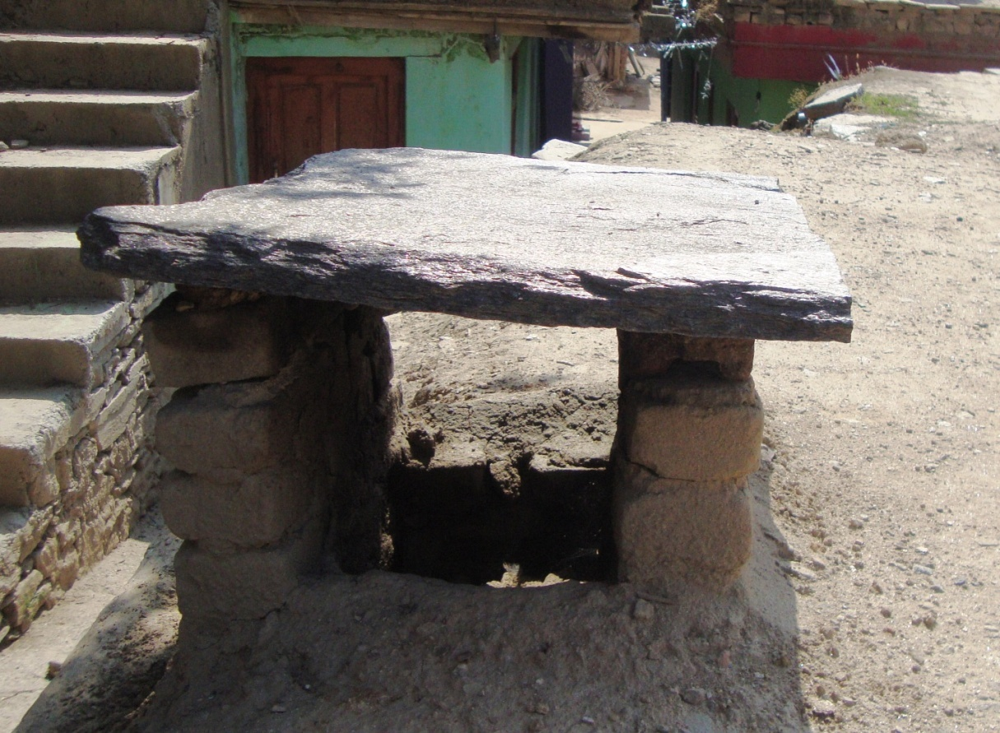

The vent of the kitchen chimney on the roof; it is covered with a flat piece of stone resting on a couple of supports which may consist of two similar but vertical pieces of stone, or some other material, such as bricks.

FOLKLORE
The American Folklore Society describes folklore in the following manner:
“Folklore is the traditional art, literature, knowledge, and practice that is disseminated largely through oral communication and behavioral example. Every group with a sense of its own identity shares, as a central part of that identity, folk traditions–the things that people traditionally believe (planting practices, family traditions, and other elements of worldview), do (dance, make music, sew clothing), know (how to build an irrigation dam, how to nurse an ailment, how to prepare barbecue), make (architecture, art, craft), and say (personal experience stories, riddles, song lyrics).”
Dell Hymes in his book "Foundations in Sociolinguistics: An Ethnographic Perspective” defines folklore as “the study of communicative behavior with an esthetic, expressive, or stylistic dimension.”
To Dan Ben Amos folklore is “artistic communication in small groups”.
Folklore includes folktales, legends, fables, fairytales, myths, songs, riddles, proverbs etc.The community at Tipri, Doda has a large storehouse of folklore. This report will be a description of the legends, fables, songs, riddles and proverbs prevalent in the community.
Legends:
Legends may be defined as narratives handed down from generation to generation by word of mouth, popularly regarded as factual, but usually a mixture fact and fiction, and which usually include humans who do something extraordinary.
Quite a number of legends of the community at Tipri revolve around a saint named Baba Buddhi Das. There is a temple dedicated to the saintlocated some two kilometers from Tipri. It is called Mandir Thaman. But one thing needs to be added here: these tales, although about a human being performing great deeds, have supernatural beings like ghosts, spirits, serpents etc and supernatural deeds like keeping a spirit under a spell, in them. They thus fall both under the legend and the fairytale categories of folklore. But we have chosen to keep them under the label Legends Baba Buddhi Das and other human characters are central to them. Here is a tale about this patron Saint of the community that was elicited from one of the informants:
It is said that Baba Buddhi Das gathered the brotherhood of all villages located around the site of Mandir Thaman and went into Samadhi (The state when one’s mind is cleared of all mundane affairs and completely focused and concentrated, and prepared to receive enlightenment) in the presence of all those gathered. The people then covered him up with earth.
It is said that after a few days the people who were far away in places like Badherwah and Aserbagar while the saint went into Samadhi came back. On hearing that the saint had gone into Samadhi, these people were surprised, for they claimed to have seen the saint at those far off places when the saint must have been in the process of going or had just gone into Samadhi.
Furthermore, it is said that the saint had a close friendship with a Muslim saint of Kishtawaar, namely, Shah Asrar and they used to meet each other quite regularly going up and down the Chenab on animal-hide carpets. It is further said that when Baba Buddhi went into Samadhi, his friend in Kishtawaar went into a similar state.
Because folklore is transmitted either by word of mouth or by behavioral example in small groups, it is inherently dynamic and variable. Thus, there may be several tales in existence which may be less or more different from each other depending on the number of elements they have in common or conversely, on the number of elements they differ in. This is amply illustrated by the following three tales about how Baba Bhuddi Das, the patron saint of the community under study, dealt with an evil spirit or a serpent that was attacking his cattle:
(1)
A long time ago, a stream used to bubble through the ravine known as Bhoot Nala today. The stream was named so, as it was once believed to be ruled by some evil-spirit. People wouldn’t through stones in this stream, for if anybody did so, he or she would immediately burn with fever and get fits and starts. One fine day a shepherdess was passing by the same stream along with her herd of cattle. She was taking thirteen cows which belonged to Baba Buddhi Das (The famous saint of this place), for grazing.
The evil-spirit in the stream saw the herd and attacked it. It ate twelve of the cows and held the shepherdess as a captive. The thirteenth cow somehow managed to survive and reached back to Baba Buddhi Das. As soon as he came to know about what all has happened he immediately went to the stream.
He being a saint was not scared of the spirit. Not only did he release the shepherdess from the clutches of the spirit, he also imprisoned it under his spell. Ever since nobody has heard of the spirit again.

(2)
Once upon a time, there was a sage named Baba Buddhi Das, who lived in the village where the community under study reside. He had many cows that were taken care of by a shepherdess. In the same village there was a stream which was believed to be under the influence of an evil-sprit. One day the shepherdess was taking the cows for grazing. The sprit saw the herd of cattle and attacked it. He ate up the shepherdess. Later on the cows reached back to Baba Buddhi Das without the shepherdess, the evil-spirit was following the herd. When Baba Bhuddi Das saw the spirit, he caught hold of a piece of burning wood from his “dhona” and threw it straight at the spirit. The piece of wood fell down on the ground. Later on a tree grew up at the same place. This tree is still there in this place. The portion of the tree touching the ground is burnt whereas the upper portion is in its bloom.
The other pieces of wood that got scattered when it was thrown, also grew into trees. Now it is believed that if any part of these trees is cut with an axe, the person has to face something bad. But if a leaf or a branch is cut off from the tree with bare hands no harm or misfortunes comes to that person. One day a shepherd came with his herd of cattle. He cut the branches of these trees with his axe and fed them to his cattle. In the morning the shepherd including the flock of cattle were dead.
(3)
Long time ago, there used to be a minister who used to hide all his wealth in a cave. He died without revealing the secret about this place to anyone. With the passage of time, a serpent came to the stream, lived there and guarded this treasure. Hence, if somebody would throw a stone in the stream he would catch fever. His body would burn with fever for as many days as many times the stones were thrown by him into the stream. At the same place there used to live a saint Baba Bhuddi Das. He had a herd of twenty to thirty cows that were taken care of by a shepherdess. The shepherdess would take the cattle to the stream for fetching them water. But every day she would lose one of the cows. When Baba noticed the loss of the cows, he went to the stream. On finding the reason of the loss, he fought against the serpent. He captured the serpent under his spell. Since then no one has heard of the serpent. Now-a-days a road has been constructed on the stream.
All the three stories/tales have at least five common elements to them:
- Baba Bhuddi Das
- His shepherdess
- A haunted mountain stream
- Baba’s cattle
- And a supernatural being associated with the stream.( It should be mentioned here that although a supernatural being is common to all the three tales, it is simply a spirit in the first two tales, but a serpent in the third).
But they differ in the following:
- The fate of the cattle
- the number of the cattle
- The fate of the shepherdess
- The manner the saint deals with the supernatural being haunting the stream.
As can be seen, the four things that the three tales differ in are somehow or the other related to the five common elements mentioned above. For example, while ‘Baba’s cattle’ is a common element in all the three tales, their fate and number differ from one tale to the other. Firstly, there are thirteen cows in the first tale, out of which twelve are eaten by the evil being; an indefinite number of them( ‘many cows’) in the second tale which are not eaten; and twenty to thirty in the third one , out of which an indefinite number disappear. Secondly, while the shepherdess is held captive by the evil being and afterwards set free by the saint in the first tale, and remains unscathed in the third tale, she is eaten in the second tale. Lastly, in the first and last tale the saint simply imprisons the evil thing under a spell, but in the second one he throws a burning piece of firewood at it which later on grows in to a sacred tree with a charred bottom and a green top. Thus it can be said that the skeletal structure of the three tales is the same, while they differ in the details that flesh it out. We might go a little further and say that the three folktales are essentially different versions of the same tale which might have existed sometime in the past, but which has no current existence.
That these three tales were elicited from three speakers belonging to the same little community spread only over a couple of miles, abundantly exemplifies the highly variable and fluid nature of folktales.
It might further be added here that even though folktales may be considerably different as far as their underlying structure is concerned, they can share certain elements. For example, while the third tale above has ‘a wealthy minister who used to hide all his wealth in a cave’ which later on came to be guarded by a serpent which lived in the stream, the following tale has ‘an enormously wealthy man or a king’ who buried an ill-gotten horde of jewels and gold in a vault undergroundalong with his assistant (also his nephew) whose spirit is still believed to haunt the place. There is some modification from earlier tale to this one (which further illustrates the fluid nature of folklore) but it can be said that they are overwhelmingly similar:
A ghost is believed to haunt a place below the village where a great treasure is believed to be buried. The legend has it that an enormously wealthy man or a king buried an ill-gotten horde of jewels and gold in a vault underground. He was helped in this by a young man who was also his nephew, whom he killed and buried along with the treasure. The place is believed to be troubled by the ghost of that young man. According to our informant people have gone missing near the place. Athough he could cite no recent incident to support this, he did tell us about an incident, which he simply referred to as an old tale, about a female cowherd returning late to the village. She disappeared and was never found again.
It is said that it is possible for a human being to get the treasure only if they sacrifice a daughter--if they are Muslim-- or a cow--if they are Hindu-- at the place.
One other tale related to the above tales because it has the elements of a ghost or a spirit and a mountain stream haunted by a ghost in common with theabove tales is the following:
Once a boy happened to walk through Bhoot Nala after midnight. He was confronted by a ghost there. The ghost challenged the boy for a fight. He told the boy that if the boy wins against the ghost he would let him go. But if the boy lost the ghost would kill him. So the boy fought the ghost and won, and as decided the ghost let him go.He also assisted him to reach his home and told him to keep his existence a secret.
Thus all the above tales may be said to belong to the same class of legends because have common elements.

Fables:
Fables are short narratives in prose or verse conveying a universal cautionary or moral truth.Here are a couple of fables transcribed from Bhadralium along with their glosses:
Buffalo and the mouse
/akʰ bej̃ θiː/ /te dərja nere kinaːre tsalirau θiː/ /to akʰ muːʃoθuæ haθantsaːro tatasere æʈʰan dʒoːt/ /tæniː cʰĩɖ maːrijaːn/ /tæni cʰĩɖ maːri betsʰa ʃuːninana bæs/ /betsʰa ʃununana de muʃo tsaɖo bẽjar piʈʰi puɖ/ / tæniː betsʰ jikunzu danta dittiː/ tes paton laɡo te ɡaːte kan neka zote miː tu kaʈʰʈiː tuiː patan laɡo/ /zote na zote zote miː paːve æʈhan tsaɖo tuiː patan laɡo zote na/ /te zote sac zotan ki bej̃jir camɖi baɖi moʈi hoti/
There was a buffalo that was walking on the bank of a river. She stepped on a mouse. It screamed. But the buffalo didn’t hear. Then the mouse got on her back and bit her but the buffalo couldn’t feel anything. The mouse then went up to her ear and asked ‘I bit you on your back, didn’t you feel anything?’ The buffalo replied ‘no’. The mouse then asked ‘didn’t you feel anything when you stepped on me?’ The buffalo again said no. It is well said that the skin of a buffalo is very thick.
Frog and the tortoise
/akʰ tuː mæ̃ɖak/ /te dərjaθu dʒãɡlare paːse/ /tas melo akʰ kecʰvo/ /tas boe tas se mulakaːd/ /tu etaro balki tsaltas / /ankiri tez tsaltiaː̃/ /eːa aːtam as akʰ reːs laːtam/ /atamkan kan jete/ /kacʰu zoteam boɖu diːmiː tsaltia mi ni tiʃi zitonu// zotai meː̃ɖak zotai boi ɡaːjʃiri reːs/ /te kacʰu zota boiɡaːj/ /kaːla dʒo boi ɡaːj de tene dʒe mæ̃ɖak na kacʰvo jetana res kene/ / kacʰvo bado diːm calto tsʰuː te mæ̃dak dʒo badoiː tez aɡruː beɖeiː aɡruː dʒuː tas melo akʰ buʈ/ /telaotarde zuli zuli rauː de uːtarde kacʰvo dʒo baɖe aɡruː baɖe taska aɡruː dʒuːda kacʰva dʒiti dʒoːde/ /mæ̃ɖak becara taɖi rau/ /te taseriː dʒiːt hotia ze hameːʃa sacaːjiː par tsalte/
One day a frog met a tortoise in a jungle and challenged it for a race. The tortoise did not accept the challenge on the pretext that the frog runs very fast and the tortoise may not be able to compete it. But on insisting the tortoise finally accepted the challenge. The very next day the two met for a race. The frog ran very fast and it soon got out of sight. The tortoise on the other hand was very heading slowly towards the finishing line. When the frog had reached far enough it decided to take some rest. It went under a tree and slept there. The frog fell fast asleep. But the tortoise did not stop and walked steadily towards the finishing line. And finally the tortoise won the race while the frog was still asleep. The moral of the story is that righteousness leads to victory
One thing that may be noted here is that the second fable is straight from Aesop’s Fables, but the rabbit or the hare in the original which is not found in the area has been replaced with a locally available variant. Thus they have adopted one of Aesop’s Fables, but given it a little local color.
Belief system
The belief system of the community has an underlying Hindu structure, but molded according to the local culture. Following is a description of that system as derived from the tales above.
The people belonging to this area are very superstitious. They believe in fantasies and mythology. Many people of the area believe in the presence of ghosts. People of this area believe that the stream called ‘Bhoot Nala’ is haunted. They narrate stories about a sage namely ‘Baba Buddhi Das’. Most of the people of this area believe and narrate the stories of his bravery, supernatural powers and spiritual powers. They believe that ‘Baba Buddhi Das’ was a spiritual person who trapped a ghost in the ‘Bhoot Nala’. There is a temple of ‘Baba Buddhi Das’ in the area. There is a tree in the compound of the temple. The tree according to the people had grown out of a fire torch when the ‘Baba’ had thrown a fire torch to hit the ghost who had eaten up his shepherdess. People of this area reveal that if someone tries to cut the branches of the tree with an implement, he or she has to face misfortune and if someone cuts the branches without the implements, nothing happens to the person.
The people of this place believe in demonic possessions. According to the people of this area, there once lived a girl besides the stream who turned insane and then died. She according to the people was possessed. People are been seen narrating their encounters with ghosts and spirits. Faith healers are of great importance to the people of this area. In case a person is not well, he or she is taken to a ‘peer’
Many stories narrated by the residents reveal the occurrence of supernatural activities happening in the area. A resident revealed that if a person throws stones into the bhoot nala, he or she gets chills and shivers. The number of chills and shivers is equal to the number of stones thrown into the stream. People narrate stories of mysterious activities at night and while passing by or over the haunted stream. People also narrate stories about their encounters with ghosts.
People of this area believe that there once lived a ruler who used to hide his wealth in a cave. According to the people, he had died without revealing the place to anyone. After his death, a snake used to guard the place.
The people of the community believe that a particular kind of tree, called /bi:r/ gives one protection against evil spirits roaming around at night. Climbing up onto its branches keeps the evil spirits and ghosts at bay. Keeping its leaves on person has the same effect.
All these stories about spiritual saints, encounters with ghosts, haunted places, supernatural activities, and demonic possessions reveal that the people of this area are highly superstitious and believe in fantasies and myths. The superstitious mystical beliefs prevail even in this era of technology.
BHADRALIAM PROVERBS:
Proverbs may be defined as short and pithy statements about the nature of life or wise and unwise conduct. Every culture is bound to have its wisdom encapsulated in a large number of small pithy statements handed orally from generation to generation. Here are some that were elicited from the people of the community under study:
- /ʃikaːr ke bele kutti aɡaːiː/
Meaning: A person who disappears when needed most.
Explanation: There is a story behind this proverb. Some people went for hunting with their dog. The dog was supposed to watch the prey until the hunters get ready to kill it. It was doing its job nicely but as soon as the hunters got ready to kill the prey, the dog went for defecating. The prey ran away to save its life. Thus the dog left the hunters alone when they needed its help the most.
- /poʧʰaːi pʰaːl/
Meaning: A person who does not want to see anyone happy.
Explanation: There was a man who lived in Pochal. He was very cruel and had a rough attitude with the people of this place.

- /kali ɖumɖiː naːk me surma/
Meaning: Haste makes waste.
Explanation: The story behind this proverb is that a lady was making herself up for attending a party. She was doing it in a hurry. She had to apply surma into her eyes but being in a rush, she accidently put it into her nose.
- /kʰaːladʒoɖuː ɡraːʈniː/
Meaning: Unity is strength.
Explanation: There was a man named Khala, who lived near the stream in Bhadarwah. He owned a grinding wheel, but it was of no use to him unless he took the help of somebody else.
- /tʰaro luca ma maro luco/
Meaning: interrupting someone.
Explanation: This proverb is actually a taunt. It is used when somebody interrupts an important conversation going on between two people. This mostly used by Gujjars.
SONGS:
Songs are a universal way of expressing ones emotions and feelings about almost everything. They can be simple with nothing more than rhythm and rhyme to them (usually when meant for children). They can be highly complex with various levels of meaning in addition to the rhyme and rhythm. Here are some of the songs encountered while studying the community at Tipri, Doda:
- /dukʰiːdilã tũiː̃jamu ketsire manaeːjaː/
/sam das naː tuː tũiː̃jamu ketsire manaeːjaː/
/dukʰiːdilã tũiː̃jamu ketsire manaeːjaː/
This is a song about a boy who is getting married within a couple of days. But the boy is singing in grief as the girl with whom he is going to tie the knot has eloped with her beloved. He wants to have her back in his life but he cannot find a way out. This makes his heart heavy and dull. Grief has overtaken the boy and he is pouring his heart out in this song.
- /ciʈʈʰiː avri laoːr /
/peɖa tas ɡorʃiː ɛktaror sare/
/daː na kan kinciːoiː/
There is a woman who is reading a letter which has come all the way from Lahore, from her beloved. The letter says: I have sent this letter to you, my beloved. Read it carefully for I have sent all my love to you through this letter. Wait for my return and don’t marry someone else even if you are asked to.
A boy and a girl, who are lovers, live on the opposite sides of a stream. The boy can see his beloved from the opposite end but he cannot meet her. In this song the lover is calling his beloved to meet him in the middle of the stream.
RIDDLES:
Riddles are short like proverbs, but unlike proverbs they present the listener with a mental problem. Two of the riddles prevalent in the community at Tipri are as follows:
- /te koze ciːze zeʃ ʃauː liɡɖa voat laɡoːr/
What do you call a thinɡ that has 100 clothes its body.
Meaning: Onion
Explanation: This riddle signifies an onion. The basic connotation behind the riddle is that an onion hides its bud under several covers or leaves. Here an onion is compared to a person who puts may garments over his body.
- /akʰ nikɖe de caːdar te puːre kamre mai bicʰaniː te katere bicʰaːni esiː/
A small blanket covering the entire room.
Meaning: Bulb
Explanation: this riddle signifies a bulb. The undertone is that a bulb is a small thing but when lit, it spreads its light in all the directions and lights the entire room. It is as if a small blanket is used to cover the whole room.

FAIRS AND FESTIVALS
Festival:
Festival is a special day or period, usually in memory of a religious event, with its own social activities, food or ceremonies. Festivals are part of every culture and have been celebrated since time immemorial. They are more likely a ritual. There are thousands of different types of festivals, which can have religious, spiritual, ethnic or seasonal backgrounds, just to name a few.They are not always only entertaining or amusing, but offer a unified focus for learning about history, government, community, social interaction, traditional values, and social change. People with the same values are brought together and thus the community spirit gets strengthened and the social cohesion fostered; furthermore traditions are taught and also the traditional beliefs get forwarded. Pride and loyalty get strengthened and the everyday stress gets reduced.Participants of a festival often feel a strong connection with each other while the festival takes place. People with different statuses, who don’t have a relation to each other in their ever day life celebrate together. They form a new community. Different norms than their every-day life are important.Many festivals take place every year, often at the same date or in a particular season.A festival can be described as a cultural performance. The events that take place in a particular festival define the characteristic of it. These celebrations have important functions: preserving heritage, fostering social cohesion, releasing tensions accumulating from daily life, and inculcating pride and loyalty.
It is believed that the first festivals arose because of the anxieties of early peoples who did not understand the forces of nature and wished to placate them. The most ancient festivals and feasts were associated with planting and harvest times or with honoring the dead. Festivals have many uses and values beyond the public enjoyment of a celebration. In prehistoric societies, festivals provided an opportunity for the elders to pass on folk knowledge and the meaning of tribal lore to younger generations. Festivals celebrating the founding of a nation or the date of withdrawal of foreign invaders from its borders bind its citizens in a unity that transcends personal concerns. Modern festivals and feasts centering on the customs of national or ethnic groups enrich understanding of their heritage. Every festival has a social, religious and mythological value. They have a great religious and social significance. They teach a moral lesson to the people and unite them. People forget all their differences and observe these festivals with a sense of togetherness. The festivals teach people how to forget their enmity, narrowness and bitterness and join hand with each other for the sake of their religion and their society and for the sake of friendship and universal brotherhood.
There are many festivals which are celebrated in the community of Tipri throughout the year, celebrating certain deities, the arrival of spring, and other events. Folk festivals throughout the year play an important part in the lives of these people. These festivals are:
- Lohri
- Jatlochi
- Diwali
- Holi
- Shiva-ratri
- Baisakhi
- Janmashtmi
- Rakhshabandhan
- Kontsoth
- Kod
- Lohri
The community in Tipri celebrates Lohrion the thirteenth of January. People light bonfires, sing traditional songs and dance accompanying the fire in the evening.Though there are different stories related to the origin of Lohri, people celebrate it mainly as a harvest festival. In January the fields grow golden harvest, and farmers celebrate Lohri before the cutting and gathering of crops. They celebrate this festival to mark the end of winter and the upcoming spring. They dedicate this festival to fire and the sun god.
There are different stories related to the origin of Lohri. According to one account, the history of Lohri dates back to Indus Valley civilization. Another account is about thestory of ‘Dulla Bhatti’. He was a Muslim highway robber who lived in Punjab during Emperor Akbar’s reign. He robbed the rich and help the poor with that money. He also rescued Hindu girls from being forcibly taken and to be sold in slave market of the Middle East. After rescuing he married them to Hindu boys.He performed the ceremony by following all the Hindu rituals and traditions. He even provided them with dowries. Although he was a robber but he became hero of everyone. So Lohri songsare sung in order to pay tribute and express gratitude to him.
According to some people Lohri has derived its name from Loi which is the name of wife of Sant Kabir as in rural Punjab the word ‘Lohri’ is pronounced as ‘Lohi’. Other people also believe that the word ‘Lohri’ comes from the word 'loh', which means a thick flat iron sheet ‘tawa’. It is used for baking chapattis at the time of community feasts. According to another legend, ‘Holika’ and ‘Lohri’ were sisters. Hollikka perished in the Holi fire, but the Lohri survived. Traditionally, on the occasion of Holi people eat sesame seeds ‘til’ and jaggery ‘rohri’. As the time passed by, perhaps‘til’gotmerged with ‘rorhi’ to to form‘tilorhi’, which later got shortened to ‘Lohri’.
- Jatlochi
Jatlochi is another festival celebrated by this community in the month of August. On this occasion a fair is organized in the Tuntibeer temple of Kaila village where people from all the places come to celebrate this festival. This festival is celebrated so that relatives and friends from different places can meet at one place and have a get-together.
- Diwali
The festival of Diwali, also known as the festival of lights, is celebratedby the people of this community on the 15th day of month ‘Kartika’ which occurs in October or November. People celebrate Diwalito commemorate the victorious return of Ram with his bride Sita to Ayodhya and the victory of Krishna over the monster Narakasura. Ram was a great warrior and was exiled by his father Dashratha along with wife Sita and younger brother Lakshman. It is believed that on this day they were returning to hometown Ayodhya after fourteen years of exile in which Ram put an end to the demon Ravana.e was a great Pundit originally and highly learned but was dominated by evil. After Ram’s victory, he returned to Ayodhya. There people welcomed and honoured them by lighting rows of lampsof clay. That is why, people celebrate this occasion in honor of Ram's victory over Ravana.
People also celebrate Diwali to commemorate the defeat of Narkasur by Krishna. According to the legend, Krishna, who is considered as the 8th incarnation of Vishnu, destroyed the demon Narkasura. He was causing great trouble and unhappiness in the world. He was believed to be a demon of filth, covered in dirt. He kidnapped beautiful young women and forced them to live with him. At last, their cries reached to Vishnu, who appeared in Krishna’s form and rescued them. He had to fight a five-headed monster who protected this demon's abode. Then he rescued all the women.
According to an ancient myth of this community, Lakshmi, who is the goddess of wealth enters all the houses on this night and it is believed she blesses all thosehouses which are most shiny and clean. So as soon as this festival nears, all the people of this community thoroughly clean their houses in anticipation of Lakshmi’s wealth and her blessings. People make beautiful ‘Rangoli’(colouful designs) on the threshold of every houseand indoors are decorated with a number of little clay lamps which add more brightness to the atmosphere. Lakshmi, the goddess of wealth and good fortune is worshipped.
Before Diwali ‘Dhanteras’ is celebrated. It is celebrated two days before Diwali. Everyone of this communitymakes purchases and buys new clothes and jewellery. This is because people considerthis day auspicious for wealth, and people believe that if anyone buys silver or gold on this occasion, they will be lucky throughout the year. Lakshmi is worshipped on this day through a ‘Lakshmipujan’, which is performed everywhere, in the houses as well in shops and offices.
Along with the lights people of this community celebrate this festival with the burst of firecrackers. The sounds of crackers and lighting of lights starts a week before to the actual day. It reaches its peak on the day of Diwali. Diwali is a day when people dress up in their best attires and visit each other, their relatives and friends. They greet them with gifts of dry fruits and sweets.
The people of Tipri also make khichdi in the name of dead ones on this occasion.
- Holi
The community of Tipri celebrate Holi on the full moon day of Phalgun i.e. March. This festival, originally known as ‘Hollika’ celebrates the arrival of spring in February or March. It is also known as the Festival of colors. It is a spring festival and considered as the happiest and most colorful religious festival of the Hindus of this community. It makes the beginning of the spring season. The beauty of nature makes this festival more colorful. The literal meaning of the word 'Holi' is 'burning'. There are various legends associated with this festival, most prominent of all these legends is the legend of demon king Hiranyakashyap.
Hiranyakashyap was cruel. He wanted everybody in his kingdom to worship only him but to his great disappointment, his own son, Prahalad rebelled and became adevout of Narayan. Hiaranyakashyap ordered his sister, Holika to jump into a blazing fire along with Prahalad in her lap. Holika had the power of entering the fire and could come out without being burnt or hurt. However, she was ignorant that this power of her worked only if she entered into fire alone. As a result, when she entered into fire with Prahalad, she died by getting burnt alive while Prahalad survived because of his devotion. The festival, therefore, celebrates the victory of good over evil and also the victory of devotion.
It is also believed that Krishna started the trend of playing with colours when he used to apply colour on Radha and gopis. Gradually, itbecame popular with the people and became a tradition.
During this festival people of this community spray each other with colored powders and colored water, forget the cares of winter, and rejoice in the onset of spring. People smear red, green, and yellow powder on each other and spray each other with colored water. The night before Holi, people light huge bonfires, symbolizing the destruction of evil. In theory, during this festival castes are forgotten and all people are equal. The pranks that Krishna played as a child are celebrated, and the story of Prahalad, a prince who was willing to sacrifice himself for Vishnu, is remembered; people make offerings around bonfires and colored water or powder is sprayed in high-spirited games.
People collect sticks and straws at a place. At night they gather at this place and set fire to the huge pile of sticks and straws. They sing songs which are accompanied with drums. The main celebration follows the next day. People spray colored water on one another. They smearcolored powders on their faces. Children spray colored water on the passers-by. They also throw balloons filled with coloured water on each other. All people forget social distinctions. They mix with all freely. People wear mostly white clothes and move about with colored water. They sing, dance, and jump. They beat drums and sing loudly in a chorus. In the evening they visit their friends and neighbors.
After playing holi, many people of this community get together again in the evening to celebrate the occasion with delicious food and desserts. People also wear new clothes on this occasion.
- Shiva-ratri
Other important festival of the community under study is Shiva-ratri, when worshipers recite prayers to be freed of sins. As the religion of the community appears to be Shaivite Hinduism Shiv-ratri is celebrated with much fervour.Shiva-ratri falls in the winter months. Tipri community celebrates Shivaratri on 13th or 14th day of dark half of Magh which occurs in February or March. Shiva-ratri actually means the 'Great Night of Shiva'. On this occasion Shiva, his wife Parvati, and their child Ganesha are honored and worshipped; offerings are made between midnight and sunrise to Shiva and people observe 24-hour fast which is broken at dawn.
One of the important legends regarding this festival is the legend of marriage of Shiva and Shakti. The story narrates how Shiva got married for a second time to Shakti. According to this legend, the day when Shiva got married to Parvati is celebrated as Shivaratri.
According to a legend, onceShiva and his wife Sati, also known as Shakti were returning through a forest. On their way, they met Ram, who was looking for his wife Sita who was kidnapped by Ravana. Shiva bowed his head in front of Ram. Sati was surprised by this gesture of Shiva. She became curious and inquired why herespected a mere mortal. Shiva informed Sati about Ram being an incarnation of Vishnu. But Sati was not satisfied with this reply and wanted to know the truth for herself.
She used the power of changing her appearance and took Sita’s form appeared before Ram. Ram immediately recognized her true identity. At this, Sati realized the truth about Ram. But, Sita was like a mother to Shiva and since Sati took the form of Sita her status had changed. From that time, Shiva detached himself from her as a wife. Sati feltdepressed with the changed attitude of Shiva but she still stayed with him at his residence, on at Mount Kailash.
After some time, Sati’s father Daksha organized a yagna (a ritual sacrifice with a specific objective.), but invited neither Sati nor Shiva because of an argument between himself and Shiva, in the court of Brahma. But Sati wanted to attend the Yagna. Shiva did not agree with her but she went still. There, Daksha ignored her and she was greatly distressed. Sati felt humiliated and jumped into the yagna fire and immolated herself.
When Shiva heard this news he became extremely furious. He carried Sati’s dead body and began to perform ‘Tandav’ the dance of destruction and wiped out the kingdom of Daksha. Everybody was terrified as Shiva’s Tandav had the power to wipe out the whole world. Later, Sati took a re-birth as Parvati.
Parvati had to undertake severe penance to win Shiva’s heart. Finally, because of her devotion she persuaded Shiva to marry her.They married on the day before Amavasya in the month of Phalgun. This festival is celebrated every year to commemorate the union of Shiva and Parvati.
According to another version of the above mentioned legend, Parvati conducted special prayers on moonless night of Shivaratri in order to protect her husband from evil. Since then, it became a custom for the womenfolk to pray for their husbands and sons on Shivaratri day. On this occasion unmarried women pray for a husband like Shiva, who is considered to be the ideal husband.
- Baisakhi
The people of this community celebrate Baisakhiin April or May. It is the Hindu solar new year. It is a festival of harvest. This festival indicates the beginning of new solar year as well as the new harvest season.People celebrate this festival by with worshiping in temples, ritual bathing, and fairs featuring music, dancing, and fireworks.Farmers are very triumphanton this festival as for them it is the time for harvest. Prosperous with the bountiful produce they look forward to celebrating Baisakhi with all eagerness. Farmers of this community also celebrate Baisakhi as a Thanksgiving Day. People get up early and take bath in ponds or rivers.They visit temples to express gratitude for the bountiful harvest and pray for prosperity and good times in future.
A Baisakhi Fair is also organized in the village to celebrate the day. People participate in this fair with lots of enthusiasm and charm.
- Janmashtami
Janmashtami is celebrated by this community to celebrate the birthday of Krishna. It is celebrated on eighth day of Bhadrapada (August). Krishna is considered to be the eighth incarnation of Vishnu. He was born at midnight on the eighth day of the waning moon in the month of Shravana(August). The people of Tipri fast for one and a half day, from morning to the noon of the next day.
The birthday of Krishna is celebrated by washing an image of the child Krishna with yogurt, ghee, honey, and milk, and then placed on a swing. Janmashtami festival has also a great religious and social significance to this community. This is the occasion when Krishna was born to kill Kansa and other demons and save the people from a great danger.
People of the area clean and decorate their houses. In the afternoon, prasad is prepared for distribution in the evenings. This is known as paggi hui meva. People prepare a small thaali containing water, rice, flowers and fruits like apple and bananas finely sliced, and keep it ready to place before the idol as offerings. They light a lamp at dusk as the sky begins to darken. They keep a small bell and arti items are ready as well because these will be used at midnight which is the time of the birth of Krishna.
At the auspicious time, people apply teeka on the forehead of Krishna’s idol. They sprinkle water and shower rice on him. People sung Bhajans in praise of Krishna accompanied with the tabla and harmonium form. Prasad is then distributed to all those present. After this everyone then sits down to a splendid vegetarian meal.
The next day people come out on the streets to break matkis which are tied at a height, reliving Krishna's favourite childhood prank of stealing butter from the pot.
- Rakshabandhan
The people of Tipri celebrate a popular family festival, Raksabandhan, which occurs in July or August. It is celebrated on full moon day of Shravan (August). It renews the bonds of affection between brothers and sisters. It is a festival that celebrates the sacred relationshipbetween brother and sister; it is the reaffirmation of a relationship in which a brother must love and protect his sister as long as he lives. Sisters tie lucky threads around the wrists of brothers and are rewarded with gifts. Sisters tie rakhis, silk threads decorated with flowers, onto their brothers' wrists as a symbol of protection.
According to a legend, Shravan, who was a pious and dutiful son whose parents were blind, one day set out to a lake in the jungle. As they felt thirsty he went out to fill a pitcher of water for them. King Dasharath, Ram's father was hunting in the very same jungle. He mistookthe gurgling sound of the water entering the pitcher, to be a thirsty deer. He shot an arrow in the same direction which pierced Shravan's heart. It is believed that Shravanwas killed because he did not have a sister who could tie a rakhi on his wrist in order to protect him from danger.
According to another legend, Sachi, the wife of Indra, tied a silken thread around the wrist of her husband when he was going to fight the asuras. He eventually won the battle and attributed it to the tying of the thread, which he thought was an auspicious act.
On the day of Raksha Bandhan, everyone in the house is up early and gets dressed in fine clothes. The puja room is swept clean. A puja thaali containing water, rice, flowers, a coconut and rakhis is first placed in front of the deity. The mistress of the house then conducts the puja by bathing the deity and tying a rakhi on it. Rice from the thaali is then showered on the deity and the ritual thus ends. The remaining rakhis in the puja thaali are then tied to the male members of the family.
To celebrate Raksha Bandhan, the sister ties a rakhi on the right hand wrist of her brother to protect him from all evil. She then puts a teeka on his forehead. With this rakhi, the sister bestows blessings on her brother and it is a symbol of the deep affection between brother and sister. As is the tradition with most Hindu customs, auspicious occasions are not complete without platters of sweets. Thus, after the sister applies teeka to her brother's forehead, they feed each other sweets. The brother accepts the rakhi with grace and love, and in return provides the sister with his unstinted support and protection. He then gives the sister a little gift as a token, often in the form of money.
If Raksha Bandhan is a working day, the family members then carry on with their daily routine. Otherwise, these festivities continue with a hearty meal and the family spends the rest of the day together. Men generally keep their teeka and wear their rakhis the entire day (some even for the next couple of days), as it is a matter of pride to show that one is loved and cared for at home. Most of the little boys in the family feel really bad if they don't have a rakhi to show off.
Rakhis come in different shapes and sizes to suit everyone's taste. There are flashy, multicoloured rakhis to suit the more flamboyant and the plain and unvarnished variety for the sober. There are white rakhis, blue rakhis, orange and pink rakhis, striped rakhis and the list is endless.
Rakhis transcend all age barriers. A seven-year-old as well as a seventy-year-old sports a rakhi with pride. Raksha Bandhan is a popular custom that even girls who do not have a brother will adopt one for the occasion in order to forge a bond of love and protection.
- Kontsoth /kontso:t̪ʰ/
This festival is also known as ‘Karwachauth’. This festival has a great importance to the married women. It is believed that the festival ensures prosperity, longevity and well-being of their husbands. This one-day festival is celebrated once a year, on the fourth day of the 'Karthik' month according to the Hindu calendar. The word 'Karwa' means an earthen pot, which symbolizes peace and prosperity and 'Chauth' refers to 'fourth day'. On this day many pooja rituals are performed and several delicious dishes are prepared too. However, the ritual that forms a significant part of this festival is the fasting ceremony observed by married women. This sacrifice is performed for the well-being of their husbands and it takes place from sunrise to sunset.
During the early period, girls were married off at a very young age and had to leave their father’s house and stay with their in-laws. When this bride reached her in-laws, she would make another woman her friend there, who would be her best friend or sister for lifetime. They would be like god-friends or god-sisters to one another. Their friendship would be sanctified through a small Hindu ceremony right during the marriage.These girls had no one except their god-sisters, with whom they could speak and share everything. These other women became their sisters for life and they shared a pure and sanctified bond of friendship. Each bride had her own god-sister and they would help each other in times of hardship, sharing their thoughts and problems with one another. That is why, this festival of Karwa Chauth was originally created for these reasons, to celebrate the bond of friendship and sisterhood.
As years passed, the festival of Karwa Chauth evolved and the fasting ritual for the longevity and wealth of husbands became the main part of this festival. However, the husband is always linked to this festival for the reason that, the bride would develop a sisterly bond with the woman who will become her god-sister, only on the day of her marriage. It makes sense that today all the married women, fast and pray together, during the celebration of this festival, as this also symbolizes friendship and sisterhood.
With the addition of mythical stories soon after, Karwa Chauth became a very religious one, which enriched the significance of this festival. The narration of many tales representing the importance festival also became a long-standing custom, followed even today. Various pooja rituals and traditions formed integral features of this festival over the passage of time.
- Kod /kɔɖ/
It is a musical fair organized on any pilgrimage oroccasions like Rakshabandan, etc. Whenever people going on a pilgrimage stop at some place, a fair is organized so that people and relatives from far-off places can gather at a place, meet and dance together. People dance on a particular melodic mode or ‘raag’ called as /ɖõ:sd̪ape:ʃ/.
/kɔɖ/ is also organized in Barshalla village. According to a legend, long time back a man died and people took his body for the last rituals. His wife also followed them because she wanted to die with her husband by burning herself alive on his /ʧit̪a:/ ‘dead body’. While people tried to stop her, her /d̪upaʈa:/ ‘a large stole’ got stuck in a blossom of a pomegranate tree. But she escaped and jumped into the fire burning herself alive with the dead body of her husband. People say that pomegranate tree blossoms throughout the year. People of Tipri celebrate this fair in the memory of this event. People prepare different vegetarian and non-vegetarian dishes in their homes on this occasion.
FAIRS
Fairs and festivals hold an integral part in the history of any region. Every civilization has emerged and multiplied through the course of time while celebrating immeasurable occasions of festivities. Such occasions not only elaborate the purpose but also describe enormous embedded information about a civilization as well.
The region of Badrawah is assumed to be Hindu populated through the course of history and the origin of the place. They worship Lord Brahma, Lord Shiva, and Vishnu.Bhadrawahi’s celebrate many festivals and fairs, most of which are associated with religious events. Their social life is also reflected in these festivals.
MELA PATT
Among all the fairs being celebrated in the region of Badrawah, Mela Patt is the notable one. Legend has it, that Raja Nagpal of Bhaderwah started this festival somewhere in the 16th century with the blessings of Lord Nag Vasuki. It is celebrated in remembrance of the spiritual victory of Raja Nagpal over Akbar. The fair continues for three days every year. People belonging to all castes in the Hindu community celebrate the three-day fair with much festivity and joy. From far and near, rich and poor, young and old, kith and kin and friend and foes come to take part in the celebrations. The fair starts around 4 am early morning before sunrise and ends at sunset. Amidst the beatings of drums and blowing of horns, complimented by the harmonious notes of the flute, an energetic person carries the `Patt' or the silk on his head from the house of Raj Guru or the Royal Priest in a procession led by musicians to the dancing compound.
MACHAIL YATRA
This Yatra follows Mani Mahesh Yatra and starts with Chari from Gatha in Badrawah and then goes to Vasu ki Nag, Ramtund where it stays for the night and then to Kailash. The Yatra takes place in August and ends on the Kailash Kund. It takes 2 hours to cover the periphery of the Kund. Legend has that Ramtund is a mythological places. Legend has that 7 headed snake is seen in Kund. Another Chari reaches The Kailash Kund from Billawer on the same day when the Badrawah Chari reached the Kund. People from Jammu, Kathua, Udhampur come to join Yatra. After one month the same Chari goes to Asha Pathi and reaches there on the day of Amawas. On this occasion there is Dako folk dance for full nights and people from other communities also participate in these functions...
The miraculous Machail Yatra to the hilly and backward micastudded area of Paddar in district Kishtwar, is really a boon for the suffering humanity. The pilgrimage has revolutionized the action and thoughts of the general public having faith upon the divine mother. The popular Machail Yatra is commencing on 18th of August from its base camp Chota Kashmir, Chinote-Bhaderwah with religious fervor and gaiety by dint of its historical, religious and natural importance.
The holy shrine splendid temple of the Goddess Chandi is situated at the height of over 10,000 feet above the sea level in Machail village surrounded by high mountains, thick devdar forests and attractive meadows adjacent world famous sapphire mines area. The most attractive and historical lion ridden idols of the Goddess Chandi and Lakshimi Ji made of pure silver and white marble inside the temple are the rare sight and source of inspiration for the pilgrims.
The holy place of Machail Shrine is about 250 kilometer away from Jammu city while 31 kilometer journey of the pilgrim age with night halts at Massu, Chishoti and the Machail villages is covered on foot. The Sankirtan and gun-gan of the Goddess continues at halting stations till late night. One of the unique features of this Yatra includes non-remembrance of home, kith and kin's by the pilgrims during pilgrimage.
For the first time in the history of popular annual Machail Yatra, the yatries have been permitted by the Yatra Management "Serve Shakti Sewak Sanstha to undertake pilgrimage from 10th of August itself to avoid rush and have glimpses of the Goddess. It is deemed necessary to mention here that the scene of the holymace (Charrimubarkh) departure from its base camp is worth seeing and immemorable rather. Thousands of the devotees who thronged at Chinote on the occasion chants and dance to the tunes of devotional songs and tears roll down from the eyes of the spectators and the participants out of emotions. It looks like a bride is departed to her in laws house. The bazaars and roads are decorated with raising of colorful gates and buntings to receive and welcome the yatra at different places with offering fresh fruit, sweet water and the other eatables like halwa-puri, chai and channa etc. as a token of love and respect to the divine mother. It is an admitted fact that who so ever joins this pilgrimage once wishes to visit the shrine again and again to satiate his spiritual thrust, such is the impression and effect of this unique pilgrimage on the human mind.
Infect, the Machail yatra has strengthened the spirit of religious tolerance, bonds of secularism and mutual brotherhood among the masses which is apparent from the fact that the people even our Muslim brethren greets the Yatra with due respect where-ever it passes, through their habitations. The most important and impressive aspect of the Machail yatra is the unique holy mace of the Goddess which remains ahead of the pilgrims and provide strength and inspiration to the pilgrims reroute.
According to the legend, the Goddess Chandi appeared at Machail long-Long ago in the shape of shola (Pindi). The mother came here from her ancient place Mindhal Battas (HP) to bless the simple, ignorant and helpless people of Paddar area. The Machail is a unique pilgrimage with unique features. Besides spiritual, its social aspect is more effective and impressive where under the Goddess asks her devotees to shun social evils like smoking, drinking and abusing each other for over all welfare of society and the mankind as a whole. By the grace of the mother majority of the pilgrims succeed in this objective with the blessings of the Goddess. Domestic problems of the devotees are also solved by the Chandi Mata by dint of "Dhooptalna programme" called 'man ki bat boojhna'. Most of the newly wedded couples reach Machail with a desire of male child first.
The main reception station of famous Machail yatra include Bhala, Puldoda, Premnagar, Thathari, Kishtwar, Athdi Paddar, Massu, Chishoti and Machail where religious congregation and Bhandaras are organized to high light the importance of religion and the yatra. The distance of about 200 Kms of the yatra from its base camp up to Gulabgarh Paddar is covered by bus in 3 days due to tremendous response and well come accorded to the pilgrimage reroute almost at every village and markets located on the road side. Mores, it is perhaps the only pilgrimage where a pilgrim has nothing to spend as the unique system of boarding, lodging and lingers are available free of cost reroute. Besides local people also welcome pilgrims in their houses from the core of hearts and offer every possible facility within their reach to the pilgrims free of cost treating them as guests of the Goddess Chandi.
"Earlier, the yatra used to reach its destination Chandi Dham Machail, on the eve of a local festival called 'Naghui' when doors of the historical Chandi temple were thrown open for Darshan of the Goddess after remaining closed throughout the year as per ancient tradition and faith. On the occasion, the local populace including Budhist Clad in multi-colour traditional dress greets the holymace and the pilgrims with enthusiasm and thus grace the occasion with their colorful appearance. The devotional songs and holy couplets sung and chanted in local Padre Language beautify the holy dances throughout the day. Besides Sankirtan, Karsewa, Yagya havna are also performed by the devotees for peace and satisfaction to the ultra-modern society which is full of tension today. But now, in view of the Independence Day celebration and security of the pilgrims the reach of the yatra has been delayed by two or three days.
The Chandi Dham Machail has the distinction of the simultaneous appearance Shiv and Shakti of at its credit. On the one hand, the Goddess Chandi (Shakti) is blessing her devotees at Machail village while on the other hand the God Mahadev Shiva abruptly appears on the opposite high mountain in the shape of lingam to provide darshans to the pilgrims on the pious occasion of the Shakti yatra. The mountain is called Shiv Pahad which often remains covered with black clouds. It is a unique union of Shiva and Shakti found at Machail only and nowhere else in the country.
It is an historical fact that a great Duggar warrior, General Zorawar Singh on his way to conquer Gilgit first bowed his head before the Goddess to get her blessings on reaching Machail. The Goddess instructed her senior disciple to accompany Zorawar Singh to Gilgit and came back with flying colors by the grace of the Goddess and this fact stands reflected in the aarti of Machail Mata.
It is necessary to mention here that the founder/originator of this unique pilgrimage is a President Award winner, Police Officer, Thakur Kulbir Singh Jamwal of Badrawah who has become a living embodiment of the Goddess Chandi. He is called Mata by the local people and replies almost all the secret and personal questions of the people by the grace of the Goddess irrespective of caste, color and creed whosoever approaches him for solution of his domestic and official problems. The Yatra is manned and conducted by a state level registered social-cum-spiritual organization, 'Sarve Shakti Sewak Sanstha' first of its kind ever formed in the State. The district and divisional administration also extend its helping hand to the Sanstha by way of deputing medical and wireless teams, Yatra Officer, security staff and deployment of pilgrim’s vehicles to make the Yatra a grand success. In view of increasing number of pilgrims year after year, much more arrangements of boarding, lodging and deployment of vehicles etc. are needed to be made on the pattern of Swami Amaranth Ji Yatra to facilitate the pilgrims reroute hilly area. The Machail Yatra is continuously becoming popular day by day and is assuming the status of the second biggest pilgrimage is the State, where more than 50 thousand pilgrim pored at Chandi Dham Machail at a time.
KAILASH YATRA
Kailash yatra in Bhaderwah starts every year from Gatha (Previously named Ghoshta) to Kailash Kund. Every year this yatra starts in the month of Bhadu on Dewadshi Thethi in krishan pakh according to Bikrami Samwat (i.e. in late days of August).
Shri Vasuki Nag, reached Kailash kund at the time when Garoodh Ji had challenged him to fight, as Garood Ji wanted to kill Shri Vasuki Nag Ji. Instead of fighting With Garoodh Ji, Shri Vasuki Nag Ji ran away to avoid the fight to keep Garoodh's promise which he had made to his mother Vaneeta. Both Vasuki Nag Ji and Garood Ji were the sons of great Saint Maharishi Kashyp.
ROUTE OF YATRA
This Yatra Starts form one of the oldest temple of Shri Vasuki Nag Ji (at village Gatha). It starts i morning with beating of Drums, blowing of flutes amidst the shouting of religious slogans by the people like "jai bolo nage baske ki jai... jai bolo nage baske ki jai... jo bole ga jai Kara hoye ga satkara bol sache darbar ki jai."
At about 2 Kms away from Gatha, yatries wait for a short period for the mace of NAGAR TEMPLE (Which is durbar of the Maharaja Vasuki Nag Ji). Then yatra proceed further towards Village SUNGLI having spring of cold water called Kali Nag and believed to be the base of Mountain. After a short rest and some tea at Sungli Yatries Start climbing mountain towards Kailash (known as KABLAS by locals).
In the middle of mountain a plain path which yatries cover to reach Ha Here Yatra take rest at night on first day of yatra. Hanyien is just above the Nalthi Village. It is Charming small plain spot which was having a temple in past. At about Noon yatra reaches at "Jiggar Gudh" a small stream in the forest at the base of another mountain "Gow Paeda" (a straight rocky strip) named as such because Shri Vasuki Nag Ji had climbed this strip after becoming cow. (Called Gow in Bhaderwah).
After finishing the heights of Gow Paeda yatra passes in a groups through wild flowers growing over a slope called "Ram Tund" which yatries climb to reach the peak of this hill. There is a green valley over the peak of this hill top, having some Gujjar Huts. Some yatries pith their tents in this valley. Some proceed ahead along with the holy "mace" (Known as Chadi or Nishani).
After this yatra reaches the "Gan Thuck" a very beautiful spot with the scenic beauty of "Seojdhar" and adjoining areas. This is the Spot where Shri Vasuki Nag Ji has changed his form to a honeybee called "Gan" in Bhadralium. Yatra takes rest here for some time takes tea etc. There are no trees onwards, only green grass and shrubs.
After "Gan Thuck" yatra reaches near slope of green grasses, from where one can see the whole Bhaderwah Valley and Mountain tops of Padder hills (Called as Dharmi and Papi hills by people). On the way yatra comes across two big stones and a small stone each attached to them as perthe story they were two "Dev Kanyas" (Daughters of Gods) who had come to collect flowers and herbs, but they made fun of Shri Vasuki Nag Ji when he was running deadly tired. Shri Vasuki Nag Ji got annoyed and cursed them to become stones and they are still in the form of stones which were named as "Shagereene" (Herb collectors).
Raja Jeemuth Vahan met Shri Vasuki Nag Ji and promised him save him till his soul is there is his body. Shri Vasuki Nag Ji reached Shankh Padhar and threw his Shunkh to get water out of the land for quenching his thrust that is why the spot is named as Shankh Padhar.
Soon after quenching his thrust, shri Vasuki Nag Ji went to Kailash Kund, near kund he became hungry and took green grass which became sweet and it is taken as parshad by yatries at present. Then after reaches at Kund Shri Vasuki Nag Ji prayed Lord Shiva who was residing there at Kund with his family. Lord Shiva became happy by the prayers of Shri Vasuki Nag Ji and assured Safety of Nag Ji and Left to Mani Mahesh as mentioned in 9th part of "Vasuki Puran".
Yatries take bath in the cold water of lake. They worship [the lake, Lord Shiva and Shri Vasuki Nag Ji. Yatra takes about 2 to 3 days.

KAILASH
Kailash in Bhaderwah is called "Kablas". It is a big lake situated at a height of 14241 ft. from sea level. It is beautiful, Pure having ice cold clear fresh water lake, surrounded by mountains and glaciers. There are many such kunds, some are large like Kailash, Rishi dals and Kal dals (Dal means Lake), and some are small kunds among the surrounding hillocks and rocks.
MANI MAHESH YATRA
This yatra starts from Badrawah with Chari and goes to Mani Mahesh. The Yatra goes in the month of August. In 2006 the Yatra will start on August 7.
This Yatra precedes Kailash Yatra. Around 10000 people participate in the Yatra. Mani Mahesh Yatra comes back after 7 days. The yatra starts with fanfare including the play of trumpets, baja.
SOME OF THE POPULAR TRADITIONS OF BHADERWAH
- DHEKU
In the town of Badrawah and its hilly roads, there are number of holy places and memorials of pious religious priests. Their doors are closed on the eve of Dussehra and opened on the day of Shivratri. Then devotees start their pilgrimage to these deities and perform 'Dheku' folk dance. Before commencing the pilgrimage the folk dancers worship the big drum called 'Dhol' with flowers, fragrance, Nazva etc. This folk dance is performed in two ways, somewhere it is performed around the bonfire and at some places in the light of the three burning 'Mashals'. The folk dancers stand around 'Ransingha','Dhonsa','flute' and many other musical instruments. With the music of 'Ransingha' the folk dance starts, the dancers dance with artistic movements of their long steps and with loud roaring sound "Oh-ho Oh-ho". They dance waving their arms artistically in the air as if the high trees are moving in the wind. Some-times they keep their hands on their waist, the women folk dancers move the upper part of their body like men to the right and then to the left and give movement to their feet on the musical sound of the instruments.
- MUSADHE
Itis basically songs with rhythm and tune. These are religious and historical songs that mostly pictures some historical event in the form of a song. It is sung on the rhythms of Kindhri and Dhapli.These songs describes the pride and truthfulness of Ramyana and Mahabharata.
- GHURAI
In the east of Bhaderwah there is a town named "Bhalesa”. The women folk dancers of this area are known as 'Gourami'. It is one of the distributary of folk dances of Badrawah. It is sung by a group of married women on the occasion of Kunchouth. These are religious songs which are sung to worship ’Gori Goddess’. The verse of these songs tells the story of marriage of Lord Shiva and Parvati Mata. All the married women except widows in colorful dresses sits in a circle and then sing Ghurai / Churaian and dances along the circle. These songs contains prayers for the long life of their life partner.
- SOHARI
It is a harvesting folk dance of the hilly area in the remote area of Kishtwar, Badrawah and Doda. There are peculiar way to get grains of Wheat, Joe etc. They make small bundkes of harvested crop, by keeping then in the centre five or six men stand on one side while five or six women stand opposite to them. They sticks in their hands tied with "Ghungurus". These sticks are called "Chhini”. In this dance the only musical instrument is the "Ghungrus". First party takes a step ahead and beats the bundle of harvesting crops with "Chhini" then the group standing opposite to them do the same. This movement of folk dance continues, there is a same movement of every folk dancer's feet. The people standing nearby sings song.
- DHARAMDEES
The first day of the month chaitar according to Panchang is celebrated as a new year in Badrawah. The preparation begins at night before this day. After dinner, rice is filled in a huge pot, and this heap of rice is decorated with silver coins, gud, flowers and fruits and kept in the kitchen. It is called "Sheehkatta" or "Kamrath" in Bhadarwahi language. This day is called the day of Dharma or Punya. On this day before the sunrise, a male member of the family goes to the source of water, after bathing there he take water in a pot and bring it home. On the main door of his home he says to the head of the family "Pumav Bhoy" and the head replies "Nich punav". The male member then goes in the kitchen where the Kamrath is kept, he looks at each thing kept there and prays to get all those things in life, then he took a little gud and eat it. After him every member of the family do the same. On this day farmers starts working in their fields, all the family members together worships the Dharti Mata (Earth), their Ox and all the instruments used in farming. It has same importance as Baisakhi has.
- PATTER-PUJA
In this ritual food is prepared in the name of Lord Shiva. This is a special type of food made of Wheat flour, Ghee and sugar and are called "Rott". After the worship of Patter and Gur, on the permission of guru Ji food grains are filled in a copper pot called patter. This ritual is performed by the head of the family. After filling the pot every family member do the same. In this ritual only Guru Ji and the Family takes part.
- ROSHERA
Roshera is a holy place of Mata Shitla. People continuously thronged the spot from Chamba, Bani Bilowar, and District Kathua for paying obseience and had the hair of their children cut in full musical sounds. The largest and biggest Mela is observed in 'Nav Roshera' and the Navratras (Ashtami) and people in thousands join this yatra.
- NAAG-PUJA
The culture of Badrawah has a great effect of 'Nag kalt'. Along with Shiv-Shakti People adore Naag devta equally. In the month of March Naag puja begins with prayers of Subar Nag. The doors of Subar Nag temple are opened after the passage of Sharad month of Hindu calendar. On this day people in different groups from various villages of Badrawah (like Chinta, Manva, Sherora, and Bhalara etc.) meets at the Temple
- YUDDHA OR LEELA OF RAM-RAAVAN-NAACH
This dance is performed mainly in the eastern parts of Badrawah in Bhalesa area during the month of November and December. It is the only folk dance in Jammu Province which is performed by weaving masks. People call this dance as 'Yudh or Mehrekha' dance on the musical rhythm of 'Dhol' the two groups of the folk dancers come running and they stand opposite to each other. They have Masks on their faces made out of wood. One group have black woolen robes whereas the other group have white woolen robes. They have heavy 'Ghungroo' tied around their ankles. They have bow-arrows in action in their hands. The musical group have a big bronze bowl, a dhouns and flutes. On the rhythm of music one-group steps ahead with bow and arrow while other group steps back. Victory loud sound is made. The folk dancers narrate the epic of Ram Na Raavan through their songs in their own mother tongue.
- DHUNDHU-KUNDHU
It is a festival of children. On this night all children collects woods at a place called Dhundhu-Kundhu, and on next morning before the sunlight appears they collect at that place, burns the woods and enjoy singing and dancing around it. It view like a camp fire. On this day, before sun rise children in different groups goes to every house of the village and the villagers have already prepared special food for them like Poi, Ghee and Honey. Then all the children recollects at the place of Dhundhu-Kundhu, they give the first bit of the collected food in the name of a witch Dhandha,then enjoy their food happily.
A day before local boys go out in the woods to collect special wooden sticks to build what is called 'Khajol'. Khajol is prepared by creating a ring of this wooden stick into which are tightly fitted long small and thin wooden pieces called 'tenturu'. This ring is connected tightly to another flexible wooden stick. The combination is called 'Khajol'. When the sun sets and it becomes dark, all the family members gather on their roof tops and kids burn the ring end of Khajol and start rotating overhead shouting ' Khajol - Khajol...'. The whole village looks like on fire on that night and every person tries to shout louder the neighbors’ voice. It becomes a kind of competitions among the kids. It looks a real fun and more fun to perform. The elders of the all the families take 'deolies' a bunch of tied burnt small wooden pieces to a nearby field and place at the edge side by side. This is done to pray for their ancestors. On the next early morning dhundu kundu is celebrated in each house. The ladies of the families’ burn dhundu kundu and kids go from house to house to collect what is called in the local language as 'poi'. They sing folk songs.
DHAKKU and GHURAI, which is religious in inspiration and characteristically devotional in nature. The dance DHAKKU is not a dance of individual participation or of a small group, but a large number of men participate in the dance. Despite of the fact that large numbers of people participate in the dance, a complete synchronization in the hands and feet is seen with elaborate, rhythmic movements and planed steps, backward and forward. Dance is performed in three stages depending upon completion of a particular ‘TAAL '. First stage is smooth and consistent in movement, which is called ‘DHAKKU'. The second stage called ‘DHORU DHAKKU' where in the movement gets accelerated and in the final stage called ‘LAASTI', climax of the dance is reached and spectators gets into ecstasy. Instruments used; In the course of dance are Dhols, Flute, Bells and historical important instrument ‘NARSINGHS'.
DHAKKU is performed on a special occasion called ‘KOOD' which signifies the annual religious festival of the people, somehow similar to the ‘MEL' gathering of other places in JAMMU. KOOD is celebrated once but on different dates at different places. There is a central camp fire in the night, around which the DHAKKU is performed. Both cultural assets: DHAKKU and KOOD find its religious importance in vast areas from Lahul-Spiti, Pangi of Himachal Pradesh to Duddu, Basant Garh and Ramnagar area of Udhampur including Bhaderwah, Doda, Kelar, Padar and other.
The other major Dance is ‘GHURAI' in which only women participate. The name of the dance GHURAI is because of the fact that this particular dance is performed with the accompaniment of particular song ‘GHURAI' sung by the participants. Some view that the dance name is named after GORI MATA consort of SHIVA. Women observe a fast on GAURI TRITYA worship GORI MATA and seek blessing for their continued marital status. This is called KONCHOWTH Fast and the occasion is termed as KONCHOWTH. In the evening women assemble at a common place and GHURAI is performed. Widows are excluded from the fast and dance. No musical instrument is used in the course dance. They dance in a circle. At the end of each round they clap their hands gently, bend down and touch the ground and dance again.
It is a hidden fact for the general masses that these both dance which represent the Duggar dances, are basically the dances of culturally and religious rich place Bhaderwah. The matter of concern is that, this dance is wrongly pronounced as ‘KOOD'. Instead of ‘DHAKKU'. The original name of the dance must be conserved and Jammu & Kashmir Cultural Academy and other organizations of state culture should promote the DHAKKU as DHAKKU.
- KANCHOTH
Unlike Karwa Chodh that is celebrated in plains, Kanchoth is celebrated in hilly Badrawah. Both are celebrated by women to pray for long life of their husbands. Style is almost same. The only difference is the timing. Whereas Kanchoth falls in winters, Karwa Chodh is celebrated during summer. Also that on Karwa Chouth women break their fast when the moon appears while as in case of Kanchoth the fast is broken after Gouri Pooja during the day. Ladies clad in their best suits and ornaments gather at the nearby water body, perform Pooja and then sing Ghurai and dance one by one.
Although the festival resides for a single day yet the festivity remains for three days. During these three days, ladies go in the neighborhood to offer ‘Thel’(respect) to one and all irrespective of creed and caste; age and sex and get in return their blessing ‘Suhagan Bho’(Live long your husband). The ladies are supposed to take food in every house they visit. In some cases it so happens that they have to take their meals in scores of houses each day. In the night ladies gather, sing Ghurai and dance at their tune. During these three days the kitchen is managed by husbands. On hilly terrain covered by snow when ladies dressed in their colorful traditional dresses move in a line from one village to another, it gives a feeling as if fairies from sky had descended on the earth.
- SHAKTI POOJA
Badrawah has been known as the land of God and Goddesses. Its famous Gods and Goddesses are-Chandi Mata, Sheetla Mata, Bhole Shankar and Vasuki Naag. Among them Chandi and Sheetla have a great significance for people of Badrawah. Every village has a temple of either of the two deities and presence of their nishanis (Tridents) at every hill top, every cave and under old trees bears testimony to the fact that the two deities have had a great impact on the civilization of Badrawah. Though people throng darbar of Sheetla Mata at Nalthi, Chinote, Haddal and Kansar round the year to pay their obeisance, the main fair is organized at Rehoshira temple where on eighth Navratra of autumn every year thousands of people from across Badrawah and adjoining Chamba district of Himachal Pradesh, Bani Basolhi of Kathua and Ram nagar and Dudu- Basantgarh areas of Udhampur reach to offer their respect to the deity Goddess. Perched on a hill top, a long and tiresome trekking to Rehos-hira makes the journey memorable. The fair becomes all the more interesting because on this day hundreds of rams are offered to Mata as sacrifice. They are beheaded, their meat cut in pieces and distributed among the devotees as Prasad to be relished at dinner. Amidst chanting of Bhajans in praise of Mata the devotees spend the night on the hill top making Mangal in the jungle.

- PIALA
Piala is attributed to Lord Shiva. Like Kanchoth, it is also celebrated by Bhadarwahi people only. Paste of Kodra flour in boiling water is made and then put in a large earthen pot called ‘Matt’ for three days to ferment. The fermented substance is called ‘Piala’ and is considered as Prasad of Shiv Ji. ‘Piala’ is prepared by selected team of experts called ‘Bhandaris’. On the third day relatives and other people from adjoining villages are invited to take the Prasad. On the occasion feast is served to the guests that generally comprises of meat of the rams slaughtered as sacrifice in the name of Shiv Ji.
Similar functions are organized by Brahmans and other backward classes separately. Whereas in case of Brahmins, it is called as Ghanchak, the people of other castes call it Bagni. All the three functions are conducted under the guidance of head priest called ‘Guru’ and he is from Yogi Family of Badrawah a tradition that has been going on for centuries together. Shivratri is also celebrated in Badrawah with full gaiety.
Bhadrawahi’s are considered comparatively simple and open-hearted with a good sense of humor. They are also known for their valor and culture. The main source of income comes from agriculture. The main agriculture season here is from April to August and from August to October is a leisure time. In this period they celebrate different regional fairs called Jatrin. This process starts from Raksha Bandan and ends on the full moon day of November. These Jatrain are celebrated through every village or in some case two/three village celebrate on same day separately. People invite their kith and kins and friends to their residences.
A delicious food is cooked in every house and a special dish called (chhloi) of Badrawah Bhadarwahi is cooked, which is consumed with honey and ghee. In this evening a kud is celebrated in honor of the clan diety call kul-devta. The whole process is executed under the guidance and direction of Chailla. A bone fire is lit and people dance cirumbulating around it throughout night at the tune of local musical instrument called Dhol, Bansri, Nigara, Nasinga, etc. early in the morning they raise slogans in honor of the diety and Chailla bare footed eaters the red charcoals of the bonfire lit in the evening and baptizes the people and forecast the good or bad events of the area to come. These yatras and Malas continue for 2-3 months.
COLOUR TERMS
Color is a shorthand way of referring to the psychologicalinterpretation of retinal and neuronal perceptionof reflected visible light. Colors are commonly thoughtof as being composed of three properties:
- hue(perception of wavelength interactions),
- brightnessor luminesence on a dark-light scale (based on reflectivityof a surface), and
- saturation (perception ofpurity of one dominant wavelength). The highestdegree of luminiscence is ‘white’ or ‘bright,’ whilethe lowest degree (no reflectivity) is ‘black’ or ‘dark’. If there is very low or no saturation, the color is interpreted as ‘gray’.
Colour Terms
Color terms are not the same thing as the psychophysical perception of wavelength and reflectivity,but are Sausseurian ‘signs’ which name color concepts.Individuals from two distinct language-culturegroups may perceive given light-wave experiencessimilarly but use very distinct patterns of color termsto talk about their experiences.
Regarding the colour and culture debate there are two versions - the universalist and the relativist. According to the universalist, version human beings are biologically same, so there are universal constraints on the development of colour terminology. And according to the relativist version, the variation in colour terms from language to language shows that it is a more culture specific phenomena.
According to Benjamin Whorf’s Linguistic Relativity Hypothesis a person’s language determines and limits what the person experiences. Not all concepts can be expressed in some languages. This language barrier can affect one’s perception of colour. Brent Berlin and Paul Kay studiedthe worldwide color naming phenomena in their work “Basic Color Terms: Their Universality and Evolution” (1969). They argued that these differences can be organized into a coherent hierarchy, and that there are a limited number of universal "basic color terms" which begin to be used by individual cultures in a relatively fixed order. Berlin and Kay based their analysis on a comparison of color words in 20 languages from around the world.
They investigated into ninety-eight languages, with detailed research into twenty of them, claimed that there is a universal inventory of only eleven colour categories, from which all languages derive eleven or fewer basic terms. English has eleven – white, black, red, green, yellow, blue, brown, purple, pink, orange and grey. They also claim that there is a partial ordering of these categories, so that it can be predicted that if a language has a certain colour term, it will have certain other ones.

There is a simple rule:

white green purple
< red < < blue < brown < pink
black yellow orange
grey

The sign < means that if a language has a term to the right it will have all the terms to the left. Thus, if it has ‘green’, it will have ‘red’, and, if it has ‘brown’, it will have ‘blue’. Some of the terms are not ordered, but grouped together. In fact, all languages have ‘black’ and ‘white’, but some languages have ‘green’ without ‘yellow’ and others ‘yellow’ without ‘green’. The last four colour terms usually occur together, although some languages have fewer than all four.
The community under study – Bhadralium, has all the last four colours viz: purple, pink, orange, grey. Then according to the above rule it must possess all the colours present on the left side of these terms. The fieldwork shows that Bhadralium has all the basic eleven colour terms proposed by Berlin and Kay.
According to Berlin and Kay colour categorization in languages is not random and that their results argue against any ‘strict relativity hypothesis’ in favour of a ‘weak universalist one’. There is enough evidence to suggest that colour categorization is not arbitrary and random. We are constrained, to some degree, to see colours as we do and so to label them in a somewhat consistent fashion. Even where languages have the ‘same’ terms, they may not apply them to exactly the same range of colours. Thus, the traditional Japanese ‘red’ and ‘blue’ would be orange and turquoise in English.
Colour terms of Bhadralium:
/ka:lo raŋ/ | Black
/ʧʰito: raŋ/ | White
/la:l raŋ/ | Red
/ɛlo raŋ/ | Yellow
/nilo raŋ/ | Blue
/sɑŋtɨroː rɑŋ/ | Orange
/sabz raŋ/ | Green
/bɛ̃gan raŋ/ | Violet
/bravʊn raŋ/ | Brown
/gʊlabi raŋ/ | Pink
/doɖa: raŋ/ | Grey
/bɛ̃gan raŋ/ | Purple

Shades of Colours
We also find different shades and degrees of colour in Bhadralium community. Almost all thecolours have different shades based on their hue, saturation and brightness. The below tableshows different shades of colours:
Colour | Shades | Description
White | ʧʰito | White
 | zja:da: sito | Shining white
Black | Kɑ:lo | Black
 | zja:da: kɑːlu | Shining black
 | ɑːndro | Dark black
 | ka:la: | Smoky black
 | ka:la: | Coal like black
Red | lɑːl | Red
 | ɡʊlɑːbi | Rose like red or pink
 | me:ru:n raŋ | Blood like red
 | me:ru:n raŋ | Maroon
 | …….. | Vermilion
ɡreen | Sabz | Green
 | zja:da sabz | Dark green
 | me:ndi: rɑŋ | Grape like green
 | sabz rɑŋ | Parrot green
 | sabz rɑŋ | Moong (dal) like green
Yellow | ɛ:lo rɑŋ | Yellow
 | ɛ:lo rɑŋ | Lemon green
 | pʰi:ko ilo | Light shining yellow
 | sɑŋtɨroː rɑŋ | Orange
 | .... | Withered yellow
Blue | ni:lo | General blue
 | ni:loni:lo | Sky blue
 | ……….. | Withered blue
 | ………... | Persian (turquoise) blue
Brown | doɖo: | Brown

Term zja:dais prefixed toany colour having more hue, saturation and brightness.
Myths related to different colours in Bhadralium
In every culture different meanings and myths are associated with different colours. In Bhadralium community various colours have traditional symbolic meaning attached to them, making the use of these colours restricted or necessary for certain occasions.
In this community white colour is associated with mourning. When a person dies his/her body is covered in a white shroud. Mourners, which include relatives and friends, wear white clothes. When a married person dies their shroud is covered with red cloth.
In Bhadralium, black colour is associated with black magic. It has evil and dark connotations. Black is considered as a symbol of evil that is whyit is prohibited in houses and temples.

KINSHIP
Man is social by nature. He establishes many types of relationships with a number of persons. The most important of these relationships is known as kinship. Kinship is a universal term, it is found in all the societies of the world. Kinship is one of the main organizing principles of Bhadralium society. It is the institution which establishes relationships between individuals and groups of Bhardralium speakers.It is the culturally defined relationship between individuals who are commonly thought of as having family ties. Although it is usually thought of in terms of biology but much of the kinship is actually culturally constructed. In Bhadralium kinship assigns guidelines for interactions between person, maintains solidarity of relationships, defines proper acceptable role relationship between /kujiː - bauː/ (father- daughter), /laː - beːn/ (brother-sister), /aːiː - puʈl/ (mother-son), /aːiː - kujiː/ (mother-daughter) etc.
Bases of Kinship
Famous Sociologist H.M. Johnson identified six important bases of kinship which are described below:
(1) Sex:
Kinship relation is differentiated in each society on the basis of sex. The term /aːiː te puʈl (brother and sister) shows the sex of blood relations.
(2) Generation:
Kinship tie is established between the persons in relation to generation. The term /maʈ̤ʰũ te bauː/ (father and son), /daːdoː te potɖ̩uː̃/ (grand-father and grandson) show the relation between two generations.

(3) Close relations or intimacy:
It refers to relationships through marriage. It does not based on blood relations. The intimacy or relationship with /dʒamaːjiː/son-in-law and /pupʰaː/ father’s sister’s husband is based on close relations or intimacy.
(4) Blood Relations:
The kinship based on blood relations is divided into two such as lineal and collateral. Close blood relatives in a direct line of descent are called lineal relatives. / daːdoː/ (Grandfather), /baːdʒiː/ (father), /mero maʈ̤ʰũ/ (son) and /potɖ̩uː̃/ (grandson) are the example of lineal relatives. Other descendants of one’s lineal kin such as /caːcoː/ (uncle) and their children refer to collateral relatives.
(5) Division:
This bases of kinship based on division and sub-division. Almost all kinship relations are divided into two parts. For example /daːdoː/(father’s father) i.e. paternal grandfather and /naːnoː/(mother’s father) i.e. maternal grandfather. Similarly /laːjriːkujiː/ (brother’s daughter) and /banezi/ (sister’s daughter), /potɖ̩uː̃/ (son’s son) and /devɖuː̃/ (daughter’s son) are two types of relations.
(6) Binding Thread:
Kinship ties are connected with a linkage. The /ʃavriː/ (affinal relatives) or /sakaː/(consanguineous relatives) act as binding thread. In other words the binding thread of these relations is close or intimate blood relationships. For example the relationship of /ʃeːro/(father-in-law) is based on the relation binding thread either of the /munɪʃ/ (husband) or that of the /konɪʃ/ (wife).

Importance of kinship
Kinship has a great importance for Bhardralium people. It is kinship which decides who can marry with whom and helps to determine the rights and obligations of the members in all the sacraments and religious practices starting from birth to death. Importance of kinship is observed on the occasion of marriage and family functions. In Bhadralium kinship not only influences the ownership of land and the concept of wealth but also the system of production and its use.
Types of kinship
Bhadralium kinship relations can be divided into three sub categories they are as following:

- Consanguineous Kinship:
Kinship characterized by the sharing of common ancestor is called /sakaː/ (consanguineous) kinship. People on both sides of family related to you through blood are consanguineous relatives. The bond between parents and their children and that between siblings is consanguineous kinship. The consanguineous kinship is carried through generations. Thus /baːdʒiː/ (father), /ama/ (mother), /mero maʈ̤ʰũ/ (son), /laː/(brother), /beːn/ (sister), /caːcoː/ (uncle), /laːjru maʈ̤ʰũ/(nephew) are consanguineous kin, i.e. relative by birth.
- Affinal Kinship:
/ʃavriː/ (affinal kinship) refers to the relationships formed on the basis of marriage. The most basic relationship that results from marriage is that between /munɪʃ/ (husband) and /konɪʃ/ (wife). When a person marries, he establishes relationship not only with the woman whom he marries but also with a number of other people in the woman’s family. For example, after marriage a person becomes not only a /munɪʃ/ (husband), but he also becomes /zeːʈʰ/ (brother-in-law) and /zemaːjiː/ (son-in- law). Likewise a /kujiː/ (girl) on marriage becomes not only a /konɪʃ/ (wife) but also becomes /nuʃ/ (daughter-in-law), she also becomes /caːciː/(aunt), etc. Affinal relations are based upon a legality or contract. Although they are considered to be members of your family, the kinship tie can be broken if the marriage dissolves, rendering you no longer related to the individual in question.
- Fictive Kinship:
/paːlroː/(fictive kinship) refers to relationships among individuals who recognize kinship obligations although the relationships are not based on /sokaː/(consanguineal) or /ʃavriː/(affinal) ties. Fictive kinship includes paːlroː/(legal adoption) and foster care.
KINSHIP ANALYSIS
Like other languages of the world, Bhadralium kinship terms are based on three kinds of relations i.e by birth, marriage and friendship.
In Doda community kinship is considered as a natural process which is bound with some laws and rules. Like other languages of the world Bhadralium has its own set of kinship terms to denote different relationships related by blood and marriage. Bhadralium has a descriptive system of kinship. Under descriptive system one term refers to only one relation and it describes the exact relation of one person towards the other.
The relationships set by blood and marriage in Doda community can be modelled as:
1) Kinship related by blood/partial blood:
a) Own Generation:
The own generation includes / laː/(brothers), / beːn / (sisters) and cousins etc. Bhadralium has the separate terms for each relationship. They have separate term for /beudʒiː/ /didiː/ (elder brother/sister) and /ɖauʈuː//kujiː/ (younger brother/sister). They have also separate terms for cousins both from /baːdʒiː riʃtaː/ father’s side and /amaː roː taraf/ mother’s side. The relationships included in own generation and their similar terms in Bhadralium are as under:
Own generation
Bhadralium Kinship terms | English Gloss
/baːjaː/ beudʒiː/ |  | Elder brother
/ɖauʈuː/ |  | Younger brother
/didiː/ |  | Elder sister
/kujiː/ |  | Younger sister
/petleːr laː/ |  | Father’s brother’s son
/petleːr beːn/ |  | Father’s brother’s daughter
/pofeːr laː/ |  | Father’s sister’s son
/pofeːr beːn |  | Father’s sister’s daughter
/mameːr laː/ |  | Mother’s brother’s son
/mameːr beːn/ |  | Mother’s brother’s daughter
/moseːr laː/ |  | Mother’s sister’s son
/moseːr beːn/ |  | Mother’s sister’s daughter
b) First Ascending Generation:
The relationships which comprises of /baːdʒiː/(father), /ama/(mother), uncles and aunts is the first ascending generation, these are one generation above in hierarchy to the individual. An individual is obliged to give respect to the persons included in first ascending generation. In Bhadralium each relationship in first ascending generation has separate terms. There are separate terms for father, mother, uncles and aunts whether they are related to a person from fathers side or mothers side. On this basis they are assigned different roles and responsibilities at different occasions. For e.g. /caːcoː/ (fathers brother) has a responsibility for his niece at the time of her marriage, /bua/ (fathers sister) is the one who gives name to the child at the time of birth. Following are the first generation terms used in Bhadralium:
First ascending generation
Bhadralium Kinship terms |  | English Gloss
/baːdʒiː/ | Father
/caːcoː/ | Father’s brother
/nikɖiː ammaː/ | Father’s brother’s wife
/bua/ | Father’s sister
/mamadʒiː/ | Father’s sister’s husband
/ama/ | Mother
/mam/ | Mother’s brother
/maːmiː/ | Mother’s brother’s wife
/mausiː | Mother’s sister
/mauso/ | Mother’s sister’s husband

c) Second Ascending Generation:
The second ascending generation comprises of grandparents of an individual. It is two generations above in hierarchy to the individual. It consists of father’s father, father’s mother, mother’s father, mother’s mother. They have an important place in the family. They are respected by all and have the power of taking important decisions for the family. Bhadralium has separate terms for each relationship included in second ascending generation and they are as following:
Second ascending generation
Bhadralium Kinship terms | English Gloss
/daːdoː/ | Father’s father
/daːdiː/ | Father’s mother
/naːnoː/ | Mother’s father
/naːniː/ | Mother’s mother

d) First Descending Generation:
The relationships which are one generation below in the hierarchy to the individual are first descending generation. It comprises of son, daughter, brother’s son, brother’s daughter, sister’s son and sister’s daughter. In Bhadralium society except for siblings other first descending generation relatives can marry each other, for example brother’s son/daughter can marry sister’s son/daughter. Bhadralium is having separate terms for each relationship which comes under first descending generation. Following are the terms used for first descending generation relationships in Bhadralim.

First descending generation
Bhadralium Kinship terms | English Gloss
/mero maʈ̤ʰũ/ | Son
/meri kujiː/ | Daughter
/laːjru maʈ̤ʰũ/ | Brother’s son
/laːjriːkujiː/ | Brother’s daughter
/banezo/ | Sister’s son
/banezi/ | Sister’s daughter

e) Second Descending Generation:
The relation which is two generations below in hierarchy to the individual is the second descending generation. It comprises of /poːtɖuː/(grandsons) and /poːtɖiː/(gr0anddaughters). Each relation is represented by a unique term in Bhadralium and they are as following:
Second descending generation
Bhadralium Kinship terms | English Gloss
/potɖ̩ũː/ | Son’s son
/potɖi/ | Son’s daughter
/devɖũː/ | Daughter’s son
/devɖiː/ | Daughter’s daughter

2) Kinship by Marriage:
The relations which are set by marriage can be classified as kinship by marriage. These relations are also called/ʃavriː/(affinal kinship). These types of relations are pro-creational in nature. When a boy marries a girl in Bhadralium society he not only establishes the relation with the girl but also with the people who are related to the girl. Likewise a girl on marriage becomes not only a wife but also becomes /caːciː/(aunt), /nuʃ/(daughter-in-law)etc. In Bhadralium, there are different terms to address the relatives with whom the relations are formed by marriage. The terms used for kinship by marriage in Bhadralium are as under:
Kinship by marriage
Bhadralium Kinship terms | English Gloss
/munɪʃ/ | Husband
/ʃeːro/ | Husband’s father
/ʃiːkʰ/ | Husband’s mother
/zeːʈʰ/ | Husband’s brother
/zeːʈʰniː/ | Husband’s brother’s wife
/zẽiː/ | Husband’s sister
/laː/ | Husband’s sisters husband
/konɪʃ/ | Wife
/ʃeːro/ | Wife’s father
/ʃiːkʰ/ | Wife’s mother
/saːloː/ | Wife’s brother
/ben/ | Wife’s brothers wife
/saːliː/ | Wife’s sister
/saːɖuː/ | Wife’s sisters husband
/nuʃ/ | Daughter-in-law
/zemaːjiː/ | Son-in-law

3) Kinship by Adoption/fictive kinship:
The relations which are formed neither by blood nor with marriage are known as fictive relationships. It is a type of kinship in which an individual is related to a person for the purpose of fulfilling the desire of having kid. Among the Bhadralium community people mostly the childless people /paːlroː/(adopt) son or daughter. /paːlroː/(adoption) is legal here and the property can also be legally transferred to the adopted child. Terms used to address such relations in Bhadralium are as under:
Kinship by adoption/fictive kinship
Bhadralium Kinship terms | English Gloss
/palroː bacoː/ | Adopted son
/paːlriː baciː/ | Adopted daughter

4) Kinship by gender:
Gender is the social category constructed to accommodate variation in sex. In some societies, gender closely parallels sex. In Bhadralium gender incorporates a wide range of attributes pertaining to and is used as differentiating term between masculine and feminine like expected forms of dress, expected ways of speaking, expected jobs or tasks. In Bhadralium, kinship by gender can be classified as:
Kinship by gender
Bhadralium Kinship terms | English Gloss
/maʈ̤ʰũ/ | Boy
/kujiː/ | Girl (unmarried)
/mard/ | Man
/koːnuʃ/ | Married woman
/lavro mard/ | Married man
5) Compound Kinship Terms:
The kinship terms having the compound structure of two or more terms which include /par daːdaː/ (great-great grandfathers) and /par daːdiː/ (great-great grandmothers) and some cousins. The terms are formed by combining two or more terms. Bhadralium has separate terms for each relationship. Some of the compound kinship terms of Bhadralium are as under:
Compound kinship terms
Bhadralium Kinship terms | English Gloss
/par daːdaː/ | Great great grandfather
/par daːdaː/ | Great grandfather
/par daːdiː/ | Great great grandmother
/par daːdiː/ | Great grandmother
/petleːr laː/ | Father’s brother’s son
/petleːr beːn/ | Father’s brother’s daughter
/mameːr laː/ | Mother’s brother’s son
/mameːr beːn | Mother’s brother’s daughter
/pofeːr laː/ | Father’s sister’s son
/pofeːr beːn/ | Father’s sister’s daughter
/moseːr laː/ | Mother’s sister’s son
/moseːr beːn/ | Mother’s sister’s daughter
/petleːr bauː/ | Step father
/petleːr aːiː/ | Step mother
/petleːr laː/ | Step brother
/petleːr beːn/ | Step sister
6) Degree of kinship:
On the basis of nearness or distance relatives can be classified in several categories. Some relatives are very close and are directly related to each other by birth or as a result of marriage, for example, husband-wife, father-son, mother- daughter, father-daughter, mother-son, younger-elder brothers, younger-elder sisters and sister-brother. They are called primary kin. Following are the terms used for the degree of kinship in Badralium:
Relationships
Bhadralium Kinship terms | English Gloss
/laː beːn/ | Sister-brother
/laː laː/ | Brother-brother
/aːiː te puʈl/ | Mother-son
/aːiː te kujiː/ | Mother-daughter
/maʈ̤ʰũ te bauː/ | Father-son
/kujiː te bauː/ | Father-daughter
/kuntliː munʃ/ | Husband-wife

RITES AND RITUALS
Birth and death rituals
The two universal events in a human being’s life everywhere in the world are: birth and death. The first is the means by which human begins his life in human society and the second event ends the span of the human life. Both these events are associated with an elaborate series of acts which are performed by the kith and kin, and friends of the people who are the subject of these events. These series of acts are performed in the same way and sequence for everyone belonging to a particular cultural group and are passed on from generation to generation. These series of events are termed as rituals. Encyclopedia Britannica defines ritual as follows:
“the performance of ceremonial acts prescribed by tradition or by sacerdotal decree. Ritual is a specific, observable mode of behaviour exhibited by all known societies. It is thus possible to view ritual as a way of defining or describing humans.”
The community under study has its own particular sets of rites and rituals performed at each of the above mentioned events. These are as follows:
Birth Rites and Rituals:
Birth, as in almost all the cultures of the world, is a very important event in the community under study, and therefore, is associated with a set rites and rituals. Though in general an occasion for celebration and distribution of sweets, the birth of a girl child is not accompanied by as much enthusiasm as is the birth of a male child. But due to the advent of education, this negative attitude towards the birth of a female child has begun to take a hit.
In the past when it was not possible to take a lady about to deliver a baby to a hospital, either because there were no such hospitals or the hospitals were located in a distant place, people usually relied on a local wet nurse, /d̪aːjiː/ to deliver the baby. Even today the process of transporting a woman in labour to the nearby hospital is not easy because of the location of the community on a steep mountain slope which traversed by an uneven and unmetalled road.
In older times there were certain myths associated with the birth of a child like if the pregnant lady’s size of the womb is larger than the normal it was believed that she will give birth to a baby girl (pait baddo hai ais kui boni hai). And if during pregnancy she could move easily it was believed that she will deliver a baby boy (zang poli hai ais matthu bono hai).
The First Food (ʃhe:d)
The first edible thing that the baby is made to taste is honey. One or two ɡrams of honey are put on baby’s tongue. It has some religious significance which the informants were unable to specify. According to them it is what the traditions dictate.
The baby is then given mother’s milk for five to six months. After six months, solid food is introduced to the baby. The process of feeding the baby with solid foods is started in a special way. It is a special occasion and is celebrated by the family. Special khiːr is prepared and the baby is made to eat it. At the same time the baby is shown various objects and the people predict the future of the baby by seeing his reaction for the object. If a baby reacts on seeing a book, it is believed that he will be a scholar and if a baby reacts on seeing gold, he is believed to be a goldsmith.

Food for the expecting mother:
The expecting mother is given high fat and high protein food. She is made to eat healthy food so that the baby is healthy. She can eat healthy food in any possible form that she is able to digest.
Food for the nursing mother:
For the first 10 days after giving birth, the mother is given special food. This is called tʰutʰa. For the preparation of tʰutʰa, water is mixed in flour and a smooth paste is made then this paste is cooked in a pan and very less salt is added. The nursing mother is given separate food which is primed in separate utensils for the first 21days. There is a strict restriction about the women being permitted to come inside the kitchen to prepare food.
Holy rituals for the baby and the mother
Reciting sacred words:
After first 21 days, a line OM NAMAH SHIVA (sacred words in Hindu religion) is recited in the ear of the baby, usually recited by the grandmother of the baby.
Thread tying ceremony (jinau)
A ritual called jinau is performed in which a thread made up of raw materials like cotton called as sutra is tied along the belly through the left shoulder is tied and his mother wears a separate thread red in color on his wrist. This ritual is performed only for a baby boy.
The Naming Process (namkaran)
The child must be named within six months of its birth. Usually there is not a particular day when Namkaran (a name giving day) is performed. The name is chosen according to Raashi(astronomical signs).
This job is left to the village priest who selects a name whose suitability is determined according to which of the twelve zodiac signs the child is born under. The parents and the relatives have a say in suggesting names for the child, but it is the local priest, /pandit̪/, who has the ultimate say.
This process of selecting a name is the same as for the Kashmiri community living nearby and for the Kashmiri Muslims in the Valley of Kashmir.
We were informed that no animal sacrifices are performed on the occasion of naming a child. Furthermore, there is no particular prayer, /pu:dʒaː/, for the occasion.
Titles and surnames:
A woman is known as Devi if she is married. Adding a devi at the end of the name is a mark of respect to these women. The people here have different caste systems in their community.
There are also class people who have acquired their names and casts based upon their occupation they do. Some of the casts and Titles are given below in the table:

SAMPLE NAMES OF BHADRALIUM SPEAKERS (MALES)
S. No | Name
 | Inder Singh
 | Hari Bhagat Singh
 | Sham Singh
 | Jager Nath Singh
 | Bhim Singh
 | Bharat Singh Mokdam
 | Sunil Singh
 | Param Veer Singh
 | Haarnaam Singh
 | Pandit Sukhram
 | Pandit Ram Lal
 | Baal Kishan
 | Dev Raaj

SAMPLE NAMES OF BHADRALIUM SPEAKERS (FEMALES)
Ramku Devi
Aashu Devi
Vidya Devi
Ankur Devi
Soma Devi
Anshu Devi
Esha Devi
Madhu
Subhaashni
Anju
Usha
The First Haircut (munɖan)
There are temples dedicated to a goddess named /sartʰal d̪eːviː/ “Goddess Sarthal” or /sartʰal maːt̪aː/ “Mother Sarthal” in districts Doda, Badherwah and Kishtwaar. The baby is taken to one of these temples for its first haircut. There the priests give the child its first haircut. The hair present on baby’s head from birth is called as /zeɖiː/. On this occasion the parents of the child make a contribution to the temple in accordance with their means. The first haircut is given within one year after six months of the birth. If the haircut is not given within a year, then the family waits for one year and the haircut is given in the third year. This occasion is celebrated and the whole community is invited. There is singing music and dance. They also sacrifice an animal and return home.
This rite of the first haircut is common through the Valley of Kashmir. The word for the first hair is also related to (most probably borrowed from) the Kashmiri word for the first hair of a baby /zadɨ/.
Purification bath for the mother(galore nahano)
The mother takes bath 12 days after giving birth. Ganga jal is mixed with the water of bathing. This is done to make the woman free from impurities. . After the purification bath, the mother can practice the religious rituals. On this day, halwa and prasa:d are prepared. This day is called barola
Death Rites and Rituals:
Just as the ceremony of birth brings together the whole community in joy and happiness and there is an all-round ambience of merriment, so does death bring together the whole community in grief and sadness and there is an ambience of mourning all around.
When a member of the community dies, his or her family informs the elders of the community, who bring together the brotherhood. The brotherhood organizes the whole ceremony required to dispose of the body of the deceased, or put in other words, to facilitate the passage of the deceased’s soul to the other life. A priest, /pandit̪/, is summoned to guide them through the whole process and to recite /mant̪ar/ “incantations” over the dead body.
Traditionally, a person of this community prefers to die at home. Nowadays the dying is increasingly kept in hospitals, even when recovery is clearly not possible. Knowing the merits of dying at home among loved ones, they bring the ill home. When death is imminent, kindred are notified. The person is placed in his room or in the entryway of the house, with the head facing east. A lamp is lit near his head, and he is urged to concentrate on his mantra. Kindred keep vigil until the great departure, singing hymns, praying and reading scripture. If he cannot come home, this happens at the hospital, regardless of institutional objections.
If the dying person is unconscious at departure, a family member chants the mantra softly in the right ear. If none is known, "Aum Namo Narayana" or "Aum Nama Sivaya" is intoned. Holy ash or sandal paste is applied to the forehead, Vedic verses are chanted, and a few drops of milk, Ganga or other holy water are trickled into the mouth. After death, the body is laid in the home's entryway, with the head facing south, on a cot or the ground--reflecting a return to the lap of Mother Earth. Relatives are beckoned to bid farewell and sing sacred songs at the side of the body.
THE HOMA FIRE RITUAL
If available, a special funeral priest is called. In a shelter built by the family, a fire ritual (homa) is performed to bless nine brass kumbhas (water pots) and one clay pot. Lacking the shelter, an appropriate fire is made in the home. The "chief mourner" leads the rites. He is the eldest son in the case of the father's death, and the youngest son in the case of the mother's. In some traditions, the eldest son serves for both, or the wife, son-in-law or nearest male relative.
The Funeral Bath and Procession:
The deceased is given a thorough bath and decked out in full attire. If the deceased is a woman she is decorated with all the ornaments. Two pots are carried: the clay kumbha and another containing burning embers from the homa. The body is carried three times counterclockwise around the pyre, then placed upon it and is covered with a white cloth,/kapʰan/, and carried down to a place near the river Chenab,/ʃamʃaːn ɡʰaːʈʰ/. All the members of the community except women and children have to accompany the bier. The priest walks in front of the funeral procession, all along repeating the name of Lord Rama who is considered the reincarnation of Vishnu that killed Ravana, the demon kidnapper of Sita, Rama’s wife. The process is called as /ra:m na:m dʒapnuː/, literally, repeating the name of Lord Rama over and over again.
Cremation:
Only men go to the cremation site, led by the chief mourner. The brotherhood of the deceased gathers the wood, and prepares the pyre, the structure of firewood on which the body of the deceased is placed. After placing the body on the pyre, the accompanying priest recites some incantations on the body. Then the eldest male heir of the deceased person is given a burning torch and he sets fire to the pyre. The eldest son of the deceased has got the first right to set fire to the pyre; in the absence of a son the responsibility falls to the eldest surviving brother; and if the deceased leaves behind neither a son nor a brother the deed is performed by the accompanying priest.
If a child dies, he is buried instead of being cremated. The burial is done for the dead children upto the age of three years.
RETURN HOME; RITUAL IMPURITY
Returning home, all bathe and share in cleaning the house. A lamp and water pot is set where the body lay in state. The water is changed daily, and pictures remain turned to the wall. The shrine room is closed, with white cloth draping all icons. During these days of ritual impurity, family and close relatives do not visit others' homes, though neighbors and relatives bring daily meals to relieve the burdens during mourning. Neither do they attend festivals nor temples, visit swamis, nor take part in marriage arrangements. This period is observed for 12 days. For the death of friends, teachers or students, observances are optional. While mourning is never suppressed or denied, scriptures admonish against excessive lamentation and encourage joyous release. The departed soul is acutely conscious of emotional forces directed at him. Prolonged grieving can hold him in earthly consciousness, inhibiting full transition to the heaven worlds.
BONE-GATHERING CEREMONY(fu:l uThano)
After three days of cremation, family men return to collect the remains. Water is sprinkled on the ash; the remains are collected on a large tray.this is known as fu:l uthano ceremony. At crematoriums the family can arrange to personally gather the remains: ashes and small pieces of white bone called "flowers." In crematoriums these are ground to dust, and arrangements must be made to preserve them. Ashes are carried or sent to India for deposition in the Ganges or placed in an auspicious river or the ocean, along with garlands and flowers.
FIRST MEMORIAL (termoh)
On the13th day (termoh), relatives gather at deceased place,priests are invited to recite holy hymns(mantras) and food is served to them. priests purify the home and perform the sapindikarana.once the first sapindikarana is completed, the ritual impurity ends.
The disposal of The Ashes:
The ashes of the deceased are called as /ast̪ʰijãː/ and the little metal pot in which the ashes are collected is called as /niːɖuː/ The ashes need to be disposed of in a river. This either done in the Chenab or in the Ganges in Haridvaar. The ashes are disposed after four days of the cremation.
ONE-YEAR MEMORIAL (ba:r bhoi jo sh raddha)
At the yearly anniversary of the death (according to the moon calendar), a priest conducts the shraddha rites in the home, offering pinda to the ancestors. On this day, only vegetarian meal is cooked and prayers are made for the deceased.
In this community, if the wife of a person dies, he cannot marry for one year and in the same way, if the husband of a woman dies, she cannot marry for one year. The widow has to wear white clothes till she is remarried.
Marriage Rites and Rituals
Marriage is both a natural institution and a sacred union because it is rooted in the divine plan of creation. The real meaning of marriage is the acceptance of a new status, with a new set of privileges and obligations, and the recognition of this new status by others. A legal marriage legitimizes a social status and creates a set of legally recognized rights and duties. Marriage is one of the oldest socially recognized institutions.
Marriage in the community is usually an occasion for dance and music, gaudy clothes and expensive jewelry, alcoholic drinks and tasty food, decorative lights and colorful streamers. But all this fanfare is actually an announcement to the whole community that two human beings have been joined in marriage, which is considered a sacred union of two souls for seven reincarnations. This reflects the basic Hindu philosophy underlying the rites and rituals of the community.
After harvesting it is the time for organizing marriages in this community. Marriages in this area are mostly arranged once. Dowry is not a curse. Parents of the bride groom give whatever is in their means. Though marriages in this area are not expensive, their festivity is far impressive. Relatives and guests arrive on the first day of the marriage that is mehndi and leave only after the departure of dulhan or her arrival. For these three days atmosphere in the house of the marriage remains festive and lively.
The marriage process goes through the following stages:
The Search:
The first step is to look for a suitable match. The parents of a boy look for a suitable girl usually within the community. Marriages are usually arranged by parents and elders.when a girl/boy reaches an age of 18-20,they are supposed to get married.
Asking for the Hand(/rishte le ga:ɳu:/):
After they have made their choice the family of the boy goes to the family of the girl to ask for her hand in marriage for their boy. This is done on a day and time chosen by an astrologer /dʒot̪ʃiː/ as auspicious. Tuesday is usually considered inauspicious for such occasions. Once the terms and conditions of marriage have been agreed upon, a group five to ten people go to the house of the girl’s parents with sweets. The utterance “nush maagne joram” means to seek consent from girls family.and if the marriage is settled mutually then the utterance “kui: ditti assi” is used.
Sometimes the girl is presented with pieces of nose gold jewellery, like /lauŋ/ “nose stud” and /murki:/ “nose ring” on this occasion.
The Date and Time of Marriage:
The date and time of marriage is set by an astrologer /dʒot̪ʃiː/. The use of jathakam or janam kundali (astrological chart at the time of birth) of the son/daughter to match with the help of a priest is common, but not always followed.Jatakam or Kundali is drawn based on the placement of the stars and planets at the time of birth. The maximum points for any match can be 36 and the minimum points for matching are 18. Any match with points under 18 is not considered as an auspicious match for a harmonial relationship. If the astrological chart of the two individuals (male and female) achieves the required threshold in points then further talks are considered for prospective marriage. Also the man and woman are given chance to talk and understand each other. Once there is an agreement then an auspicious time is chosen for the wedding to take place.The astrologer decides not only the time and date of the actual ceremony but of every ceremony that either leads up to the main ceremony or is performed after it. No marriages take place during the time of shraads etc.
The Preparation:
Then starts the time period between the above rituals and the main marriage. This is employed by both the families to prepare for the marriage ceremony. This mainly involves buying clothes and gold jewellery for the bride or the bridegroom, buying and accumulating dowry /d̪a:z/ for the bride, gathering financial strength for carrying out the actual ceremony and the accompanying feast.
Few days before the wedding the families of the bride and the groom to be start with the preperations. Both the families start gathering firewood used to cook the feast. In this they are assisted by the brotherhood of the community , /ɡuaːnɖiː/, which include neighbours and the near and dear ones. Things like pulses and firewood are bought home. The families celebrate this event. It is considered as an auspicious ceremony as the new things enter the house for a good cause. This event is called /k^{h}ush s^{h}ugan/.
The women of community help the families in preparing the spices and winnowing the rice. After that /tsau pilano/ ceremony is carried out. On this day the rice collected from their own fields is taken to the mill to grate it and make it fine.
The time and date for /k^{h}ush s^{h}ugan/ and /tsau pilano/ is also determined by the astrologer.
The Henna Night /mẽhd̪iː raːt̪/ː
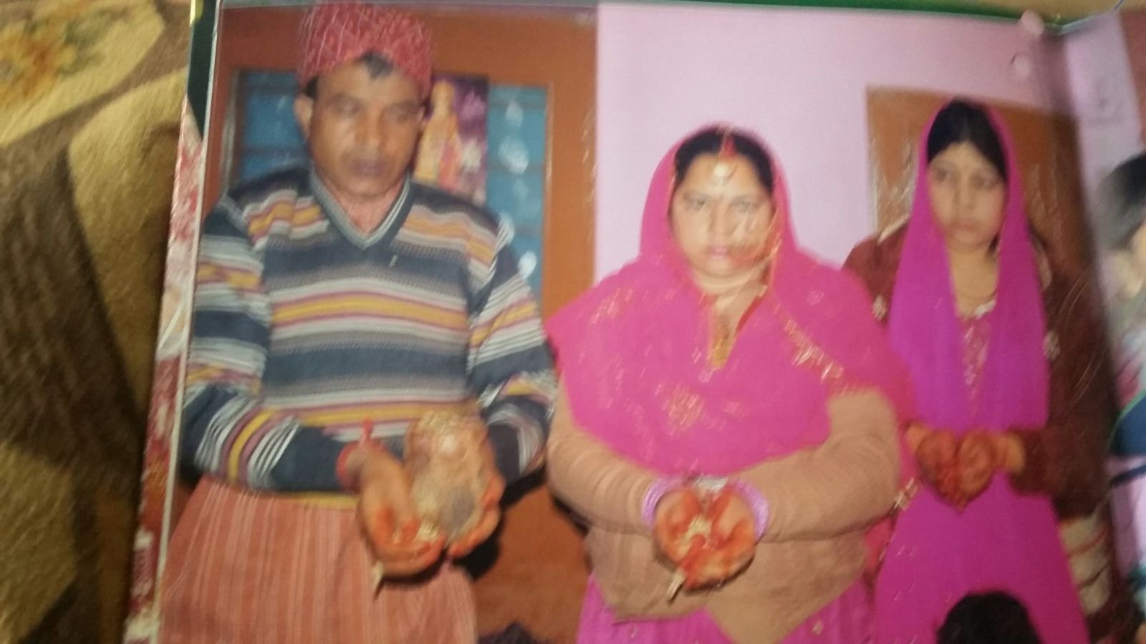
The night before the marriage the bride is given a bath in perfumed water and henna is applied to her hands, arms, feet, and legs. This henna is brought to the bride’s house by the people from the bridegroom’s family. People dance and sing songs to the music of drums and pipes all night. The bride’s parents start fasting the moment the henna from the groom’s family arrives at their house. They only break the fast after the whole process is over and not with food prepared for the feast, but with something that is cooked for the family after the feast.
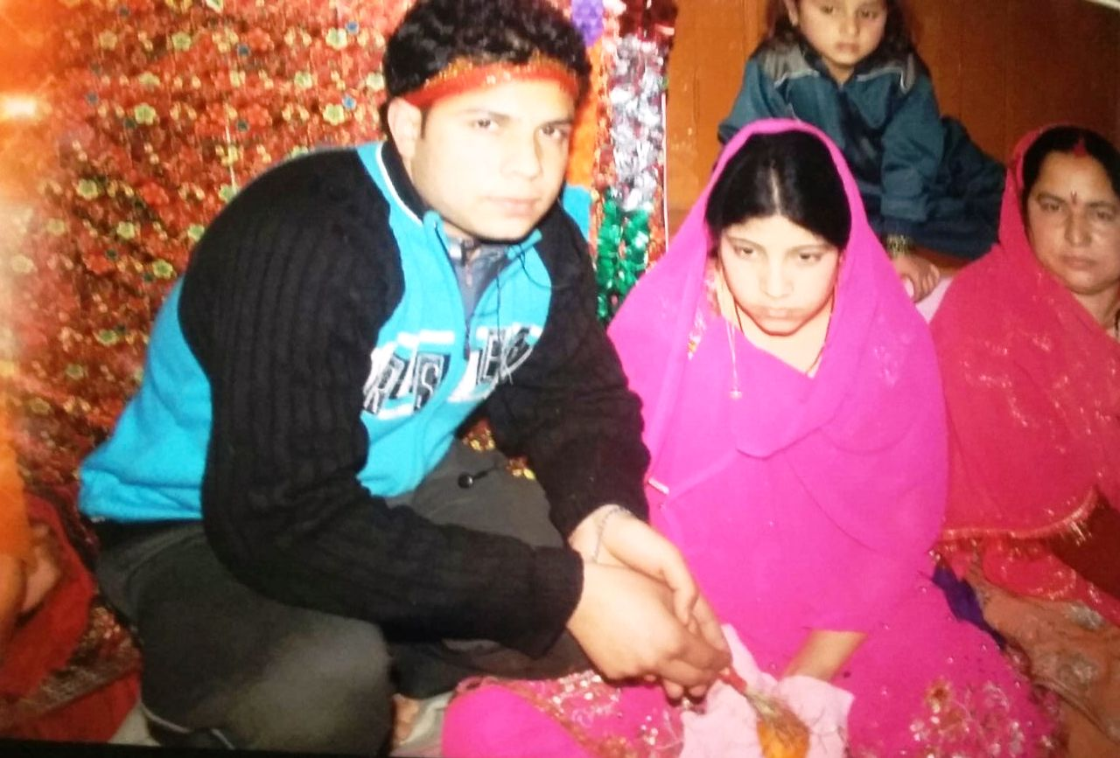
The Henna Night is celebrated at the groom’s house too. The henna is prepared in a wide and shallow container and kept before the bridegroom. The bridegroom holds an orange like fruit called as /kim/ in both his hands over the aforementioned container while his friends, family and neighbors present him with money and apply henna to the fruit in his hands with grass. The fruit is considered as sacred and a bringer of good luck. No definite answers as to the full significance of the above mentioned /kim/ rite could be obtained from the informants
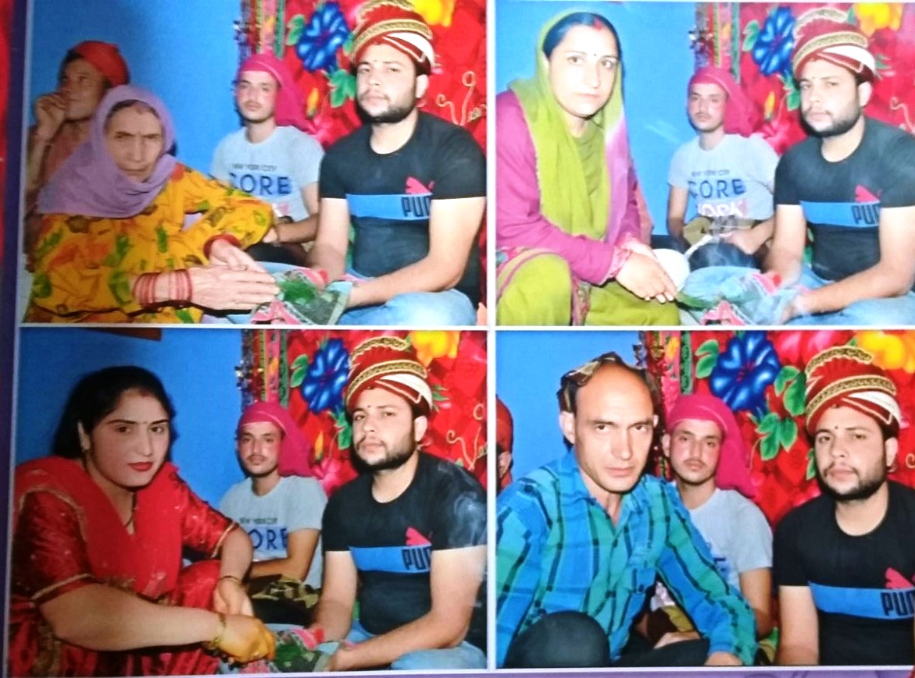
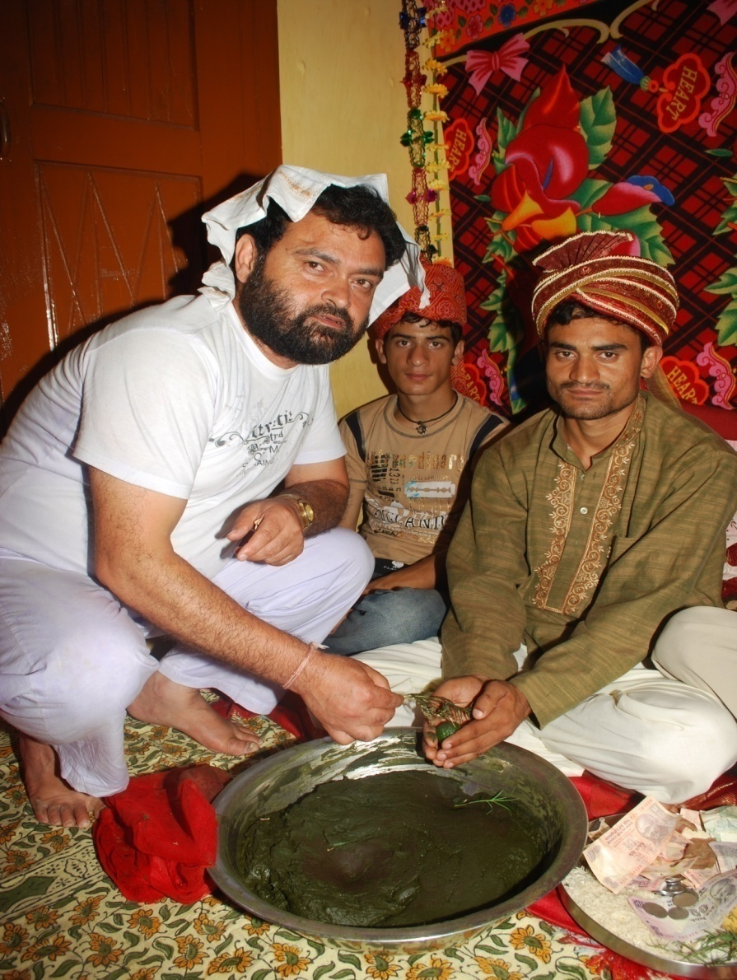
The /kim/ Ceremony.
This ritual of Henna Night is common throughout the state of Jammu and Kashmir.
The Marriage /laɡan/
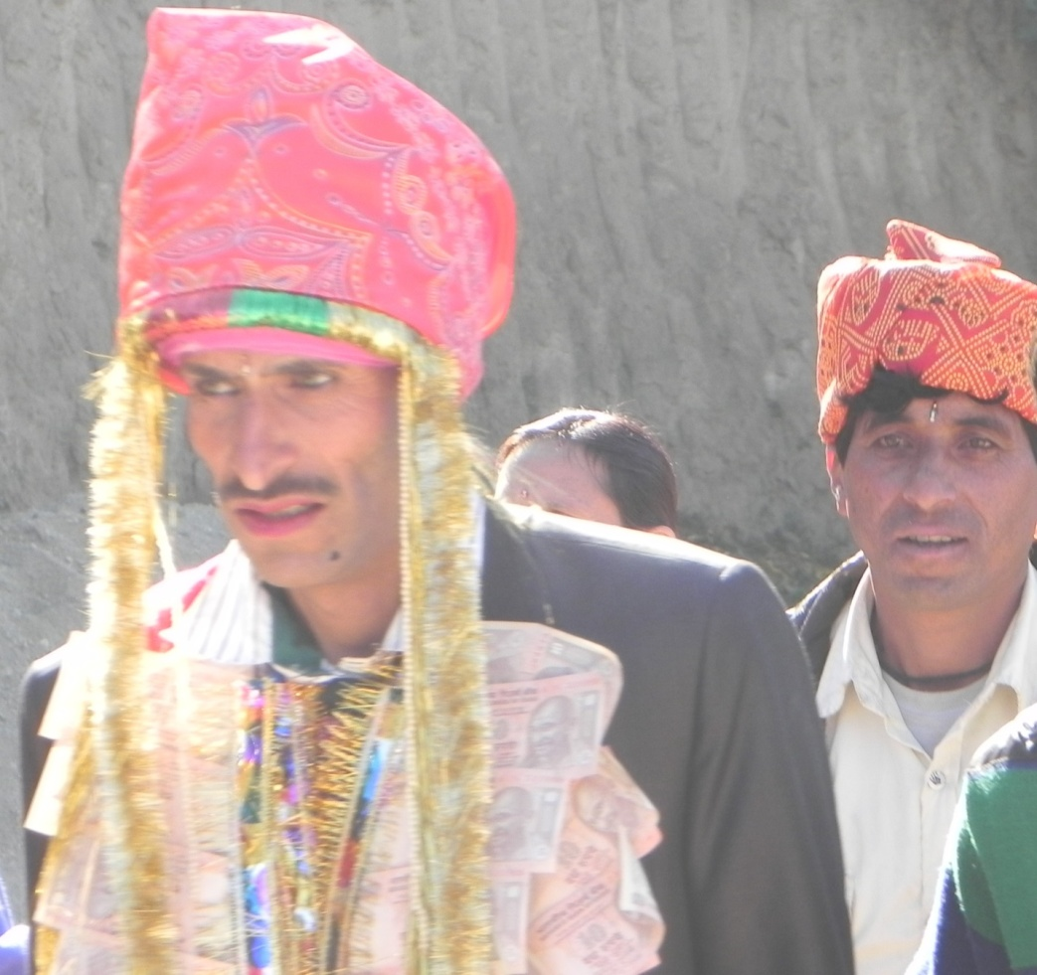
/laːdaː/, The Groom

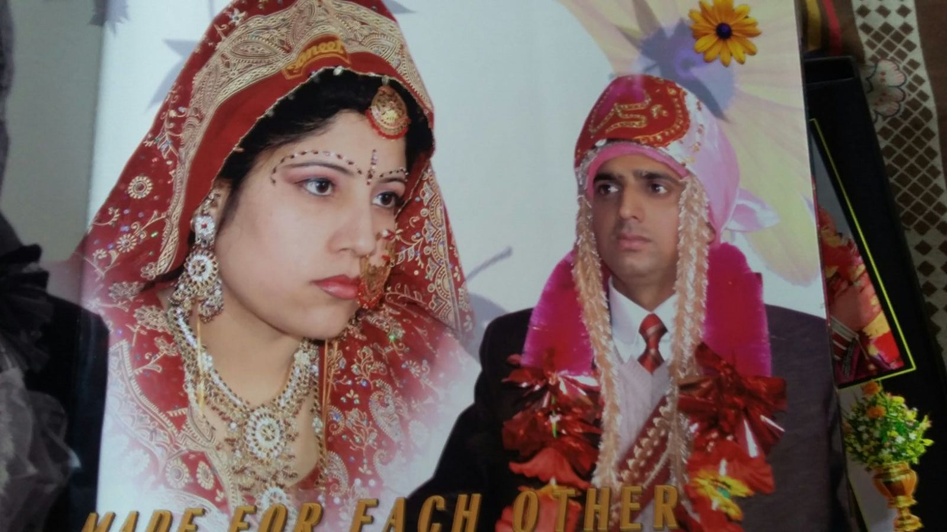
‘The bride and the groom’
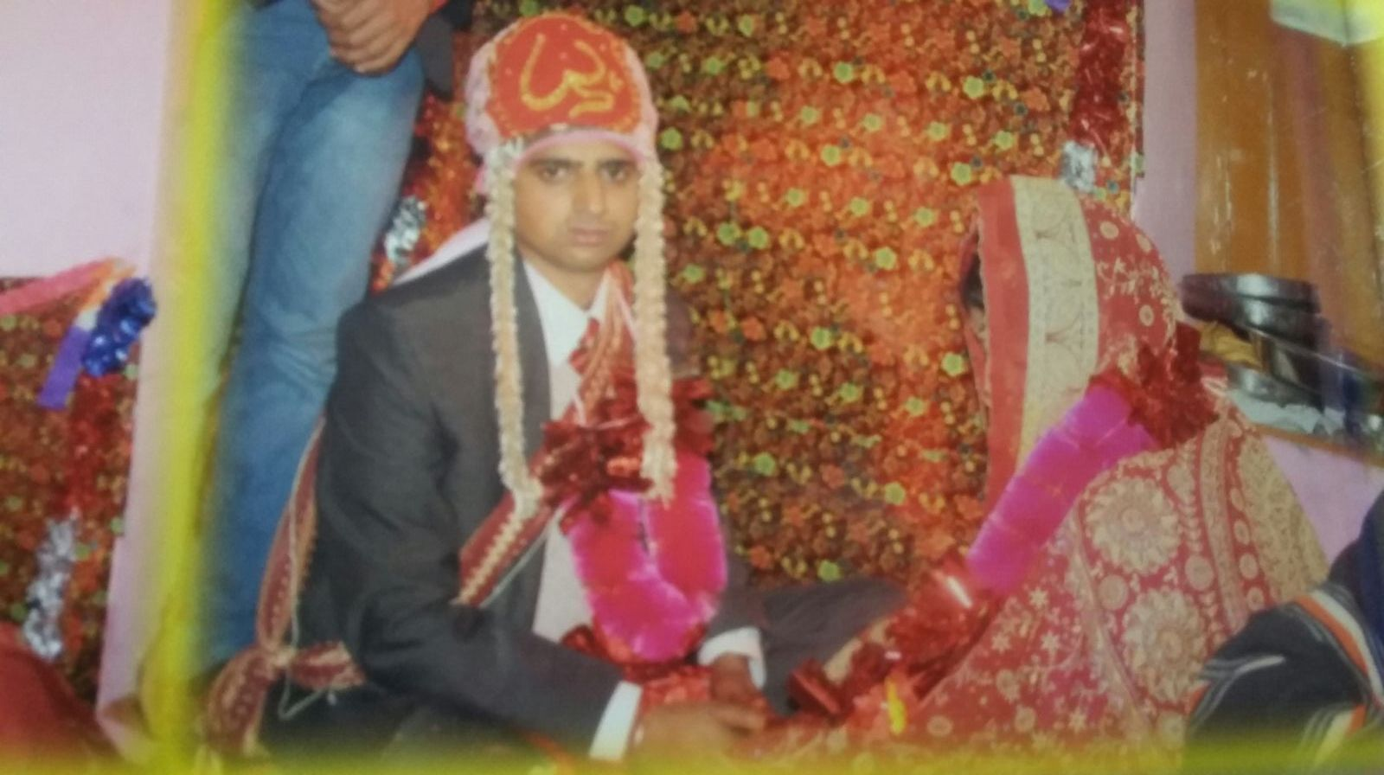
The ceremony lasts two days. At the bride’s home the feast is prepared in the morning and the bridegroom, /laːdaː/, along with a large procession of his neighbors, relatives and friends, which is accompanied by drummers, bagpipers and the people with cymbals, arrives in the afternoon.the bride usually wears a red wedding dress. Girls from the neighborhood and the friends of the bride dress her up for the wedding. The bridegroom usually comes riding on a decorated mare and wearing a /guʈanna/ (a type of trouser), a shirt and a turban. The groom also wears money garlands and carries a ceremonial decorated sword. These days it is not uncommon for a groom to come in a car with the procession dancing all around it. The whole village comes out to watch as the procession /bʰa:ra:t̪/ traverses the village and comes to halt at the door step of the bride’s family’s house.
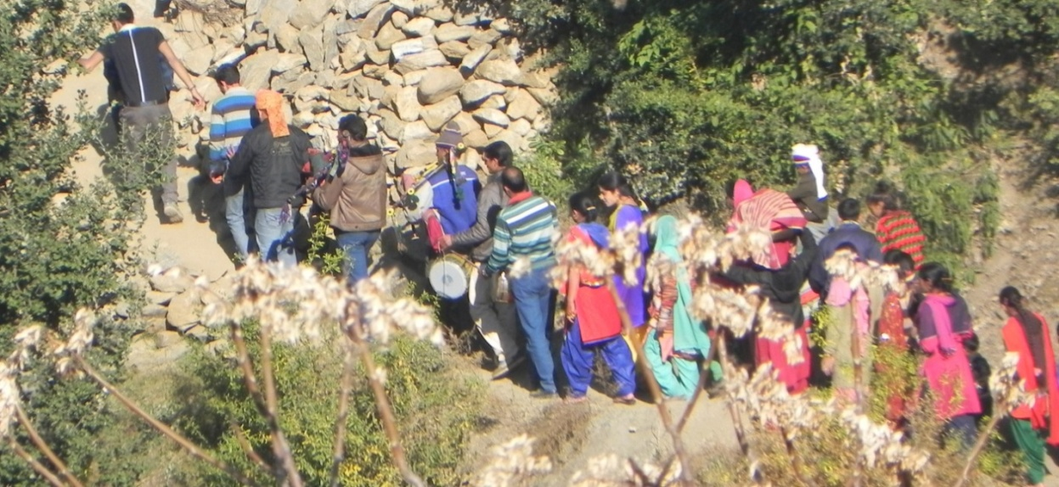
/bʰaːraːt̪/, The Procession.

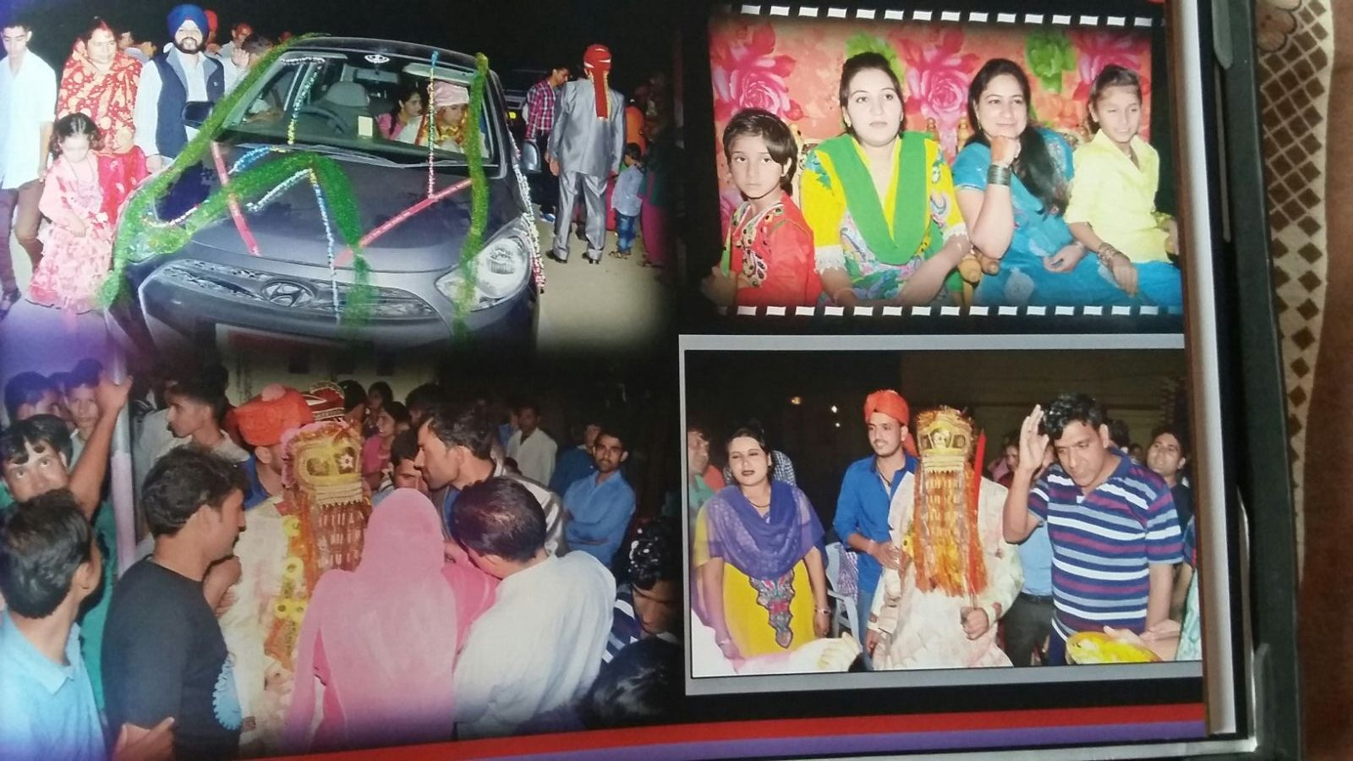
At the door of the bride’s house the bridegroom waits while a priest recites some incantations. The process takes around an hour to complete. Then the groom enters the house and proceeds directly to the place where the main ceremony takes place. This ceremony is conducted by the priest that accompanies the groom. As in all typical Hindu marriages the bride and the groom are connected symbolically by a knot between their garments and made to move seven times around a fire into which the priest drops some ghee from time to time. The seven turns represent the seven incarnations, /sa:tʰ dʒanam/, that a human being has to pass through and the knot represents their marital bond. The fire, /aɡniː/, stands for the god of fire , /aɡniː d̪eːvt̪aː/ who is taken as a witness to this bond for seven incarnations. The whole ceremony takes over five hours.
The Feast:
Then the bridegroom and the people accompanying him are provided with a feast. The feast may be vegetarian consisting of pulses like red kidney beans, /raːdʒmaːʃ/, a combination of ɡreens and cheese, /paːlak paniːr/, collard ɡreens, /kadam/, and the like. Some people provide a combination of the vegetarian and non-vegetarian elements in a feast to the groom and the accompanying guests, which consists of a couple of mutton dishes in addition to the usual vegetarian dishes. There is a complete segregation of the two types of food (veg and non-veg) where some die-hard vegetarians don’t want their food contaminated by the non-vegetarian material.
The Departure:
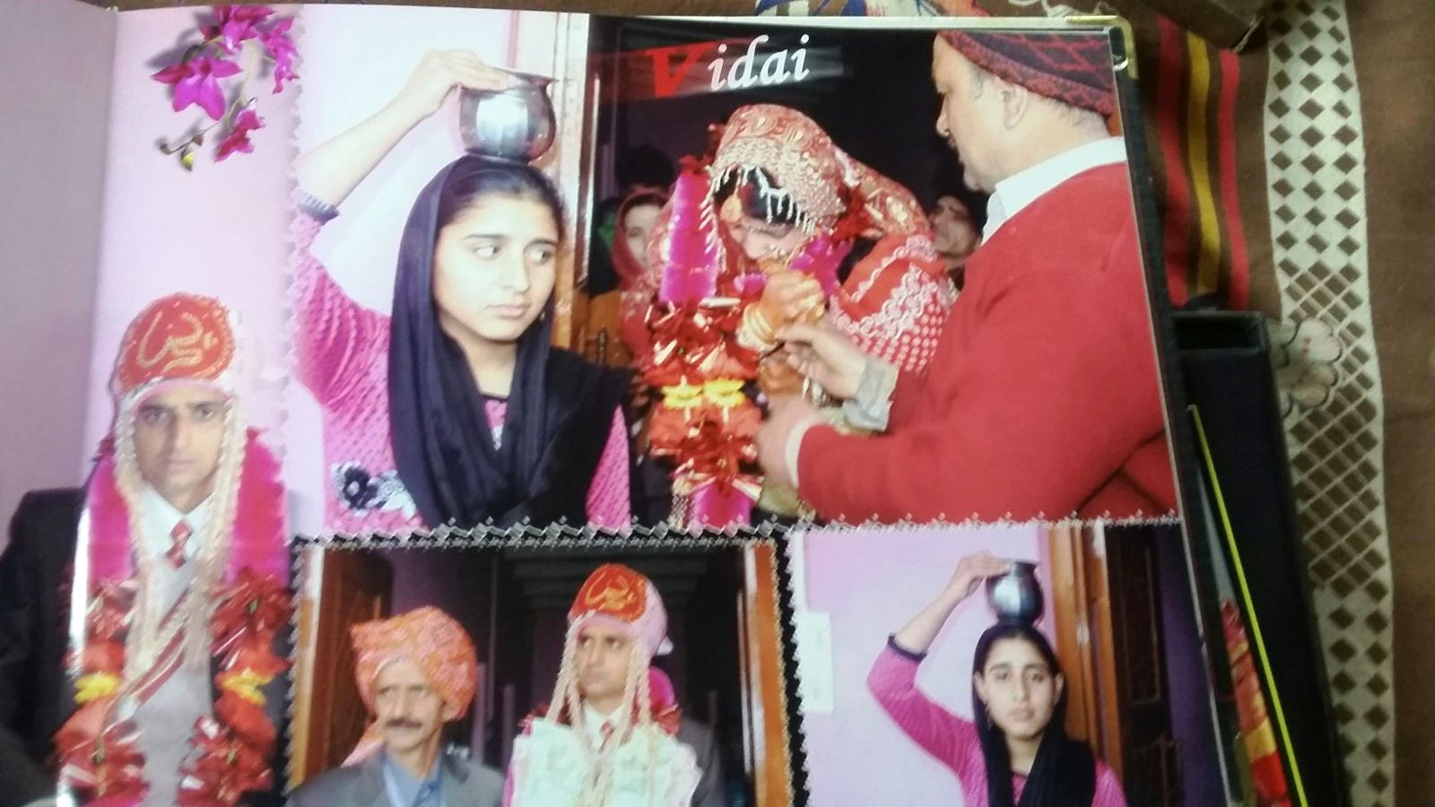
Tradition dictates that the groom and the people with him should stay for the night and leave next day in the morning taking the bride with them. However, nowadays leaving late in the night after enjoying the feast is getting increasingly common.
As is common in the Indian Sub-continent, the time of the Bride’s departure from her parent’s home to her husband’s home is a sad time for the bride and her family.
The Return:
The bride is brought back to her parents’ home after a couple of days by some five to ten people. As with every other step in the marriage the time and day when the bride returns to her parents’ home is determined by the astrologer, /dʒot̪ʃiː/, at the very beginning of the process. The astrologer prepares a document which is called as /laɡan tʃiʈʈʰiː/, literally, “ the letter of union”. This document lists the auspicious dates and times of all the activities of the marriage process. She stays for two to three days and then is sent back to her husband along with some gifts for her in-laws such as clothes and some dishes. Again this is done according to “the letter of union”.
Dowry/d̪a:z/:
The custom of giving dowry to the bride is also prevalent in the community. The dowry goes with the bride when she leaves her parents’ home for the first time with her husband. Gold, bedding or utensils are usually given as dowry. The status of the family of the bride decides the dowry.

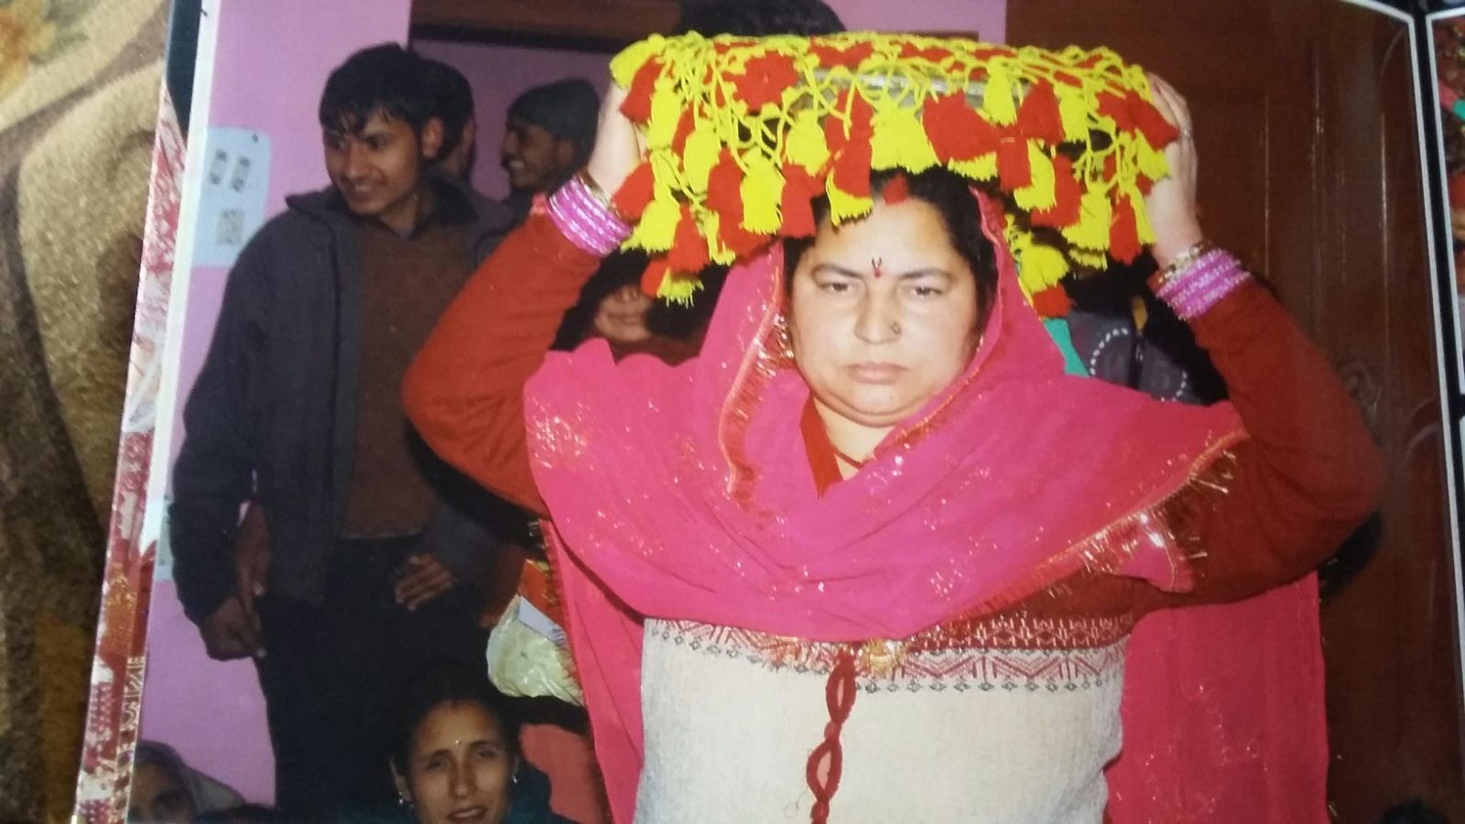

Taboos
In this community, Sororate and Levirate marriages are not permissible. A woman of this community cannot marry her deceased husband’s brother and a man in this community cannot marry the sister of his deceased wife.
Widows in the past were not allowed to remarry but now widow remarriage is getting acceptability in this community.
Love marriages and eloped marriages are not acceptable in this community. If a person marries outside the community, he or she can be disowned by the members of the community.

JUDICIARY
Judiciary is the part of a government which is responsible for its legal system and which consists of all the judges in the courts of law. It is the system of courts that interprets and applies the law in the name of the state.The judiciary plays a pivotal role by maintaining and administering the laws. It not only administers justice but also protects the rights of the citizens. Judiciary interprets the laws and acts as a custodian of the Constitution. Courts, tribunals and regulators together work and form this integrated system for the benefit of the nation.
The civil and the criminal laws in Tipri are those of the central government. Crimes and disputes are handled and solved by the police according to the law. However, cases and disputes of local nature are solved by Sarpanch who is the village-level head of the local self-government called Panchayat or Gram Panchayat. It comprises of Sarpanch along with other elected members called as Panchas. Sarpanch acts as an interface between government officials and the people of village. Sarpanchs have some judicial powers under which they can solve civil and criminal cases. They can punish and impose fine on guilty.
The Panchayati Raj system is the first tier or level of democratic government. It works in three levels:
At the lowest level is Gram Panchayat. Gram Panchayat is answerable to the Gram Sabha because it is the members of the Graam Sabha who elect them.
Above it is Block level, which is called the Janpad Panchayat or the Panchayat Samiti. The Panchayat Samiti has many Gram Panchayats under it.
Above Panchayat Samiti is the District Panchayat or the Zila Parishad. Zila Parishad actually makes the developmental plans at the district level. With the help of Panchayat Samitis, it also regulates the money distribution among all the Gram Panchayats.
District Panchayat

Panchayat Samiti

Gram Panchayat

Gram Panchayat:
Panchayat is the oldest system of governance. Gram Panchayat forms the base of the three-tier Panchayati Raj system. It is the first executive tier having jurisdiction over a village or group of villages. The members of the Gram Panchayat—the Panchas and Sarpanch —are directly elected. Their number in each panchayat varies from 5 to 31 according to population of the concerned village. In addition to the elected Panchas and Sarpanch, there is a provision for co-option of two ladies, and one SC and ST member each, if they have not been elected as Panchas.
Every village Panchayat is divided into wards, i.e. smaller areas. Each ward elects a representative who is known as the Ward Member (Panch). All the members of the Gram Sabha also elect a Sarpanch who is the Panchayat President. The Ward Panchs and the Sarpanch form the Gram Panchayat. The Gram Panchayat is elected for five years.
The main functions of the Gram Panchayat are:
1. Law and order:
To maintain peace and harmony in the area which comes under this panchayat.
2. Civic:
It is the duty of Panchayat to construct wells, ponds, water reservoirs and distribution tanks; public streets, public latrines and maintenance of roads, etc.
3. Welfare:
Relief work in times of famine and flood, welfare programmes for women, children, handicapped and weaker sections.
4. Administrative:
To collect funds, maintain records, budget and accounts, registration of births and deaths, etc.;
5. Commercial:
To supervise community orchards, grazing ground, etc.
6. Developmental:
Prepare and execute plans for the promotion of agriculture, irrigation, co-operatives, cottage and small-scale industries. For Panchayat, the main sources of income are the grants from government, taxes on buildings, vehicles, etc., octroi on goods and animals, pilgrim tax, etc.

Panchayat Samiti:
It is the middle tier of the Panchayati Raj system—between Gram Panchayat and Zilla Parishad. This tier was same as the tehsil or taluka. This is composed of Sarpanchas of all the Gram Panchayats within a block along with MLA of the area. In addition to these members, there are some co-opted members—two women, one SC and ST representatives each, if they have not already been elected as primary members.
The chairperson of the Panchayat Samiti is called Pradhan. He is elected by the members of the Panchayat Samiti amongst themselves. At certain places, Panchas of Gram Panchayat also take part in the election of Pradhans.
The main functions of the Panchayat Samiti are:
(i) Agriculture— to formulate plans for the development of agriculture, tree plantation and soil conservation;
(ii) animal husbandry;
(iii) health and sanitation;
(iv) education—running primary schools;
(v) communication—construction and maintenance of inter-panchayat roads, etc.;
(vi) co-operation—promotion of co-operative societies;
(vii) development of cottage and small-scale industries; and
(viii) miscellaneous work.
The main sources of income of Panchayat Samiti are annual grants by state government, share from land revenue, proceeds from taxes, fees and loans, contributions, etc.
Zilla Parishad:
It is the apex body of the Panchayati Raj system located at the district level. It is composed of:
(i) Chairpersons/Presidents of Panchayat Samitis within its jurisdiction;
(ii) MPs, MLAs, and MLCs of the area;
(iii) members representing women, SCs and STs are co-opted if they are not otherwise members;
(iv) representatives of co-operative societies, municipalities of the area; and
(v) some persons having experience in the field of administration, public life or rural development are also co-opted.
The membership of the Zilla Parishad remains in the range of 40 to 60 persons. The elected head of Zilla Parishad is known as Zilla Pramukh (President). He is elected either directly or indirectly from amongst the members of the Zilla Parishad. Zilla Pramukh works through committees which look after specific works like education, planning and finance. The main sources of income of the Zilla Parishads are grants-in-aid from the state government, share in the land revenue and other taxes like the cess.
The above structure and functions of all the Panchayati Raj bodies have been changing over the years. It has aroused a spirit of self-help and popular participation to some extent among the rural people. The process of decision-making has come close to the rural people. It has also helped in the emergence of a new democratic leadership at the local level. But, the competitive elections have politicized the environment of all villages.

Language Identification
The mother tongue Bhadralium spoken in Tipri village of district Doda belongs to the Indo-Aryan group of languages. It’s also called as Bhaderwahi by non natives. The language has got no writing system (script). Because it has no writing system to speak of, there are no books written or published in this language. There is no linguistic or cultural organization to represent the community. Bhadralium community functions in three languages i.e. Bhadralium (mother tongue), Kashmiri and Urdu. The Muslims speak Kashmiri among themselves and with Hindus.
Languages Employed for Four Basic Purposes (L, S, R, W):
Following is the table showing what languages the people of this community use and for which basic purposes:
Bhadralium | Yes | Yes | No | No
Hindi/urdu | Yes | Yes | Yes | Yes
Kashmiri | No | Yes | No | No
English | Yes | No | Yes | Yes

INDEX
L- Learning
S- Speak
R-Read
W-Write

As the distribution of yeses and noes in the above table shows, Hindi/Urdu is the only language used for all the four activities and, therefore appears to be dominant among the group of languages the people can use in one way or the other. But this table masks the fact that speech is the primary and the most usual mode in which a language is used and, therefore, the language which is spoken the most but not used in any other activity can be the most predominant in people’s lives. Bhadralium and Kashmiri, because they are the languages employed in speech in an overwhelmingly large number of domains, such as agriculture, home, market, community and village meetings, schools, etc. are the most prevalent in the lives of the people. English is the least prevalent even though it’s used in three of the four activities.
Domains of Use:
1) Home Domain:
Following is the table showing what the pattern of language use at the homes of the people.
a. With parents | Bhadralium
b. With grandparents | Bhadralium
c. With spouse | Bhadralium
d. With children | Bhadralium
e. With grandchildren | Bhadralium
f.With siblings | Bhadralium
g. With ancestors who have passed away | Bhadralium
h. With pets and livestock | Bhadralium

At their homes people use their mother tongue, Bhadralium, to communicate with the members of their families and in such activities as petting an animal, calling the cattle, cursing etc.
2) School Domain:
Following is the table showing which languages are used in schools.
a. With the teacher in the classroom | Hindi/ Urdu
b. With the teacher outside the classroom | Hindi/Urdu
c. With friends in the classroom | Bhadralium/ Kashmiri
d. With friends outside the classroom | Bhadralium/Kashmiri

It is clear from the table that Hindi/Urdu is used by the students to talk to someone in authority, and Bhadralium to those of equal status.
3) Market:
The following table shows the pattern of language use at a market.
a.With the shopkeeper or vendor of the same community | Bhadralium
b. With the shopkeeper or vendor of some other community | Kashmiri with local Muslims and Hindi/ Urdu with others.
c. With an acquaintance | Kashmiri with local Muslims and Hindi/ Urdu with others.

Because the people use mainly two other languages in addition to their own mother tongue, it is inevitable that these languages will influence their mother tongue at various linguistic levels—this is a typical multilingual situation where the interacting languages are bound to converge.
4) Place of Worship:
The following table shows the pattern of language use at a place of worship.
a. Praying to gods | Bhadralium
b. Reciting or performing rituals | Sanskrit
c. Singing religious songs | Bhadralium
d. During Exorcism | Sanskrit and Bhadralium
e. Talking with other worshippers | Bhadralium
f. For religious discussion sat the place of  worship | Bhadralium

Sanskrit is restricted only to recitations of religious texts during rituals. Generally, people are not acquainted with it and the select few (priests) who are, know only to pronounce it.
5) Community meeting and village meetings:
The people use Bhadralium when it’s a meeting of Bhadrlium speaking community, Kashmiri and Hindi/Urdu when it is a village meeting, where people from all the three communities are present.
6) Interaction with Strangers:
In the case of a stranger, the people of the community communicate in Kashmiri to him or her if he or she is a Kashmiri speaker, otherwise they resort to Hindi/Urdu.

7) Interaction with a Doctor or a Healer:
To a healer--someone within the community who uses the locally available medicinal plants, animal products etc. to cure the sick, and usually also includes religious rituals in his or her practice—the people talk in their mother tongue, Bhadralium.
8) Mass Media:
The language is entirely absent from mass-media. There is no newspaper in the language; there is no program on TV in which it is used or which is about it. But there is a thirty minute program in the language broadcast on radio.
9) Occupations:
During their occupations like agriculture, bee raising, cattle rearing etc. they employ their mother tongue when interacting with members of their own community, and Kashmiri and Hindi with others.
10. Day to Day Activities:
The following is a table showing a list of some common day to day activities along with the languages employed to carry them out.
S. No. | Activity | Language Employed.
1. | Counting | Bhadralium
2. | Abusing | Bhadralium
3. | Joking | Bhadralium
4. | Story telling | Bhadralium
5. | Singing Songs | Bhadralium and Hindi/Urdu
6. | Riddles | Bhadralium
7. | Cajoling | Bhadralium
8. | Praising | Bhadralium
9. | Expressing pain | Bhadralium
As can be seen from the table, Hindi songs are sung by the people along with Bhadralium songs. What this table does not show is that Hindi songs are sung most often by all the age groups except the senior most members of the community. This is clearly an invasion by a dominant language where the native tongue is fighting a losing battle. Furthermore, although the table shows Bhadralium as the language used for most of the day to day activities, the younger people have started to use Hindi/Urdu for most of these activities.
LANGUAGE ATTITUDE
What people think about their language has a very serious effect on whether that language has any chance of surviving in this world of multilingual societies. Whether that language gets dominated by other languages interacting with it or dominates them, depends to a great extent on whether its native speakers have a negative or a positive attitude towards it. Prestige plays a very important role in the interplay of languages in a multilingual community. Prestige, in turn, depends on different factors like whether a language has an official status, is used to write literature, or is used in mass media.
The language under investigation is confined to a small community in the village Tipri in district Doda of the state of Jammu and Kashmir. Although the village is a very remote one, it is not remote enough for the reach of languages like Hindi/Urdu and Kashmiri. The language under investigation is confined to intra-community use and excluded from inter-community use where Hindi/Urdu and Kashmiri dominate the scene. Even within the community the frequency of its use is observed to decrease from the most elderly to the youngest. Most of the people of the community when interviewed express the opinion that their native tongue should be preserved somehow, but at the same time want their children to concentrate on learning languages like Hindi/Urdu and English. They even encourage their children to use these languages within their homes. They do this because of the opportunities in life that languages like Hindi/Urdu and English provide their children in gaining employment and also because being well versed in these languages elevates them socially.
A series of questions was asked from every respondent which was intended to reveal their attitude towards their mother tongue. The questions, along with a summary of the answers received, are listed below.
- Is your mother tongue easy to learn/ speak?
All the respondents agreed that learning to speak their mother tongue is easy. This unanimous opinion expressed by the people of the community fits the obvious and generally known linguistic fact that people tend to acquire the ability to speak a language without effort if they are exposed to it on a daily basis. No amount of instruction or teaching can achieve the same effect. This generally known linguistic fact also points to a danger which the native tongue of the community faces, i.e., the people are not exposed only to their mother tongue on a daily basis, but also to dominant languages like Hindi/ Urdu and English. This happens through mass-media and the different kinds of inevitable and necessary interaction with people of other speech communities. The people of the community learn to speak their mother tongue mostly because of their exposure to it at their homes.
- Can you express your thoughts in your mother tongue?
All the respondents answered this question in the positive. However, it was observed that while the elders of the community rarely switched to other languages when talking to each other, the young members of the community (teenagers and people in their twenties) frequently switched to words, phrases and whole sentences from other languages when talking to each other. This might indicate the facility of the elders with expressing their thoughts in their mother tongue and the lack of such facility in the younger members who have to seek help from other languages to express their thoughts. On the other hand, this might also indicate the lack of appropriate words and constructions in the mother tongue needed to refer to novel objects and ideas with which youth are much more likely to be acquainted than the elderly.
- Do you accept mixing other language words with your mother tongue?
Most of the people accept borrowing words from other languages into their mother tongue. They even approve of it if the words or expressions concerned are from English or Hindi/ Urdu and it is also considered a sign of being educated. However, the frequency with which these words and expressions are used varies along two dimensions: the dimension of gender and the dimension of age. The frequency decreases from males to females; and from the youth to the elderly.
- Given opportunity, would you be willing to learn to write in your mother tongue?
Mixed responses were obtained from the respondents as to their willingness to learn to write their mother tongue. Some expressed willingness to do so because they thought it would enrich their experience. Others expressed the opinion that it would be a waste of time and effort, because it would not in any way improve their chances of getting employed.
- Do you think that your language is suited for such activities as business, schooling, etc.?
It was found that most of the respondents had never thought about whether their mother tongue would be up to the task of being employed as an official language or a medium of instruction in schools. However, they expressed the opinion that using it to do business is possible as long as the party you are doing business with belongs to the same community. In cases where the other party belongs to some other community using the mother tongue is out of the question.
- Do you think that other languages are easy to learn?
All the respondents answered this question in the negative in the case of English language. They all agreed that English language is the most difficult to learn. In the case of Hindi/Urdu, the respondents thought that it was difficult to learn, but not as difficult as learning English. The following table shows the level of difficulty in learning some other language as per the responses obtained by the investigators from the people of the community.
Difficulty level  Language | Very Difficult | Difficult | Easy
Kashmiri
Hindi/ Urdu
English

The degree of difficulty of learning a language is directly proportional to the degree of familiarity with it. It means the people of the community find English the most difficult to learn because it is rarely used in their surroundings. Similarly, they find Kashmiri the least difficult to learn because it is used on a daily basis in their surroundings.
- Do you think that one language is enough for all types of usages?
Most of the respondents responded to this question in the negative. In their opinion, different languages are suitable for different settings. English and Urdu are suitable for schools and in formal situations. Bhadralium is suitable for domestic and intra-community use. Kashmiri and Hindi/Urdu are suitable for inter-community use. The following table matches languages with their suitable settings.
Settings  Language | Intra-community |  |  | Inter-community
Settings  Language | Formal |  | Informal
Settings  Language |  |  | Informal | Formal | Informal
Bhadralium
Kashmiri
Hindi/ Urdu
English

- Do you think that learning other languages improves your knowledge?
All of the respondents agreed that learning other languages improves knowledge. In their opinion the level of knowledge improvement increases from Bhadralium to Kashmiri to Hindi/Urdu to English. The following table shows whether the respondents think their knowledge improves or not by a particular language.
Knowledge improvement  Level Language | Improvement | No Improvement
Bhadralium
Kashmiri
Hindi/Urdu
English

- How do you react when the speakers of your mother tongue speak other languages?
The response to this query depends upon the language concerned and the age group the respondent belongs to. The following table shows how respondents belonging to different age groups react when a speaker of their mother tongue speaks in some other language to them.
Language  Age Group | Kashmiri | Hindi/ Urdu | English
Above 50 | Get Annoyed | Get annoyed | Get Annoyed
From 30 to 50 | Get annoyed | Get annoyed | Get Annoyed
Below 30 | Get annoyed | Encourage | Encourage
Below 20 | Encourage | Encourage | Encourage

This table shows how most of the people belonging to a particular age group react when interacting with a member of their own community who uses a language other than his/ her mother tongue. Within an age group there may be people who react in a different manner to what is recorded in the table.
- Do you think your language is a hindrance to socio-economic mobility?
All the respondents denied that their language stops them from moving up the socio-economic ladder. However most of them agreed that learning languages like English certainly improves their chances of moving up the ladder. The following table shows whether most of the respondents think that a particular language improves their chances of socio-economic mobility up the socio-economic scale or not.
Response Received  Language | Improvement | No improvement
Bhadralium
Kashmiri
Hindi/ Urdu
English

Again we see a word which has an almost identical Kashmiri equivalent: /d̪aːdʒ/ “dowry”.

