ETHNO LINGUISTICS
EP01-AA000 (STORIES):
EP01-AA001
Creation/evolution story (formation of the earth etc.)
They believed that, the earth is created by the ‘Mala Daiva’. They have trust and faith in Gods.
EP01_AA002 :
Mythological story (Ramayana, Mahabharata, stories of Buddhism etc.)
Kutiya’s are known as the beginners of cardamom cultivation. It is said that, during the age of Pandavas, they were going to Hastinavati, they went on giving boons to natives. Each and every clan got boons. When they reached to Kutiya’s they threw betal they spit the chewing betal. And there cardamom grew. Then they threw the discharge from the nose which became a tree named “bayini”. Pandava’s boons made their life happier.
EP01_AA003 :
Stories of legendry character (bravery,freedom fighter etc.) They consider their ancestors are brave and strong enough to support and oppose to any force and evil respectively according to the truth and justice them being.
EP01-AA005 : Stories of possessed and the cure.
They believe supernatural spirits. There are no particular stories regarding possession. But they used to put cashew nuts and paddy (nelkkathir) in front of their houses and in their prayer room. And also they used to put metal locket “eelas” with their chain. For protecting themselves from these negative energies they arrange “Ganapati puuja” i.e worship towards the God ‘Ganapati’.

EP02_AA001 : Narration
EP02_AA001
Origin and migration (Oral History)
Once, Lord Shiva decided to visit Earth. Parvathy also wanted to join with him but he refused. When Shiva went on journey, she started to follow him. Lord Shiva saw her following him and she was exhausted. She had left her son Subramaniya at home and had not fed milk for a long time to her child. Shiva seeing her distress, took out the dried up sweat from his face, moulded it in the form of a child and gave it life. Shiva asked her to feed that child.
While feeding that milk to the baby, she told the baby (to have the milk) as ‘mole Kutiya” means to “suck the breast”. Later Shiva asked her to leave that child, but she was not willing. So he called out his team Kadilodeyya and Maley Muriya in order to look after the child. Years passed, One day Lord Shiva and Parvathy went out to look for the child. They found that child became a grown man. Shiva asked Parvathy for his companion. So that Parvathy took some mud and made an idol. Shiva gave life. The boy and that girl later get married and Mala kutiya is considered as their children.
2. By the origin, they are hunters. They are known for the honey collection. While they went for hunting, probably they used to have or collect honey. Once someone went to forest, he happened to see a bee hive on the top of a tree. He used his bow and arrow in order to bring that honey in his hand. Instead to hit the hive, honey started flowing through it. The hunter directly took that honey into his mouth. As they live on the top of hills and as the hunter drank the honey directly, they got the name Mala Kutiya.
EP02_AA002 : The contact with animal in forest
Generally they are not hunters. but whenever they do hunting, they do not treat animals roughly. They are friendly. Rather hunting, they like fishing. They do keep pet animals and domestic animals in their home. And they treat them very gently.
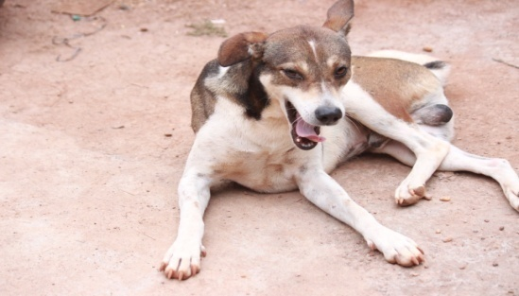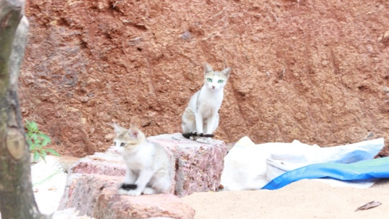
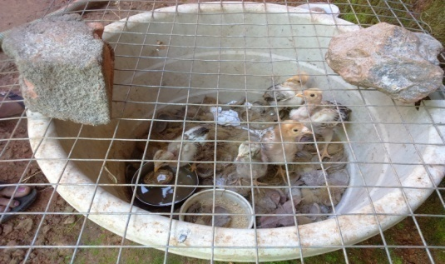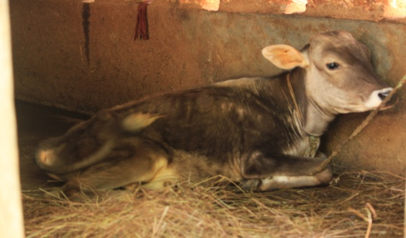

EP02_AA003 : Their experience in profession (market)
Mostly they are doing agriculture. Honey collection, fire wood collection, fishing are the profession of their own. Some of them are doing business.

EP03_AA000 : FOLKLORE MATERIALS

EP03_AA001 : Mythology
According to Kutiya tribes, there are 12 months known as ‘tulu maasam’. Among these months, they supposed to celebrate festivals in the name of God with offerings and prayers and rejoice themselves with folk arts of their own. They celebrate these festivals without fail.

Twelve Tulu months are as follows:
1. suggi February- March
2. paggu March- April
3. bēáya April- May
4. k¡rtti´kko½½u May-June
5. ¡ ¶¶ii June- July
6. s°¸¸o July- August
7. nirunn¡½½o August-September
8. bo¸ttiµga ½ September- October
9. j¡rtt® October-November
10. p®r¡rdhe November- December
11. po¸i December- January
12. m¡yi January- February
The art forms below showed are they performed during these months in relation to the worship towards God.

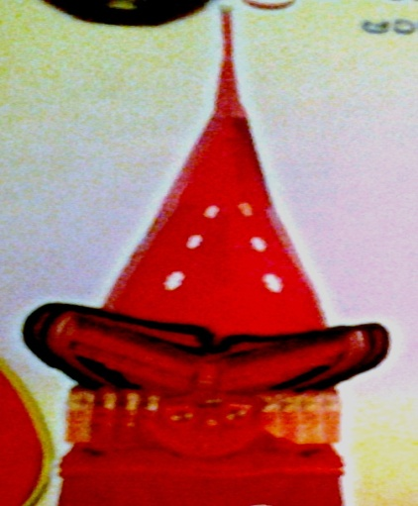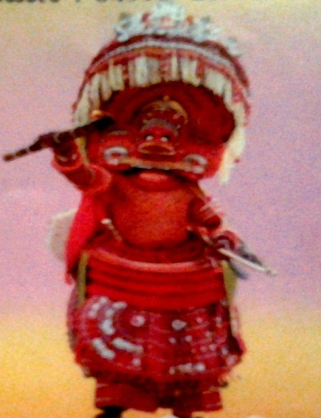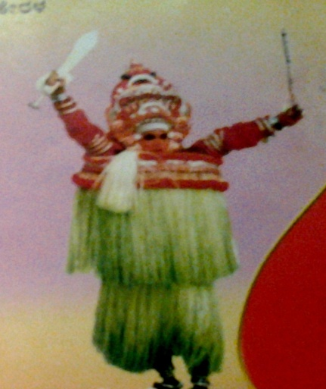(KALIYAATTOM & THEIYAM)

PANJURULI THEIYAM: (pañjuruli teiyyam)
This art form is prearranged for ten day in the month of bēṡya i.e, May of English months. They used to put ‘kolams’ of four or five Gods, one and a half day before whom they prayed most. For making ‘kolams’ they use natural colours green, yellow, etc. ‘kolams’ are made by experts in their community or otherwise from the outside. Prayers are done by puujaari or priest. Those Ten days are delights with traditional hormonal instruments; ‘vaadhiya melam’. The dress and make ups they used in theiyam is known as ‘vēṡaŋŋaḷ’. They do this for the blessings of God. Every year they do all the arrangements without any fail.
Panjuruli theyam is a sacred art form. The teenagers or the women whom having menstrual periods, widows, who has ‘Pulaas’ of any death cases, pregnant women are not permitted to attend the Theiyam. They are not permitted to light lamps in their houses too. It is considered to be improper and sinful state which may causes curse from the Lord God.

NAGARA PANJAMI
This ceremony is orchestrated in the sōṇṇo month of Tulu, which is almost in between the English months of July and August. This ceremony is mainly done for the blessings of ‘Naaga Deivam’. Muupan gives milk to Puujaari for Poojas. After the prayers Puujaari offer that milk to ‘Naaga Muurthi’. Later he breaks coconuts in front of the temple. This is done as a fortification from all the evils called as ‘viknagal’ .Then Puujaari gives that milk and turmeric paste to everyone called as ‘p¡lu pres¡dam and maµjal pres¡dam.

CHAAMUNDI PUUJA
Chaamundi God is considered as their prime God. They also believed in ‘CHAUDESWARY’, ‘GULIKA’,’MUKAMBIKA’. ‘Chaamundi puuja’ is for the blessings and wishes that should come true. In order to satisfy the Chaamundi God, they used to put ‘pori’, tender coconut, cock, ‘pinkaara’, ‘puunkula’, turmeric water, banana fruit, toddy etc. At the end of the prayer, at the end of a stick covered with cotton, he will put fire. At the time, the bell rings, all should bow their head for receiving blessings.
KRISI MASOM
‘Krishi masom’ is a fest or ceremony in the Tulu month of PERARDHE (per¡rdhe) i.e from November 10-15 of English months. Muppan makes 'bali kuupam' which should be making with banana stem.
EP03_AA005 : Belief System
They feel in secure when they are failed to commit their offerings in time to their Lord. They have certain fantasies and believe as to protect themselves from bad eyes and curses. They do not permit anybody to go out while some body having food. They don’t let anybody to go anywhere when a cat crossed their way.
EP03_AA008: Poems
They have songs related to worship and during harvesting times. They consider to get relief and freshness from those songs.

EP04_AA000: ETHNO-LINGUISTICS

EP04_AA001: House Structure
The house structure is resembled to the house of localised people. Most of the houses are made up of bricks and cement. The concept of “tharavaadu” which is not at all common in tribal people can be seen here. The moopan’s house is called “tharavaadu” for all the members of their family. It is same as to everyone according to their own family.
EP04_AA003 : Shape of roof and materials used.
EP04_AA004: Flooring
EP04_AA005 : Shape of facing doors and windows and the logic

EP04_AA002 : Materials used in building houses.
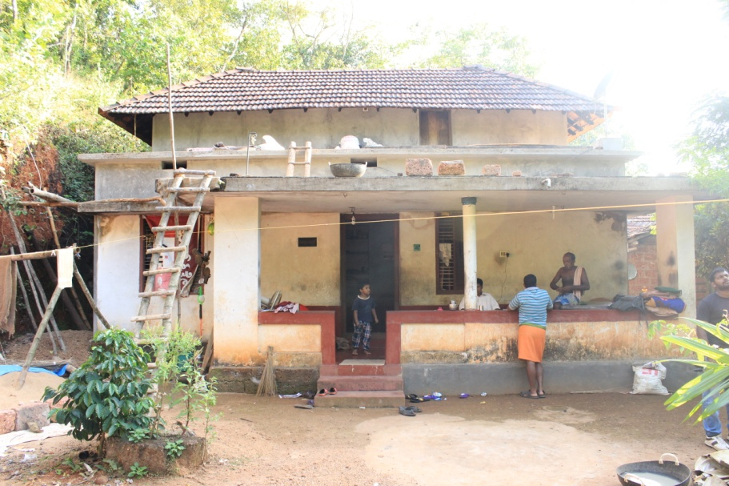
(A Kudiya House at Kojappe - Moopan’s house)
Mostly the houses or huts are made with an oblong mass of hardened clay, roofs are of tile, wooden slabs and stones. Rooms are facilitated accordingly with the need. They called house as “ illu”.

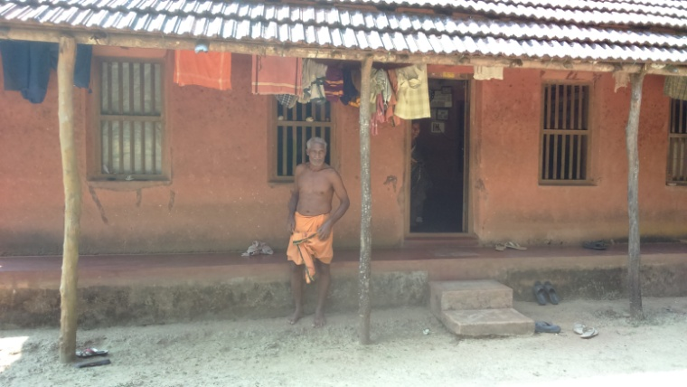
Each house has varenda, hall, prayer room, bed rooms, kitchen, store room (sometimes inside the house, otherwise outside the kitchen). Bathroom are always outside of their house.
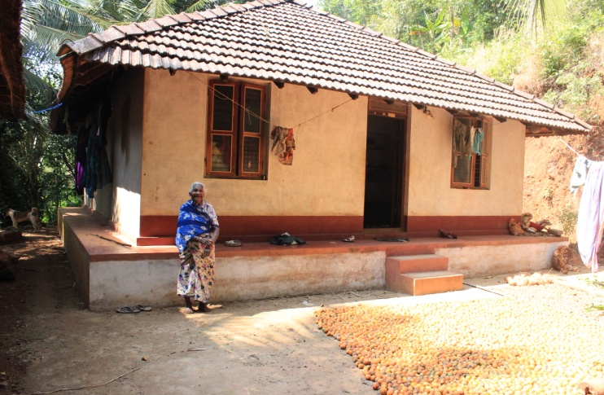
Earlier times they were used dry coconut leaves, dry palm leaves, and dry straws for covering house roof. And also they used wooden pieces tied with dry coconut leaves as like walls and shades.

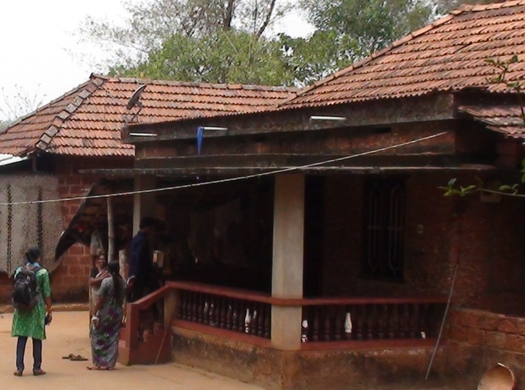
They are very much careful about cleanliness inside their house. The floor is made up of clay paste or cow dung paste. Certain houses have only cement floor.
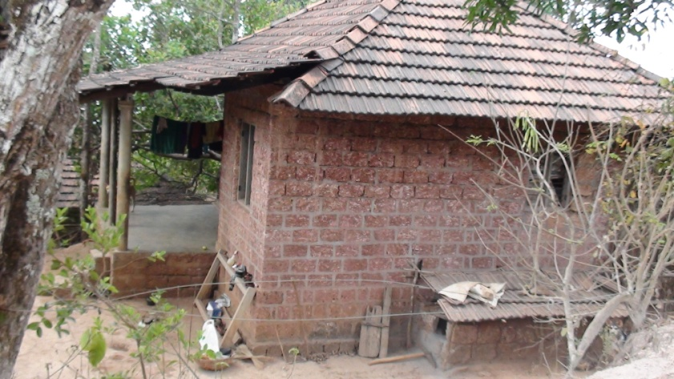
Triangle shaped roofs are common among their house roof structure. Previously they used dried leaves mat for roof in order to keep coolness inside of the hut or house.
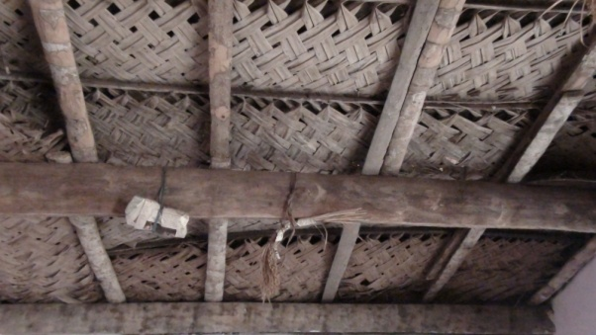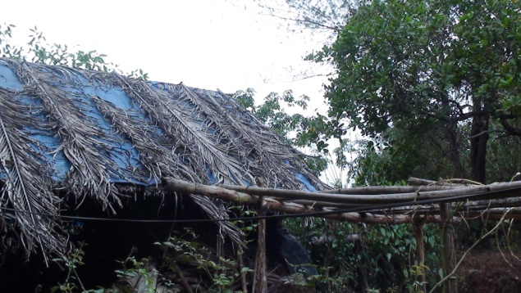
In front of the house, the doors are opened towards east side. Windows are placed as according to the way for light and fresh air should passes through.
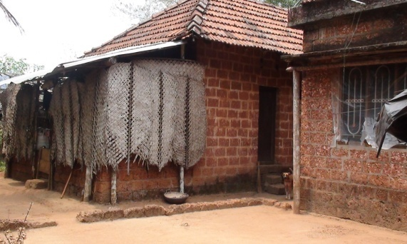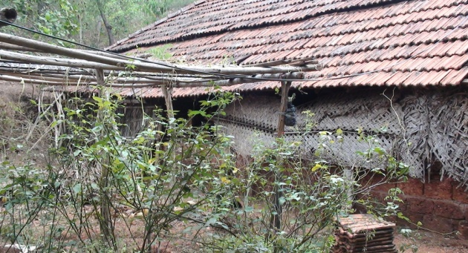
The sameness to every house is only the straws, cashew nuts; rice plant, rice flake etc were wrapped in a cloth pieces and hang in front of the roof of the house.
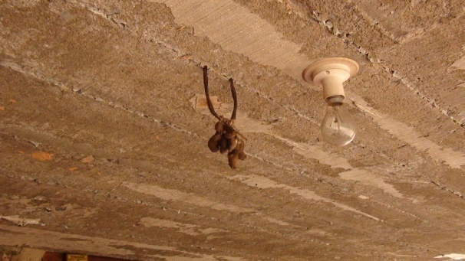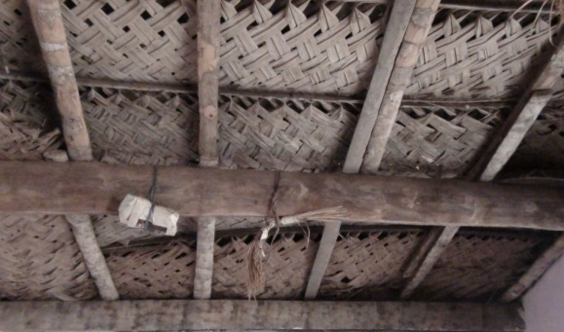

They also wrote “OM” just above the front door. These are a part of their belief. By these, they try to protect houses from bad eyes.

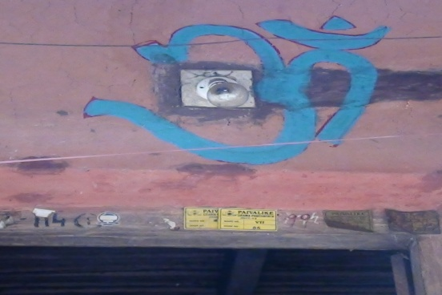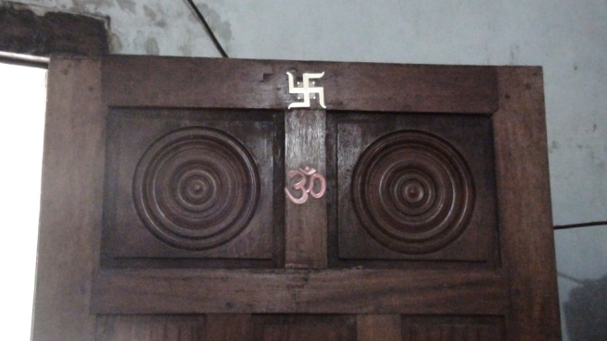
EP05_AA000: KITCHEN ITEMS
These days, Kuṭiyas are much more sophisticated in their kitchen holdings. They used modern grinder, mixi and all. In earlier periods they used wooden plates and vessels rather than steel and aluminium. Glass items are less during those days. Some of the vessels and kitchen items are as follows.
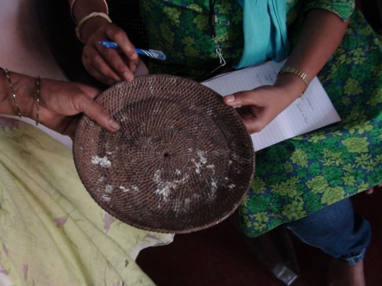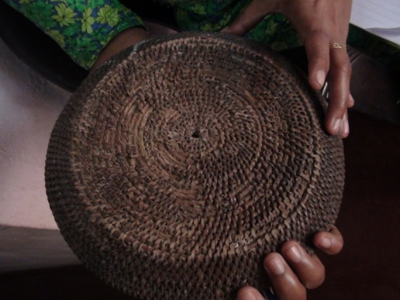
This plate is made up of bamboo. “muudi, is used to cover the top of the “kopee” or vessel and pots
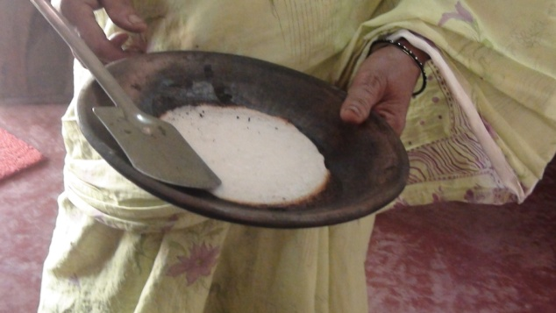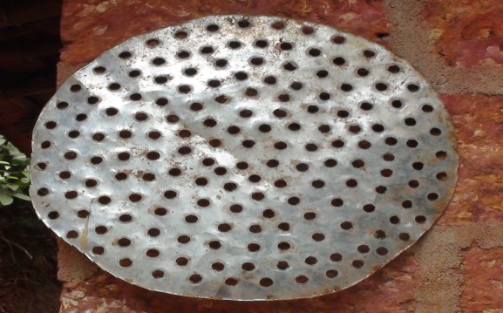
EP05_AA004 : Kinds of Knives, peelers.
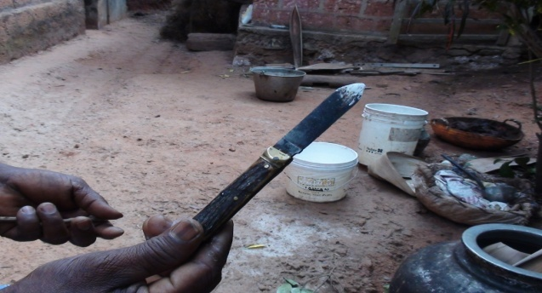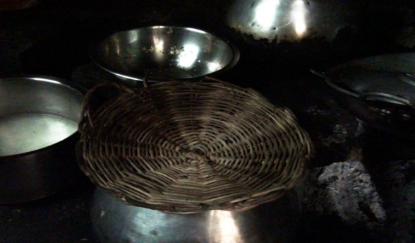
EP05_AA002 : Kinds of plates, glass and bowls ( shape and material)
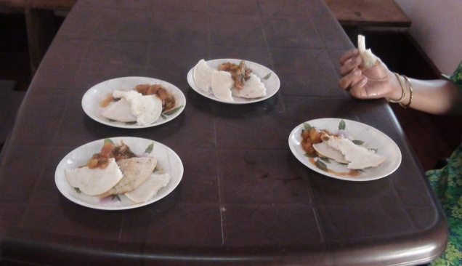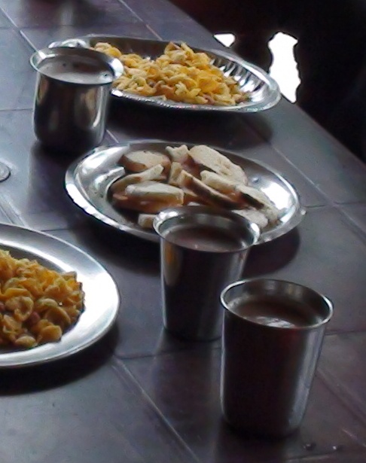
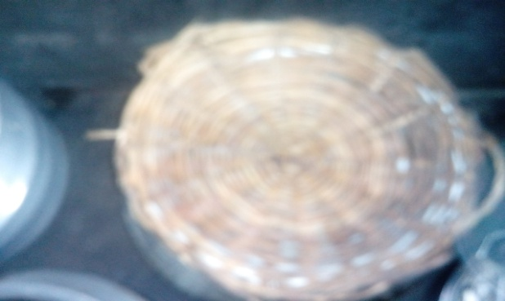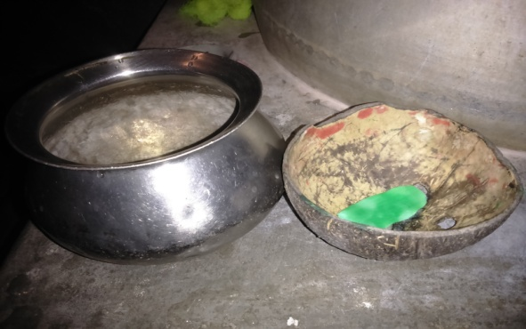
EP05_AA001 : kinds of vessels used in cooking ( shape and materials)
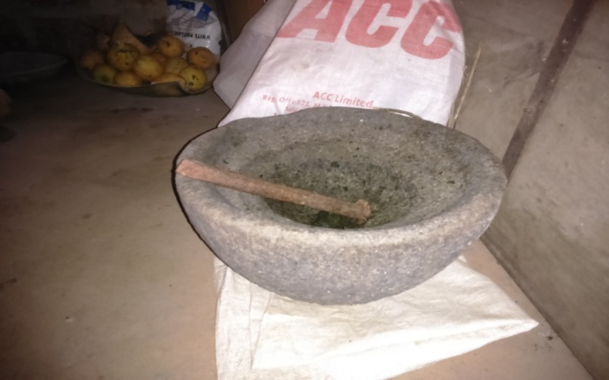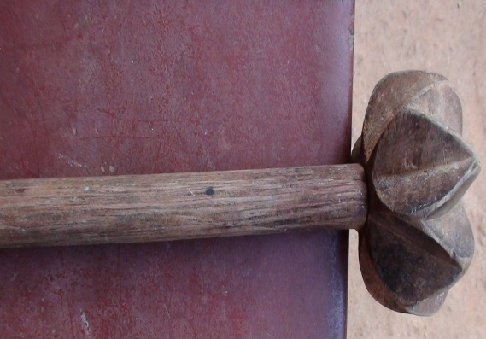
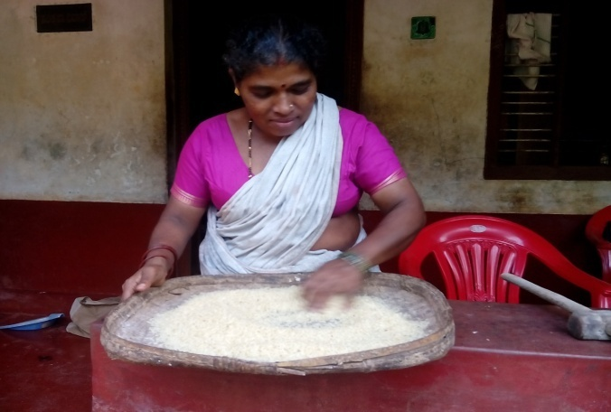
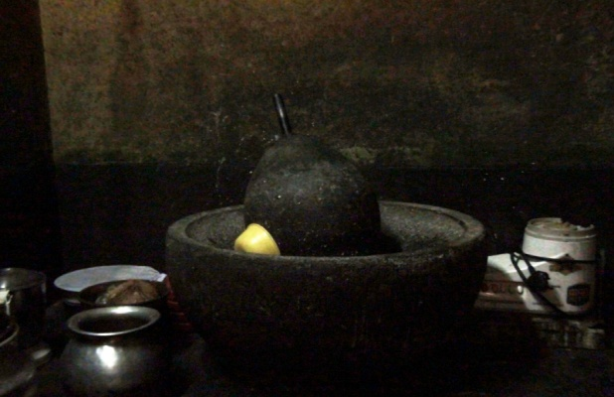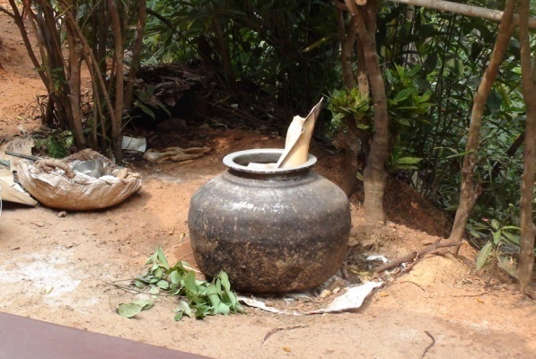
The above showings are some of the items used in their kitchen. Mostly they used steel vessels and clay pots. Wooden items are also used. Rarely did they use glass items and plastic plates for visitors.
EP06_AA000 Households Items
EP06_AA001 Furniture
In earlier times, they mostly use wooden chairs, benches and stools. But now a day they use plastic chairs. Instead of using coat and bed, they uses mat for sleeping. Tables are also plastic and rarely wooden tables found out.
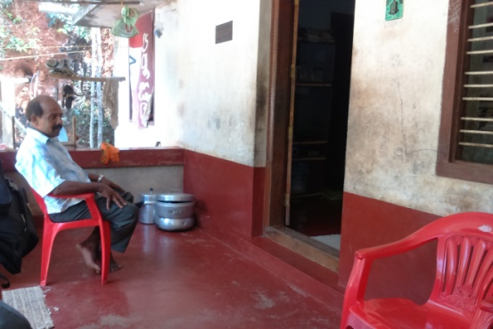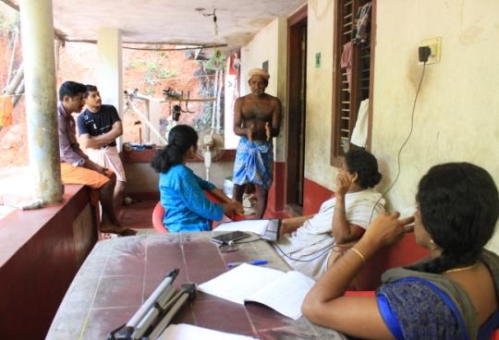
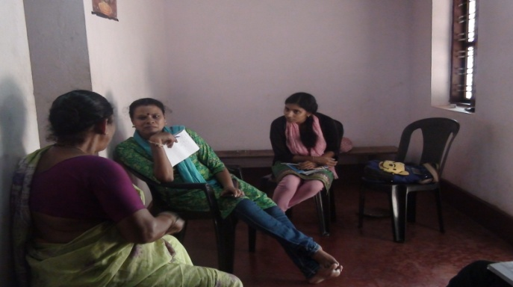

While they had food, they all are sit on the floor and used to take food on banana leaves. It is same as for the outsiders too.
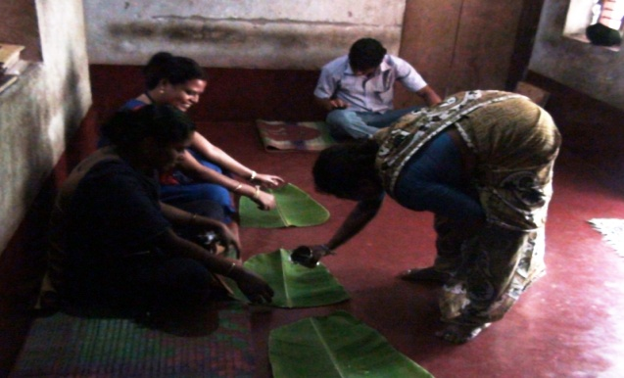
EP06_AA002: Kinds of brooms
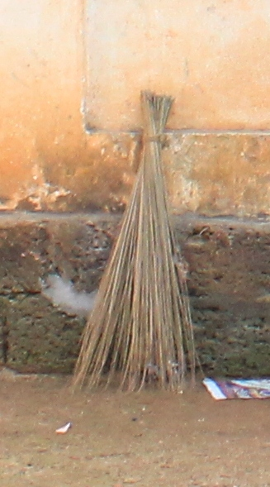
They cleaned the coconut leaves and took its stems and tied it with a coir piece. They used it as broom.
EP06_AA003 : Kinds of lamps
They used oil lamps and candles during power cut and rest of the time they use solar light and bulbs. Oil lamps or kerosene lamps are made up of aluminium and certain with copper.
EP07_AA000 : Food Items
They are generally use vegetables and also fish in their foods. Fibres and tubers are common in their foods items. They do make different recipe of pickle, fish curry, fry, sambar etc.
EP09_AA001 : Agriculture ( tools, main crops, season, irrigation system)
Tools:
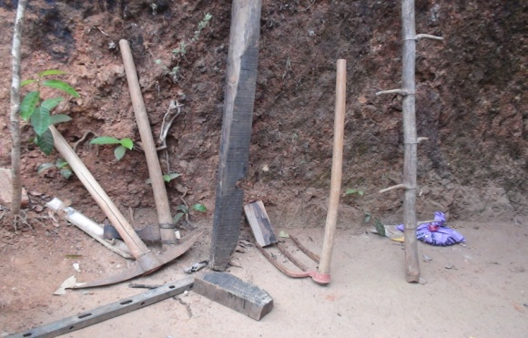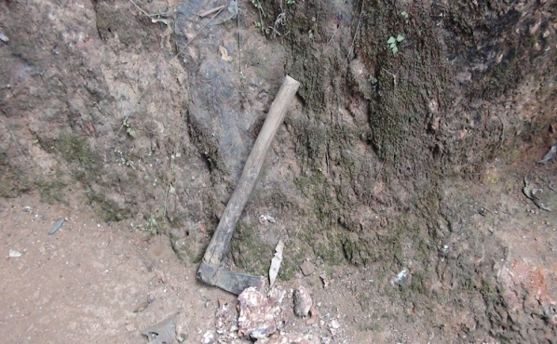
These are some of the tools used for digging soil , climbing trees and shades, axe for cutting trees and branches etc.
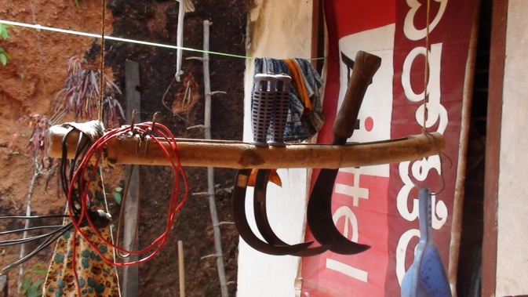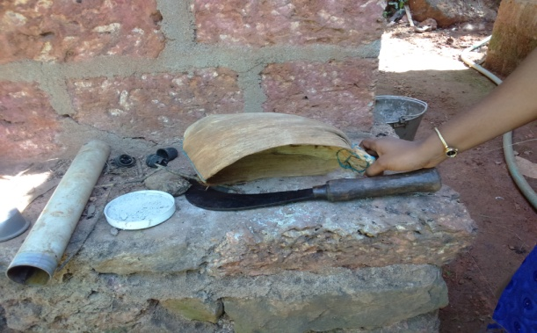
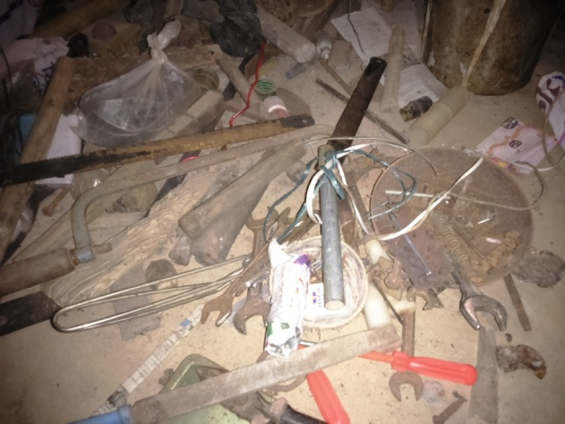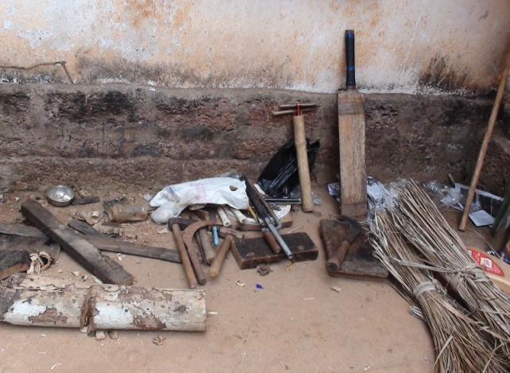
These are some of knives and tools used for agricultural needs.
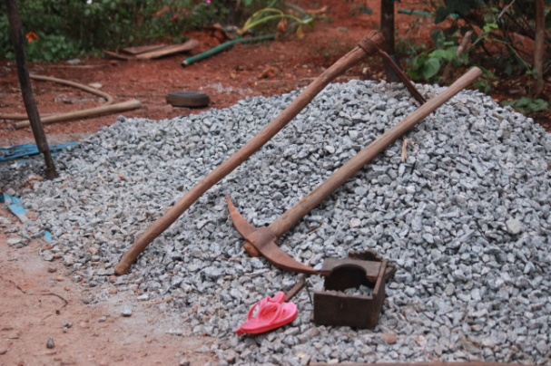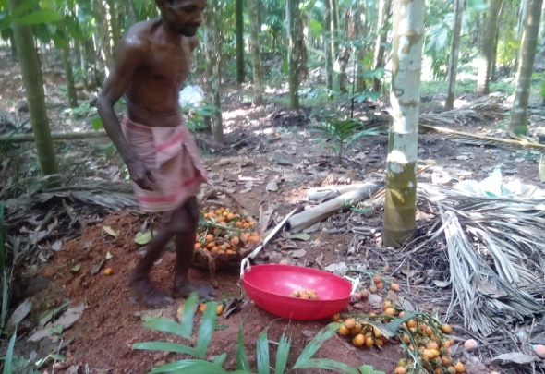
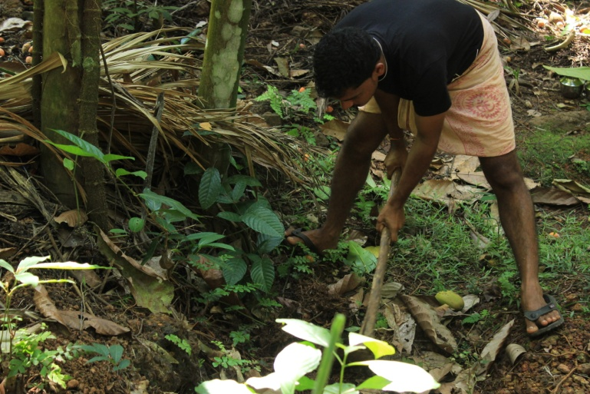
They are hard workers and before going into the cultivated land / cultivation they offer their crops and fruits to God.
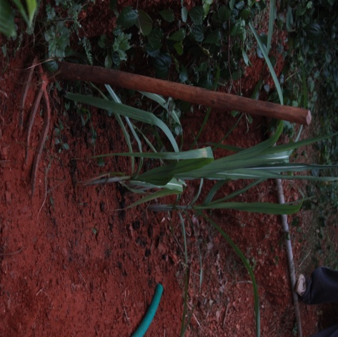
Crops and cultivation:
Kutiya denotes “the top of the hill”. They are known for collecting honey. Though they are said to be the beginners of Cardamom cultivation, they used to cultivate other crops as follows:
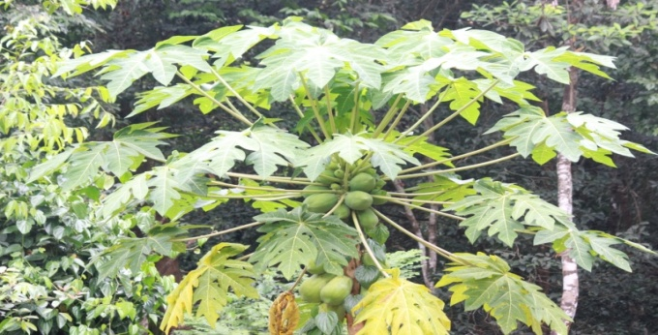 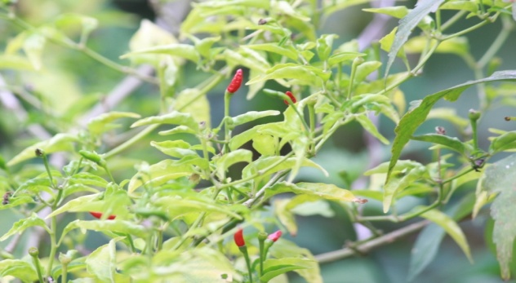 PAPPAYA : bappankaayi KANTHARI : Gaanthari munchi
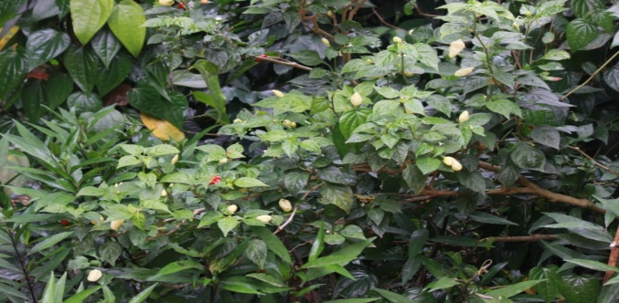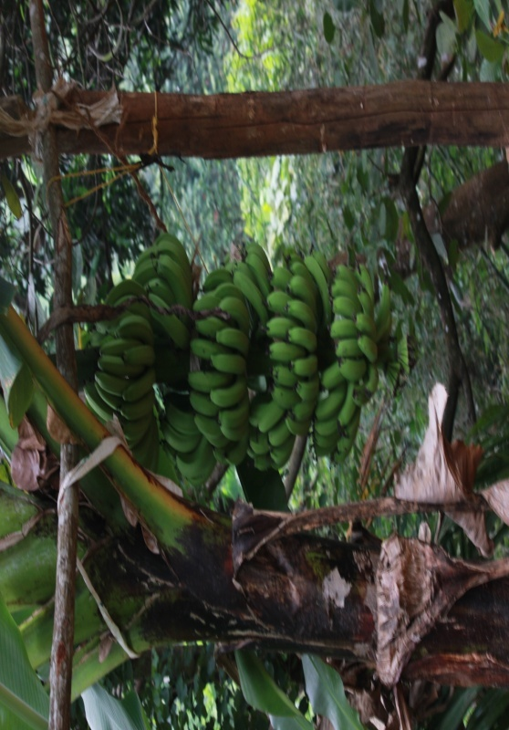
UNDA CHILLY: Kaayi munchi BANANA: Baaretha kaayi/ Baaretha/

paRant (riped)
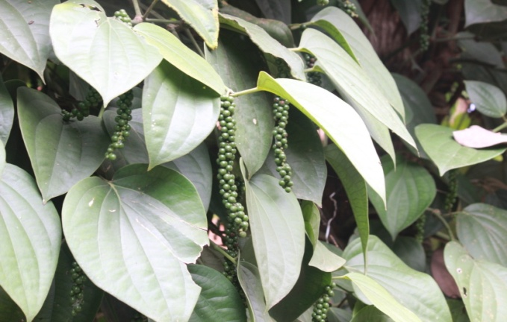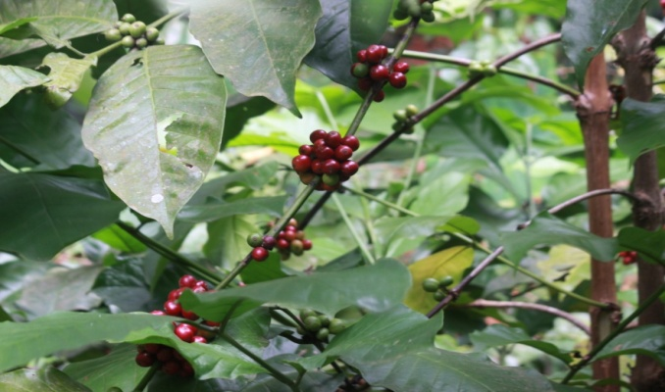
BLACK PEPPER: eddemunchi COFFEE : Kaapi
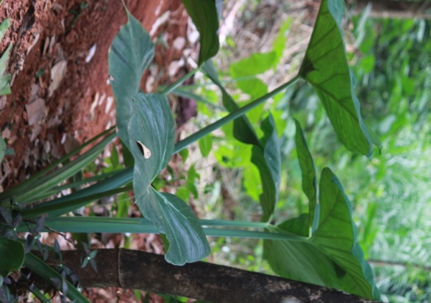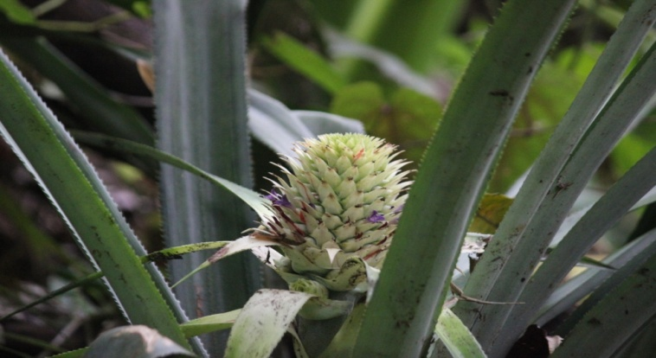
COLLOCASIA (CHEMBU):peeRcheevu PINEAPPLE: PaRa´ka½akk¡yi
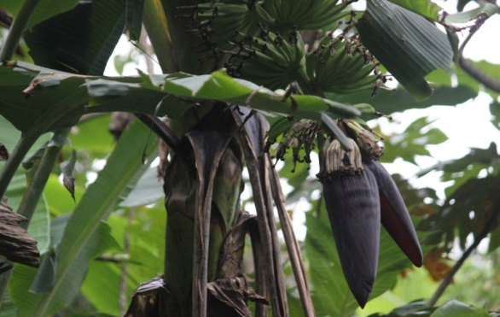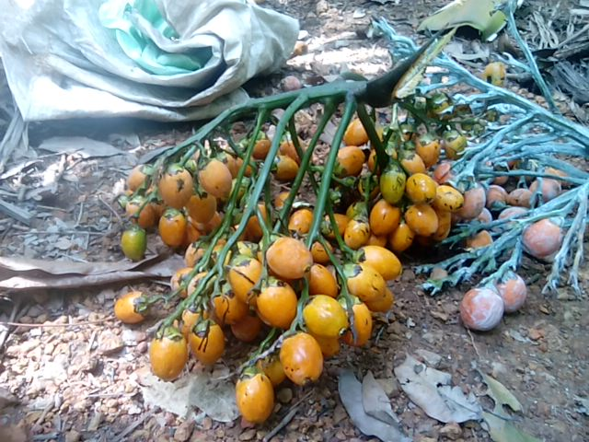
VAZHA KUUMBU: Puumbe ARECUNUT: bajjei
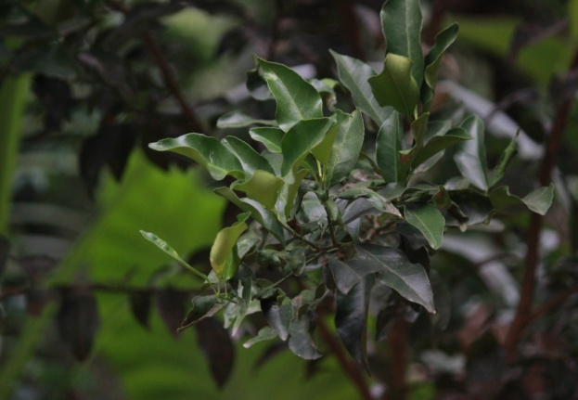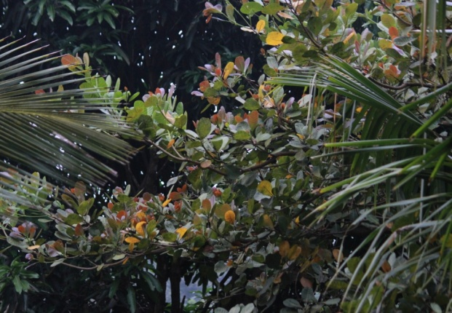
ORANGE: Nayichithupuli/ citt£½i CASHEW: Beejetha maRa /
CASHEW fruit g°´gu/
CASHEW nut: g°´guta blje.

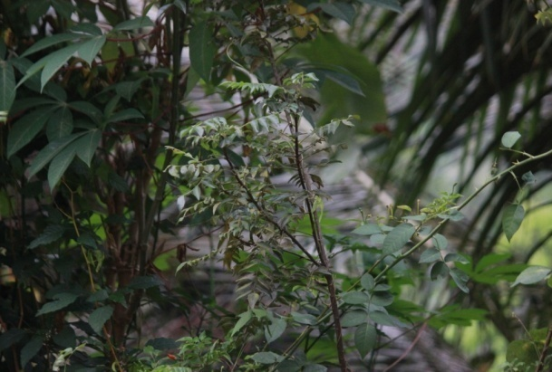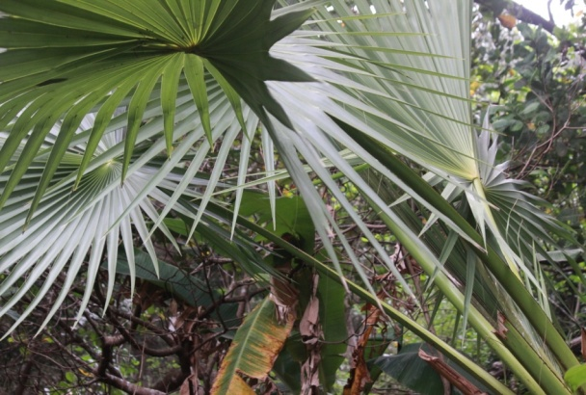
CURRY LEAVES: beesappu PALM TREE: Tharitha maRa
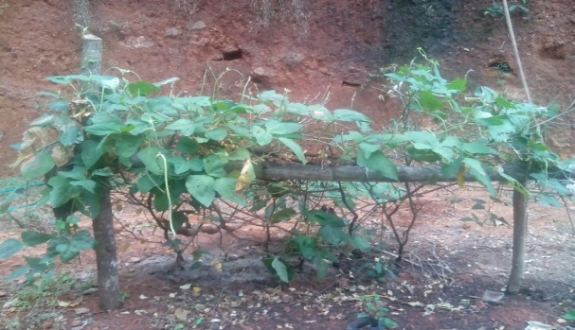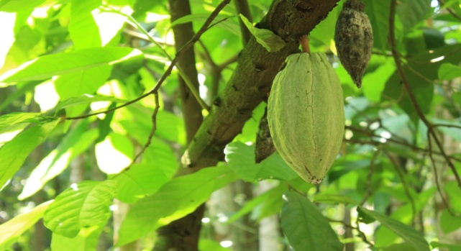
PEA PLANT: Althandei dhai COCO
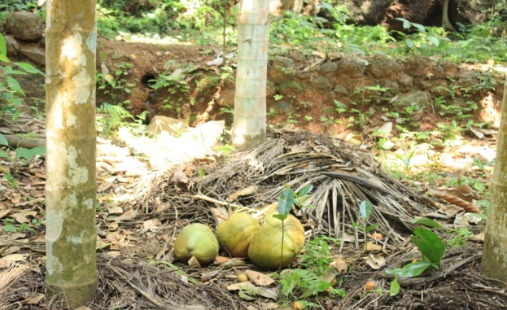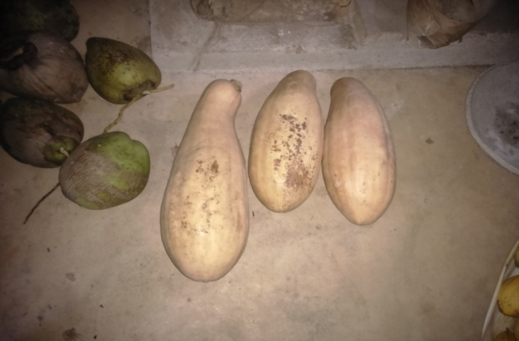
Coconut Shell: ceppə cucumber: maņōļi
The medicinal plants like tulasi, ginger, turmeric, pomegranate, sambrani etc are also cultivated there.
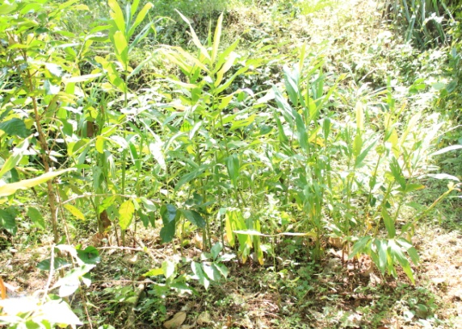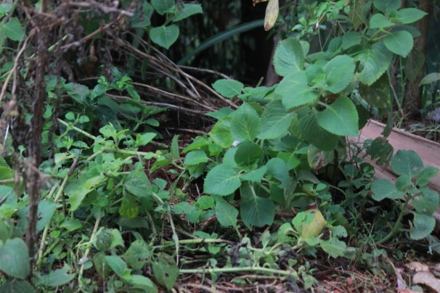
Turmeric : maŋjiļa saambraani( medicine for fever and cough)
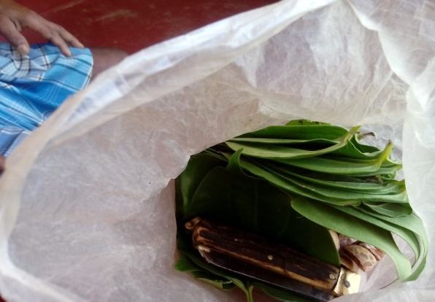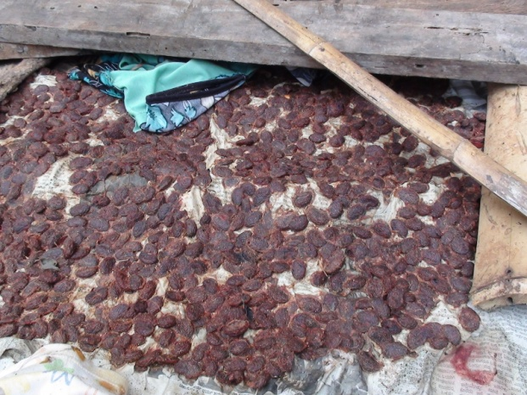
Betel leaves : bettaa Tamarind : puņike
EP009_AA002 : Fishing (tools, hooks, net,( types of net and materials), weaving practis, local fishes)
As like an entertainment programme, they went for fishing. But they don’t go much away from their home for fishing. Often they do fishing but they don’t eat too much fish.
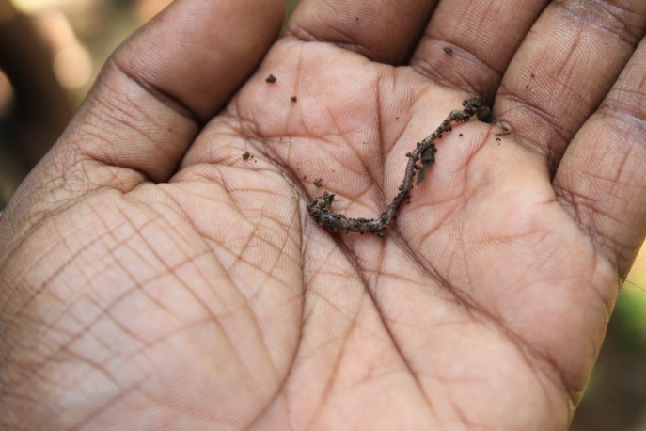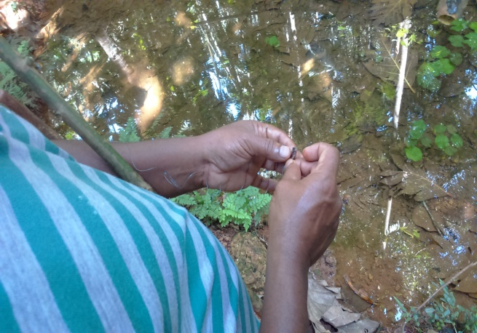
First they took “nakru” i.e and knot with hook. Hook is tied with plastic twine which is connected with a stick. Put that into water and they wait for some time and when fish trapped in the hook, they caught it. The below figures represented the steps they are using to catch a fish.
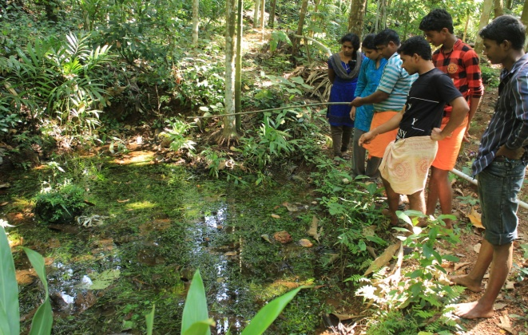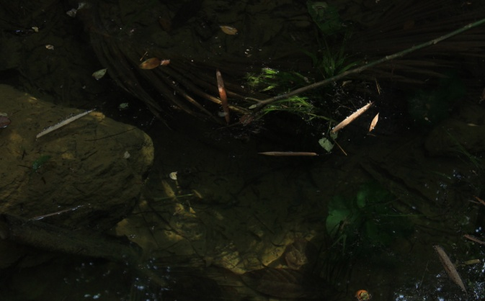

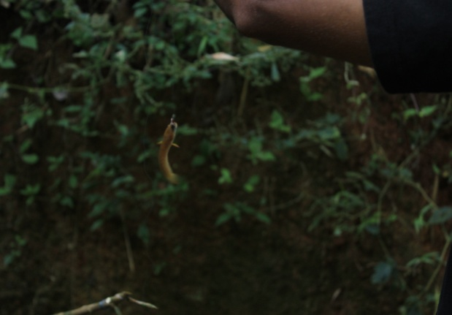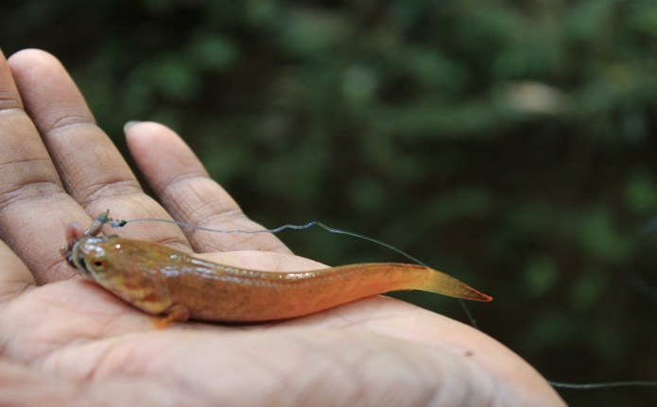
Normally they used these tricks for fishing. Also they used big nets for fishing. It is probably used for trapping big fishes. For the tricks they said it as “cap·i”. Generally they had fishes like ‘ kaaņdaayi’- gar fish, ‘kallee·e’- bonito fish, ‘kalkore’- a kind of fish, ‘karli’- sabre fish, ‘kujji’- a kind of fish, ‘filopi’- a kind of fish . Some of the fish usually seen in valleys near to their place are ‘moraņţai’, ‘cobaţţai’, ‘d®bardhāRu’, eţţi’(prone), ‘kalambuRo’ etc. These are mainly seen in small stream called ‘kaiyāru’.
EP09_AA003 : Hunting (trap, other tools, strategy, use)
They make traps for birds and rats mainly. For that, they use toins, wooden pieces, pots, knives etc. They used tricks and traps as like an entertainment. They do fishing, birds traps etc.
EP011_AA000 : TRANSPORTATION
Their settlement is situated at a location of 1500 feet above sea level. Mainly there are bus services, jeep and ape auto. That is not available to their house premises. They had to walk a distance to reach their settlement.
EP012_AA000 : CLOTHES (Materials)
EP012_AA001 Aged Men
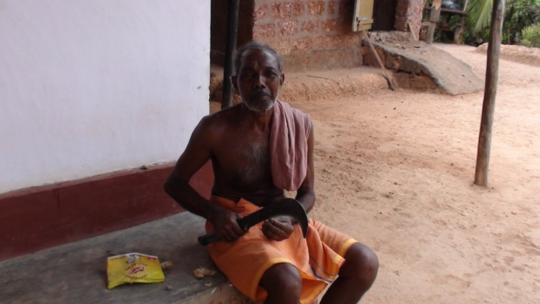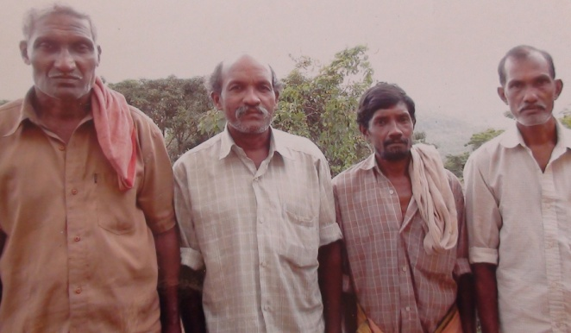
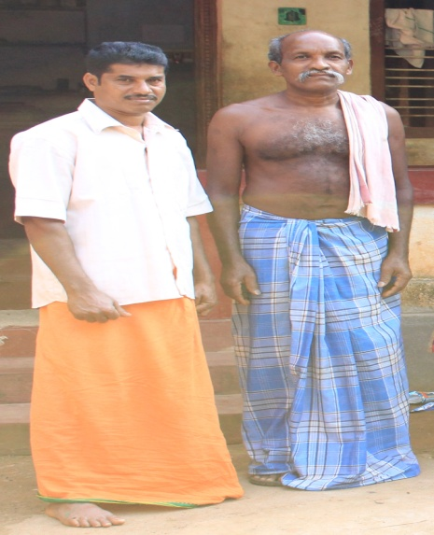
Generally in home situation, they simply use “dhoti” and “ tooRthu”. Otherwise they used to wear shirts, dhoti sometimes thooRthu ( put in the left shoulder)
EP012_AA002 : Aged Women
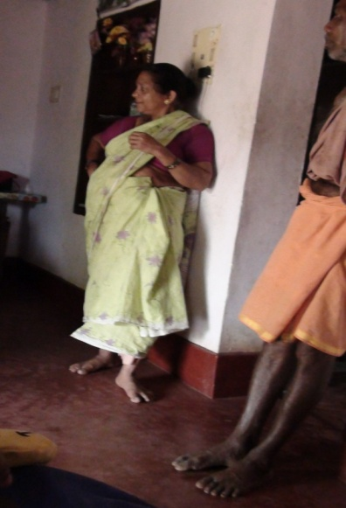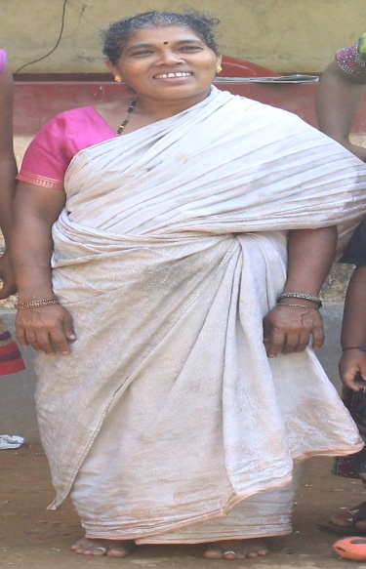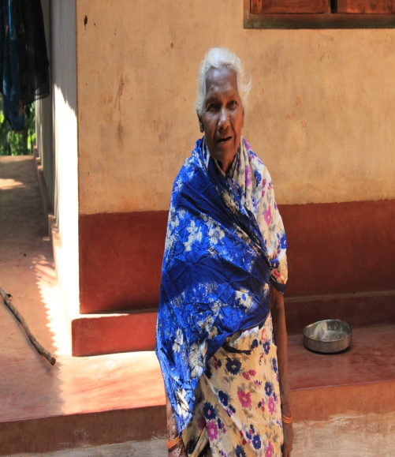
Commonly aged women were using saree.
EP012_AA003 : Younger Generation
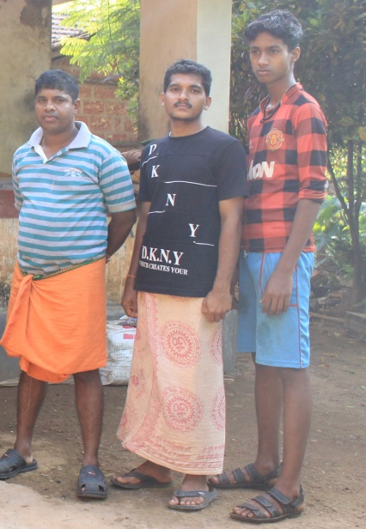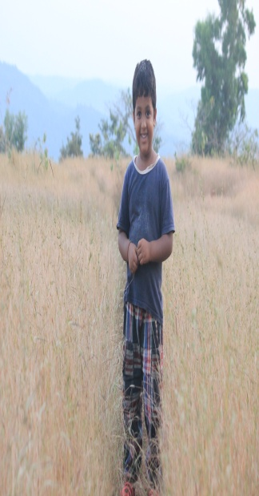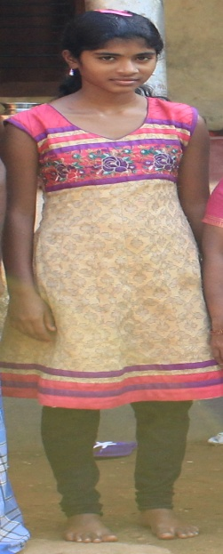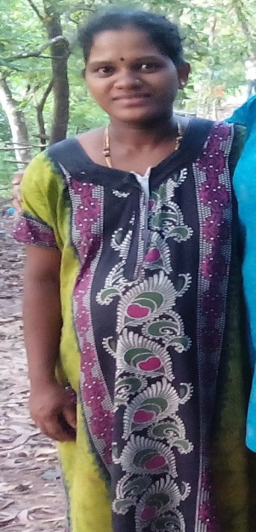
Younger generation were wear T-shirts, trousers, churidhar, maxis, saree etc. Occasionally they do wear traditional dresses.

EP014_AA000 : ATTIRE, ADORNAMENTS
According to the Kutiya colloquial celebrations and practises they used their traditional ornaments. Usually women wore bangles, rings, studs etc rather than men.
EP014_AA001 Head ornaments/ turban
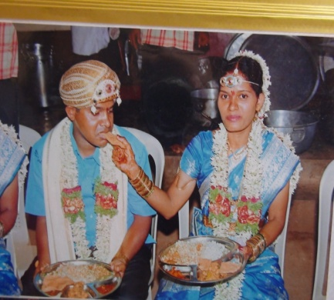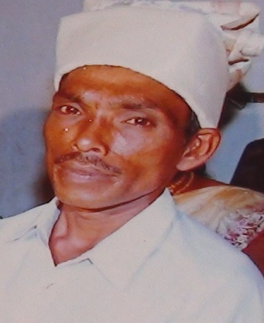
Turban is certainly used at marriage ceremony called ‘madim®’, the bride and groom uses particular ornaments. Turban is must for groom. It is a custom which is traditionally followed by Kutiyas. They called it “pak·i” or “thalapp¡vu” . It is made up of silk piece of cloth. In front of the turban, they use silken buttons, pearls and shinning toin which must be arranged very beautifully.
But now a day the groom uses according to their taste and interest. Turban is wore by bride’s brother or uncle on the occasion. The “chutti& maatti” wore by bride is especially used only at marriage.
EP014_AA002 : Ornaments of the neck
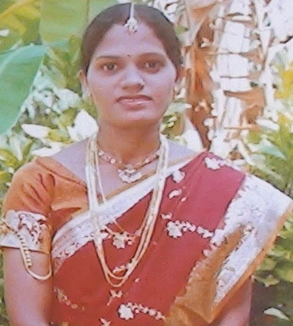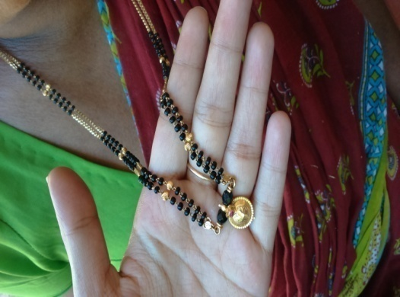
A Kutiya woman at her marriage “ Thaali” of a Kutiya woman
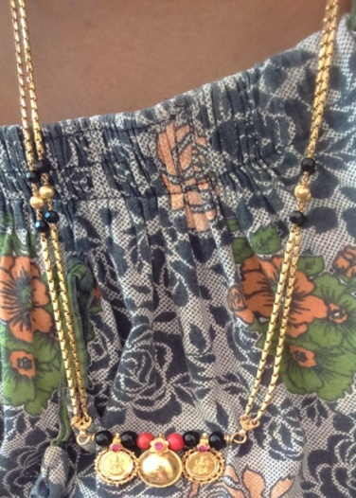
This type of “thali” is used by the women who are belongs to Karnataka region. The goddess Lekshmi is stamped on the lockets.
Married women wear “mangal sutra” / “thaali”. It is tied by groom at the marriage time. Till the death of her husband, she should wear it. Kutiya woman ought to wear “Thaali” after her marriage. A women’s neck ornaments are called by the name “cānūlu”.

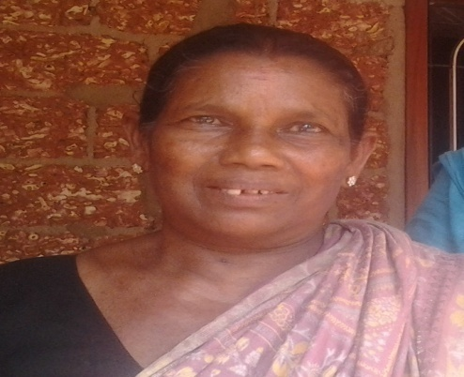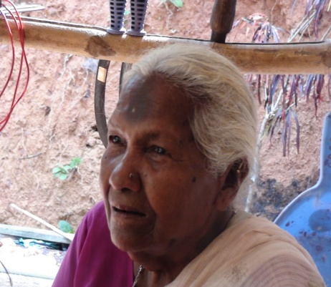
Those who became widow donot wear “thaali”. Sometimes they wear “kallu maala”.

EP014_AA003: Ornament for Nose

The women use single stone or three stone studs on their left side of the nose. Sometimes they put studs on the both sides also. They called it as ‘tikki’.

EP014_AA004 : Ornament for Ear (round/ long)
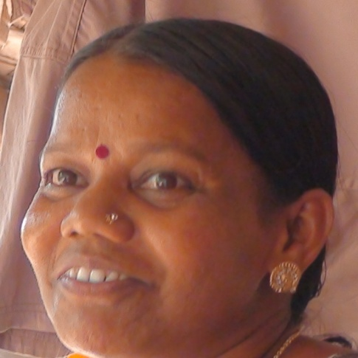
Kutiya women mostly wear studs and second studs. They called it as “kuņdalo”. These types of studs are like flowers. And the ear ring is called b¡lsara. “aralōle” is also a kind of ear ornament.

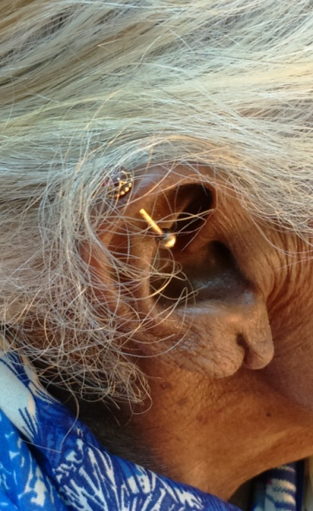
For old women they wear “koppu” (a stud on the top of the ear)
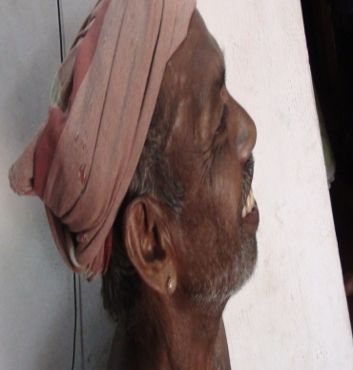
An ear ornament known as ko·a´ge worn by male. They use round studs for ear. They used to call it as ku·uka.
EP14-AA005 : Ornament for hand (bangles)
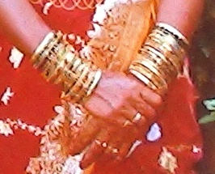
Mostly they wore gold bangles, glass and plastic colorful bangles.
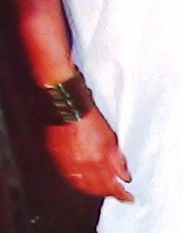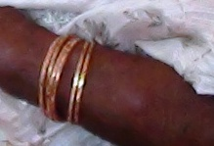

Mistress is always used to wear bangles.

EP014_AA006 : Ornament for hand finger (ring)
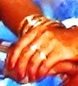
Finger ring also called ‘urulə’ is wore by the people whom they like to wear.
EP014_AA007: Ornament for hip
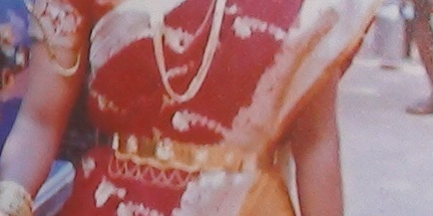
For bride they used to wear hip ornament in their marriage.

EPO14_AA008 : Ornament for ankle
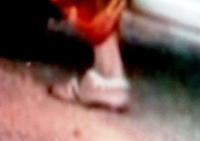
It is not at all a compulsory to wear ankle jewel in their community. Mostly the newly married women are using this.

WORD LIST

HUMAN BODY PARTS
- This domain will contain terms for both external and internal organs of the body.
- Types of the different human body parts and also its sub parts such as types of fingers, lips, hair, leg, hand, tooth, bone etc should be included.
- Elicit at least twenty words from the following nouns using the following sentence frames:
- Every boy has a/two __________
- The ghost/god had four/ eleven/ twenty-one ____________
- The boy did not have any ________________
- The boy has no ________________
- Keep the sentence frame data in a separate file.
WLHB_001 | Head
  taRrai
WLHB_002 | Face | m°ne
WLHB_003 | Temple
WLHB_004 | Dimple
WLHB_005 | forehead | muṇṭo
WLHB_006 | eyebrow | kaṇṇəta karai
WLHB_007 | eyeball | kaṇṇəta karuvalə
WLHB_008 | eyelash | kaṇṇəta reppei
WLHB_009 | Nose | Muukku
WLHB_010 | nose hair | kujaḷə
WLHB_011 | moustache | miiṣe
WLHB_012 | beard | gaḍḍe
WLHB_013 | jaw | dauḍe
WLHB_014 | Tooth | Kuli
WLHB_015 | Gum
WLHB_016 | Skull | patippə/taRrattacippi/ ma¸·e
WLHB_017 | skeleton | elukoṭṭe
WLHB_018 | neck | kekkəḷə/naaḷi
WLHB_019 | Throat | Kekki
WLHB_020 | Chest | Tigale
WLHB_021 | Breast | Tigale
WLHB_022 | forearm
  kooḷukai, kaita¶¶u
WLHB_023 | elbow | Munkai
WLHB_024 | finger | Viral
WLHB_025 | Palm | aṅkai
WLHB_026 | nail | Ugguru
WLHB_027 | Hip | soṇṭa
WLHB_028 | Abdomen
WLHB_029 | Belly
WLHB_030 | Thigh | tuṭai
WLHB_031 | waist | soṇṭo
WLHB_032 | Wrinkle
WLHB_033 | Bald
WLHB_034 | Lobe
WLHB_035 | Mole
WLHB_036 | Back | Berainkallu
WLHB_037 | Bone | aṭṭe
WLHB_038 | rib | aRgiḷə
WLHB_039 | spine | berimuḷḷə
WLHB_040 | bone marrow
WLHB_041 | Blood
WLHB_042 | Lung | kooṅganaaḷi
WLHB_043 | Heart | tigaḷe
WLHB_044 | Liver | kaRḷə
WLHB_045 | bladder
WLHB_046 | Nerve
WLHB_047 | Brain
WLHB_048 | Kidney
WLHB_049 | Ligament
WLHB_050 | Flesh
WLHB_051 | Muscle
WLHB_052 | Hair | TaRrakkatavu
WLHB_053 | Eye | kaṇṇə
WLHB_054 | eyelid | kaṇṇəta reppei
WLHB_055 | Ear | Kibi
WLHB_056 | cheeks | keppaṭṭe
WLHB_057 | lip | Bimma/oṭṭe
WLHB_058 | chin | maṇṭige
WLHB_059 | mouth
WLHB_060 | tongue | naaḷagei
WLHB_061 | shoulder | pageelə
WLHB_062 | hand (left, right) | eṭatta kai / valatta kai
WLHB_063 | wrist | maṇigeṇṭə
WLHB_064 | Leg
  Kaal
WLHB_065 | knee | kaalə gaṇṭə
WLHB_066 | ankle | maṇi gaṇṭə
WLHB_067 | foot | kaaRdhaṇṭi
WLHB_068 | heel | kaḍai kaalə

AIR AND RELATED
- Terms of air and wind known to the local people must be collected.
WLAR_001 | air | g¡li
WLAR_002 | gas
WLAR_003 | fog (types of fog) | mayintə
WLAR_004 | storm
WLAR_005 | wind | g¡li
 | Mist/dew | maindu

CELESTIAL BODIES AND RELATED
- The investigator should collect words and its types of heavenly objects such as clouds, stars, moon and its stages etc.
WLCR_001 | cloud | mauka½a ,m°do
WLCR_002 | lightning | miµci,  kittu
WLCR_003 | moon | candr®, tinka½da
WLCR_004 | sunshine | dhumbu
WLCR_005 | rainbow
WLCR_006 | thunder
WLCR_007 | planet
WLCR_008 | milky way
WLCR_009 | star | bo½½i
WLCR_010 | sky | b¡ ¸am,  ak¡so
WLCR_011 | sun | s£rya
WLCR_012 | seven star
WLCR_013 | galaxy
WLCR_014 | solar eclipse
 | New moon | am¡se
 | Full moon | puņņame

RELIGIOUS and other ceremonious terminology
WL12_AA002 Bell : yaņde
WL12_AA003 Blessing : matipu
WL12_AA004 Demon : pedakkāle
/ rekasi
WL12_AA006 Festival : parbā
WL12_AA008 God : d®veru
WL12_AA009 Goddess : appe / d®vi
WL12_AA0010 Heaven : sorga
WL12_AA0011 Holy place : edejāge
WL12_AA0012 Idol : innepun®
WL12_AA0013 Incense stick : mantra tandu
WL12_AA0014 Temple : kenni
WL12_AA0015 Birth rituals : amm®
WL12_AA0016 Death rituals : sāvu
WL12_AA017 Ceremony of first entrance : eļokiļ
Into the house
WL12_AA019 First rice ceremony :bal®gu /
nupukorpiņi
WL12_AA020 Harvest festivals :keikoipiņ®
WL12_AA021 Cattle festivals :gōpūjei
WL12_AA022 Kite flying festivals :gālipaţţa
WL12_AA024 Thread ceremony : am®
WL12_AA025 Marriage :madim®
WL12_AA026 Spring festivals : basanta
WL12_AA027 Fishing festivals :miiµə
WL12_AA028 Forest festivals :gu··ə
WL12_AA029 Bamboo festivals :badhiRata
kōlu
WL13_AA000 EARTH and RELATED
WL13_AA001 Ash :boµµa
WL13_AA002 Cave :sorańga
WL13_AA003 Cloud :kesaRa
WL13_AA004 Cold :simo
WL13_AA005 Darkness :iraļa
WL13_AA006 Desert :bōləgu··e
WL13_AA007 Earthquake :būkamba
WL13_AA008 Echo :swarakańtnei
WL13_AA011 Flame :uri/ suta eri
WL13_AA013 Forest : kādu
WL13_AA016 Hill :gu··e
WL13_AA018 Mud : kiriµci

COLOUR TERMS
WLCT_001 | Black |  | k¡la, kappu
WLCT_002 | White |  | b°ltu, bili
WLCT_003 | Red |  | Kempu
WLCT_004 | Yellow |  | maµja½
WLCT_005 | Blue |  | niili
WLCT_006 | Orange |  | K®sari
WLCT_007 | Green |  | pacce, kaÀuru
WLCT_008 | Violet
WLCT_009 | Brown |  | saudu
WLCT_010 | Pink |  | gul¡bi
WLCT_011 | Grey |  | buuti
WLCT_012 | Purple

WILD ANIMALS AND RELATED
WLWA_001 | lion | simmam
WLWA_002 | tiger | Pili
WLWA_003 | elephant | ¡µe
WLWA_004 | bear | kara·i
WLWA_005 | deer | ji´ge
WLWA_006 | fox | kotige
WLWA_007 | jackal | paļļu
WLWA_008 | rhinoceros
WLWA_009 | monkey | kora´gə
WLWA_010 | mongoose
WLWA_011 | cub
WLWA_012 | den

LIFE CYCLE AND RELATED

EPLC_001 : birth ceremony
From birth to death their life style is marked with observances, religious and non-religious. Here again there are differences but on the whole there is similar.
During the 7th month of pregnancy, from the boy’s side , prepare all sorts of eatables and ask her to eat. Before she goes to her parents, her hands are immersed in flour liquid and she keeps her hands on the wall. People were not sure whether she would be alive when she delivers. Thus she asked to put her hand on the wall as a remembrance. As soon as baby born, pepper powder mixed with honey is given to the new born babe, and the mother is given bath.
On the 7th day after delivery, the ritual named “amesudham” celebrates. And after 16 days, baby is put into “thottle” ie, “saalakke thottikettunne”. On this day, baby having his or her name by grandmother or grandfather. And also the “nuulukettu” doing afterwards. It’s the black colour toin that tie around the hip of the baby. Before “saalakke thottikettunne” there is “throttle puuja”. Its having branches of “kasarka” tree, “chennersurli”,skin of “kothumbu” of coconut tree, turmeric. They used 5 beetle leaves, one areca nut, one coin, eyes of coconut offer to God and after prayer they tied all those in the “thottle”. So that baby is safe from all the evil spirits.
After this, they celebrate by sharing sugar crystals and pieces of coconuts to everyone. In boy’s home they used to give “karipetty paani” which is made up of water and “karipetty” to everyone. The boy should give hot chilis, one bunch of “bellam”, and money to girl’s home. Following 40 days, Ayurveda medicines should be giving to girl.
EPLC_002 : Naming ceremony
Naming ceremony is on the sixteenth day of the child’s birth. During that day, after giving a name to the child, mother or mother-in-law do ‘nuulukettal’ ( a tie knot around the hip of the child) with prayers . They do ‘puuja’ to the ‘tottil’ inorder to protect baby from evil spirits and horror dreams.
EPLC_003 : puberty
In their community, while a girl became matured, only her mother and other women can go to her and prepare her for the rituals.
On the first day, she is taken to temple after bath. After that everybody in their community (only ladies) gave her a copper coin. On the third day, she has to take bath. Otherwise she is taken inside of the house and they make her to bath with turmeric and so on. In case of boys, at the age of 12, there is a ceremony in relation with their growing stage. It is called as “kajicchuthamathamee”.
But, it is not compulsory for them to celebrate it.
EPLC_004 : Marriage
Their marriage ceremony is beginning with prayer to Lord Krishna. For prayer they had to arrange a small “manpa” in front of girl’s house.In that manpa they put Lord Krishna muurthi for prayer. They should offer “Tulasi leaves, bananas, coconut, flowers, water, banana leaves, areca nut, “nilavilakku”, turmeric powder,etc. During prayer girl and her parents should present there” Maama and Maammy “ (uncle and aunt) are arranging and doing all the things. They are responsible. During prayer, girl is supposed to give rice to her hand which she should submit to Lord in fire. Later, put “mayilanji” in her palm by families and after everyone is offered for the blessings of Lord. This ceremony is celebrated a day before marriage.
On that day of marriage, the boy should reach the “kalayana manba” earlier. He has to enter into the manba first. After that girl and her family should get into the mandaba. Both families were enter into the hall after “thorana puuja” and “thorane kampe “ ritual. The representatives from both families do it
Before boy enter into the hall, his feet is washes by girl’s younger brother. And “thilaka” will put by aunt in the forehead of the groom and for the girl also.” Thilaka dhali” is with turmeric powder, kumkum (red colour powder) and light. The boy’s elder sister put “karimani dhandee” (necklace) to boy. And the younger brother of the girl put “The feet of the girl’s is washed by boy’s elder sister. Later they will enter into the manpa.
The elders from both girl and boy sit together and take decision to gave word for the marriage. Boy’s uncle gave “saree, flowers, ornaments, and all the things for girl to girl’s uncle. Girl’s uncle asked to bless those things by everyone. For “puuja” they used to have rice, cocnut, flowers, beetle leaves, areca nut , water, light, agarbathi, coin and all the those things that given by boy’s uncle. Later they exachanged a plate of beetel leaves and areca nut to girl’s side and girl’s aunt gave “dhali “ of saree and other things to boy’s aunt.
Boy’s aunt and sisters grooming the girl. Girl’s uncle put “thalapavu” on boy’s head.He also put “mailanji” in his palms. It is the boy’s sister who accompanied the girl to “mandapa”. During prayer they asked to put “flower maale” to each other. In between them , there should a curtain. After that they put “thilaka” to each other. Later then the boy put “karimani” ie, thali to girl.aAnd its said to be “maaale padune”. put “kumkum” to her forehead. Both are asked to do the prayers and asked to hold their hands together and they have “dharaa meyipune” in which milk is shower on their hands. Later everybody bless them. If anyone of the bride or groom’s father died, then their mother is not supposed to sit with them in that function. They called this ceremony as ‘kaid¡re'.
EPLC_006: Death/funeral process
For funeral they called it ‘kaim¡da.If anybody dies, they inform everybody. With the help of everyone they make bath to dead body. They put coconut with light and placed on the toe and head part.The body is placed on the banana leaf, they put white clothes on the dead body. And also give thulasi water into the dead body’s mouth and put flower maale on it. Later they took it into cemetery for ashes. They used mango tree branches and dried leaves for fire. The fire should give by the relatives and it should be from both head and toe side. After 5 days, they collect ashes from the cemetery and put these ashes into a pot and following 13 days, they celebrates “uliyilappunne”. They invite everyone to take part in it. Ever year they do ‘s¡rdo' (death anniversary) without fail.

FIRE AND RELATED
- The investigator will collect fire and its related words.
- Inquire for local terms also.
WLFI_001 | fire | s£, ¡gu
WLFI_002 | smoke | puha
WLFI_003 | coal
WLFI_004 | fuel
WLFI_005 | firewood | ka¸aku
WLFI_006 | flame | uri
WLFI_007 | ash | c¡ram
WLFI_008 | forest fire | k¡·us£
WLFI_009 | cracker
WLFI_010 | camphor
WLFI_011 | ember
WLFI_012 | furnace
 | charcoal | kari

KINSHIP TERMS ADDRESS AND REFERENCE TERMS
WLKT_001 | great grandfather (father’s side)
WLKT_002 | great grandmother (father’s side)
WLKT_003 | great grandfather (mother’s side)
WLKT_004 | great grandmother (mother’s side)
WLKT_005 | grandfather (father’s side) | ajj®
WLKT_006 | grandmother (father’s side) | ajji
WLKT_007 | grand father (mother side) | muttajj®
WLKT_008 | grandmother (mother’s side) | muttajji
WLKT_009 | father | amm®
WLKT_010 | mother | appe
WLKT_011 | son | m°nu, mage
WLKT_012 | daughter | m°ni, maga½
WLKT_013 | son (first born) | kadiru
WLKT_014 | daughter (first born) | Kadiru
WLKT_015 | grand-son | pu½½i
WLKT_016 | grand-daughter | pu½½i
WLKT_017 | great grand –son/daughter
WLKT_018 | great great grand-son/daughter
WLKT_019 | father’s elder brother | nellemme
WLKT_020 | father’s elder brother’s wife
WLKT_021 | father’s younger brother | sidhiyemme
WLKT_022 | father’s younger brother’s wife
WLKT_023 | father’s elder sister | nelleppe
WLKT_024 | father’s elder sister’s husband
WLKT_025 | father’s younger sister | sidhiyappe
WLKT_026 | father’s younger sister’s husband
WLKT_027 | mother’s elder brother | tag®
WLKT_028 | mother’s elder brother’s wife
WLKT_029 | mother’s younger brother
WLKT_030 | mother’s younger brother’s wife
WLKT_031 | mother’s elder sister
WLKT_032 | mother’s elder sister’s husband
WLKT_033 | mother’s younger sister
WLKT_034 | mother’s younger sister’s husband
WLKT_035 | twins (male)
WLKT_036 | twins (female)
WLKT_037 | elder brother | a¸¸e
WLKT_038 | middle brother
WLKT_039 | younger brother | Megi
WLKT_040 | youngest brother
WLKT_041 | elder brother’s wife
WLKT_042 | younger brother’s wife
WLKT_043 | elder sister | akka
WLKT_044 | middle sister
WLKT_045 | younger sister | megati , ta´gati, megti
WLKT_046 | youngest sister | ta´gati
WLKT_047 | elder sister’s husband
WLKT_048 | younger sister’s husband
WLKT_049 | sister’s son | arvatt®
WLKT_050 | sister’s daughter
WLKT_051 | brother’s son | arvatt®
WLKT_052 | brother’s daughter
WLKT_053 | father’s brother’s son
WLKT_054 | father’s brother’s daughter
WLKT_055 | mother’s brother’s son
WLKT_056 | mother’s brother’s daughter
WLKT_057 | father’s sister’s son
WLKT_058 | father’s sister’s daughter
WLKT_059 | mother’s sister’s son
WLKT_060 | mother’s sister’s daughter
WLKT_061 | husband | ka¸¶ani
WLKT_062 | wife | bu¶ati
WLKT_063 | husband’s elder brother
WLKT_064 | husband’s elder brother’s wife
WLKT_065 | husband’s younger brother | Maitne
WLKT_066 | husband’s younger brother’s wife
WLKT_067 | husband’s elder sister | atye
WLKT_068 | husband’s elder sister’s husband
WLKT_069 | husband’s younger sister
WLKT_070 | husband’s younger sister’s husband
WLKT_071 | wife’s elder brother | tage
WLKT_072 | wife’s elder brother’s wife
WLKT_073 | wife’s younger brother
WLKT_074 | wife’s younger brother’s wife
WLKT_075 | wife’s elder sister | atye
WLKT_076 | wife’s elder sister’s husband
WLKT_077 | wife’s younger sister
WLKT_078 | wife’s younger sister’s husband
WLKT_079 | son’s wife
WLKT_080 | daughter’s husband
WLKT_081 | mother in law | mami
WLKT_082 | father in law | samma½an
WLKT_083 | daughter’s father in law
WLKT_084 | husband’s wife (relation between two wives)
WLKT_085 | step father
WLKT_086 | step- mother
WLKT_087 | Widow
WLKT_088 | widower
WLKT_089 | son's mother in law
WLKT_090 | daughter's mother in law
WLKT_091 | son's father in law
WLKT_092 | sister's son from male ego's side
WLKT_093 | sister's son from female ego's side
WLKT_094 | sister's daughter from male ego's side
WLKT_095 | sister's daughter from female ego's side
WLKT_096 | lineage
WLKT_097 | ancestor
WLKT_098 | generation
 | Sister –in-law | mitidi
 | Brother –in-law | b¡va
 | Sister –in-law (elder) | akka
 | Sister –in-law (younger) | megti
 | Son –in-law | maRmmayya
 | Daughter –in-law | maRmma½a

LANGUAGE STATUS OF KUTIYA TRIBE
Mostly the language of a tribe itself is known for their community name. But in the case of Kutiya tribe, their language is said to be ‘Tulu’ and their community is known as Kutiya. According to the recent field study, their language is seemed to be influenced by other languages. Especially the language, Kannada. Malayalam is least influenced. Around 1600 of population, most of them are bilingual or trilingual. Only the old ones are monolingual. Kannada, Malayalam, Tulu are mainly spoken by them. In their home situations and in their community they speak Tulu. They don’t have Tulu script for writing. Instead they used Kannada script. As part of their progress, they are working on the establishment of ‘Tulu script’.
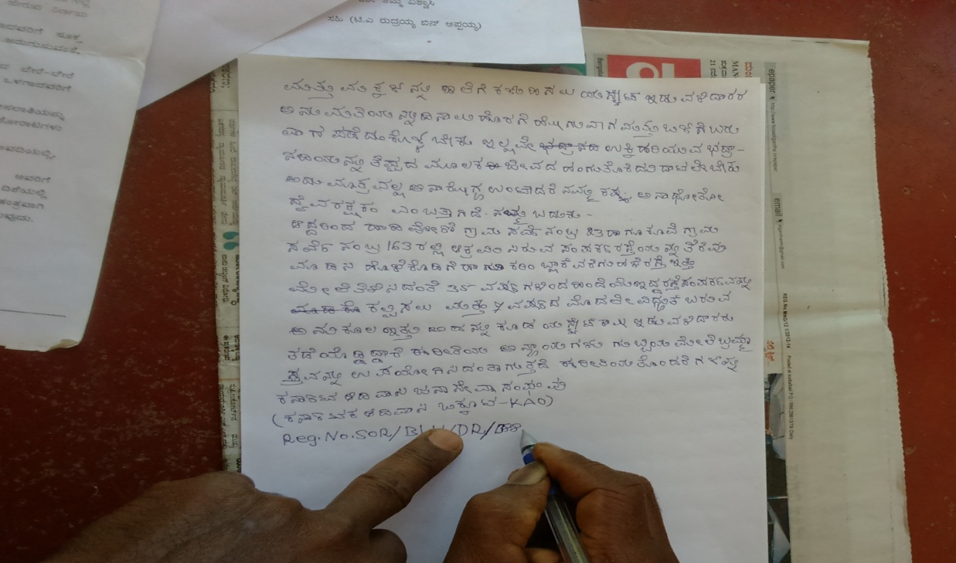
Education status:
Qualification status gives the impression. New generation are well educated. The majority of the children are gone outside for studies.
Other Facilities:
Compared to the primitive Kutiya people with present generation, there is so much changes happened in their life style and the facility they occupied. Earlier time, they only uses woods for fire. For that they should go to forest in order to collect the fire woods. Now they are using gas stove. They were using bio gas plant for their cooking.
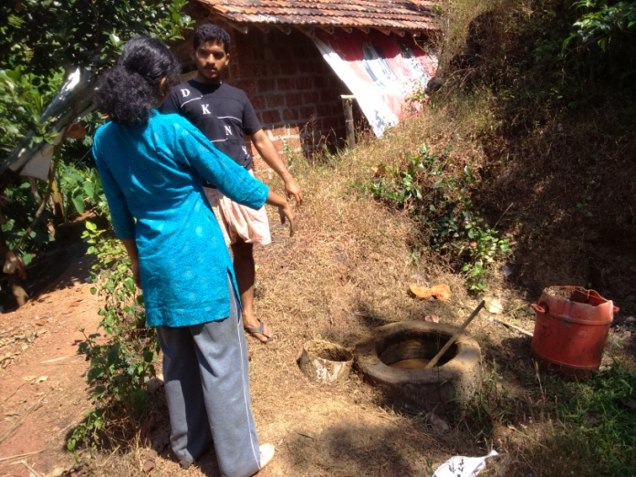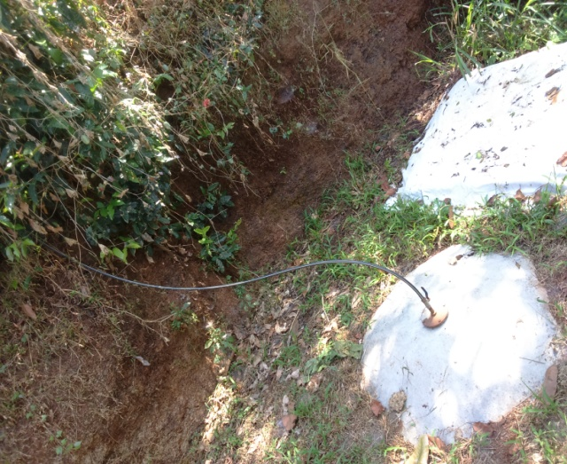
For that they use cow dung and other vegetable waste from kitchen and etc.
Once they were brought water from the river or pond near to them for the personnel needs and also for agriculture purpose. These days they are well known about the machineries and pump sets for irrigation.
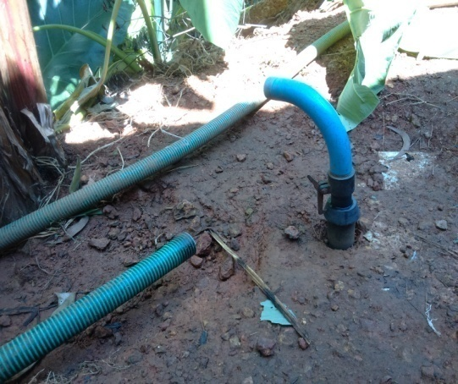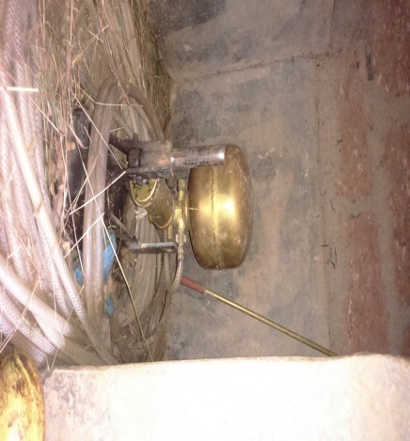
Moreover they are free to use television. Previously they are unaware about television programmes and are having fear in themselves. Most of them thought that whom they are watching are really stuck inside the T.V. Now luckily they are watching channels with dish antenna.
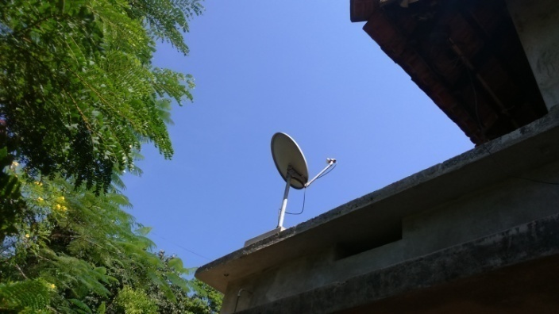
They do washing regularly. For that they made a separate place not so far from their house.
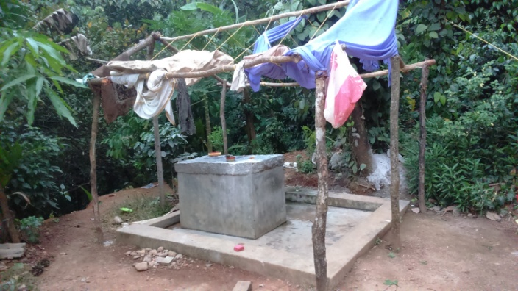
Very interesting fact can be seen with the construction style of their bathroom. They can make hot water inside the bathroom where the fire is set from outside of the bathroom.
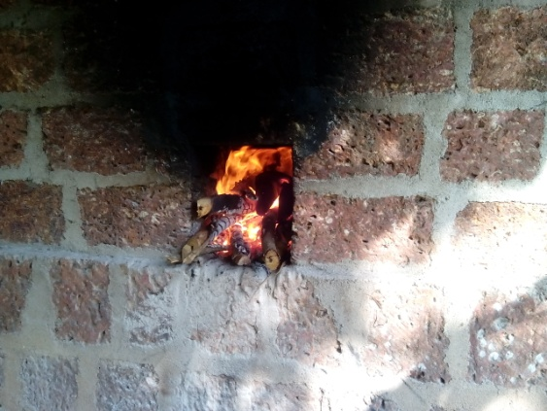
This is the back side of the bathroom. The fire is set here. The inside picture is shown below.
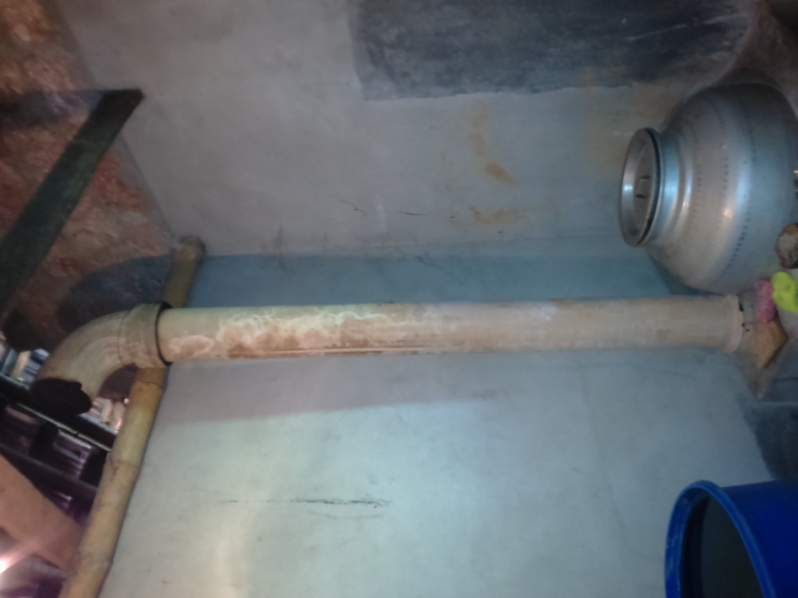
They made a big aluminium pot inside the bathroom which is fixed with cement. It get heated when fire set up. Thus according to the need they can make hot water.

