Date 31/12/14 Project Progress Report
Scheme for protection and preservation of endangered language
Program (CIIL)

The monthly report of the project on Darma Language is being presented here. The project has been allocated to the Department of linguistics, University of Lucknow and is being supervised by Prof. K. Srikumar and Prof. Kavita Rastogi who are the principal Investigators of the Project. A three persons team is working under their guidance which includes, Ashish Kumar Pandey, Dr. Vishnu Singh and Ajay Singh. The last October team went for field survey and visited many a places being resided by the target respondents of the Darma language. Many Darma speakers normally migrate in winter season to Dharchulla and the team decided to visit the place during this time. So in last October, the team visited the place, met a significant number of respondents and collected data. Now we are transcribing the same data.
Almost fifty percent of word list data we have transcribed. Earlier we have sent you transcribed word list 18th (semantics field) in two parts and now this word list whatever I am sending is till item number 25 of semantic fields. This data we have collected from more than one informant, whose names and pictures are inserted in figure 1.1
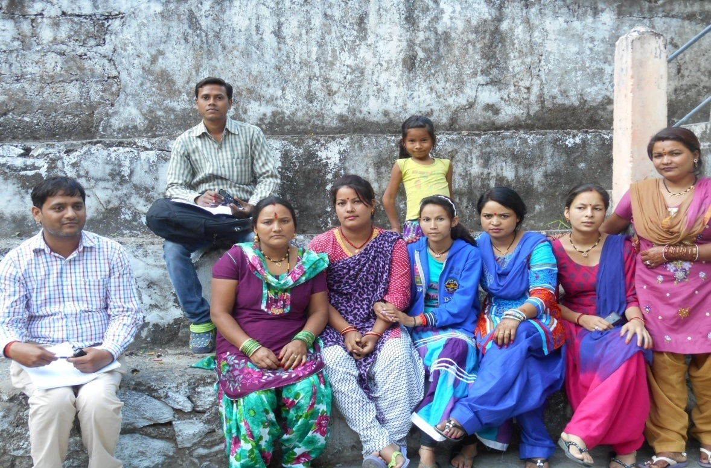

About the ornaments and cloths we have gathered data from Kalawati Nangliyal and confirm the same from other Nangliyaal families:

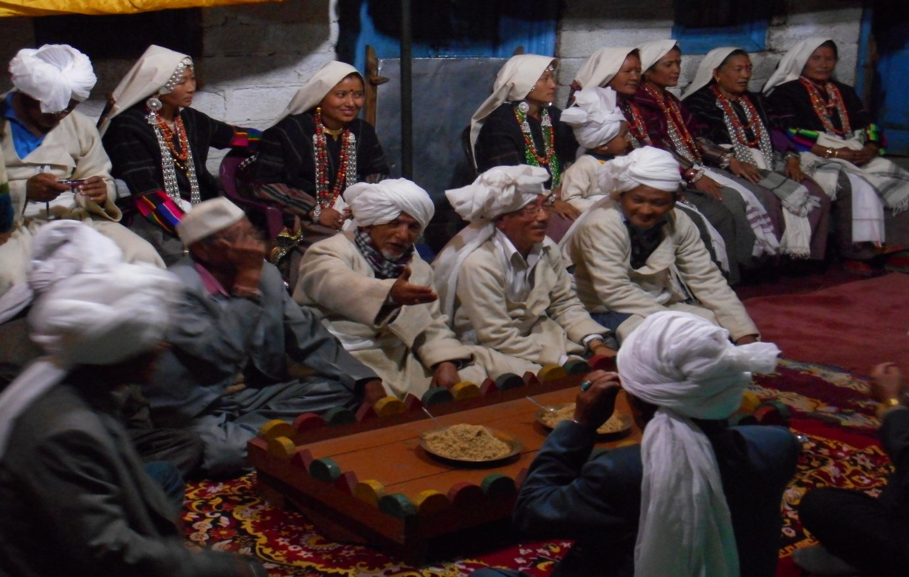
Figure no 1.2 ornaments and traditional cloths

The work of data transcription is based on Word list provided by the CIIL. In this progress report, we have transcribed the data of Darma, that has been collected by me in the October month, Dharchulla (Glaati Nangling village). The Semantic fields, which we have transcribed in this data is as follows- Time and Season, Ordinal-cardinal numbers, Sports and Games, Musical Instruments, Performances, Adornments and customs, Ailments and remedy. According to geographical and various other natural reasons, there are number of things which do not exist in their environment so we could not find those words, which are related to those things like transportation, medical facilities, and games.

Yours faithfully
Mr Ashish Kumar Pandey
Junior Resource Person, Research Scholar
Department of Linguistics University of Lucknow,
Lucknow- 226007

